Supplementary Information
Electroanalytical biosensor based on GOx/FCA/PEG modified SWCNT electrode for determination of glucose

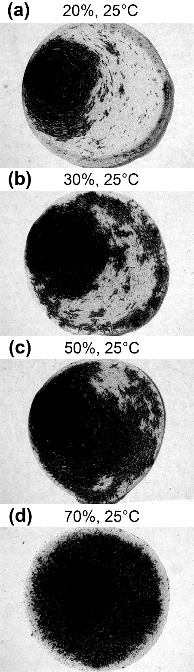
Figure S1. Microscope images of GOx/FCA/PEG modified SWCNT electrode obtained at different humidity conditions.

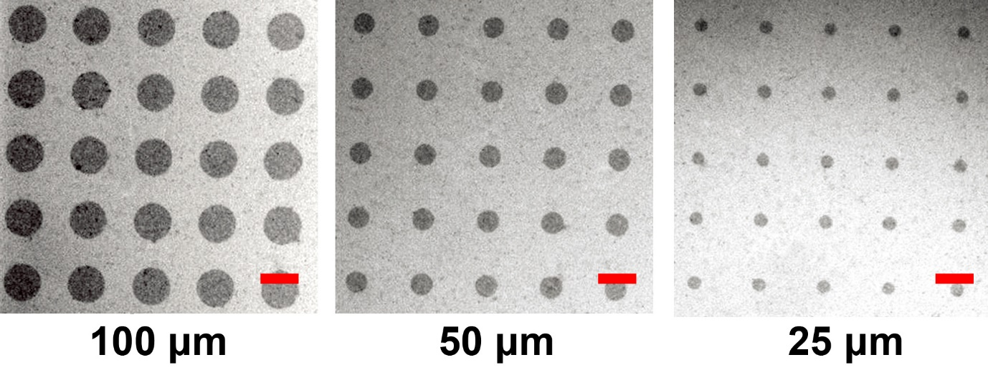
Figure S2. SEM images of SWCNT patterns on PET plastic substrate treated by O₂ plasma etching (diameter of SWCNT patterns: 100 μm, 50 μm, and 25 μm). Scale bar represents 100 μm.

Table S1. Comparison of analytical performances with other reported methods.
Modified materials | Method* | Dynamic range (mM) | LOD  (μM) | Assay time | Stability  (retention %) | Ref.
GOx/FCA/PEG/SWCNT | Electro | 0–10 | 28 | 10 s | 1 month (95%) | This work
Nf/GOx/Ag-Pdop/CNTs | Electro | 0.05–1.1 | 17 | 3 s | 2 weeks (92%) | [1]
Au/GOx/PB | Electro | 0.012–70 | 12 | 3 s | 2 weeks (77%) | [2]
GN/Py/GOx | Electro | 0.2–2.2 | 50 | 5 s | 1 month (NM#) | [3]
GOx-CHI/Pt | Electro | 0.01–15 | 50 | 1 min | 1 month (55%) | [4]
AgNP/GOx/CS | Electro | 0.1–10 | 10 | 40 min | 3 weeks (95%) | [5]
AuNCs/FGO | Fluoro | 1–10 | 160 | 70 min | NM | [6]
C₃N₄-Ru | Fluoro | 0.01–0.25 | 4.73 | 80 min | NM | [7]
PtNZHG | Color | 0.01–10 | 3.9 | 15 min | 2 months (90%) | [8]
GOx/GO/MnO₂ | Color | 1.39–16.65 | 170 | 4 min | 1 day (95%) | [9]
Fe-MOF | Color | 0.001–0.5 | 0.49 | 30 min | 2 months (90%) | [10]
GOx, glucose oxidase; FCA, ferrocenecarboxylic acid; PEG, polyethylene glycol; SWCNT, single-walled carbon nanotube; Nf, nafion; Pdop, Polydopamine; PB, Prussian Blue; GN, Graphite nanoparticle; Py, 1-pyrenebutyric acid; AgNP, Ag nanoparticle; CS, chitosan; AuNCs, Au nanoclusters; FGO, fluorescent graphene oxide; C₃N₄-Ru, Graphitic carbon nitride-Ru; PtNZHB, Platinum nanoparticle hydrogel composite; GO, graphene oxide; Fe-MOF, Fe–metal-organic framework.
*Fluoro, Fluorometry; Electro, Electrochemistry; Color, Colorimetry.
#NM, not mentioned.

- Wang Y., Liu L., Li M., Xu S., Gao F. Multifunctional carbon nanotubes for direct electrochemistry of glucose oxidase and glucose bioassay, Biosens. Bioelectron. 30 107–111 (2011).
- Wang H., Ohnuki H., Endo H., Izumi M. Effects of self-assembled monolayers on amperometric glucose biosensors based on an organic–inorganic hybrid system, Sens. Actuators B Chem. 168 249–255 (2012).
- Piao Y., Han D.J., Seo T.S. Highly conductive graphite nanoparticle based enzyme biosensor for electrochemical glucose detection, Sens. Actuators B Chem. 194 454–459 (2014).
- Ang L.F., Por L.Y., Yam M.F., Development of an amperometric-based glucose biosensor to measure the glucose content of fruit, PLoS ONE. 10 e0111859 (2015).
- Tran H.V., Le T.A., Giang B.L., Piro B., Tran L.D. Silver nanoparticles on graphene quantum dots as nanozyme for efficient H₂O₂ reduction in a glucose biosensor, Mater. Res. Express. 6 115403 (2019).
- Su L., Yang L., Sun Q., Zhao T., Liu B., Jiang C., Zhang Z. A ratiometric fluorescent paper sensor for consecutive color change-based visual determination of blood glucose in serum, New J. Chem. 42 6867–6872 (2018).
- Wang X., Qin L., Lin M., Xing H., Wei H., Fluorescent graphitic carbon nitride-based nanozymes with peroxidase-like activities for ratiometric biosensing, Anal. Chem. 91 10648–10656 (2019).
- Park J.S., Choi J.S., Han D.K., Platinum nanozyme-hydrogel composite (PtNZHG)-impregnated cascade sensing system for one-step glucose detection in serum, urine, and saliva, Sens. Actuators B Chem. 359 131585 (2022).
- Lee P.C., Li N.-S., Hsu Y.-P., Peng C., Yang H.W., Direct glucose detection in whole blood by colorimetric assay based on glucose oxidase-conjugated graphene oxide/MnO₂ nanozymes, Analyst. 144 3038–3044 (2019).
- Xu W., Jiao L., Yan H., Wu Y., Chen L., Gu W., Du D., Lin Y., Zhu C., Glucose oxidase-integrated metal-organic framework hybrids as biomimetic cascade nanozymes for ultrasensitive glucose biosensing, ACS Appl. Mater. Interfaces. 11 22096–22101 (2019).

