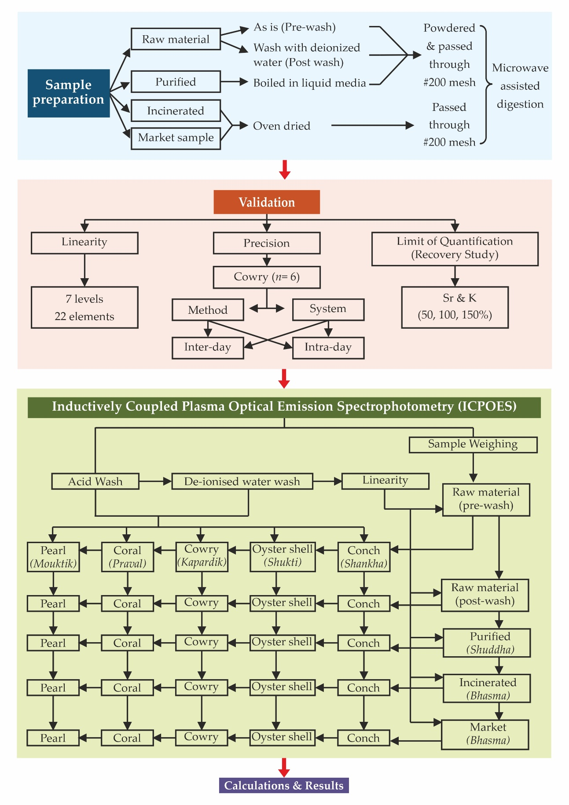
Supplementary File 2 Figure S1. Schematic presentation of the study design for analysis of Ayurvedic Marine Drugs (AMD).

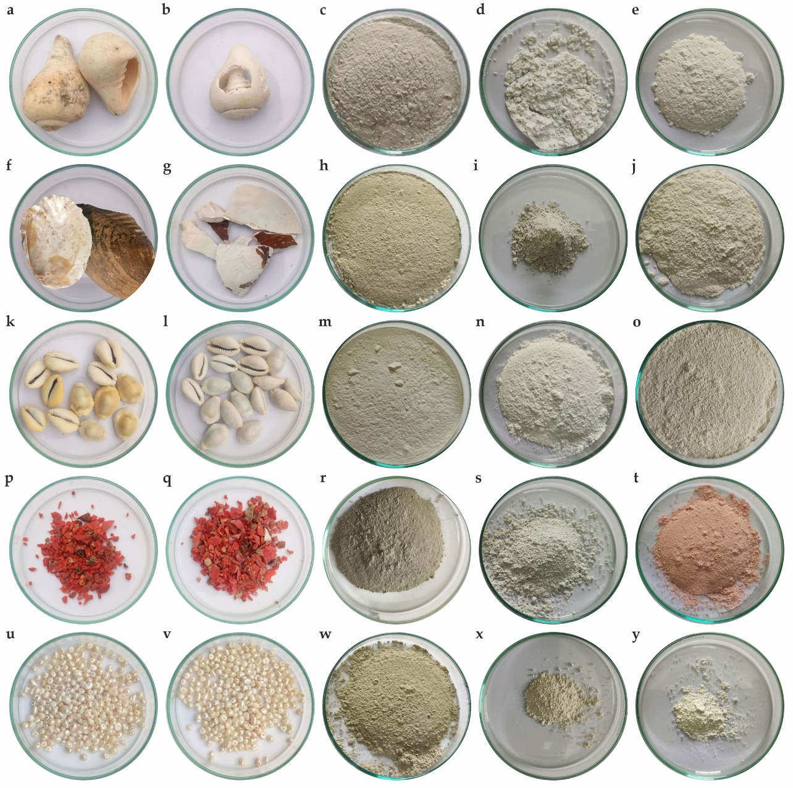
Supplementary File 2 Figure S2. Comparative visual representation of raw, purified and incinerated five marine materials used in experimental batches along with their respective market samples of finished products. (a) Raw conch (Shankha); (b) Conch purified; (c) Incinerated conch- Shankha Bhasma (SHA-B/1), (d) Market sample- Shankha Bhasma 1 (SHA/B-D); (e) Market sample- Shankha Bhasma 2 (SHA/B-U); (f) Raw oyster shell (Shukti); (g) Oyster shell purified; (h) Incinerated oyster shell- Shukti Bhasma (SHU-B/1); (i) Market sample Shukti Bhasma (SHU/B-D); (j) Market sample Shukti Bhasma (SHU/B-B); (k) Raw cowry (Kapardik); (l) Cowry purified, (m) Incinerated cowry- Kapardik Bhasma (KAP-B/1); (n) Market sample- Kapardik Bhasma (KAP/B-B); (o) Market sample- Kapardik Bhasma (KAP/B-D); (p) Raw coral (Praval); (q) Coral purified; (r) Incinerated coral- Praval Bhasma (PRA-B/1); (s) Market sample- Praval Bhasma (PRA/B-D); (t) Market sample- Praval Bhasma (PRA/B-U); (u) Raw pearl (Mouktik); (v) Pearl purified; (w) Incinerated pearl- Mouktik Bhasma (MOU-B/1); (x) Market sample- Mouktik Bhasma (MOU/B-D); (y) Market sample- Mouktik Bhasma (MOU/B-U).
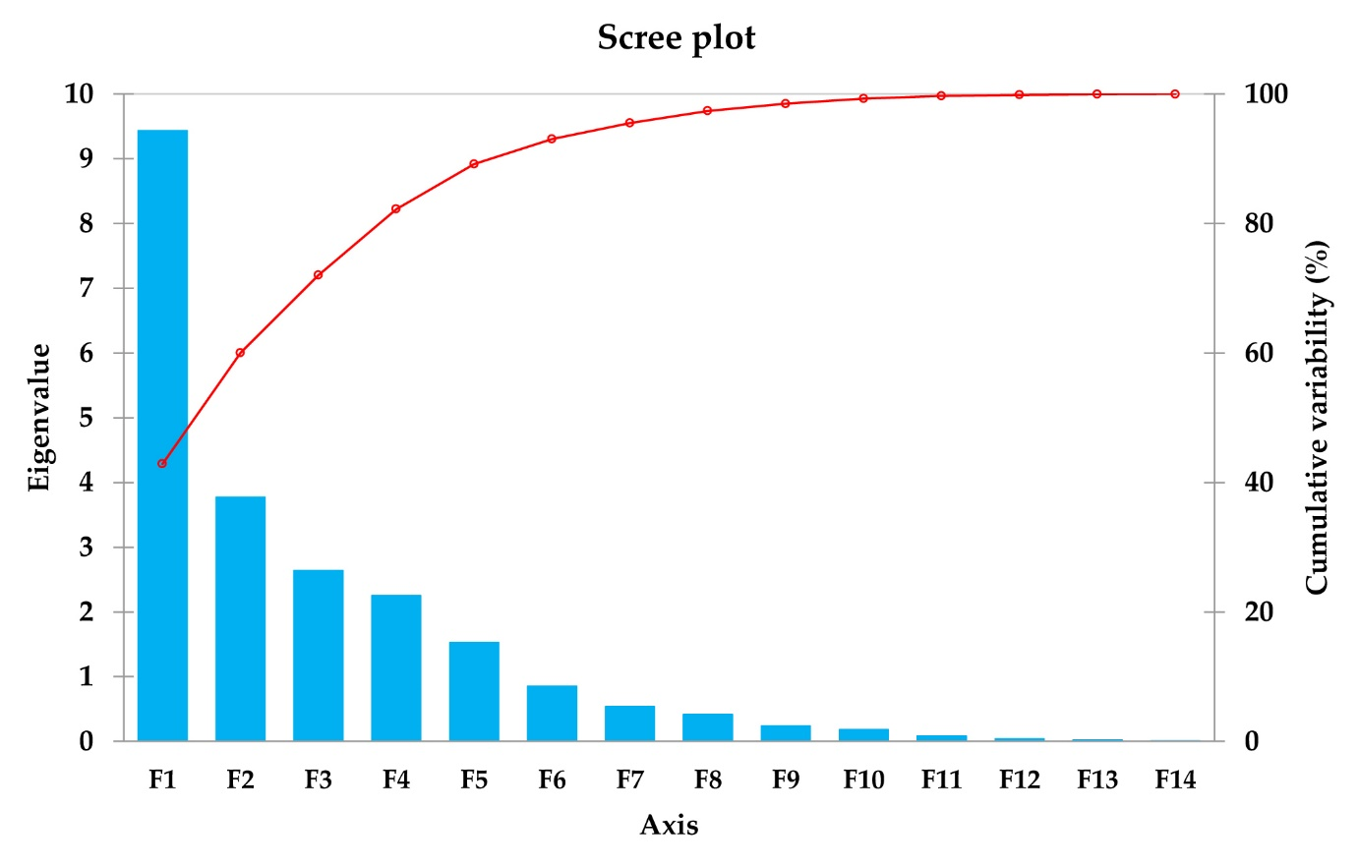
Supplementary File 2 Figure S3. Scree Plot of Principal Component Analysis of elements detected in five AMD
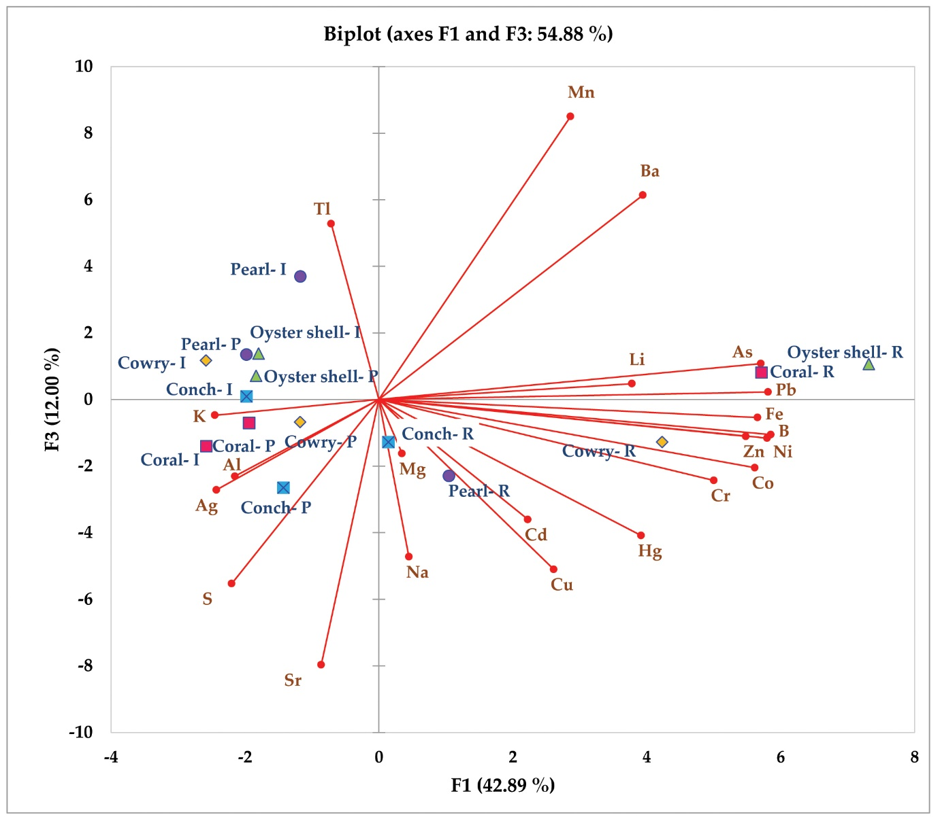
Supplementary File 2 Figure S4. Biplot of axes F1 vs F3 components under Principal Component Analysis of elements detected in five AMD.

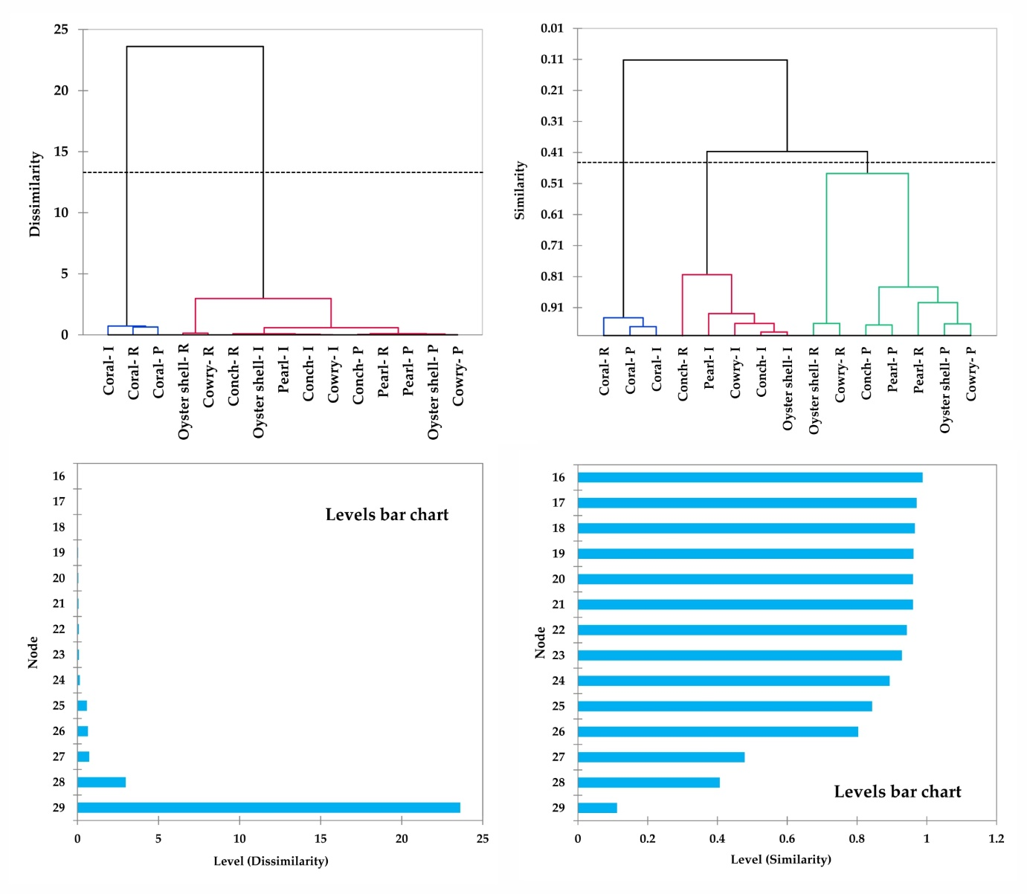
Supplementary File 2 Figure S5. Dendrogram derived from Agglomerative Hierarchical cluster analysis (AHCA) of different stages of five AMD showing separate clusters for purified and incinerated forms while raw material scattered in all the three clusters along with Level Chart Bars.

