Supplementary Material
Occurrence, distribution, source apportionment, and health risks of Per- and polyfluoroalkyl substances (PFAS) in the Nakdong River Basin, South Korea

Table S1. Detailed information on PFAS compounds and their corresponding internal standards used in this study.
No. | PFAS Compound | Abbreviation | Internal Standard | Syringe Internal Standard
1 | Perfluoropentanoic Acid | PFPeA | ¹³C₂–PFHxA | ¹³C₈–PFOA
2 | Perfluorohexanoic Acid | PFHxA
3 | Perfluoroheptanoic Acid | PFHpA | ¹³C₄–PFOA
4 | Perfluorooctanoic Acid | PFOA
5 | Perfluorononanoic Acid | PFNA | ¹³C₅–PFNA
6 | Perfluorodecanoic Acid | PFDA | ¹³C₂–PFDA
7 | Perfluoroundecanoic Acid | PFUnDA | ¹³C₂–PFUndA | ¹³C₇–PFUnDA
8 | Perfluorododecanoic Acid | PFDoDA | ¹³C₂–PFDoDA
9 | Perfluorotridecanoic Acid | PFTrDA
10 | Perfluorotetradecanoic Acid | PFTeDA
11 | Perfluorobutanesulfonic Acid | PFBS | ¹³C₃–PFBS | ¹³C₈–PFOS
12 | Perfluoropropanesulfonic Acid | PFPeS
13 | Perfluorohexanesulfonic Acid | PFHxS | ¹⁸C₂–PFHxS
14 | Perfluoroheptanesulfonic Acid | PFHpS
15 | Perfluorooctanesulfonic Acid | PFOS | ¹³C₄–PFOS
16 | Perfluorononanesulfonic Acid | PFNS
17 | Perfluorodecanesulfonic Acid | PFDS

Table S2. Instrumental parameters for PFAS compound analysis, including gradient conditions, MRM transitions, and retention times.
Parameters | Conditions
Analysis Apparatus | LC/MS/MS, tandem mass spectrometry SCIEX QTRAP 4500 coupled with an Agilent 1260 Infinity HPLC
Column | Agilent Eclipse XDB–C18, 4.6 × 150 mm, 3.5 μm
Mobile Phase | A: 2 mM Ammonium Acetate in Water, B: Methyl Alcohol
Gradient Mode | Time (min) 0 0.75 3 15 22.5 25.5 27 27.1  A(%) 95 95 30 5 5 95 95 95  B(%) 5 5 70 95 95 5 5 5
Flow Rate | 0.40 mL/min
Injection Volume | 2 μL
Ionization Mode | ESI negative
Spray Gas | N₂
Vaporizer Temperature | 500 °C
Detection Method | Multiple Reaction Monitoring (MRM)

Table S3. Method detection limits (MDLs), limits of quantification (LOQs), and limits of detection (LODs) for PFAS compounds.
PFAS Compound | Method Detection Limit (MDL) ng/L | Limit of Quantification (LOQ) ng/L | Limit of Detection (LOD) ng/L
PFPeA | 0.443 | 1.411 | 0.466
PFHxA | 0.179 | 0.570 | 0.188
PFHpA | 0.523 | 1.667 | 0.550
PFOA | 0.110 | 0.352 | 0.116
PFNA | 0.389 | 1.238 | 0.408
PFDA | 0.431 | 1.371 | 0.453
PFUnDA | 0.499 | 1.589 | 0.524
PFDoDA | 0.615 | 1.959 | 0.647
PFTrDA | 0.264 | 0.840 | 0.277
PFTeDA | 0.253 | 0.806 | 0.266
PFBS | 0.192 | 0.611 | 0.201
PFPeS | 0.532 | 1.693 | 0.559
PFHxS | 0.139 | 0.442 | 0.146
PFHpS | 0.132 | 0.422 | 0.139
PFOS | 0.552 | 1.757 | 0.580
PFNS | 0.506 | 1.613 | 0.532
PFDS | 0.243 | 0.775 | 0.256

Table S4. Sample recovery (%) and QC Spike Accuracy (%) for 17 PFAS analytes, including the field blank.
Analytes | Sample Recovery (%) | QC Spike Accuracy (%)
PFPeA | 77.7–97.3 | 97.4–102.8
PFHxA | 77.7–87.3 | 97.9–103.2
PFHpA | 84.5–105.9 | 93.6–105.2
PFOA | 91.0–105.9 | 95.3–106.9
PFNA | 88.6–107.3 | 93.8–106.8
PFDA | 92.9–109.2 | 95.9–103.5
PFUnDA | 87.9–109.8 | 94.7–105.3
PFDoDA | 88.0–103.9 | 98.6–101.1
PFTrDA | 88.0–103.9 | 97.4–102.2
PFTeDA | 88.0–103.9 | 96.3–102.6
PFBS | 56.7–77.0 | 98.5–101.0
PFPeS | 56.7–77.0 | 97.3–102.5
PFHxS | 85.1–109.2 | 97.6–104.9
PFHpS | 85.1–109.2 | 97.4–101.3
PFOS | 83.7–105.4 | 92.4–106.8
PFNS | 83.7–105.4 | 94.8–111.9
PFDS | 83.7–105.4 | 95.6–105.2

Table S5. Parameters used for discharge estimation and gauged sites with real-time discharge measurements (Q₂). RI-1 discharge reflects the 15–16 August 2024 average, obtained from the Water Environment Information System (WEIS) operated by the Korean Ministry of Environment.
Site | Q₂ (measured)  (m³/s) | A₂ (drainage areas of gaged sites)  (km²) | Q (streamflow)  (L/s) | Note
RI-1† | 89.96 | 10886.1 | 89860 | Real-time gauge by MoE
RI-3† | = RI-1 | = RI-1 | 89860 | Same drainage area as RI-1
† RI-1 hosts the real-time gauge; RI-3 is presumed to share the same drainage area and flow regime, so its discharge equals that of RI-1.

Table S6. Exposure parameters used for estimating EDI, HQ and HQ_{mix} values of PFAS across different age groups, obtained from Korea Health Industry Development Institute (KHIDI) and Texas Commission on Environmental Quality (TCEQ).
PFAS | Age group | Mean concentration  (ng/L) | IR  (L/day) | EF  (days/yr) | ED  (yr) | BW  (kg) | AT  (days) | RfD  (ng/kg/day)
PFPeA | Children (0–5) | 9.00 | 0.89 | 360 | 6 | 15.5 | 2190 | 500
PFPeA | Adolescents (6–18) | 9.00 | 1.20 | 360 | 13 | 46.9 | 4745 | 500
PFPeA | Adults (19–65) | 9.00 | 1.50 | 360 | 47 | 67.6 | 17155 | 500
PFPeA | Elderly (> 65) | 9.00 | 1.40 | 360 | 20 | 60.6 | 7300 | 500
PFHxA | Children (0–5) | 9.49 | 0.89 | 360 | 6 | 15.5 | 2190 | 500
PFHxA | Adolescents (6–18) | 9.49 | 1.20 | 360 | 13 | 46.9 | 4745 | 500
PFHxA | Adults (19–65) | 9.49 | 1.50 | 360 | 47 | 67.6 | 17155 | 500
PFHxA | Elderly (> 65) | 9.49 | 1.40 | 360 | 20 | 60.6 | 7300 | 500
PFHpA | Children (0–5) | 4.97 | 0.89 | 360 | 6 | 15.5 | 2190 | 23
PFHpA | Adolescents (6–18) | 4.97 | 1.20 | 360 | 13 | 46.9 | 4745 | 23
PFHpA | Adults (19–65) | 4.97 | 1.50 | 360 | 47 | 67.6 | 17155 | 23
PFHpA | Elderly (> 65) | 4.97 | 1.40 | 360 | 20 | 60.6 | 7300 | 23
PFOA | Children (0–5) | 7.89 | 0.89 | 360 | 6 | 15.5 | 2190 | 12
PFOA | Adolescents (6–18) | 7.89 | 1.20 | 360 | 13 | 46.9 | 4745 | 12
PFOA | Adults (19–65) | 7.89 | 1.50 | 360 | 47 | 67.6 | 17155 | 12
PFOA | Elderly (> 65) | 7.89 | 1.40 | 360 | 20 | 60.6 | 7300 | 12
PFNA | Children (0–5) | 1.45 | 0.89 | 360 | 6 | 15.5 | 2190 | 12
PFNA | Adolescents (6–18) | 1.45 | 1.20 | 360 | 13 | 46.9 | 4745 | 12
PFNA | Adults (19–65) | 1.45 | 1.50 | 360 | 47 | 67.6 | 17155 | 12
PFNA | Elderly (> 65) | 1.45 | 1.40 | 360 | 20 | 60.6 | 7300 | 12
PFDA | Children (0–5) | 0.32 | 0.89 | 360 | 6 | 15.5 | 2190 | 15
PFDA | Adolescents (6–18) | 0.32 | 1.20 | 360 | 13 | 46.9 | 4745 | 15
PFDA | Adults (19–65) | 0.32 | 1.50 | 360 | 47 | 67.6 | 17155 | 15
PFDA | Elderly (> 65) | 0.32 | 1.40 | 360 | 20 | 60.6 | 7300 | 15
PFUnDA | Children (0–5) | 0.28 | 0.89 | 360 | 6 | 15.5 | 2190 | 12
PFUnDA | Adolescents (6–18) | 0.28 | 1.20 | 360 | 13 | 46.9 | 4745 | 12
PFUnDA | Adults (19–65) | 0.28 | 1.50 | 360 | 47 | 67.6 | 17155 | 12
PFUnDA | Elderly (> 65) | 0.28 | 1.40 | 360 | 20 | 60.6 | 7300 | 12
PFBS | Children (0–5) | 11.76 | 0.89 | 360 | 6 | 15.5 | 2190 | 1400
PFBS | Adolescents (6–18) | 11.76 | 1.20 | 360 | 13 | 46.9 | 4745 | 1400
PFBS | Adults (19–65) | 11.76 | 1.50 | 360 | 47 | 67.6 | 17155 | 1400
PFBS | Elderly (> 65) | 11.76 | 1.40 | 360 | 20 | 60.6 | 7300 | 1400
PFHxS | Children (0–5) | 0.96 | 0.89 | 360 | 6 | 15.5 | 2190 | 4
PFHxS | Adolescents (6–18) | 0.96 | 1.20 | 360 | 13 | 46.9 | 4745 | 4
PFHxS | Adults (19–65) | 0.96 | 1.50 | 360 | 47 | 67.6 | 17155 | 4
PFHxS | Elderly (> 65) | 0.96 | 1.40 | 360 | 20 | 60.6 | 7300 | 4
PFOS | Children (0–5) | 1.74 | 0.89 | 360 | 6 | 15.5 | 2190 | 23
PFOS | Adolescents (6–18) | 1.74 | 1.20 | 360 | 13 | 46.9 | 4745 | 23
PFOS | Adults (19–65) | 1.74 | 1.50 | 360 | 47 | 67.6 | 17155 | 23
PFOS | Elderly (> 65) | 1.74 | 1.40 | 360 | 20 | 60.6 | 7300 | 23

Table S7. Concentrations of 11 detected PFAS, ΣPFAS (ng/L), pH, and EC (µS/cm) at the 23 sampling sites.
Sample | Category | PFPeA | PFHxA | PFHpA | PFOA | PFNA | PFDA | PFUnDA | PFBS | PFPeS | PFHxS | PFOS | ΣPFAS | pH | EC
RI-1 | River | 1.72 | 2.44 | 1.08 | 2.32 | 0.48 | N.D* | 0.32 | 2.52 | N.D* | 0.44 | 0.12 | 11.44 | 8.4 | 201.8
RI-2 | River | 1.92 | 2.44 | 1.32 | 2.08 | 0.56 | N.D* | 0.24 | 2.40 | N.D* | N.D* | 0.32 | 11.28 | 7.83 | 200.7
RI-3 | River | 1.64 | 2.16 | 1.08 | 1.96 | 0.40 | N.D* | 0.24 | 1.80 | N.D* | N.D* | N.D* | 9.28 | 8.67 | 194.2
HA-1** | Agricultural | 6.32 | 8.64 | 6.16 | 30.72 | 1.44 | 0.20 | 0.24 | 16.48 | 0.16 | 0.84 | 1.08 | 72.28 | 8.44 | 301.6
HA-2** | Industrial | 3.80 | 4.76 | 3.60 | 12.96 | 0.72 | N.D* | 0.20 | 7.36 | N.D* | 0.64 | 0.64 | 34.68 | 8.51 | 223.6
HA-3** | Agricultural | 7.36 | 7.64 | 5.24 | 16.84 | 1.44 | N.D* | 0.24 | 11.88 | 0.24 | 1.14 | 2.00 | 54.02 | 7.64 | 256.9
HA-4** | Agricultural | 2.36 | 3.48 | 2.80 | 6.24 | 1.12 | N.D* | 0.24 | 5.68 | N.D* | 0.28 | 0.12 | 22.32 | 8.09 | 254.5
HA-5** | Agricultural | 2.92 | 4.12 | 3.12 | 6.80 | 0.92 | N.D* | 0.24 | 7.88 | N.D* | 0.48 | N.D* | 26.48 | 8.2 | 260.2
HA-6** | Industrial | 3.88 | 5.28 | 3.36 | 7.96 | 1.12 | N.D* | 0.20 | 11.64 | N.D* | 0.64 | 3.32 | 37.40 | 9.25 | 305.1
HA-7** | Urban | 7.92 | 10.52 | 3.48 | 8.12 | 1.16 | N.D* | 0.24 | 21.96 | 0.12 | 1.08 | 7.92 | 62.52 | 8.64 | 840.6
HA-8** | Urban | 8.32 | 11.92 | 3.48 | 6.92 | 0.88 | N.D* | 0.24 | 26.68 | 0.08 | 1.04 | 5.00 | 64.56 | 7.85 | 863.7
HA-9 | Agricultural | 1.60 | 2.12 | 0.72 | 1.44 | 0.16 | N.D* | 0.04 | 4.48 | 0.04 | 0.20 | 1.00 | 11.80 | 8.37 | 746.2
HA-10 | Agricultural | 1.64 | 2.04 | 0.72 | 1.68 | 0.20 | N.D* | 0.04 | 4.52 | 0.04 | 0.24 | 1.16 | 12.28 | 8.33 | 706.6
GA-1** | Urban | 2.00 | 2.96 | 2.44 | 4.24 | 0.68 | N.D* | 0.20 | 1.00 | N.D* | N.D* | N.D* | 13.52 | 7.46 | 177.7
GA-2** | Urban | 4.28 | 5.72 | 3.56 | 7.28 | 1.08 | N.D* | 0.24 | 6.56 | N.D* | 0.64 | 1.08 | 30.44 | 7.78 | 242.8
GA-3** | Industrial | 45.20 | 39.28 | 19.48 | 12.04 | 4.76 | 1.76 | 0.56 | 41.20 | 0.52 | 3.24 | 3.36 | 171.4 | 6.95 | 1558
IG-1** | Urban | 27.04 | 27.48 | 14.16 | 12.28 | 5.16 | 3.52 | 1.00 | 26.84 | 0.08 | 1.80 | 2.80 | 122.1 | 7.06 | 1091
IG-2** | Industrial | 31.76 | 28.24 | 13.64 | 9.80 | 3.64 | 1.28 | 0.44 | 28.08 | 0.32 | 2.20 | 3.68 | 123.1 | 7.29 | 1214
IG-3** | Industrial | 31.52 | 27.12 | 14.56 | 8.88 | 3.00 | 0.56 | 0.32 | 26.36 | 0.36 | 2.52 | 4.32 | 119.5 | 7.67 | 1105
SU-1** | Agricultural | 5.36 | 7.88 | 4.00 | 8.64 | 1.56 | N.D* | 0.28 | 2.04 | N.D* | 0.08 | 0.20 | 30.04 | 7.66 | –
SU-2 | Agricultural | 2.92 | 4.12 | 2.08 | 3.80 | 0.92 | N.D* | 0.20 | 4.24 | N.D* | 2.04 | 0.44 | 20.76 | 8.26 | 744.6
SU-3 | Agricultural | 2.44 | 3.48 | 1.80 | 3.36 | 0.60 | N.D* | 0.24 | 4.28 | N.D* | 0.68 | 0.16 | 17.04 | 7.84 | 351.7
SU-4** | Agricultural | 3.16 | 4.48 | 2.44 | 5.04 | 1.28 | N.D* | 0.28 | 4.64 | N.D* | 1.80 | 1.24 | 24.36 | 7.63 | 302.1
 | Mean | 9.00 | 9.49 | 4.97 | 7.89 | 1.45 | 0.32 | 0.28 | 11.76 | 0.09 | 0.96 | 1.74 | 47.94 | 7.99 | 551.9
 | SD | 11.93 | 10.22 | 5.08 | 6.30 | 1.34 | 0.81 | 0.18 | 10.98 | 0.14 | 0.88 | 2.00 | 44.16 | 0.54 | 400.6
 | Min | 1.60 | 2.04 | 0.72 | 1.44 | 0.16 | N.D* | 0.04 | 1.00 | N.D* | N.D* | N.D* | 9.28 | 6.95 | 177.7
 | Max | 45.20 | 39.28 | 19.48 | 30.72 | 5.16 | 3.52 | 1.00 | 41.20 | 0.52 | 3.24 | 7.92 | 171.4 | 9.25 | 1558
*N.D = Not detected.
**Sampling sites exceeding the USEPA maximum contaminant level (MCL) for PFOA (4.0 ng L⁻¹).
– = Not available

Table S8. Summary of discharge (Q₁) and PFAS mass flux calculations in the Nakdong River Basin
Table S8-A. Discharge (Q₁) estimated for ungauged sites using the drainage-area ratio method by Equation (2).
Site | Q₂(measured)  (m³/s) | A₂ (drainage areas of gaged sites) (km²) | A₁ (drainage areas of ungauged sites) (km²) | Q₁ (flow at the ungauged site (m³/s) | Q (streamflow)  (L/s)
GA-3 | 89.96 | 10886.1 | 12.88 | 0.1063 | 106.3
IG-3 | 89.96 | 10886.1 | 24.32 | 0.2008 | 200.8
HA-10 | 89.96 | 10886.1 | 148.7 | 1.227 | 1227.5
SU-4 | 89.96 | 10886.1 | 29.89 | 0.2467 | 246.7

Table S8-B. Summary of PFAS mass fluxes at each sampling site within the Nakdong River Basin. Mass flux was calculated using Equation (1), as the product of total PFAS concentration (ΣPFAS) and streamflow (Q), representing instantaneous PFAS transport capacity (mg/s). Dominant PFAS compounds and land-use classifications are included for contextual interpretation.
Site ID | Site Type | Q (L/s) | ΣPFAS (ng/L) | Mass Flux (mg/s) | Dominant PFAS | Land-use Classification
RI-3 | Mainstream | 89860 | 9.28 | 834 | PFHxA | River (Upstream)
RI-1 | Mainstream | 89860 | 11.4 | 1028 | PFBS | River (Downstream)
GA-3 | Tributary | 106 | 171 | 18.2 | PFPeA | Industrial (WWTP effluent)
IG-3 | Tributary | 201 | 120 | 24.0 | PFPeA | Industrial
HA-10 | Tributary | 1228 | 12.3 | 15.1 | PFBS | Agricultural (transition zone)
SU-4 | Tributary | 247 | 24.4 | 6.1 | PFOA | Agricultural

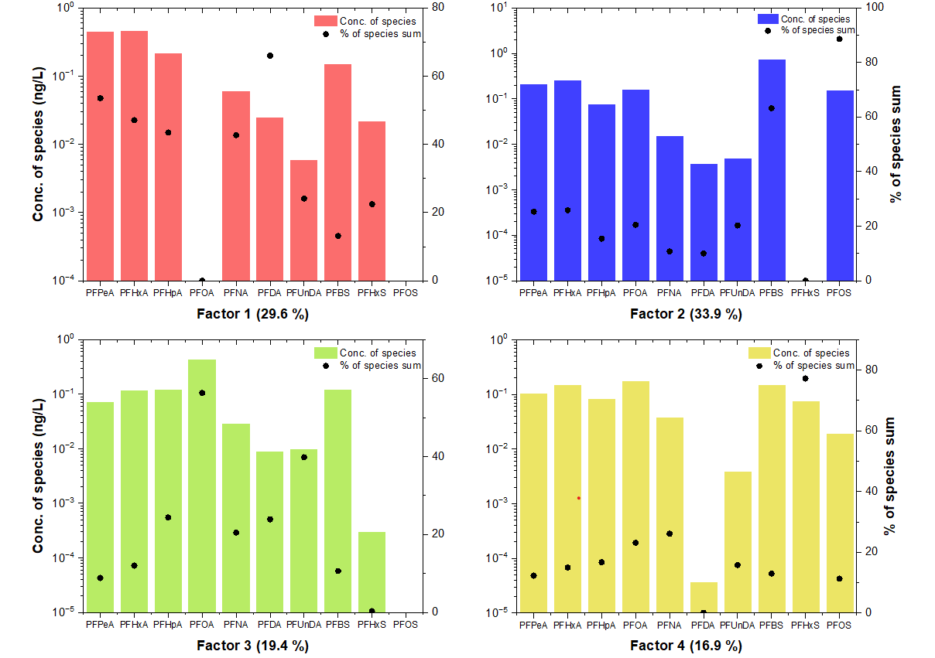
Fig. S1. Source profiles of PFAS in surface water identified using PMF. Each panel represents one of the four extracted factors, with bars indicating the concentrations (ng/L) of each PFAS compound, and black circles denoting the percentage contribution to the total species sum.

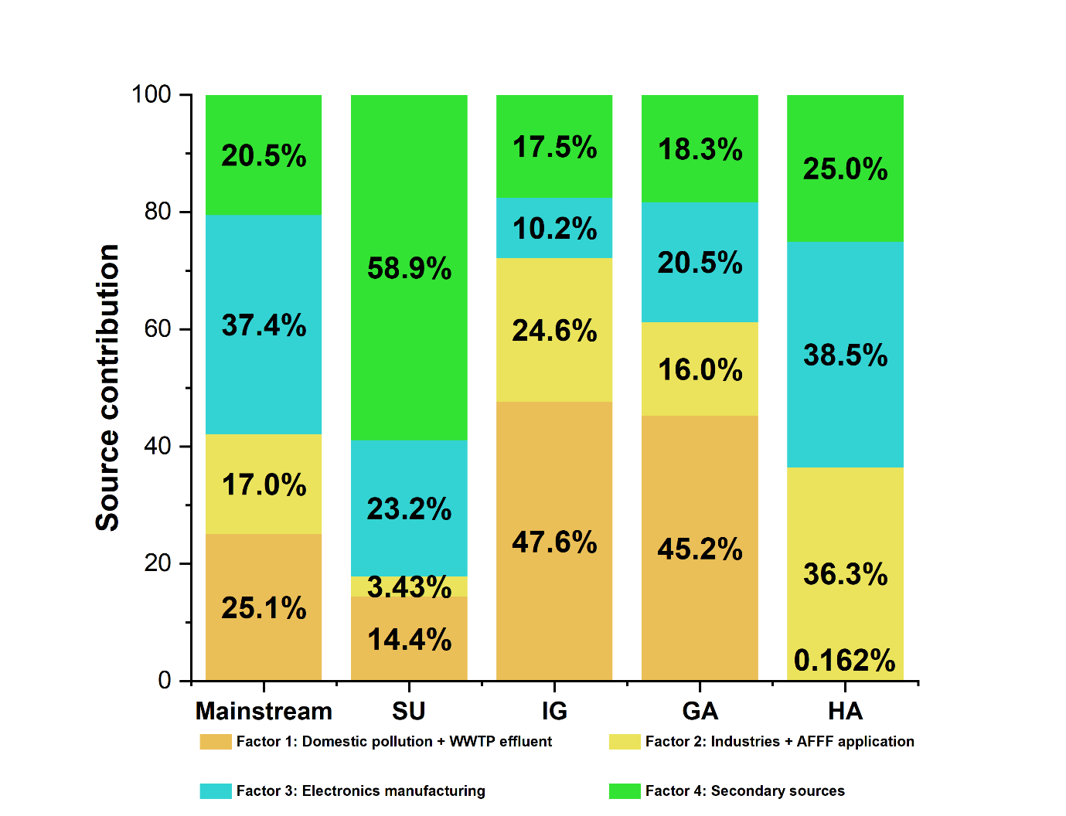
Fig. S2. Relative source contributions of four PMF derived factors across the mainstream and four tributaries (SU, IG, GA, and HA) in the Nakdong River Basin. Factor 1 (domestic sources + WWTP effluent), Factor 2 (industrial sources + AFFF use), Factor 3 (electronics manufacturing), and Factor 4 (secondary sources) exhibit spatially variable dominance in accordance with land-use characteristics. Notably, industrial and electronics-associated factors (Factors 2 and 3) dominate in IG, GA, and HA tributaries, while secondary sources (Factor 4) are more prevalent in SU.

Reference
Korea Health Industry Development Institute (KHIDI). Nutristat. Available from: https://www.khidi.or.kr/nutristat (accessed 1 December 2025).
Ministry of Environment (Korea). River Information Management GIS (RIMGIS). Available from: https://river.go.kr/index.do (accessed 1 December 2025).
Ministry of Environment (Korea). Water Environment Information System (WEIS). Available from: http://water.nier.go.kr (accessed 1 December 2025).
Texas Commission on Environmental Quality. Per- and polyfluoroalkyl substances (PFAS). Austin (TX): TCEQ; 2023. Available from: https://www.tceq.texas.gov/downloads/toxicology/pfc/pfcs.pdf (accessed 1 December 2025).

