[Supporting Information]
Toward Poisson-like scaling with synchronized-clock transient absorption spectroscopy via high-repetition rate pulse accumulation
1. Optical layout of home-built transient absorption spectroscopy system.

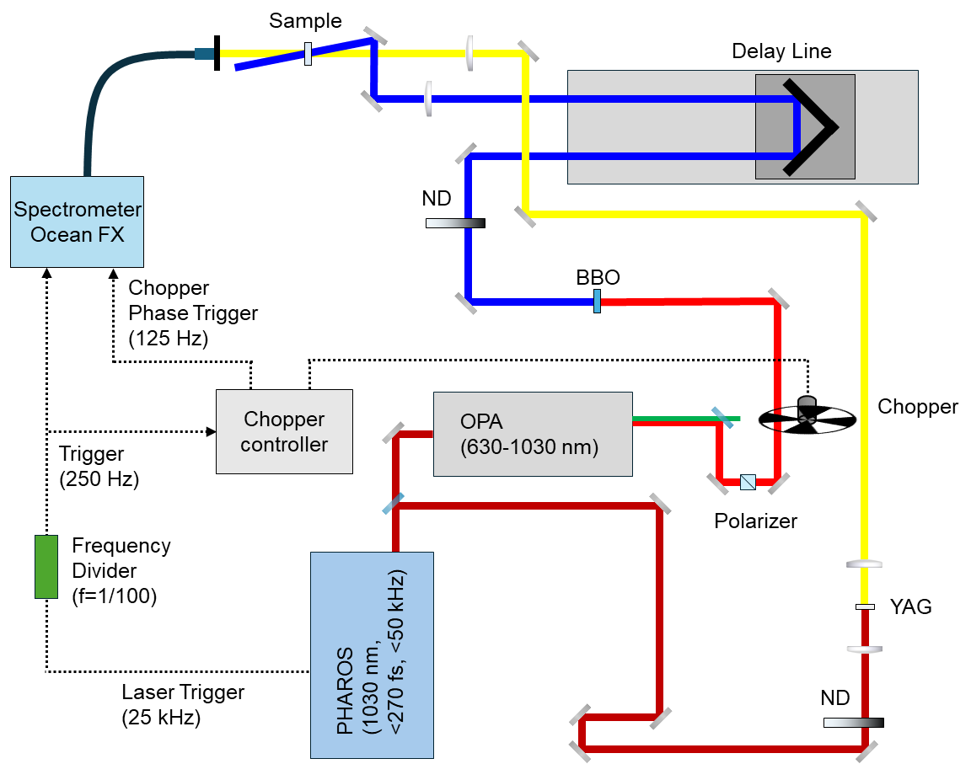

Figure S1. Schematic layout of the femtosecond transient absorption (TA) spectroscopy setup used for noise characterization experiments.

2. Fast Fourier Transform (FFT)-based analysis for separating the signal from noise.
The FFT-based analysis process began with an analysis of the TA spectra at multiple time delays, as shown in Figure S2(a). We performed an FFT on the TA spectra for each time series to investigate how its evolution in the time domain translated to the frequency domain. We identified the specific frequency range that was directly influenced by the dynamics of the TA signal. This process of designating the signal region and selecting a cutoff frequency from the FFT spectrum is visually detailed in Figure S2(b).
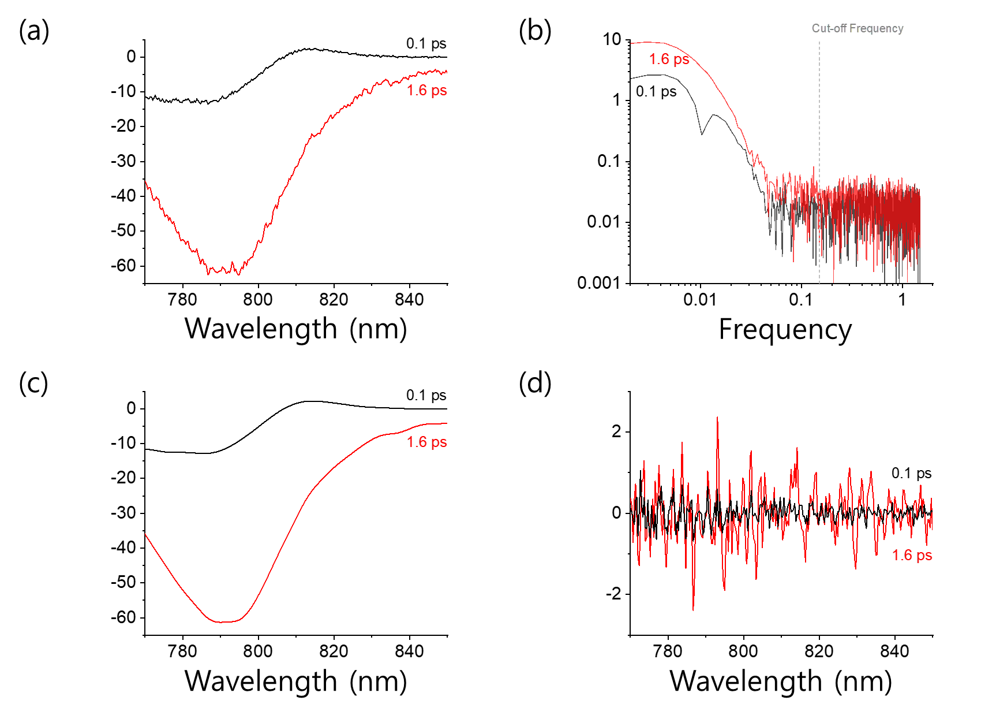
Figure S2. Illustration of the FFT-based filtering process for noise separation. (a) Raw TA spectra measured at two pump-probe delay times (0.1 and 1.6 ps). (b) The corresponding FFT spectra of two representative TA signals, indicating the identified signal-dominant region and the chosen cutoff frequency (vertical dashed line). The resulting (c) filtered spectra and (d) separated noise components, demonstrating the effectiveness of the filtering process.
A cutoff frequency was then established at the upper boundary of this identified signal region. Subsequently, a low-pass filter was applied. This filter attenuated all frequency components above the cutoff frequency, which were attributed to random noise, while preserving the signal components below it. This procedure effectively decomposed the raw TA data into its two constituent parts, the clean signal and the isolated noise component. A representative example of this separation is displayed in Figure S2(c) and S2(d), which directly represent the filtered signal and the extracted noise.

3. Optical layout of home-built transient absorption spectroscopy system.

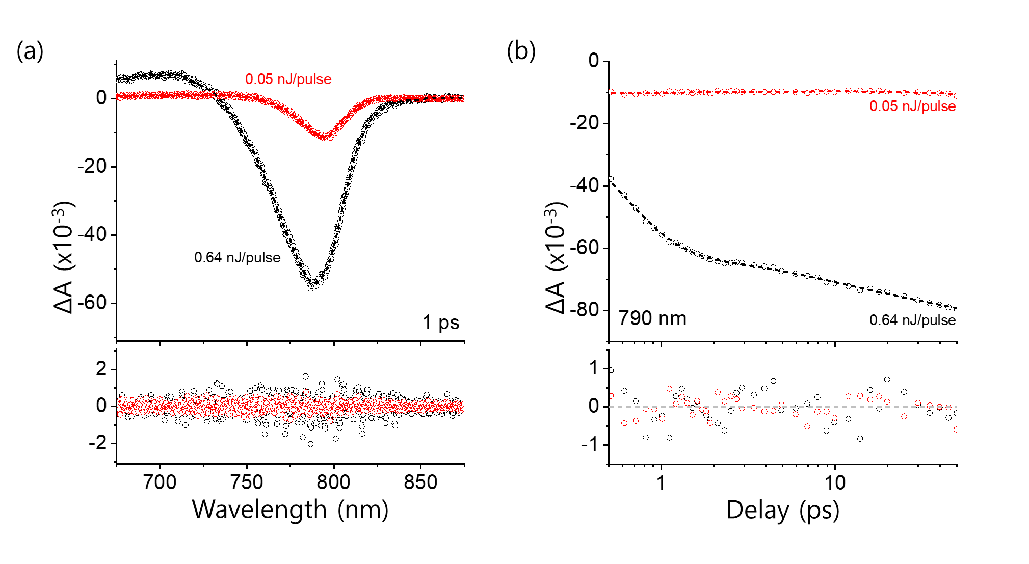
Figure S3. Comparison of TA data and residuals at two excitation pulse energies. (a) TA spectra at a pump–probe delay of 1 ps recorded at 0.64 nJ/pulse and 0.05 nJ/pulse (upper panel), together with the corresponding residuals (lower panel) obtained after FFT-based separation and fitting with a Gaussian–exponential convolution function. (b) TA kinetics at 790 nm measured under the same excitation conditions (upper panel), and the corresponding residuals extracted from the FFT-based separation and Gaussian–exponential convolution analysis (lower panel).

4. Fixed-pattern noise observed in transient absorption (TA) spectra as a function of signal magnitude.
Figure S4 presents transient absorption (TA) spectra of the FAPbI₃ perovskite thin film, recorded over pump-probe delays from 0.1 ps to 1.6 ps in 100 fs increments, using a 400 nm pump with a pulse energy of 0.64 nJ/pulse. For each delay step, the measured spectra were processed using FFT-based separation to isolate the noise contribution in the spectral domain. The upper panel shows the raw TA spectra across the delay range, while the lower panel displays the corresponding residuals obtained by subtracting the FFT-filtered signal component from the measured data.
The residuals exhibit a stable spatial pattern that persists across all delay times, characteristic of fixed-pattern noise (FPN) originating from pixel-to-pixel sensitivity variations (photo response non-uniformity, PRNU) and detector readout offsets. Notably, the FPN amplitude increases proportionally with the absolute TA signal magnitude as the pump–probe delay evolves. This proportional scaling confirms that the FPN term in the composite noise model [Eqs. (3)-(4) in the main text] is a signal-dependent systematic noise source.
At higher TA signal levels, the proportional FPN component becomes increasingly dominant relative to stochastic (Poisson) noise, which explains the observed saturation in spectral SNR improvement with pulse accumulation. This finding supports the model assumption that 𝑁_{FPN} is constant for a given pixel but contributes a multiplicative noise term proportional to the probe intensity $I_{0}(λ)$. The quantitative scaling extracted from these residuals serves as a critical input for the composite noise model, enabling it to accurately reproduce the noise behavior observed in the TA spectra.

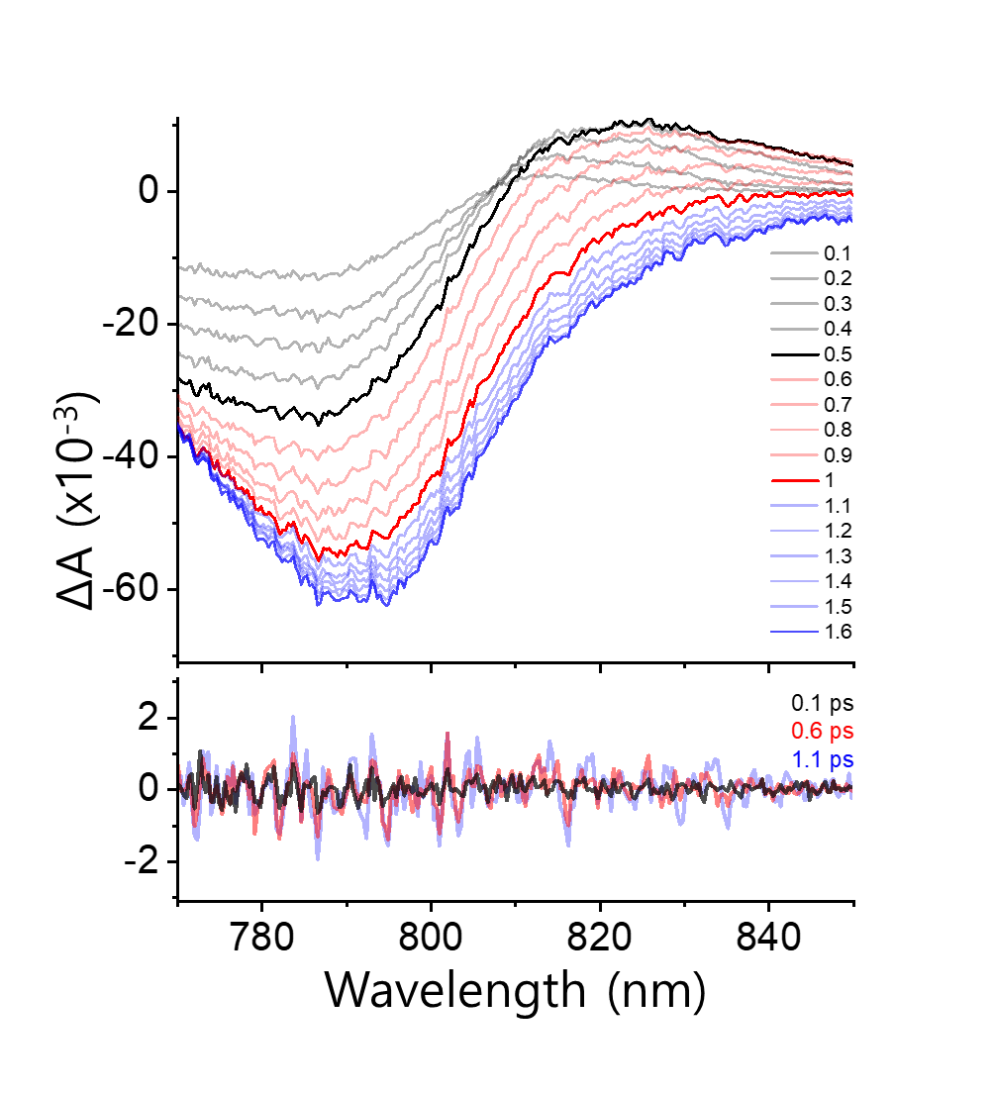
Figure S4. Transient absorption evolution (upper) and residuals (lower) extracted from FFT-based separation of the Perovskite (FAPbI₃) films range of 0.1 ps to 1.6 ps in 100 fs increments, using a pump pulse energy of 0.64 nJ/pulse at 400 nm, is represented.

5. Characterization of signal-independent readout noise.
Figure S5 provides experimental evidence that the readout noise in our spectrometer is independent of both measurement repetition and pulse accumulation number, thereby validating its treatment as a constant baseline term (𝜖) in the composite noise model.

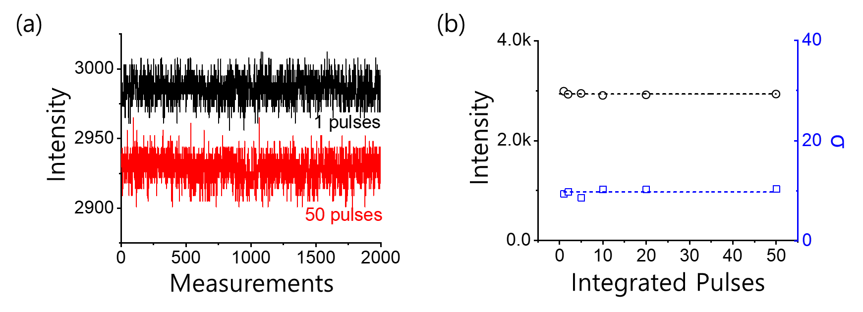
Figure S5. (a) Variation of the dark signal with repeated measurements, showing stable mean level and fluctuation magnitude, indicating purely electronic origin. (b) Mean dark count (“signal”) and standard deviation (“noise”) as a function of accumulated pulse number under dark conditions, both remaining constant across all accumulation numbers.

Figure S5(a) shows the mean dark signal level recorded over multiple measurement cycles. Both the average intensity and the fluctuation magnitude remain constant throughout the sequence, confirming that the observed variations are of purely electronic origin and unaffected by optical input. Figure S5(b) presents the mean dark count (“signal”) and its standard deviation (“noise”) as a function of the number of accumulated pulses per sampling. Measurements were performed under identical dark conditions while varying the integration time to change the accumulation number. The constancy of both signal and noise over the entire accumulation range demonstrates that the readout noise does not scale with accumulated photon number or integration time.
These results confirm that the readout noise term ($ϵ$) in the composite noise model [Eq. (3) in the main text] can be treated as a fixed, signal-independent baseline contribution. This behavior contrasts with the signal-dependent scaling of fixed-pattern noise observed in Figures S4, and it provides the experimental justification for modeling the readout noise as a constant term across all measurement conditions.

6. Dependence of probe spectral noise on signal magnitude for varying pulse accumulation.
Figure S6 characterizes how the spectral noise in the probe signal varies with signal magnitude when the number of accumulated pulses per sampling is systematically changed. Measurements were carried out with a 400 nm pump at 0.64 nJ/pulse while varying the spectrometer integration time to control the accumulation number.

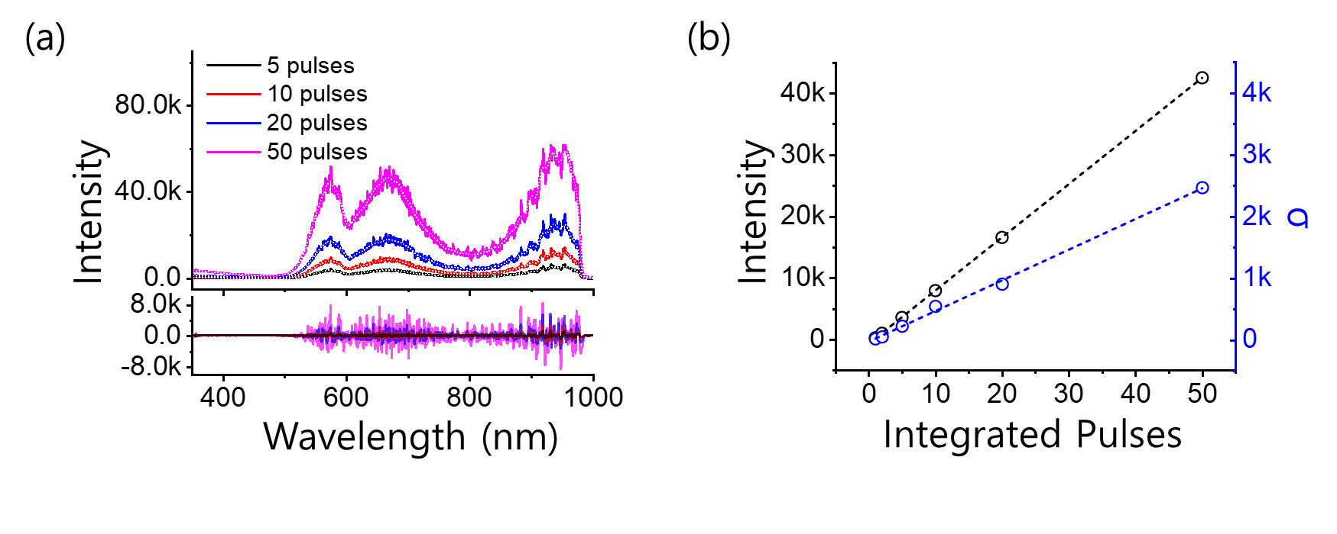
Figure S6. (a) Probe spectra (upper) at different pulse accumulation numbers with corresponding residuals (lower) obtained by FFT-based signal–noise separation. (b) Residual noise in the 640–660 nm range, extracted from FFT-based separation, plotted against probe spectral amplitude for varying pulse accumulation numbers.

Figure S6(a) shows representative probe spectra (upper) for different accumulation numbers and the corresponding residuals (lower) obtained via FFT-based separation of signal and noise components. As the number of accumulated pulses increases, the probe signal amplitude rises proportionally, and the residual noise magnitude changes in step, indicating that the noise amplitude is directly linked to the underlying probe intensity. Figure S6(b) plots the root-mean-square (RMS) values of the residual noise against the corresponding probe spectral amplitude, specifically for the 640–660 nm wavelength range. The residuals for this range were extracted from the FFT-based separation for each accumulation condition. The resulting linear correlation confirms that a dominant fraction of the spectral noise scales proportionally with the probe intensity, consistent with the fixed-pattern noise (FPN) term in the composite noise model [Eq. (3) in the main text].
This probe-level measurement of the FPN trend serves as the experimental basis for applying a signal-dependent scaling of FPN in the composite noise model. Incorporating this relationship enables the model to reproduce the noise behavior observed in TA spectra (Figure S4), thereby linking probe-domain measurements directly to the spectral-domain noise characteristics of transient absorption signals.

7. Derivation of the Composite Noise Model
In transient absorption (TA) measurements, the detected signal contains multiple noise contributions: stochastic noise originating from photon counting statistics (Poisson noise), systematic noise primarily due to detector-related fixed-pattern components (FPN), and signal-independent readout noise from the electronics. To quantitatively describe the dependence of these noise sources on TA signal amplitude and probe intensity, we develop a composite model that incorporates all three contributions. We define the measured probe intensity $I_{meas}(λ)$ at wavelength $λ$ as
$$I_{meas}\left(λ\right)=ϵ+\left(1+N_{FPN}\right) I_{0}\left(λ\right)+η\left(λ\right)\sqrt{I_{0}\left(λ\right)}, \left(Eq.S1\right)$$
where $I_{0}(λ)$ is the ideal (noise-free) probe intensity, $N_{FPN}$​ represents fixed-pattern noise factor for a given pixel (assumed constant with respect to pulse accumulation), $η\left(λ\right)$ is the wavelength-dependent Poisson noise coefficient, and $ϵ$ represents the constant, signal-independent readout noise. The measured TA signal is given by
$$ΔA_{meas}​=-\log{​\left(\frac{I_{PumpON​}-I_{BKG}}{I_{PumpOFF​}-I_{BKG}}​​​\right)}, \left(Eq.S2\right)$$
where $I_{Pump ON}$ and $I_{Pump OFF}$ are the measured probe intensities with and without the pump, respectively, and $I_{BKG}$ is the background (dark) signal. In our measurements, $I_{BKG}$ was negligible compared to the probe intensity and thus omitted in the subsequent derivation.
Assuming the ideal pump-off signal is $I_{0}(λ)$ and the pump-on signal is $I_{0}\left(λ\right){10}^{-ΔA}$, where $ΔA$ is the true TA signal, noise contributions are incorporated into both terms as follows:
$$ΔA_{meas}=-\log\left(\frac{ϵ+\left(1+N_{FPN,ON}\right)I_{0}\left(λ\right){10}^{-ΔA}+η_{ON}\left(λ\right)\sqrt{I_{0}\left(λ\right){10}^{-ΔA}}}{ϵ+\left(1+N_{FPN,OFF}\right) I_{0}\left(λ\right)+η_{OFF}\left(λ\right)\sqrt{I_{0}\left(λ\right)}}\right), \left(Eq.S3\right)$$
For signal conditions, a first-order Taylor expansion of the logarithmic function can be applied.
$$\log\left(a+b\sqrt{x}+cx\right)=\log{c}+\log{x}+\frac{b}{c\sqrt{x}}+\frac{a}{cx}-\frac{1}{2}{\left(\frac{b}{c\sqrt{x}}+\frac{a}{cx}\right)}^{2}+…, \left(Eq.S4\right)$$
Higher-order terms are negligible in this regime, allowing the measured TA signal to be approximated as
$$ΔA_{meas}≈ΔA+\log\left(\frac{1+N_{FPN,OFF}}{1+N_{FPN,ON}}\right)+\frac{η\left(λ\right)}{\sqrt{I_{0}\left(λ\right)}}\left[\frac{1}{1+N_{FPN,OFF}}-\frac{\sqrt{{10}^{ΔA}}}{1+N_{FPN,ON}}\right]+\frac{ϵ}{I_{0}\left(λ\right)}\left[\frac{1}{1+N_{FPN,OFF}}-\frac{{10}^{ΔA}}{1+N_{FPN,ON}}\right]. \left(Eq.S5\right)$$
In this expression, the fixed-pattern noise term, represented by the logarithmic ratio, scales proportionally with the TA signal amplitude because it is multiplicative with respect to $I_{0}(λ)$. The Poisson noise term, with its inverse square-root dependence on $I_{0}(λ)$, dominates at low probe intensities. The readout noise term remains constant regardless of signal strength, defining a baseline noise floor. This composite formulation provides a direct link between measurable noise behavior and its physical origins, enabling quantitative comparison with experimental scaling trends in both spectral and kinetic domains.

