Supporting information
Supporting experimental section
Clinical sample handling
Human serum samples were collected from 10 healthy volunteers and 10 clinically diagnosed cerebral infarction patients at Changsha Fourth Hospital. The study was approved by the hospital’s ethics committee, and informed consent was obtained from all participants. The serum samples were separated by centrifugation at 3000 rpm for 10 min at 4 °C and stored at -80 °C until use. For analysis, serum samples were thawed at room temperature and diluted 10-fold with reaction buffer to minimize matrix effects. For recovery experiments, synthetic miRNA-124 was spiked into healthy serum samples at final concentrations of 0.1, 0.5, 1, 5, and 10 pM, followed by the same detection procedure as described in Section 2.3. For clinical sample analysis, endogenous miRNA-124 levels in patient and healthy control sera were directly quantified using the established method, and the results were compared with those obtained by qPCR.
Calculation of LOD
The detailed calculation of LOD is as follows: from 20 replicate blank determinations, the mean and standard deviation of the blank signal were 312 ± 26 CPS (counts per second). The threshold signal was calculated as mean + 3σ = 390 CPS. Using the linear regression equation CPS = 1,028,153 × lgC + 986,718, the corresponding concentration was obtained by solving C = 10^((CPS − 986,718) / 1,028,153), yielding C = 1.1×10⁻¹⁶ M = 0.11 fM.

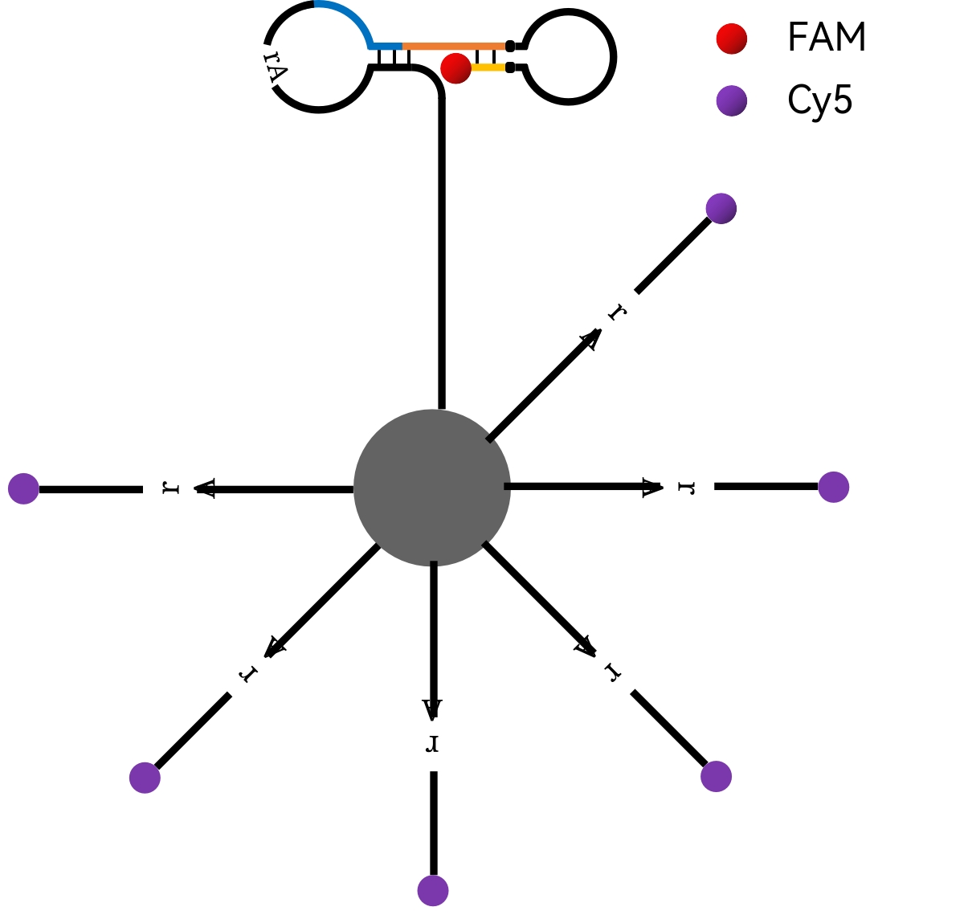
Figure S1. Schematic illustration of the fluorescent assay to test the assembly of DNA walker.

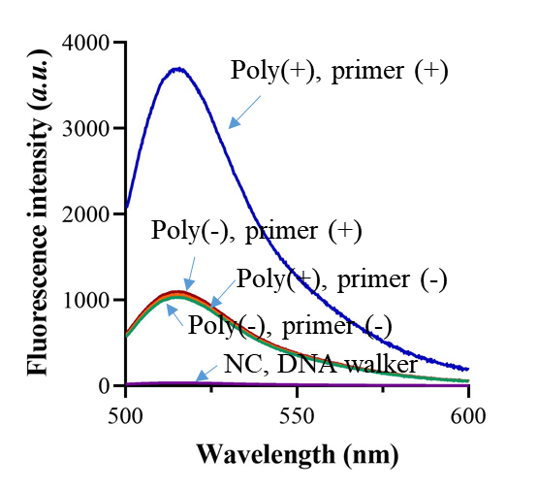
Figure S2. Fluorescence spectrum of the DNA walking system when PER process is included or not.

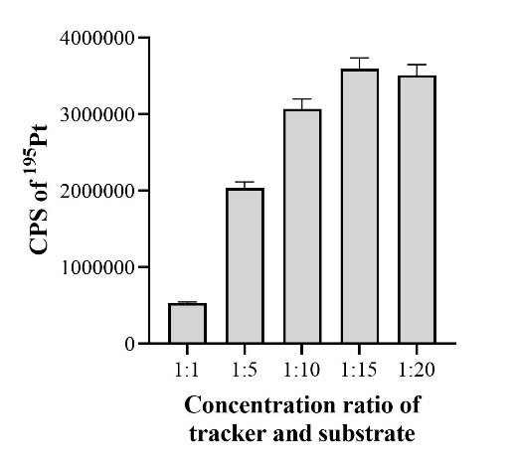
Figure S3. ¹⁹⁵Pt CPS of the method when detecting miRNA with different tracker and substrate concentration ratio.

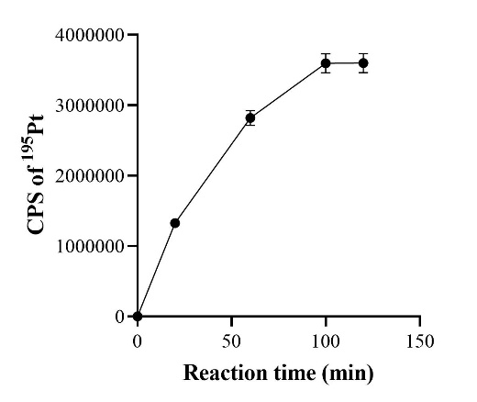
Figure S4. ¹⁹⁵Pt CPS of the method when detecting miRNA with different reaction time.

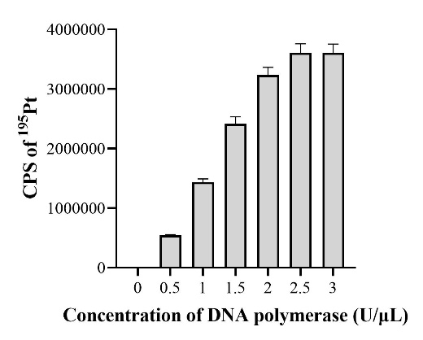
Figure S5. ¹⁹⁵Pt CPS of the method when detecting miRNA with different DNA polymerase concentration.

Table S1. Oligonucleotides sequences were used in this work.
Title | Sequences (5’ to 3’)
miRNA-124 | UAGC UUA UCA GAC UGA UGU UGA
s1 | TCA ACA TCA GTC GGT CGA AAT AGT GAG TCG CTC
s2 | CAT CTC TTC TCC GAG CCT GAT AAG CTA
Tracker | CAAT CTA TTA GGG CCT TTT GGC CCT AAT AGA TTG GTA CAT GGA ACC CCC ATT TTA CTT ATT CCA CTC ATT GAG CGA CTC ACT ATr AGG AAG AGA TGT GAG RGG AAT AAG TAT TTT TTT TTT TTT TTT TTT
Substrate | TTTGA GCG ACT CAC TAT rAG GAA GAG ATG -Pt
primer | GAC AAC GGA CGT CGT CCT GAG

Table S2. A brief comparison of the method with former ones.
Title | Mechanism | LOD | Enzymes | Time | Ref
The method | DNAzyme cleavage+ PER | 0.11 fM | DNA polymerase | 100 min
RACE | RCA | 90 fM | T4 DNA ligase; phi29 polymerase; Cas9 | 150 min | ¹
Enhanced | RCA+ trans-cleavage of Cas12a/crRNA | 47 fM | T4 DNA ligase; phi29 polymerase; Cas12a | 120 min | ²
Dual modes | PER+ LAMP | 0.31 fM | DNA polymerase | 120 min | ³
Notes: PER, primer exchange reaction; RCA, rolling circle amplification; LOD, limit of detection.

References:
1. Wang, R.; Zhao, X.; Chen, X.; Qiu, X.; Qing, G.; Zhang, H.; Zhang, L.; Hu, X.; He, Z.; Zhong, D.; Wang, Y.; Luo, Y., Rolling Circular Amplification (RCA)-Assisted CRISPR/Cas9 Cleavage (RACE) for Highly Specific Detection of Multiple Extracellular Vesicle MicroRNAs. Anal Chem 2020, 92 (2), 2176-2185.
2. Zhang, G.; Zhang, L.; Tong, J.; Zhao, X.; Ren, J., CRISPR-Cas12a enhanced rolling circle amplification method for ultrasensitive miRNA detection. Microchemical Journal 2020, 158.
3. Liu, X.; Peng, H.; Ye, X.; Zhang, X.; Xu, G.; Zhao, X., A Versatile Colorimetric Diagnostic Platform Based on Primer Exchange Reaction Cascades Driven Loop-Mediated Isothermal Amplification. Anal Chem 2025, 97 (16), 9000-9007.

