Figure S1: Comparison of PDCs by patient characteristics

- Patients with PDC >=0.8 in ACE inhibitors and follow up of 12 months
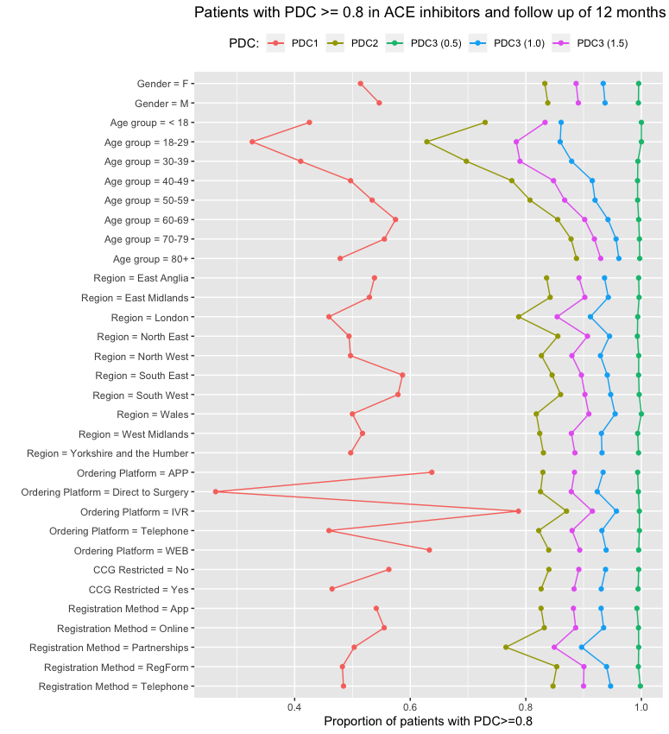

- Patients with PDC >=0.8 in Statins and follow up of 12 months
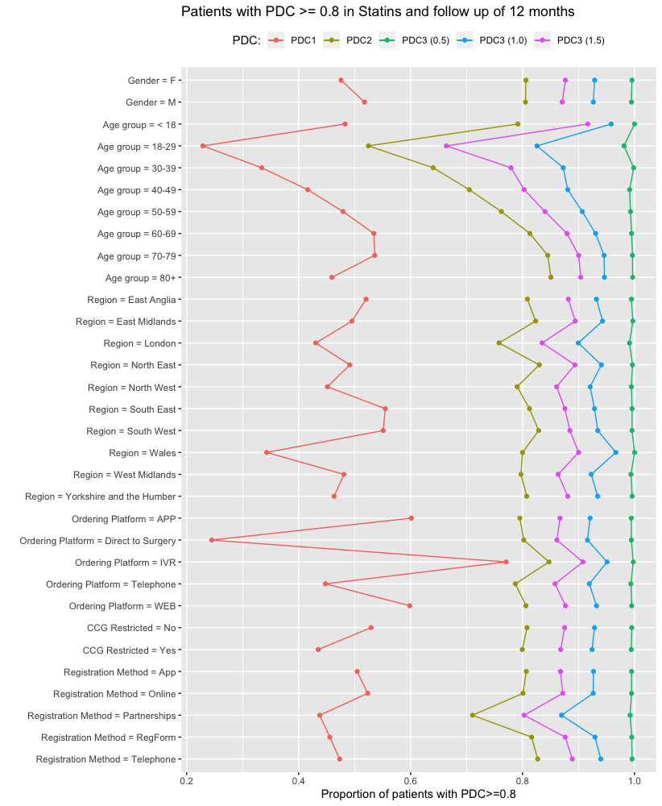

- Patients with PDC >=0.8 on thyroid hormones and follow up of 12 months

