Appendix 1: Sources employed in the review of the regulatory framework
Table A.1. Summary of the resources employed
Country | National Legislation | International Organisations | Existing Academic Literature
Austria | 5 | 1 | 5
Belgium | 7 | 1 | 4
Bulgaria | 5 | 1 | 5
Croatia | 6 | 2 | 6
Cyprus | 4 | 1 | 3
Czech Republic | 5 | 1 | 4
Denmark | 8 | 1 | 4
Estonia | 5 | 1 | 4
Finland | 6 | 2 | 2
France | 9 | 1 | 3
Germany | 6 | 2 | 3
Greece | 8 | 2 | 3
Hungary | 8 | 1 | 3
Ireland | 6 | 1 | 5
Italy | 10 | 1 | 5
Latvia | 7 | 1 | 4
Lithuania | 8 | 1 | 3
Luxembourg | 8 | 1 | 3
Malta | 4 | 1 | 2
Netherlands | 6 | 1 | 4
Norway | 9 | 1 | 3
Poland | 8 | 1 | 4
Portugal | 14 | 1 | 4
Romania | 5 | 1 | 3
Slovakia | 4 | 1 | 3
Slovenia | 9 | 1 | 4
Spain | 6 | 1 | 4
Sweden | 7 | 1 | 5
Switzerland | 6 | 2 | 4
UK | 7 | 1 | 3
Common
ABDA. (2021). Density of Pharmacies in the EU. ABDA. Retrieved May 4, 2022, from https://www.abda.de/en/pharmacies-in-europe/density-of-pharmacies-in-the-eu
Martins, S. F., Van Mil, J. W., & Da Costa, F. A. (2015). The organizational framework of community pharmacies in Europe. International journal of clinical pharmacy, 37(5), 896-905. https://doi.org/10.1007/s11096-015-0140-1
Morthorst, B. R., Erlangsen, A., Nordentoft, M., Hawton, K., Hoegberg, L. C. G., & Dalhoff, K. P. (2018). Availability of paracetamol sold over the counter in Europe: a descriptive cross‐sectional international survey of pack size restriction. Basic & Clinical Pharmacology & Toxicology, 122(6), 643-649. https://doi.org/10.1111/bcpt.12959
OECD & European Union. (2020). Health at a Glance: Europe 2020: State of Health in the EU Cycle. OECD Publishing, Paris. https://doi.org/10.1787/82129230-en
OECD. (2021). Health at a Glance 2021: OECD Indicators. OECD Publishing, Paris. https://doi.org/10.1787/ae3016b9-en
Oleszkiewicz, P., Krysinski, J., Religioni, U., & Merks, P. (2021, February). Access to Medicines via Non-Pharmacy Outlets in European Countries—A Review of Regulations and the Influence on the Self-Medication Phenomenon. In Healthcare (Vol. 9, No. 2, p. 123). Multidisciplinary Digital Publishing Institute. https://doi.org/10.3390/healthcare9020123
Vogler, S. (2014). Liberalization in the pharmacy sector. OECD Global Forum on Distribution.
World Health Organization. Regional Office for Europe. (‎2019)‎. The legal and regulatory framework for community pharmacies in the WHO European Region. World Health Organization. Regional Office for Europe. https://apps.who.int/iris/handle/10665/326394
Austria
Langer, T., Spreitzer, H., Ditfurth, T., Stemer, G., & Atkinson, J. (2018). Pharmacy practice and education in Austria. Pharmacy, 6(3), 55. https://doi.org/10.3390/pharmacy6030055
BWB (2018). Sector Inquiry Health. Part I: The Austrian Pharmacy Market, BWB/AW-431, Vienna.
Bundesrecht konsolidiert: Gesamte Rechtsvorschrift für Apothekengesetz. (2021). Rechtsinformationssystem. Retrieved March 31, 2022, from https://www.ris.bka.gv.at/GeltendeFassung.wxe?Abfrage=Bundesnormen&Gesetzesnummer=10010169
Bundesrecht konsolidiert. (2015, June 25). Rechtsinformationssystem. Retrieved March 31, 2022, from https://www.ris.bka.gv.at/eli/bgbl/1983/185/P59/NOR40170422?Abfrage=Bundesnormen&Kundmachungsorgan=&Index=&Titel=Arzneimittelgesetz&Gesetzesnummer=&VonArtikel=&BisArtikel=&VonParagraf=59&BisParagraf=&VonAnlage=&BisAnlage=&Typ=&Kundmachungsnummer=&Unterzeichnungsdatum=&FassungVom=23.03.2022&VonInkrafttretedatum=&BisInkrafttretedatum=&VonAusserkrafttretedatum=&BisAusserkrafttretedatum=&NormabschnittnummerKombination=Und&ImRisSeitVonDatum=&ImRisSeitBisDatum=&ImRisSeit=Undefined&ResultPageSize=100&Suchworte=&Position=1&SkipToDocumentPage=true&ResultFunctionToken=9f119e31-31f4-470e-bef0-f307077ad5ce
Austria-Forum. (2020, January 22). Medikamentenabgabe. Retrieved March 31, 2022, from https://austria-forum.org/af/AustriaWiki/Medikamentenabgabe
Bundesrecht konsolidiert: Gesamte Rechtsvorschrift für Arzneimittelgesetz. (2022). Rechtsinformationssystem. Retrieved March 31, 2022, from https://www.ris.bka.gv.at/GeltendeFassung.wxe?Abfrage=Bundesnormen&Gesetzesnummer=10010441
Austrian medicinal product index – Online Search for medicinal products. (n.d.). Austrian Medicines and Medical Devices Agency. Retrieved March 31, 2022, from https://aspregister.basg.gv.at/aspregister/faces/aspregister.jspx
Belgium
SPF Economie. (2018, July 10). Médicaments en vente libre ou médicaments OTC (Over The Counter) | SPF Economie. Retrieved January 23, 2022, from https://economie.fgov.be/fr/themes/ventes/politique-des-prix/prix-reglementes/medicaments-usage-humain/medicaments-originaux/medicaments-en-vente-libre-ou
Agence Fédérale des Médicaments et des Produits de Santé (AFMPS). (n.d.). Réglementation - Médicaments par internet. AFMPS. Retrieved January 23, 2022, from https://www.campagnesafmps.be/fr/medicaments-par-internet/reglementation
Agence Fédérale des Médicaments et des Produits de Santé (AFMPS). (n.d.-a). Pharmacies ouvertes au public. AFMPS. Retrieved January 23, 2022, from https://www.afmps.be/fr/humain/medicaments/medicaments/distribution/pharmacies_ouvertes_au_public
Agence Fédérale des Médicaments et des Produits de Santé (AFMPS). (2022, January 20). Arrêté royal concernant l’enregistrement et la répartition des officines ouvertes au public, et abrogeant les arrêtés royaux du 25 septembre 1974 concernant l’ouverture, le transfert et la fusion d’officines pharmaceutiques ouvertes au public et du 21 septembre 2004 relatif au transfert d’une officine ouverte au public vers un bâtiment d’un aéroport. MONITEUR STAATSBLAD BELGE. Retrieved May 15, 2022, from http://www.ejustice.just.fgov.be/cgi_loi/change_lg.pl?language=fr&la=F&table_name=loi&cn=2022011601
Agence Fédérale des Médicaments et des Produits de Santé (AFMPS). (2021, April 7). Lois et Arrêtés. AFMPS. Retrieved January 23, 2022, from https://www.afmps.be/fr/items-HOME/Lois_et_Arretes
Agence Fédérale des Médicaments et des Produits de Santé (AFMPS). (n.d.-a). Banque de données des médicaments. AFMPS. Retrieved January 23, 2022, from http://banquededonneesmedicaments.fagg-afmps.be/
Centre Belge d’Information Pharmacothérapeutique (CBIP). (n.d.). Répertoire. Retrieved January 23, 2022, from https://www.cbip.be/fr/chapters
Bulgaria
Dimova, A., Rohova, M., Atanasova, E., Kawalec, P., & Czok, K. (2017). Drug policy in Bulgaria. Value in Health Regional Issues, 13, 50-54. https://doi.org/10.1016/j.vhri.2017.08.001
Petkova, V., & Atkinson, J. (2017). Pharmacy practice and education in Bulgaria. Pharmacy, 5(3), 35. https://doi.org/10.3390/pharmacy5030035
министъра на здравеопазването. (2008, December 9). НАРЕДБА № 28 ОТ 9 ДЕКЕМВРИ 2008 Г. ЗА УСТРОЙСТВОТО, РЕДА И ОРГАНИЗАЦИЯТА НА РАБОТАТА НА АПТЕКИТЕ И НОМЕНКЛАТУРАТА НА ЛЕКАРСТВЕНИТЕ ПРОДУКТИ. Lex. Retrieved March 28, 2022, from https://www.lex.bg/en/laws/ldoc/2135610889
Bulgarian Drug Agency. (n.d.). Нормативни актове. Retrieved March 28, 2022, from https://www.bda.bg/bg/%D0%BD%D0%BE%D1%80%D0%BC%D0%B0%D1%82%D0%B8%D0%B2%D0%BD%D0%B8-%D0%B0%D0%BA%D1%82%D0%BE%D0%B2%D0%B5
National Council on Prices and Reimbursement of Medicinal Product. (2019, August 6). ORDINANCE ON THE TERMS, RULES AND PROCEDURE FOR REGULATION AND REGISTRATION OF PRICES FOR MEDICINAL PRODUCTS. Retrieved March 28, 2022, from https://www.ncpr.bg/en/regulations/bulgarian-legislation/regulations/
ИЗПЪЛНИТЕЛНА АГЕНЦИЯ ПО ЛЕКАРСТВАТА. (n.d.). КРАТКИ ХАРАКТЕРИСТИКИ НА РАЗРЕШЕНИ ЗА УПОТРЕБА ЛЕКАРСТВЕНИ ПРОДУКТИ. Bulgarian Drug Agency. Retrieved March 28, 2022, from https://www.bda.bg/images/stories/documents/bdias/drugs2_list2_1.htm
National Council on Prices and Reimbursement of Medicinal Products. (2022, May 2). Drug search. Retrieved May 17, 2022, from https://portal.ncpr.bg/registers/pages/register/list-medicament.xhtml
Croatia
Končić, M. Z., & Atkinson, J. (2018). Pharmacy Practice and Education in Croatia. Pharmacy, 6(3), 89. https://doi.org/10.3390/pharmacy6030089
Jonjić, D., & Vitale, K. (2014). Issues around household pharmaceutical waste disposal through community pharmacies in Croatia. International Journal of Clinical Pharmacy, 36(3), 556-563. https://doi.org/10.1007/s11096-014-9936-7
Agency for Medicinal Products and Medical Devices of Croatia. (n.d.). Medicinal Products Database. HALMED. Retrieved March 25, 2022, from https://www.halmed.hr/en/Lijekovi/Baza-lijekova/
Agency for Medicinal Products and Medical Devices of Croatia. (n.d.-b). Over-the-counter (OTC) Medicines. HALMED. Retrieved March 25, 2022, from https://www.halmed.hr/en/Lijekovi/Informacije-o-lijekovima/Bezreceptni-OTC-lijekovi/
Agencija za lijekove i medicinske proizvode. (n.d.). Promet, proizvodnja i inspekcija - Krivotvoreni lijekovi. HALMED. Retrieved March 25, 2022, from https://www.halmed.hr/Promet-proizvodnja-i-inspekcija/Krivotvoreni-lijekovi/
Employed Community Pharmacists in Europe (EPhEU). (2018, January 9). More about pharmacy in Croatia. Retrieved March 25, 2022, from https://epheu.eu/croatia-more-about-pharmacy/#:%7E:text=The%20owner%20of%20an%20independent,30%20students
Ministarstvo Zdravlja. (2014). Pravilnik o uvjetima za davanje dozvole specijaliziranim prodavaonicama za promet na malo lijekovima. Narodne Novine. Retrieved March 25, 2022, from https://narodne-novine.nn.hr/clanci/sluzbeni/2014_10_122_2348.html
Hrvatska Ljekarnička Komora. (1998). Pravilnik o načinu oglašavanja rada ljekarnika privatne prakse i zdravstvenih ljekarničkih ustanova u privatnom vlasništvu. Narodne Novine. Retrieved March 25, 2022, from https://narodne-novine.nn.hr/clanci/sluzbeni/1998_05_66_800.html
Ministarstvo zdravstva. (2018, November 22). Zakon o lijekovima. Zakon. Retrieved March 25, 2022, from https://www.zakon.hr/z/399/Zakon-o-lijekovima
Cyprus
Republic of Cyprus - Pharmaceutical Services, Ministry of Health Design & Development: Department of Information Technology Services. (n.d.). Pharmacies - Online Pharmacies | Pharmaceutical Services |. Ministry of Health Design & Development. Retrieved March 20, 2022, from https://www.moh.gov.cy/moh/phs/phs.nsf/All/23DFAFA481BB9FEAC225857D0030E9B2?OpenDocument
Republic of Cyprus - Pharmaceutical Services, Ministry of Health Design & Development: Department of Information Technology Services. (n.d.-b). Pricing Policy | Pharmaceutical Services |. Ministry of Health Design & Development. Retrieved April 20, 2022, from https://www.moh.gov.cy/moh/phs/phs.nsf/pricingpolicy_en/pricingpolicy_en?OpenDocument
Republic of Cyprus - Pharmaceutical Services, Ministry of Health Design & Development: Department of Information Technology Services. (n.d.). Pharmacies - Pharmacies | Pharmaceutical Services |. Ministry of Health Design & Development. Retrieved April 20, 2022, from https://www.moh.gov.cy/moh/phs/phs.nsf/All/089F47BF3620A2CCC225857D002E0846?OpenDocument
Φαρμακεία - Επιχείρηση Φαρμακοποιού | Φαρμακευτικές Υπηρεσίες. (n.d.). Retrieved April 20, 2022, from https://www.moh.gov.cy/moh/phs/phs.nsf/All/A1D13D2E41A1AC64C225857A00314260?OpenDocument
Czech republic
Nachtigal, P., Šimůnek, T., & Atkinson, J. (2017). Pharmacy practice and education in the Czech Republic. Pharmacy, 5(4), 54. https://doi.org/10.3390/pharmacy5040054
AION CS. (2022, March 8). 228/2008 Sb. Vyhláška o registraci léčivých přípravků. Zákony pro lidi. Retrieved April 13, 2022, from https://www.zakonyprolidi.cz/nabidka/cs/2008-228/zneni-20080701#p20-1
AION CS. (2022a, February 1). 378/2007 Sb. Zákon o léčivech. Zákony pro lidi. Retrieved April 13, 2022, from https://www.zakonyprolidi.cz/cs/2007-378
AION CS. (2022a, January 1). 84/2008 Sb. Vyhláška o správné lékárenské praxi, bližších podmínkách zacházení s léčivy v lékárnách, zdravotnick. . . Zákony pro lidi. Retrieved April 13, 2022, from https://www.zakonyprolidi.cz/cs/2008-84
SÚKL. (n.d.). State Institute for Drug Control. Retrieved April 14, 2022, from https://www.sukl.eu/?sukl_session=r3jsgci294tohugfit8o1b6ka4
SÚKL. (2022, April 30). Medicinal products database. Retrieved May 4, 2022, from https://www.sukl.eu/modules/medication/search.php?lang=2
SÚKL. (2021, April 16). LEK-16 verze 4, Státní ústav pro kontrolu léčiv. Retrieved April 14, 2022, from https://www.sukl.cz/lekarny/lek-16-verze-4
Denmark
Danish Medicines Agency. (2015, December 14). Pharmacies and sale of medicines. Retrieved March 29, 2022, from https://laegemiddelstyrelsen.dk/en/pharmacies/
Danish Medicines Agency. (2019, September 3). Sale outside pharmacies. Retrieved March 29, 2022, from https://laegemiddelstyrelsen.dk/en/pharmacies/sale-outside-pharmacies/
Danish Medicines Agency. (2019a, September 3). Over-the-counter medicines. Retrieved March 29, 2022, from https://laegemiddelstyrelsen.dk/en/pharmacies/over-the-counter-medicines/
Danish Medicines Agency. (2019a, July 1). Prices of medicines. Retrieved March 29, 2022, from https://laegemiddelstyrelsen.dk/en/reimbursement/prices/
Ministry of Health. (2017). Healthcare in Denmark - an Overview.Version 1.2. Ministry of Health. https://www.healthcaredenmark.dk/media/ykedbhsl/healthcare-dk.pdf
Sundheds- og Ældreministeriet. (2018, June 12). LBK nr 801 af 12/06/2018 - Bekendtgørelse af lov om apoteksvirksomhed. Retsinformation. Retrieved March 29, 2022, from https://www.retsinformation.dk/eli/lta/2018/801
Styrelsen for Patientsikkerhed. (n.d.). Opbevare og bortskaffe medicin. Retrieved March 29, 2022, from https://stps.dk/da/ansvar-og-retningslinjer/vejledning/haandtering-af-medicin/korrekt-haandtering-af-medicin-uden-for-sygehusene/opbevare-og-bortskaffe-medicin/
Lægemiddelstyrelsen. (n.d.). Produktresuméer. Produktresume. Retrieved March 29, 2022, from http://www.produktresume.dk/AppBuilder/search
Estonia
Sepp, K., Tuula, A., Bobrova, V., & Volmer, D. (2021). Primary health care policy and vision for community pharmacy and pharmacists in Estonia. Pharmacy Practice (Granada), 19(2). http://doi.org/10.18549/PharmPract.2021.2.2404
Gross, M., & Volmer, D. (2016). Restrictions to Pharmacy Ownership and Vertical Integration in Estonia—Perception of Different Stakeholders. Pharmacy, 4(2), 18. https://doi.org/10.3390/pharmacy4020018
Konkurentsiamet. (2015, December 14). New restrictions on establishment of pharmacies significantly harm free competition. Retrieved February 20, 2022, from https://www.konkurentsiamet.ee/en/news/new-restrictions-establishment-pharmacies-significantly-harm-free-competition
Ravimiamet. (2022). Tegevuslubade otsing. Retrieved February 20, 2022, from https://rkav.sm.ee/rkav/faces/pages/tegevuslubaForm/tegevuslubaOtsing.xhtml
Ravimiamet. (2022b, January 4). Apteek. Retrieved February 20, 2022, from https://www.ravimiamet.ee/ravimid-muugiload-ohutus-ja-kaitlemine/ravimi-kaitlemine/apteek
Ravimiamet. (n.d.). Ravimiregister. Retrieved February 20, 2022, from https://ravimiregister.ee/?pv=HumRavimid.Otsing
Ravimiamet. (2022c, February 2). Internetiapteek. Retrieved February 20, 2022, from https://ravimiamet.ee/ravimite-kaitlemine/ravimi-kaitlemine/internetiapteek
Finland
HE 295/2018 - Hallituksen esitykset. (2018). FINLEX. Retrieved February 17, 2022, from https://www.finlex.fi/fi/esitykset/he/2018/20180295#idm45237815573088
Buying medicines online. (2020, May 27). EU-Healthcare.Fi. Retrieved February 17, 2022, from https://www.eu-healthcare.fi/medicines/medicines-purchased-online/
Ordering medicines online. (n.d.). FIMEA. Retrieved February 17, 2022, from https://www.fimea.fi/web/en/for_public/internet-trade-in-medicines
Katja Lösönen, U. O. (2021, May 10). Kuka päättää lääkkeen hinnan? Apteekki. Retrieved February 17, 2022, from https://www.apteekki.fi/terveydeksi/laaketietoa/kuka-paattaa-laakkeen-hinnan.html
Valtioneuvoston asetus lääketaksasta 713/2013 - Ajantasainen lainsäädäntö. (2022, March 24). FINLEX. Retrieved May 17, 2022, from https://www.finlex.fi/fi/laki/ajantasa/2013/20130713#P4
Lääkehaku. (n.d.). Apteekki. Retrieved February 17, 2022, from https://www.apteekki.fi/laakehaku.html
FIMEA. (n.d.). FimeaWeb. Retrieved February 17, 2022, from https://www.fimea.fi/web/en/databases_and_registers/fimeaweb
France
Ministère des Solidarités et de la Santé. (2022, March 16). Le circuit de distribution du médicament en France. Retrieved January 17, 2022, from https://solidarites-sante.gouv.fr/soins-et-maladies/medicaments/le-circuit-du-medicament/article/le-circuit-de-distribution-du-medicament-en-france
Ordre National Des Pharmacies. (2021, May 19). Vente de médicaments sur Internet en France - Les patients - Ordre National des Pharmaciens. Retrieved January 17, 2022, from http://www.ordre.pharmacien.fr/Les-patients/Vente-de-medicaments-sur-Internet-en-France
Code de la santé publique - Article L5121-5. (2016, July 15). Légifrance (Gouvernement Français). Retrieved January 17, 2022, from https://www.legifrance.gouv.fr/codes/article_lc/LEGIARTI000032906195/
Code de la santé publique - Article L5125-33. (2020, December 9). Légifrance (Gouvernement Français). Retrieved January 17, 2022, from https://www.legifrance.gouv.fr/codes/article_lc/LEGIARTI000042655996/
Code de la santé publique - Article R5125-70. (2015, July 1). Légifrance (Gouvernement Français). Retrieved January 17, 2022, from https://www.legifrance.gouv.fr/codes/article_lc/LEGIARTI000026897520/
Ministère des Solidarités et de la Santé. (2016, June 13). Prix et tarif des médicaments (spécialités pharmaceutiques). Retrieved January 17, 2022, from https://solidarites-sante.gouv.fr/soins-et-maladies/medicaments/professionnels-de-sante/consulter-la-reglementation-sur-les-medicaments/article/prix-et-tarif-des-medicaments-specialites-pharmaceutiques
Code de la santé publique - Chapitre V : Pharmacie d’officine. Section 2: General conditions of authorization (Articles L5125-3 to L5125-5-1). (2018, January 3). Légifrance (Gouvernement Français). Retrieved January 17, 2022, from https://www.legifrance.gouv.fr/codes/id/LEGISCTA000036401035/2018-07-31
Code de la santé publique - Chapitre V : Pharmacie d’officine. (Articles L5125-1 à L5125-22). (2009, July 21). Légifrance (Gouvernement Français). Retrieved January 17, 2022, from https://www.legifrance.gouv.fr/codes/id/LEGISCTA000020890194/2009-07-23
Agence Nationale de Sécurité du Médicament et des Produits de Santé (ANSM). (2022, April 29). Autorisation - Accueil. ANSM. Retrieved May 17, 2022, from http://agence-prd.ansm.sante.fr/php/ecodex/index.php
Germany
Bundesministerium für Gesundheit. (2021, March 26). Preisgestaltung für nicht verschreibungspflichtige Arzneimittel. Retrieved January 28, 2022, from https://www.bundesgesundheitsministerium.de/themen/krankenversicherung/online-ratgeber-krankenversicherung/arznei-heil-und-hilfsmittel/preisgestaltung-fuer-nicht-verschreibungspflichtige-arzneimittel.html
Bundesministerium für Gesundheit. (2020, October 21). Verordnung über apothekenpflichtige und freiverkäufliche Arzneimittel. Bundesministerium Der Justiz. Retrieved January 28, 2022, from https://www.gesetze-im-internet.de/amverkrv/BJNR021050988.html
ABDA. (n.d.). Versandhandel. Retrieved January 28, 2022, from https://www.abda.de/themen/versorgungsfragen/versandhandel/
ABDA. (n.d.-a). Grundlagen für den Apothekenbetrieb. Retrieved January 28, 2022, from https://www.abda.de/apotheke-in-deutschland/grundlagen-fuer-den-apothekenbetrieb/
Bundesministerium für Gesundheit. (2021b, September 27). Gesetz über den Verkehr mit Arzneimitteln (Arzneimittelgesetz - AMG). Bundesministerium Der Justiz. Retrieved January 28, 2022, from https://www.gesetze-im-internet.de/amg_1976/BJNR024480976.html
Bundesinstitut für Arzneimittel und Medizinprodukte (BfArM). (n.d.). PharmNet.Bund - Drug Information System. PharmNet. Retrieved January 28, 2022, from https://www.pharmnet-bund.de/dynamic/en/drug-information-system/index.html
Paris, V. and E. Docteur (2007), "Pharmaceutical pricing and reimbursement policies in Germany.", OECD Health Working Papers, No. 39, OECD Publishing, Paris. http://dx.doi.org/10.2139/ssrn.1320147
Greece
Kalavrezou, N. and Jin, H., (2021) Healthcare Reform in Greece: Progress and Reform Priorities. IMF Working Papers, 2021(189). https://doi.org/10.5089/9781513588834.001
Yfantopoulos, J. N., & Chantzaras, A. (2018). Drug policy in Greece. Value in Health Regional Issues, 16, 66-73. https://doi.org/10.1016/j.vhri.2018.06.006
Government Gazette. (2017, May 29). ΦΕΚ 1761/Β/22.05.2017- Καθορισμος ενδεικτικής τιμής λιανικής πώλησης & ανώτατης νοσοκομειακής τιμής – ΜΗ.ΣΥ.ΦΑ. SFEE. Retrieved February 23, 2022, from https://www.sfee.gr/fek-1761v22-05-2017-kathorismos-endiktikis-timis-lianikis-polisis-anotatis-nosokomiakis-timis-mi-si-fa/
Government Gazette. (2016, May 30). ΦΕΚ 1445/Β/23.06.2016 – Ρυθμίσεις επαγγέλματος φαρμακοποιού – Ίδρυση φαρμακείου. SFEE. Retrieved February 23, 2022, from https://www.sfee.gr/fek-1445v23-06-2016-rithmisis-epangelmatos-farmakopiou-idrisi-farmakiou/
Government Gazette. (2017a, May 22). ΦΕΚ 2219/Β/18.07.2016 – Διάθεση ΓΕΔΙΦΑ. SFEE. Retrieved February 23, 2022, from https://www.sfee.gr/fek-2219v18-07-2016-diathesi-gedifa/
Government Gazette. (2018, July 11). ΦΕΚ 124/Α/11.7.2018 - Ρυθμίσεις επαγγέλματος φαρμακοποιού - Ίδρυση φαρμακείου. Τράπεζα Πληροφοριών Νομοθεσίας. Retrieved February 23, 2022, from https://www.e-nomothesia.gr/kat-ygeia/farmakeia/proedriko-diatagma-64-2018-phek-124a-11-7-2018.html
Υπουργείου Υγείας. (2016, May 18). Δημιουργία της υποκατηγορίας «Γενικής Διάθεσης Φάρμακα» (ΓΕΔΙΦΑ). Retrieved February 23, 2022, from https://www.moh.gov.gr/articles/ministry/grafeio-typoy/press-releases/3917
ΕΟΠΥΥ. (n.d.). Ε.Ο.Π.Υ.Υ. - Εθνικός Οργανισμός Παροχής Υπηρεσιών Υγείας. Retrieved February 23, 2022, from https://www.eopyy.gov.gr/medicine/list
Arvanitis, C. (2014, April 10). Ερμηνεία του Νέου Νόμου για τα Φαρμακεία. Χρήστος Δ. Αρβανίτης & Συνεργάτες. Retrieved February 23, 2022, from https://arvanitislaw.gr/blog/2014/04/10/%CE%B5%CF%81%CE%BC%CE%B7%CE%BD%CE%B5%CE%AF%CE%B1-%CF%84%CE%BF%CF%85-%CE%BD%CE%AD%CE%BF%CF%85-%CE%BD%CF%8C%CE%BC%CE%BF%CF%85-%CE%B3%CE%B9%CE%B1-%CF%84%CE%B1-%CF%86%CE%B1%CF%81%CE%BC%CE%B1%CE%BA%CE%B5/
Government Gazette. (2014, April 7). ΦΕΚ Α 85/07.04.2014 - Μέτρα στήριξης και ανάπτυξης της ελληνικής οικονομίας στο πλαίσιο εφαρμογής του ν. 4046/2012 και άλλες διατάξεις. kodiko.gr. Retrieved February 23, 2022, from https://www.kodiko.gr/nomothesia/document/96016/nomos-4254-2014
Hungary
National Institute of Pharmacy and Nutrition. (2022, April 21). Lists. Retrieved May 16, 2022, from https://ogyei.gov.hu/lists
National Institute of Pharmacy and Nutrition. (2019, June 12). Laws. Retrieved May 16, 2022, from https://ogyei.gov.hu/laws_and_regulations
National Institute of Pharmacy and Nutrition. (2018, November 28). Gyógyszertáron kívüli gyógyszerforgalmazás. Retrieved May 16, 2022, from https://ogyei.gov.hu/gyogyszertaron_kivuli_gyogyszerforgalmazas
National Institute of Pharmacy and Nutrition. (2021, September 7). Magyar jogszabályok. Retrieved May 16, 2022, from https://ogyei.gov.hu/magyar_jogszabalyok
National Institute of Pharmacy and Nutrition. (2021b, November 18). OGYÉI állásfoglalások. Retrieved May 16, 2022, from https://ogyei.gov.hu/ogyei_allasfoglalasok
National Institute of Pharmacy and Nutrition. (2020, June 3). Internetes gyógyszer-kereskedelem. Retrieved May 16, 2022, from https://ogyei.gov.hu/internetes_gyogyszer_kereskedelem/
Wolter Kluwer. (2005). 52/2005. (XI. 18.) EüM rendelet az emberi alkalmazásra kerülő gyógyszerek forgalomba hozataláról - Hatályos Jogszabályok Gyűjteménye. Wolters Kluger. Retrieved May 16, 2022, from https://net.jogtar.hu/jogszabaly?docid=a0500052.eum#lbj196id3495
National Institute of Pharmacy and Nutrition. (n.d.). Gyógyszer-adatbázis. Retrieved May 16, 2022, from https://ogyei.gov.hu/gyogyszeradatbazis/
Ireland
Gorecki, P. K. (2011). Do you believe in magic? Improving the quality of pharmacy services through restricting entry and aspirational contracts, the Irish experience. The European Journal of Health Economics, 12(6), 521-531. https://doi.org/10.1007/s10198-010-0264-0
Health Products Regulatory Authority (HPRA). (n.d.). Retailers and General Sale Medicines. Retrieved February 3, 2022, from http://www.hpra.ie/homepage/medicines/regulatory-information/retailers
Pharmaceutical Society of Ireland (PSI). (n.d.). Internet Supply Medicines. Retrieved February 3, 2022, from https://www.thepsi.ie/gns/Internet-Supply/Internet_supply_list_overview.aspx#:%7E:text=In%20Ireland%2C%20only%20non%2Dprescription,allowed%20to%20be%20sold%20online.&text=General%20sales%20medicines%3A%20These%20are,such%20as%20supermarkets%20and%20newsagents
Pharmaceutical Society of Ireland (PSI). (n.d.-a). Guidelines for Pharmacies. Retrieved February 3, 2022, from https://www.thepsi.ie/gns/Pharmacy_Practice/practice-guidance/Guidelines_for_Pharmacies.aspx
Houses of the Oireachtas. (2020, June 3). Medicinal Products. Retrieved February 3, 2022, from https://www.oireachtas.ie/en/debates/question/2020-06-03/694/
Department of Health. (1996, May 30). S.I. No. 152/1996 - Health (Community Pharmacy Contractor Agreement) Regulations, 1996. Electronic Irish Statute Book (eISB). Retrieved February 3, 2022, from https://www.irishstatutebook.ie/eli/1996/si/152/made/en/print
Health Products Regulatory Authority (HPRA). (n.d.-a). Find a medicine. Retrieved February 3, 2022, from http://www.hpra.ie/homepage/medicines/medicines-information/find-a-medicine
Italy
Gallone, E. L., Enri, L. R., Pignata, I., Baratta, F., & Brusa, P. (2020). The 2017 deregulation of pharmacies in Italy: Introducing non-pharmacist ownership. Health Policy, 124(12), 1281-1286. https://doi.org/10.1016/j.healthpol.2020.08.013
Gazzetta Ufficiale - PLEGGE 2 aprile 1968, n. 475. (1968, April 27). Retrieved January 20, 2022, from https://www.gazzettaufficiale.it/atto/serie_generale/caricaDettaglioAtto/originario?atto.dataPubblicazioneGazzetta=1968-04-27
Ministero della Salute. (2015, June 23). Vendita on line di medicinali senza obbligo di prescrizione, precisazioni del Ministero. Retrieved January 20, 2022, from https://www.salute.gov.it/portale/news/p3_2_1_1_1.jsp?lingua=italiano&menu=notizie&p=null&id=2133
Ministero della Salute. (2014, February 19). Attuazione della direttiva 2011/62/UE, che modifica la direttiva 2001/83/CE, recante un codice comunitario relativo ai medicinali per uso umano, al fine di impedire l’ingresso di medicinali falsificati nella catena di fornitura legale. Trova Norme & Concorsi - Normativa Sanitaria. Retrieved January 20, 2022, from https://www.trovanorme.salute.gov.it/norme/dettaglioAtto?id=48428
Ministero della Salute. (2006, August 4). Disposizioni urgenti per il rilancio economico e sociale, per il contenimento e la razionalizzazione della spesa pubblica, nonche’ interventi in materia di entrate e di contrasto all’evasione fiscale. Trova Norme & Concorsi - Normativa Sanitaria. Retrieved January 20, 2022, from https://www.trovanorme.salute.gov.it/norme/dettaglioAtto?id=29585
Ministero della Salute. (2019, April 30). Esercizi commerciali (Parafarmacie). Retrieved January 20, 2022, from https://www.salute.gov.it/portale/tracciabilita/dettaglioContenutiTracciabilita.jsp?lingua=italiano&id=5092&area=tracciabilita%20farmaco&menu=produzioneDistribuzione
Ministero della Salute. (1998, April 24). Riforma della disciplina relativa al settore del commercio, a norma dell’articolo 4, comma 4, della legge 15 marzo 1997, n. 59. Trova Norme & Concorsi - Normativa Sanitaria. Retrieved January 20, 2022, from https://www.trovanorme.salute.gov.it/norme/dettaglioAtto?id=23960&articolo=4
Ministero della Salute. (2011, December 22). Conversione in legge, con modificazioni, del decreto-legge 6 dicembre 2011, n. 201, recante disposizioni urgenti per la crescita, l’equita’ e il consolidamento dei conti pubblici. Trova Norme & Concorsi - Normativa Sanitaria. Retrieved January 20, 2022, from https://www.trovanorme.salute.gov.it/norme/dettaglioAtto?id=41148&completo=true
Ministero della Salute. (2021, July 6). Trasparenza sui SOP. Retrieved January 20, 2022, from https://www.salute.gov.it/portale/tracciabilita/dettaglioContenutiTracciabilita.jsp?lingua=italiano&id=5165&area=tracciabilita%20farmaco&menu=vuoto
Ministero della Salute. (1991, November 16). Gazzetta Ufficiale - LEGGE 8 novembre 1991, n. 362. Gazzetta Ufficiale. Retrieved January 20, 2022, from https://www.gazzettaufficiale.it/atto/serie_generale/caricaDettaglioAtto/originario?atto.dataPubblicazioneGazzetta=1991-11-16&atto.codiceRedazionale=091G0244&elenco30giorni=false
Agenzia Italiana del Farmaco. (n.d.). Home | Banca Dati Farmaci dell’AIFA. Retrieved January 20, 2022, from https://farmaci.agenziafarmaco.gov.it/bancadatifarmaci/home
Latvia
Muceniece, R., Riekstina, U., Maurina, B., Enina, V., & Atkinson, J. (2018). Pharmacy practice and education in Latvia. Pharmacy, 6(1), 9. https://doi.org/10.3390/pharmacy6010009
Silins, J., & Szkultecka-Dębek, M. (2017). Drug policy in Latvia. Value in health regional issues, 13, 73-78. https://doi.org/10.1016/j.vhri.2017.08.006
Cabinet of Ministers. (2016, May 6). Criteria for the Location of Pharmacies and Pharmacy Branches. LIKUMI. Retrieved January 11, 2022, from https://likumi.lv/ta/en/en/id/234279
State Agency of Medicines of the Republic of Latvia. (n.d.). Purchase of medicines in pharmacy. Retrieved January 11, 2022, from https://www.zva.gov.lv/en/patients-and-public/medicines/purchase-medicines-pharmacy
State Agency of Medicines of the Republic of Latvia. (n.d.-a). Online pharmacies. Retrieved January 11, 2022, from https://www.zva.gov.lv/en/patients-and-public/medicines/purchase-medicines-pharmacy/online-pharmacies
State Agency of Medicines of the Republic of Latvia. (n.d.-b). Publications. Retrieved January 11, 2022, from https://www.zva.gov.lv/en/publications
Latvijas Vēstnesis. (n.d.). Legal acts of the Republic of Latvia. Likumi. Retrieved January 11, 2022, from https://likumi.lv/about.php
Cabinet of Ministers. (2015, August 27). Regulations Regarding the Principles for the Determination of the Price of Medicinal Products. LIKUMI. Retrieved January 11, 2022, from https://likumi.lv/ta/en/en/id/120074-regulations-regarding-the-principles-for-the-determination-of-the-price-of-medicinal-products
State Agency of Medicines of the Republic of Latvia. (n.d.-a). Medicinal Product Register of Latvia. Retrieved January 11, 2022, from https://dati.zva.gov.lv/zalu-registrs/?&lang=en
Lithuania
State Medicines Control Agency of Lithuania. (n.d.). Legislation. Retrieved February 8, 2022, from https://www.vvkt.lt/index.php?1148175238
Lietuvos Respublikos Seimas. (2022, January 31). X-709 Lietuvos Respublikos farmacijos Ä¯statymas. E-Seimas. Retrieved February 8, 2022, from https://e-seimas.lrs.lt/portal/legalAct/lt/TAD/TAIS.280067
Lietuvos Respublikos sveikatos apsaugos ministerija. (2020, May 19). Jau greitai receptinius vaistus bus galima įsigyti ir internetu. Retrieved February 8, 2022, from https://sam.lrv.lt/lt/naujienos/jau-greitai-receptinius-vaistus-bus-galima-isigyti-ir-internetu
Lietuvos Respublikos Seimas. (2003). ĮSTATYMAS FARMACINĖS VEIKLOS ĮSTATYMO PAKEITIMO. Retrieved February 8, 2022, from https://e-seimas.lrs.lt/portal/legalActPrint/lt?jfwid=-9dzqnub28&documentId=TAIS.225492&category=TAP
Losinskij, B. (2021). Visuomenės vaistinių pacientų nuomonė apie nereceptinių vaistų įsigijimą mažmeninėse prekybos įmonėse. Available in https://www.lsmu.lt/cris/handle/20.500.12512/111214
Valstybinė vaistų kontrolės tarnyba. (n.d.). Medicines search. Retrieved February 8, 2022, from https://vapris.vvkt.lt/vvkt-web/public/medications?lang=en
Lietuvos Respublikos Seimas. (2019, September 2). Nr. (1.72E)1A-1567 - Dėl Vaistinių preparatų, leidžiamų parduoti vaistinių preparatų mažmeninės prekybos įmonėse, sąrašo patvirtinimo pakeitimo. Retrieved February 8, 2022, from https://www.e-tar.lt/portal/lt/legalAct/1b2d6870cd7111e9929af1b9eea48566
V-203 DÄl Nekompensuojamojo vaistinio preparato registruotojo ar lygiagretaus importo leidimo turÄtojo . . . (n.d.). Retrieved January 11, 2022, from https://www.e-tar.lt/portal/lt/legalAct/TAR.A8E42F1FE02D
Luxembourg
Rémuzat, C., Urbinati, D., Mzoughi, O., El Hammi, E., Belgaied, W., & Toumi, M. (2015). Overview of external reference pricing systems in Europe. Journal of market access & health policy, 3(1), 27675. https://doi.org/10.3402/jmahp.v3.27675
Journal Officiel du Grand-Duché de Luxembourg. (1997, May 27). Règlement grand-ducal du 27 mai 1997 relatif à l’octroi des concessions de pharmacie. - Legilux. Retrieved February 12, 2022, from https://legilux.public.lu/eli/etat/leg/rgd/1997/05/27/n1/jo
Journal Officiel du Grand-Duché de Luxembourg. (2002, February 11). Règlement grand-ducal du 11 février 2002 modifiant le règlement grand-ducal du 27 mai 1997 relatif à l’octroi des concessions de pharmacie. - Legilux. Retrieved February 12, 2022, from https://legilux.public.lu/eli/etat/leg/rgd/2002/02/11/n2/jo
Journal Officiel du Grand-Duché de Luxembourg. (2013, October 18). Règlement grand-ducal du 18 octobre 2013 modifiant le règlement grand-ducal modifié du 27 mai 1997 relatif à l’octroi des concessions de pharmacie. - Legilux. Retrieved February 12, 2022, from https://legilux.public.lu/eli/etat/leg/rgd/2013/10/18/n3/jo
Ordre National des Pharmaciens. (n.d.). Ordre National des Pharmaciens. Retrieved February 12, 2022, from http://www.ordre.pharmacien.fr/
Journal Officiel du Grand-Duché de Luxembourg. (2011, December 1). Règlement grand-ducal du 1er décembre 2011 déterminant les critères, les conditions et la procédure relative à la fixation des prix des médicaments à usage humain. - Legilux. Retrieved February 12, 2022, from https://legilux.public.lu/eli/etat/leg/rgd/2011/12/01/n5/jo
Institutions de Sécurité Sociale. (2011, December 1). Règlement grand-ducal modifié du 1er décembre 2011 - CODE DE LA SÉCURITÉ SOCIALE. Retrieved February 12, 2022, from https://www.secu.lu/assurance-maladie/reglements/reglement-grand-ducal-modifie-du-1er-decembre-2011/
Institutions de Sécurité Sociale. (n.d.). Prestations de soins de santé - CODE DE LA SÉCURITÉ SOCIALE. Retrieved February 12, 2022, from https://www.secu.lu/assurance-maladie/livre-i/chapitre-ii-objet-de-lassurance/prestations-de-soins-de-sante/art-22/
Journal Officiel du Grand-Duché de Luxembourg. (2018, August 16). Règlement grand-ducal du 18 juillet 2018 relatif à la préparation, à la division, au conditionnement ou reconditionnement et à la vente par internet de médicaments. Retrieved February 12, 2022, from https://legilux.public.lu/eli/etat/leg/rgd/2018/07/18/a683/jo
Malta
Government of Malta. (n.d.). Legal Notice 279 of 2007 - Pharmacy Licence Regulations, 2007. Legislation Malta. Retrieved April 18, 2022, from https://legislation.mt/eli/ln/2007/279/eng/pdf#:~:text=(1)%20The%20number%20of%20pharmacies,pharmacies%20already%20holding%20a%20licence
Government of Malta. (2020, July 14). CHAPTER 458 - MEDICINES ACT. Legislation Malta. Retrieved April 18, 2022, from https://legislation.mt/eli/cap/458/eng/pdf
Malta Medicines Authority. (n.d.). Buying Medicinal Products Over The Internet And Internet Pharmacies. Retrieved April 19, 2022, from https://medicinesauthority.gov.mt/internetpharmacies
Government of Malta. (2007, October 5). SUBSIDIARY LEGISLATION 458.16 - PHARMACY LICENCE REGULATIONS. Legislation Malta. Retrieved April 18, 2022, from https://legislation.mt/eli/sl/458.16/eng/pdf
Medicines Malta Authority. (n.d.). Home. Retrieved April 19, 2022, from https://medicinesauthority.gov.mt/
Netherlands
Ministerie van Volksgezondheid, Welzijn en Sport. (2022, January 31). Regeling Geneesmiddelenwet. Overheid. Retrieved February 4, 2022, from https://wetten.overheid.nl/BWBR0022160/2022-01-31/0
College ter Beoordeling van Geneesmiddelen. (2021, September 1). Medicijnen met en zonder recept. Retrieved February 4, 2022, from https://www.cbg-meb.nl/onderwerpen/medicijninformatie-medicijnen-met-en-zonder-recept#modal-5
Ministerie van Algemene Zaken. (2015, September 29). What do I pay for prescription drugs? Government of Netherlands. Retrieved February 4, 2022, from https://www.government.nl/topics/medicines/question-and-answer/what-do-i-pay-for-prescription-drugs
College ter Beoordeling van Geneesmiddelen. (2021a, January 22). Legal status of supply. Medicines Evaluation Board. Retrieved February 4, 2022, from https://english.cbg-meb.nl/topics/mah-legal-status-of-supply-and-otc-medicinal-products
College ter Beoordeling van Geneesmiddelen. (2021b, July 7). GS legal status of supply. Medicines Evaluation Board. Retrieved February 4, 2022, from https://english.cbg-meb.nl/topics/mah-legal-status-of-supply-and-otc-medicinal-products/gs-legal-status-of-supply
College ter Beoordeling van Geneesmiddelen. (2022, May 11). Geneesmiddeleninformatiebank. Medicines Evaluation Board. Retrieved May 16, 2022, from https://www.geneesmiddeleninformatiebank.nl/ords/f?p=111:1:0::NO:RP,1:P0_DOMAIN,P0_LANG:H,EN
Norway
Statens Legemiddelverk. (2018, April 16). Generelt om pris på legemidler. Retrieved February 9, 2022, from https://legemiddelverket.no/offentlig-finansiering/pris-pa-legemidler#priser-p%C3%A5-reseptfrie-legemidler
Statens Legemiddelverk. (2018a, March 26). Liste over legemidler som kan omsettes utenfor apotek. Retrieved February 9, 2022, from https://legemiddelverket.no/import-og-salg/salg-utenom-apotek/liste-over-legemidler-som-kan-omsettes-utenfor-apotek
Statens Legemiddelverk. (2022, January 17). Veiledning til utsalgssteder som skal selge legemidler utenom apotek. Retrieved February 9, 2022, from https://legemiddelverket.no/import-og-salg/salg-utenom-apotek/veiledning-til-utsalgssteder-som-skal-selge-legemidler-utenom-apotek#er-det-mengdebegrensninger-ved-salg-av-legemidler?-
Helse-og omsorgsdepartementet. (2022, January 1). Lov om apotek (apotekloven). Lovdata. Retrieved February 9, 2022, from https://lovdata.no/dokument/NL/lov/2000-06-02-39
Statens Legemiddelverk. (2021, September 10). Tillatelse til å eie og drive apotek. Retrieved February 9, 2022, from https://legemiddelverket.no/import-og-salg/apotekdrift/apotektillatelser#s%C3%B8knad-om-apotekkonsesjon
Statens Legemiddelverk. (2022b, April 8). Godkjente nettapotek og andre registrerte utsalgssteder for salg av legemidler på nett. Retrieved May 15, 2022, from https://legemiddelverket.no/import-og-salg/apotekdrift/registreringsordning-for-netthandel-med-legemidler/godkjente-utsalgssteder
Statens Legemiddelverk. (n.d.). Legemidler som utleveres uten resept - OTC. Retrieved February 9, 2022, from https://legemiddelverket.no/godkjenning/godkjenning-av-legemidler/reseptfrihet-otc
Statens Legemiddelverk. (n.d.-a). Legemiddelsøk. Retrieved February 10, 2022, from https://www.legemiddelsok.no/
Statens Legemiddelverk. (2010, December 14). Prisundersøkelse 2010 LUA-ordningen. Retrieved February 10, 2022, from https://legemiddelverket.no/Documents/Offentlig%20finansiering%20og%20pris/Pris/Pris%20p%C3%A5%20reseptfrie%20legemidler/prisunders%C3%B8kelse_2010.pdf
Poland
Wiśniewski, M., Religioni, U., & Merks, P. (2020). Community Pharmacies in Poland—The Journey from a Deregulated to a Strictly Regulated Market. International Journal of Environmental Research and Public Health, 17(23), 8751. https://doi.org/10.3390/ijerph17238751
Chief Pharmaceutical Inspectorate. (n.d.). Online medicines sale. Republic of Poland. Retrieved February 21, 2022, from https://www.gov.pl/web/chief-pharmaceutical-inspectorate/online-medicines-sale
RAPORT Pozaapteczny obrót lekami OTC. (n.d.). Stowarzyszenie Leki Tylko z Apteki. Retrieved February 21, 2022, from https://lekitylkozapteki.pl/strona/raport-pozaapteczny-obrot-lekami-otc
Dziennik Ustaw - RZECZYPOSPOLITEJ POLSKIEJ. (n.d.). Dziennik Ustaw - RZECZYPOSPOLITEJ POLSKIEJ. Retrieved February 21, 2022, from https://dziennikustaw.gov.pl/DU
Poz. 208 ROZPORZĄDZENIE w sprawie wykazu substancji czynnych wchodzących w skład produktów leczniczych, które mogą być dopuszczone do obrotu w placówkach obrotu pozaaptecznego oraz punktach aptecznych, oraz kryteriów klasyfikacji tych produktów do poszczególnych wykazów. (2022, January 28). Dziennik Ustaw - RZECZYPOSPOLITEJ POLSKIEJ. Retrieved February 21, 2022, from https://dziennikustaw.gov.pl/D2022000020801.pdf
Luty, O. (2010, March 28). Sprzedaż leków małoletnim. Domański Zakrzewski Palinka (DZP). Retrieved February 21, 2022, from https://www.dzp.pl/blog/pharma/sprzedaz-lekow-maloletnim/
Celejewski, B. (2021, November 8). Obrót produktami leczniczymi. Ministerstwo Zdrowia. Retrieved February 21, 2022, from https://www.gov.pl/web/zdrowie/obrot-produktami-leczniczymi1
Naczelna Izba Aptekarska. (2017, June 26). NOWELIZACJA USTAWY – PRAWO FARMACEUTYCZNE (TZW. „APTEKA DLA APTEKARZA”). Retrieved February 21, 2022, from https://www.nia.org.pl/2017/06/26/nowelizacja-ustawy-prawo-farmaceutyczne-tzw-apteka-dla-aptekarza/
Rejestru Produktów Leczniczych (RPL). (n.d.). Znajdź produkt leczniczy. Retrieved February 21, 2022, from https://rejestrymedyczne.ezdrowie.gov.pl/rpl/search/public
Portugal
Moura, A., & Barros, P. P. (2020). Entry and price competition in the over‐the‐counter drug market after deregulation: Evidence from Portugal. Health economics, 29(8), 865-877. https://doi.org/10.1002/hec.4109
Autoridad Nacional Do Medicamento e Productos de saúde. (2022). Lista de locais de venda MNSRM. INFARMED. Retrieved January 14, 2022, from https://www.infarmed.pt/web/infarmed/entidades/licenciamentos/locais-de-venda-mnsrm/lista-de-locais-de-venda-mnsrm
Autoridad Nacional Do Medicamento e Productos de saúde. (n.d.). Locais de venda MNSRM. INFARMED. Retrieved January 14, 2022, from https://www.infarmed.pt/web/infarmed/entidades/licenciamentos/locais-de-venda-de-medicamentos-nao-sujeitos-a-receita-medica-lvmnsrm
Ministério da Saúde. (2015, June 1). Diário da República n.º 105/2015, Série I de 2015–06-01, páginas 3453 - 3464. Diário Da República Electrónico. Retrieved January 14, 2022, from https://dre.pt/dre/detalhe/decreto-lei/97-2015-67356991
Casanova, M. A. R. (2011). Medicamentos Não Sujeitos a Receita Médica (MNSRM). Requisitos regulamentares e análise da evolução do mercado. Colégio da especialidade de assuntos regulamentares Ordem dos Farmacêuticos. Retrieved January 14, 2022, from https://www.ordemfarmaceuticos.pt/fotos/editor2/Colegios_de_Especialidade/Titulo_Especialidade/Especialidade_AR/Especialistas_Anteriores/2011/2011_Maria_Angels_Rafel_Casanova.pdf
Assembleia da República. (2005, June 21). Lei 38/2005, de 21 de Junho. Diários da República. Retrieved January 14, 2022, from https://dre.tretas.org/dre/186920/lei-38-2005-de-21-de-junho
Assembleia da República. (2005b, August 16). Decreto-lei 134/2005, de 16 de Agosto. Diários da República. Retrieved January 14, 2022, from https://dre.tretas.org/dre/188658/decreto-lei-134-2005-de-16-de-agosto
Ministério da Saúde. (2022, January 14). Decreto-Lei n.º 307/2007 - O regime jurídico das farmácias de oficina. Diário Da República Electrónico. Retrieved January 14, 2022, from https://dre.pt/dre/legislacao-consolidada/decreto-lei/2007-75425909
Ministério da Saúde. (2012, October 30). Portaria n.º 352/2012, de 30 de outubro. Diário Da República Electrónico. Retrieved January 14, 2022, from https://dre.pt/dre/detalhe/portaria/352-2012-191539
Autoridad Nacional Do Medicamento e Productos de saúde. (n.d.-a). Dispensa de medicamentos ao domicílio ou através da Internet. INFARMED. Retrieved January 14, 2022, from https://www.infarmed.pt/web/infarmed/entidades/licenciamentos/farmacias/servicos-aos-utentes/dispensa_domicilio_internet
Instituto Nacional da Farmácia e do Medicamento (INFARMED). (2005, December 7). Deliberação n.º 1706/2005, de 7 de Dezembro - Registo prévio dos pontos de venda de medicamentos não sujeitos a receita médica. INFARMED. Retrieved January 14, 2022, from https://www.infarmed.pt/documents/15786/1068384/035-D_Delib_1706_2005_VF.pdf
Instituto Nacional da Farmácia e do Medicamento (INFARMED). (2005a, September 14). Portaria n.º 827/2005, de 14 de Setembro - Estabelece as condições de venda de medicamentos não sujeitos a receita médica (MNSRM). INFARMED. Retrieved January 14, 2022, from https://www.infarmed.pt/documents/15786/17838/portaria_827-2005.pdf/616667b1-92e0-437f-b411-ca71abcf5369
Ministério da Saúde. (2005, August 16). Decreto-Lei n.o 134/2005 de 16 de Agosto. Diário Da República. Retrieved January 14, 2022, from https://files.dre.pt/1s/2005/08/156a00/47634765.pdf
Ministério da Saúde. (2007, June 19). Decreto-Lei n.o 238/2007 de 19 de Junho. Diário Da República. Retrieved January 14, 2022, from https://files.dre.pt/1s/2007/06/11600/38983900.pdf
INFOMED. (n.d.). Base de dados de medicamentos de uso humano. Retrieved January 14, 2022, from https://extranet.infarmed.pt/INFOMED-fo/index.xhtml
Romania
Sandulovici, R., Mircioiu, C., Rais, C., & Atkinson, J. (2018). Pharmacy practice and education in Romania. Pharmacy, 6(1), 5. https://doi.org/10.3390/pharmacy6010005
Online Pharmacies logo. (2019). Ministerul Sănătăţii. Retrieved February 25, 2022, from http://www.ms.ro/wp-content/uploads/2019/06/Acord-de-licenta-Logo-RO-COM-limba-engleza.pdf
Ministerul Sănătăţii. (n.d.). Legislatie. Retrieved February 25, 2022, from https://www.ms.ro/legislatie/
Ministerul Sănătăţii. (2017). ORDIN pentru aprobarea Normelor privind modul de calcul și procedura de aprobare a prețurilor maximale ale medicamentelor de uz uman. Retrieved February 23, 2022, from http://www.ms.ro/wp-content/uploads/2017/03/ORDIN-Metodologie-pre%C8%9Buri-15.03.2017-docx.pdf
Ministerul Sănătăţii. (2008). THE LAW OF PHARMACY. Retrieved February 23, 2022, from https://www.anm.ro/en/_/LEGI%20ORDONANTE/Law%20of%20Pharmacy%20no.%20266%20of%2007.11.2008.pdf
Agenția Națională a Medicamentului și a Dispozitivelor Medicale (ANMDMR). (n.d.). Lista medicamentelor din NOMENCLATOR. NOMENCLATOR. Retrieved February 23, 2022, from https://nomenclator.anm.ro/medicamente
Slovakia
ŠÚKL. (2022). Zoznam subjektov vykonávajúcich internetový výdaj. Retrieved March 2, 2022, from https://www.sukl.sk/hlavna-stranka/slovenska-verzia/inspekcia/lekarenstvo/internetovy-vydaj-liekov-a-zdravotnickych-pomocok/zoznam-subjektov-vykonavajucich-internetovy-vydaj?page_id=4380
ŠÚKL. (n.d.). Vyhľadávanie v databáze registrovaných liekov. Retrieved March 2, 2022, from https://www.sukl.sk/hlavna-stranka/slovenska-verzia/databazy-a-servis/vyhladavanie-liekov-zdravotnickych-pomocok-a-zmien-v-liekovej-databaze/vyhladavanie-v-databaze-registrovanych-liekov?page_id=242
Národná rada Slovenskej republiky. (2022, January 4). Zákon č. 362/2011 Z. z. - Zákon o liekoch a zdravotníckych pomôckach a o zmene a doplnení niektorých zákonov. Zákony pre ľudí. Retrieved March 2, 2022, from https://www.zakonypreludi.sk/zz/2011-362
Zákony pre ľudí. (1950, January 1). 271/1949 Zb. - Zákon o výrobe a distribúcii liečiv. Retrieved March 2, 2022, from https://www.zakonypreludi.sk/zz/1949-271
Slovenia
Božič, B., Obreza, A., & Atkinson, J. (2018). Pharmacy Practice and Education in Slovenia. Pharmacy, 7(1), 4. https://doi.org/10.3390/pharmacy7010004
Agency for Medicinal Products and Medical Devices of the Republic of Slovenia (JAZMP). (n.d.). Pricing of Medicinal Products. Retrieved May 14, 2022, from https://www.jazmp.si/en/human-medicines/pricing-of-medicinal-products/
Služba Vlade Republike Slovenije za zakonodajo. (2014, March 7). Medicinal Products Act. Pravno-Informacijski Sistem. Retrieved May 14, 2022, from http://www.pisrs.si/Pis.web/pregledPredpisa?id=ZAKO6295
Služba Vlade Republike Slovenije za zakonodajo. (2008, May 9). Rules on the classification, prescribing and dispensing of medicinal products for human use. Pravno-Informacijski Sistem. Retrieved May 14, 2022, from http://www.pisrs.si/Pis.web/pregledPredpisa?id=PRAV8737#
Služba Vlade Republike Slovenije za zakonodajo. (2016, December 28). Pharmacy Practice Act. Pravno-Informacijski Sistem. Retrieved May 14, 2022, from http://www.pisrs.si/Pis.web/pregledPredpisa?id=ZAKO7375
Ministrstvo za zdravje. (2022, April 13). Mreža javne zdravstvene službe. GOV.SI. Retrieved May 14 2022, from https://www.gov.si/teme/mreza-javne-zdravstvene-sluzbe/
Ministry of Health. (2022, April 4). Retail trade in medicinal products. SPOT.Gov.Si. Retrieved May 14, 2022, from https://spot.gov.si/en/activities-and-professions/activities/retail-trade-in-medicinal-products/
Služba Vlade Republike Slovenije za zakonodajo. (2009, August 10). Rules concerning the requirements to be met by specialized shops for retail trade in medicinal products and onthe procedure for ascertaining their compliance. Pravno-Informacijski Sistem. Retrieved May 14, 2022, from http://www.pisrs.si/Pis.web/pregledPredpisa?id=PRAV8759
Centralna baza zdravil 2. (n.d.). Centralna Baza Zdravil. Retrieved May 14, 2022, from http://www.cbz.si/cbz/bazazdr2.nsf/Search/$searchForm?SearchView
Zakon o lekarniški dejavnosti. (n.d.). Pisrs. Retrieved May 14, 2022, from http://www.pisrs.si/Pis.web/pregledPredpisa?id=ZAKO7375
Spain
Ministerio de Sanidad, Servicios Sociales e Igualdad. (2013). BOE.es - BOE-A-2013-11728 Real Decreto 870/2013, de 8 de noviembre, por el que se regula la venta a distancia al público, a través de sitios web, de medicamentos de uso humano no sujetos a prescripción médica. Agencia Estatal Boletín Oficial del Estado. Retrieved January 14, 2022, from https://www.boe.es/buscar/doc.php?id=BOE-A-2013-11728
Ministerio de Sanidad, Servicios Sociales e Igualdad. (2021, December 21). BOE.es - BOE-A-2015-8343 Real Decreto Legislativo 1/2015, de 24 de julio, por el que se aprueba el texto refundido de la Ley de garantías y uso racional de los medicamentos y productos sanitarios. Agencia Estatal Boletín Oficial del Estado. Retrieved January 14, 2022, from https://www.boe.es/buscar/act.php?id=BOE-A-2015-8343
Jefatura del Estado. (1997). BOE.es - BOE-A-1997-9022 Ley 16/1997, de 25 de abril, de Regulación de Servicios de las Oficinas de Farmacia. Agencia Estatal Boletín Oficial del Estado. Retrieved January 14, 2022, from https://www.boe.es/buscar/doc.php?id=BOE-A-1997-9022
Besalduch, J. (2007, July 1). Formas de propiedad de la farmacia en España | Farmacia Profesional. Elsevier. Retrieved January 14, 2022, from https://www.elsevier.es/es-revista-farmacia-profesional-3-articulo-formas-propiedad-farmacia-espana-13108587
Ministerio de Sanidad. (1997, April 25). Ministerio de Sanidad, Consumo y Bienestar Social - Profesionales - Legislación. Agencia Estatal Boletín Oficial del Estado. Retrieved January 14, 2022, from https://www.sanidad.gob.es/profesionales/farmacia/legislacion/leyes/ley_16_97.htm
AEMPS. (2020, April 15). Información sobre la venta de medicamentos a través de sitios web y aplicaciones para móviles. Agencia Española de Medicamentos y Productos Sanitarios. Retrieved January 14, 2022, from https://www.aemps.gob.es/informa/campannas/medIlegales/informacion-sobre-la-venta-de-medicamentos-a-traves-de-sitios-web-y-aplicaciones-para-moviles/?lang=en
Sweden
Wisell, K., & Sporrong, S. K. (2015). The Raison D’être for the community pharmacy and the community pharmacist in Sweden: a qualitative interview study. Pharmacy, 4(1), 3. https://doi.org/10.3390/pharmacy4010003
Wisell, K., Winblad, U., & Sporrong, S. K. (2015). Reregulation of the Swedish pharmacy sector—A qualitative content analysis of the political rationale. Health Policy, 119(5), 648-653. https://doi.org/10.1016/j.healthpol.2015.03.009
Läkemedelsverket. (2021, November 19). Vilka regler finns gällande prissättning av receptfria läkemedel? Retrieved February 14, 2022, from https://fragor.lakemedelsverket.se/org/lakemedelsverket/d/vilka-regler-finns-gallande-prissattning-av-recept/
Läkemedelsverket. (n.d.). Retail sale of OTC medicines. Retrieved February 14, 2022, from https://www.lakemedelsverket.se/en/trading-pharmaceuticals/retail-sale-of-otc-medicines
Omreglering av apoteksmarknaden. (2008). Riskdagen. Retrieved February 14, 2022, from https://www.riksdagen.se/sv/dokument-lagar/dokument/statens-offentliga-utredningar/omreglering-av-apoteksmarknaden-del-1_GWB34/html
The Swedish Parliament. (n.d.). Riksdagen. Retrieved February 14, 2022, from https://www.riksdagen.se/en/
Läkemedelsverket. (2022, January 27). Distance trading and e‍-‍trading in OTC medicines. Retrieved February 14, 2022, from https://www.lakemedelsverket.se/en/trading-pharmaceuticals/retail-sale-of-otc-medicines/distance-trading-and-e-trading-in-otc-medicines
Läkemedelsverket. (n.d.-b). Sök läkemedelsfakta. Retrieved February 17, 2022, from https://www.lakemedelsverket.se/sv/sok-lakemedelsfakta?activeTab=1
Läkemedelsverket. (2020, December 4). Selling OTC medicines. Retrieved February 14, 2022, from https://www.lakemedelsverket.se/en/trading-pharmaceuticals/retail-sale-of-otc-medicines/selling-otc-medicines
Switzerland
Paris, V. and E. Docteur (2007), "Pharmaceutical Pricing and Reimbursement Policies in Switzerland", OECD Health Working Papers, No. 27, OECD Publishing, Paris, https://doi.org/10.1787/136157357151
Federal Office of Public Health (FOPH). (n.d.). Simplified supply of medicinal products subject to prescription. Retrieved January 31, 2022, from https://www.bag.admin.ch/bag/en/home/medizin-und-forschung/heilmittel/abgabe-von-arzneimitteln.html
The Federal Assembly of the Swiss Confederation. (2009, January 1). Federal Act on Medicinal Products and Medical Device. The Federal Council. Retrieved January 31, 2022, from https://fedlex.data.admin.ch/filestore/fedlex.data.admin.ch/eli/cc/2001/422/20190101/en/pdf-a/fedlex-data-admin-ch-eli-cc-2001-422-20190101-en-pdf-a.pdf
Le Conseil fédéral. (2021, November 24). Vente par correspondance de médicaments non soumis à ordonnance. Retrieved January 31, 2022, from https://www.newsd.admin.ch/newsd/message/attachments/69154.pdf
Swissmedic, Swiss Agency for Therapeutic Products. (n.d.). Selbstmedikation wird erleichtert – Anpassungen bei der Abgabe von Arzneimitteln. Retrieved January 31, 2022, from https://www.swissmedic.ch/swissmedic/de/home/news/mitteilungen/selbstmedikation-wird-erleichtert--anpassungen-bei-der-abgabe-vo.html#:%7E:text=Selbstmedikation%20wird%20erleichtert%20%E2%80%93%20Anpassungen%20bei%20der%20Abgabe%20von%20Arzneimitteln,-10.04.2017%20-%20Die&text=Die%20Abgabekategorie%20C%20(Apothekenpflicht)%20gibt,nicht%20verschreibungspflichtigen%20Arzneimittel%20abgeben%20k%C3%B6nnen
Pharmapro. (n.d.). Über den Beruf Apotheker. Retrieved January 31, 2022, from https://www.pharmapro.ch/de/blog/beruf-apotheker-dach.htm
Lists and directories. (n.d.). Swissmedic, Swiss Agency for Therapeutic Products. Retrieved January 31, 2022, from https://www.swissmedic.ch/swissmedic/en/home/services/listen_neu.html
United Kingdom
NHS. (2021, November 18). Dangers of buying medicines online. Retrieved March 4, 2022, from https://www.nhs.uk/nhs-services/prescriptions-and-pharmacies/pharmacies/dangers-of-buying-medicines-online/
Government of UK. (2022, April 4). Medicines: reclassify your product. Retrieved May 17, 2022, from https://www.gov.uk/guidance/medicines-reclassify-your-product#classifications-of-medicines
Pharmaceutical Services Negotiating Committee. (n.d.). Market Entry Regulations · Regulations · PSNC. Retrieved March 4, 2022, from http://archive.psnc.org.uk/pages/control_of_entry.html
Government of UK. (2022b, April 14). Medicines and Healthcare products Regulatory Agency. Retrieved May 17, 2022, from https://www.gov.uk/government/organisations/medicines-and-healthcare-products-regulatory-agency
NHS. (2021b, November 18). How old do you have to be to buy medicine? NHS. Retrieved March 4, 2022, from https://www.nhs.uk/common-health-questions/childrens-health/what-age-can-children-buy-over-the-counter-otc-medicines/
Queen’s Printer of Acts of Parliament. (2013). The National Health Service (Pharmaceutical and Local Pharmaceutical Services) Regulations 2013. Legislation.Gov.Uk. Retrieved March 4, 2022, from https://www.legislation.gov.uk/uksi/2013/349/contents
Pharmaceutical Services Negotiating Committee. (n.d.-b). Pharmaceutical Needs Assessment. Retrieved March 4, 2022, from https://psnc.org.uk/contract-it/market-entry-regulations/pharmaceutical-needs-assessment/

Appendix 2: Establishment restrictions for pharmacy retail
Country | Distance | Inhabitants
Spain | 250 m (Regulation can be changed at the regional level) | 2,800 (It can be changed at the regional level)
France | N/A | Minimum 2,500 inhabitants. Afterward every 4,500 inhabitants it is possible to open a new pharmacy. the quota of 2,500 inhabitants is set at 3,500 inhabitants for the department of Guyana and the departments of Moselle, Bas-Rhin, and Haut-Rhin
Belgium | 1 km, 3 km, or 5 km depending on the number of inhabitants and if the existent pharmacy covers the needs of the inhabitants | The number of pharmacies per municipality should not exceed the division of the number of inhabitants by the following: a) 3,000 for municipalities with more than 30,000 inhabitants; b) 2,500 for municipalities with between 7,500 and 30,000 inhabitants; c) 2,000 for municipalities with fewer than 7,500 inhabitants
Luxembourg | N/A | The government according to demographic criteria issue new concessions to operate new pharmacies
Austria | 500 m | 5,500 inhabitants
Finland | When assessing the availability of medicine, the population of the area, the pharmacy services already in the area, and the location of other health care services must be taken into account | When assessing the availability of medicine, the population of the area, the pharmacy services already in the area, and the location of other health care services must be taken into account
Latvia | 500 m | If the population is 4,000 or less, two pharmacies may be opened, they employ a formula to estimate the maximum number of pharmacies
Malta | 300 m | 2,500
Portugal | 350 m | 3,500
Italy | 200 m | 3,300
United Kingdom (England) | In the case of the UK, the control of entry restrictions are a limitation based on population needs that are decided by local health authorities | In the case of the UK, the control of entry restrictions are a limitation based on population needs that are decided by local health authorities
Hungary | In municipalities where there is already a public pharmacy, the establishment of a new public pharmacy may be permitted if the applicant can prove that the distance between the entrance of the existing public pharmacy and the entrance of the new public pharmacy is at least 250 meters in municipalities with a population of more than 50,000 and metropolitan districts with a population of more than 50,000, and at least 300 meters in other municipalities and other metropolitan districts | In a municipality where a public pharmacy already exists, the state health administration body may invite tenders for the establishment of a new public pharmacy if the average number of inhabitants of all public pharmacies including the new pharmacy is at least 4,000 in municipalities with more than 50,000 inhabitants and metropolitan districts with more than 50,000 inhabitants, and at least 4,500 in other municipalities and other metropolitan districts
Romania | N/A | in urban areas, a community pharmacy may be set up for a minimum of 3,000 inhabitants in Bucharest city and at least 3,500 inhabitants in county seat cities, and at least 4,000 inhabitants in the other cities;  in rural areas, a community pharmacy may be set up for a minimum of 4,000 inhabitants in localities over 4,000 inhabitants and no more than one pharmacy in localities under 4,000 inhabitants
Poland | 500 m | 3,000, if the pharmacy is located further than 1 km this restriction does not apply
Slovenia | The minimum distance between an existing and a new pharmacy or a branch of a pharmacy, measured on a public road, is:  - in urban areas of at least 400 m,  - in other areas at least 5 km | 6,000
Greece | N/A | 1,000
Croatia | The minimum distance between pharmacies in cities with more than 500,000 inhabitants is 200 m; the minimum distance between pharmacies in cities with 100,000-500,000 inhabitants must be 300 m, and in cities with under 100,000 inhabitants pharmacies must be 500 m apart | The demographic criterion for opening pharmacies stipulates that one pharmacy should serve 3,000 insured persons and each further pharmacy 5,000 insured persons

Appendix 3: Summary of pharmacy chains regulation.
Country | Pharmacy chains
Spain | Not allowed
France | Not allowed
Belgium | Allowed
Luxembourg | Not allowed
Germany | Not allowed, a pharmacist can own up to 3 additional branch pharmacies
Austria | Not allowed
Finland | Not allowed
Greece | The maximum number of licenses is limited to 10. Pharmacy chains are not allowed
Estonia | Pharmacy chains outlawed in 2020, pharmacists cannot own more than 4 pharmacies
Lithuania | Allowed
Latvia | Allowed
Slovakia | Allowed
Cyprus | Not allowed
Malta | Not allowed to operate more than one pharmacy in the same village/town. Pharmacy chains are allowed.
Portugal | Ownership restriction up to 4 pharmacies. Pharmacy chains are not allowed
Italy | Allowed
United Kingdom | Allowed
Ireland | Allowed
Hungary | Ownership restriction up to 4 pharmacies. Pharmacy chains are not allowed
Denmark | Not allowed
Norway | Allowed
Netherlands | Allowed
Sweden | Allowed
Romania | Allowed
Poland | Not allowed to open new pharmacy chains, but existent can still operate. Ownership restricted to up to 4 pharmacies
Czech Republic | Allowed
Switzerland | Allowed
Slovenia | Not allowed
Croatia | Allowed
Bulgaria | Allowed

Appendix 4: Examples of the application of the regulatory framework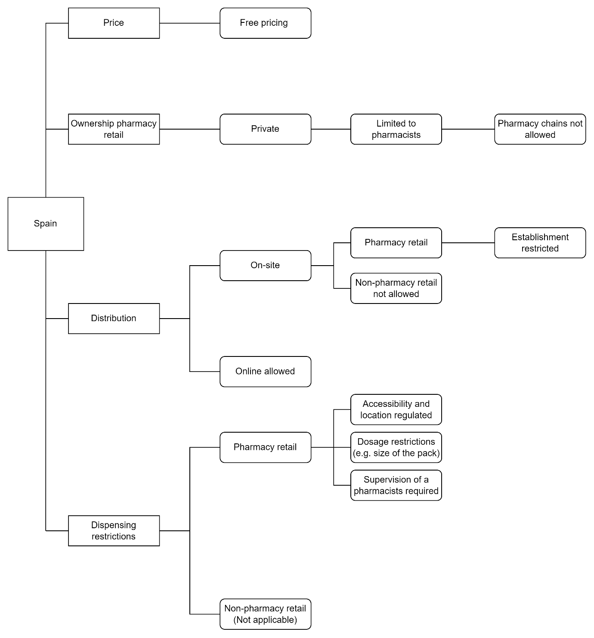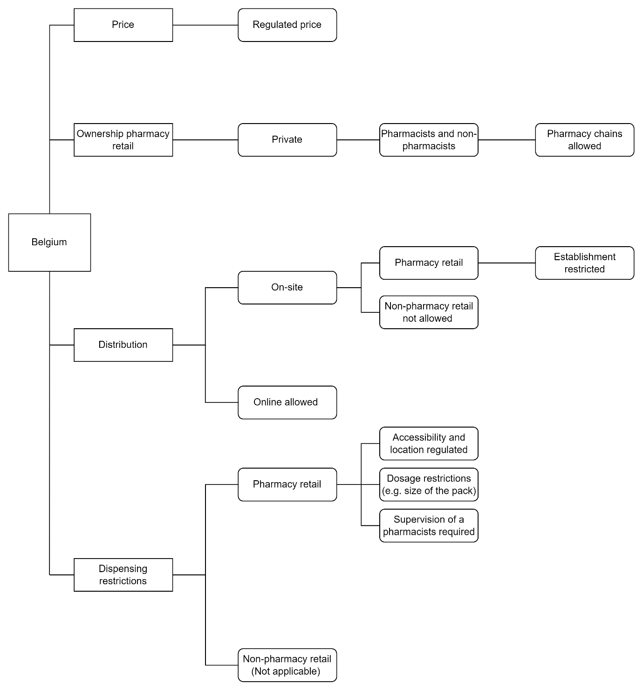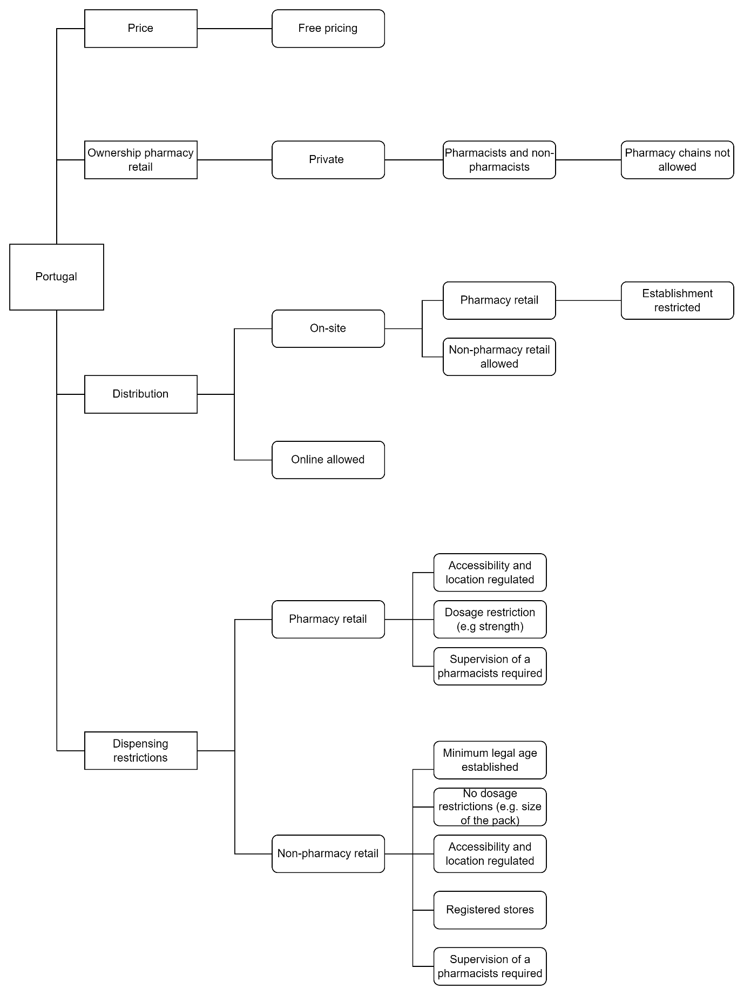

Appendix 5: Dendrograms
- Pharmacy retail only
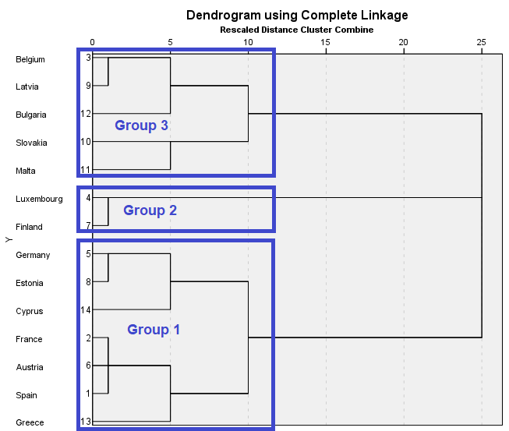
- Pharmacy and non-pharmacy retail allowed
