Additional file 1: Example for a written, pharmacy-specific performance feedback using graphically edited benchmarking

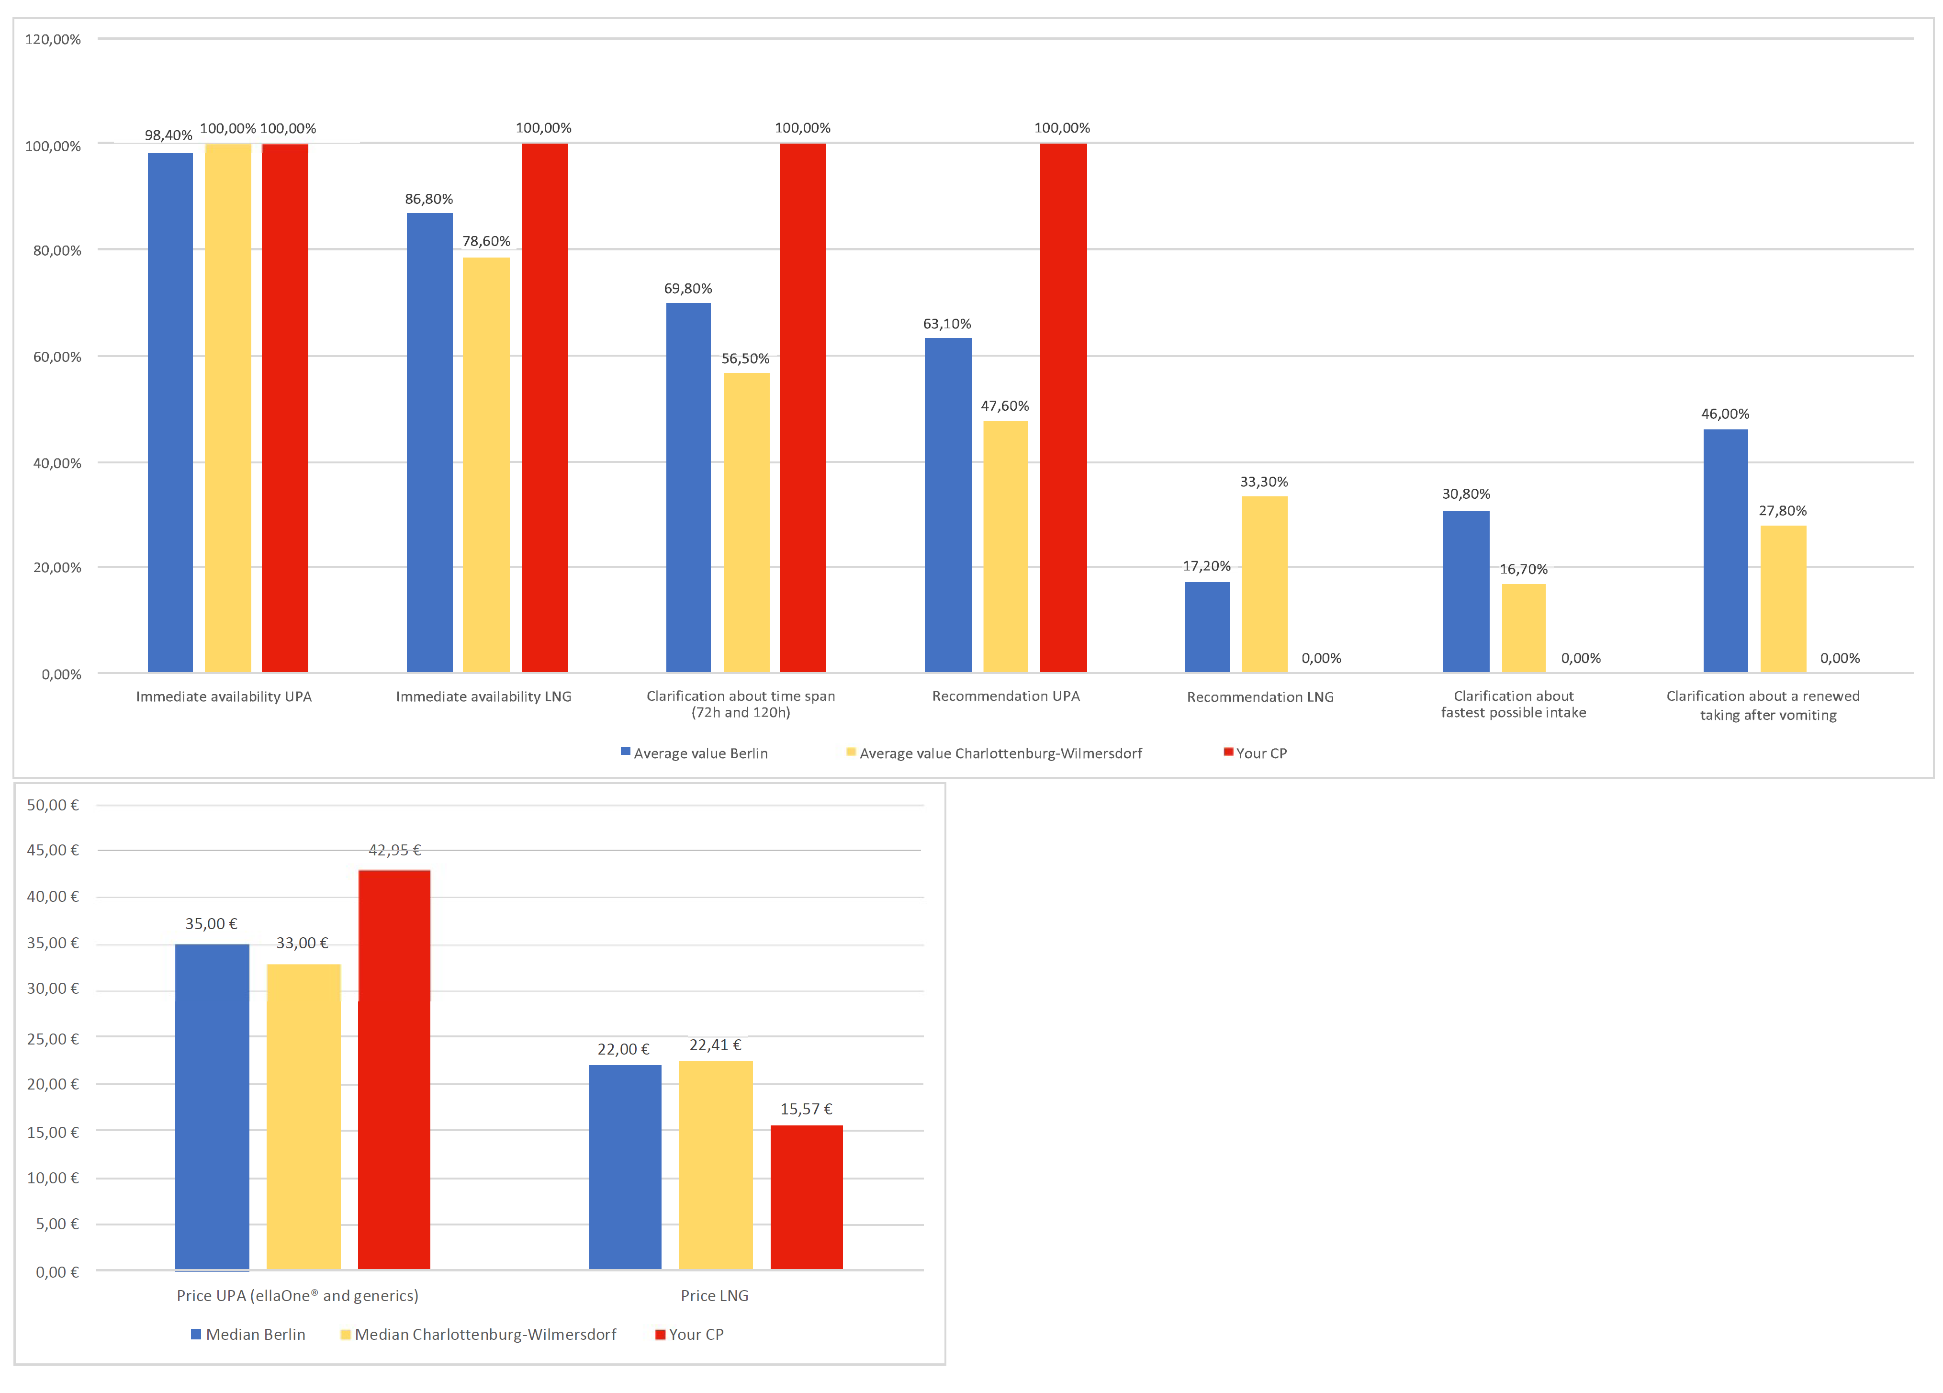
Notes:
Original in German, translated in English;
Blue bars: values for Berlin;
Yellow bars: values for the district in which the respective pharmacy is located;
Red bars: values of the respective pharmacy.

