Additional file 2: Price of UPA medications (n = 241) by district, median price (minimum price - maximum price).
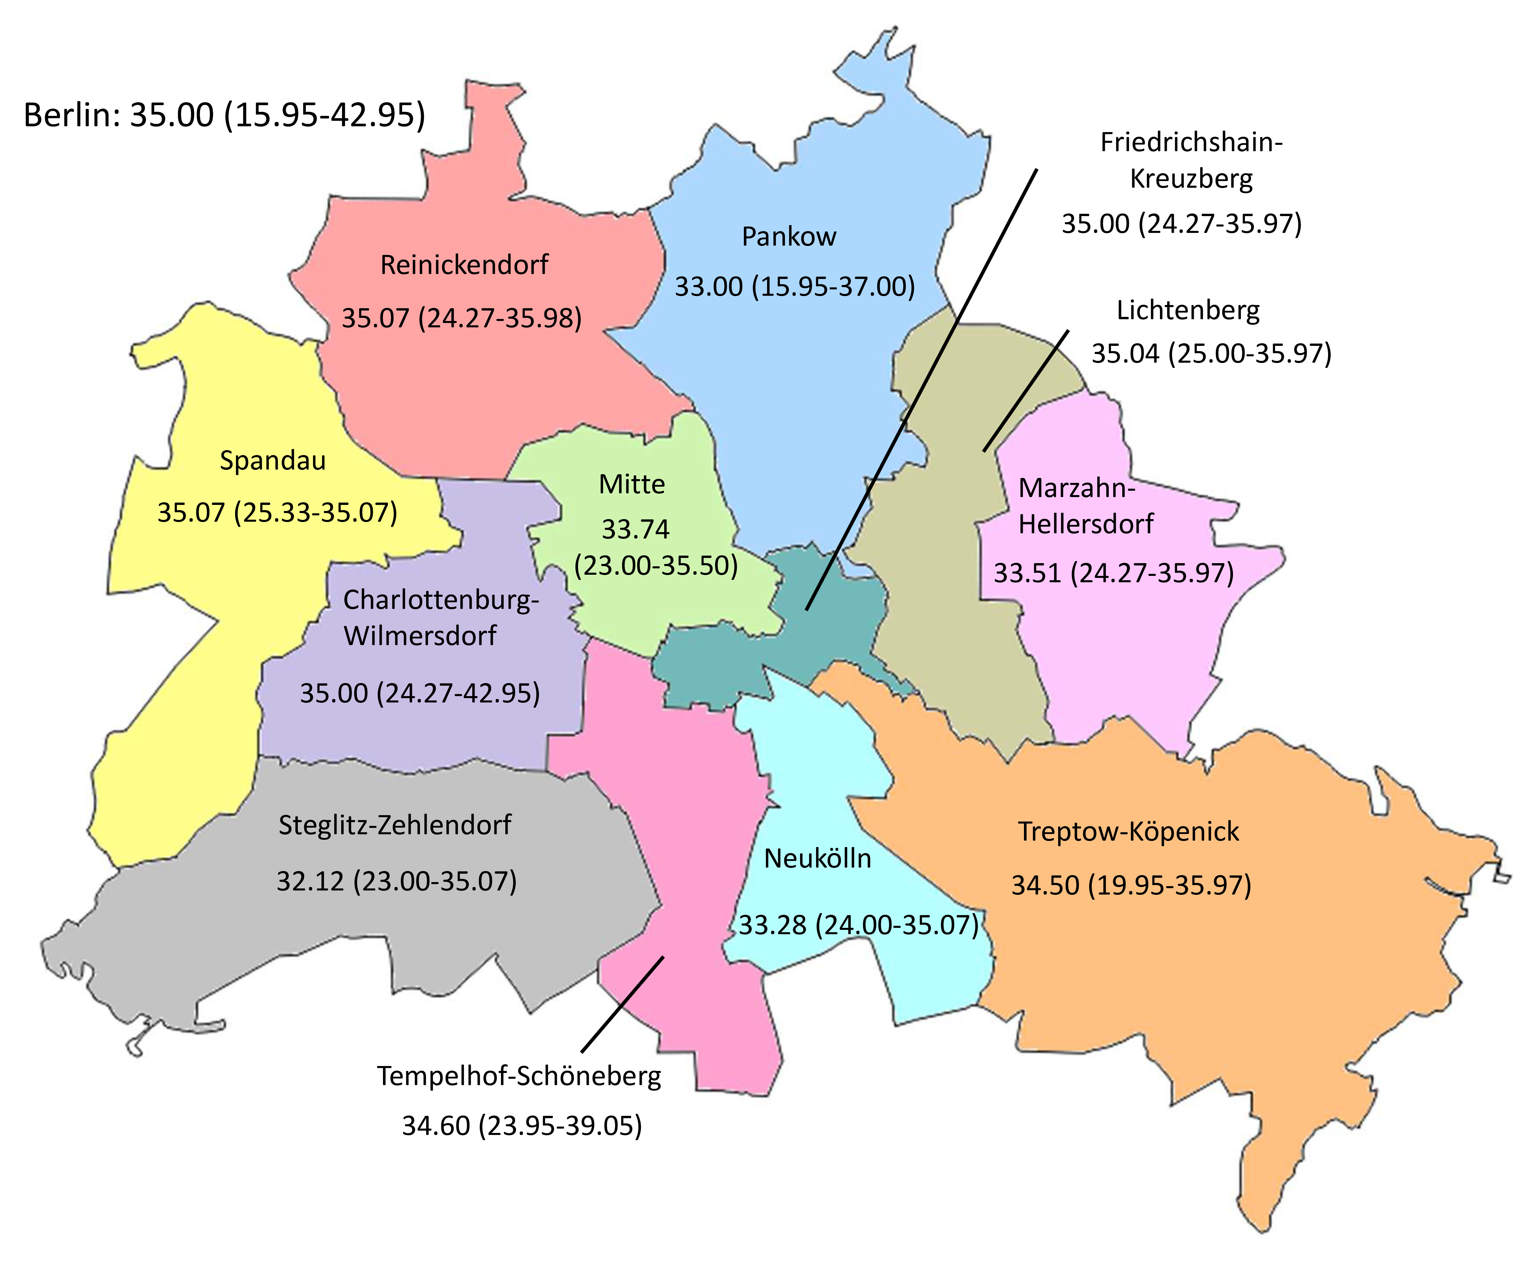

Additional file 2: Price of ellaOne® (n = 224) by district, median price (minimum price - maximum price)
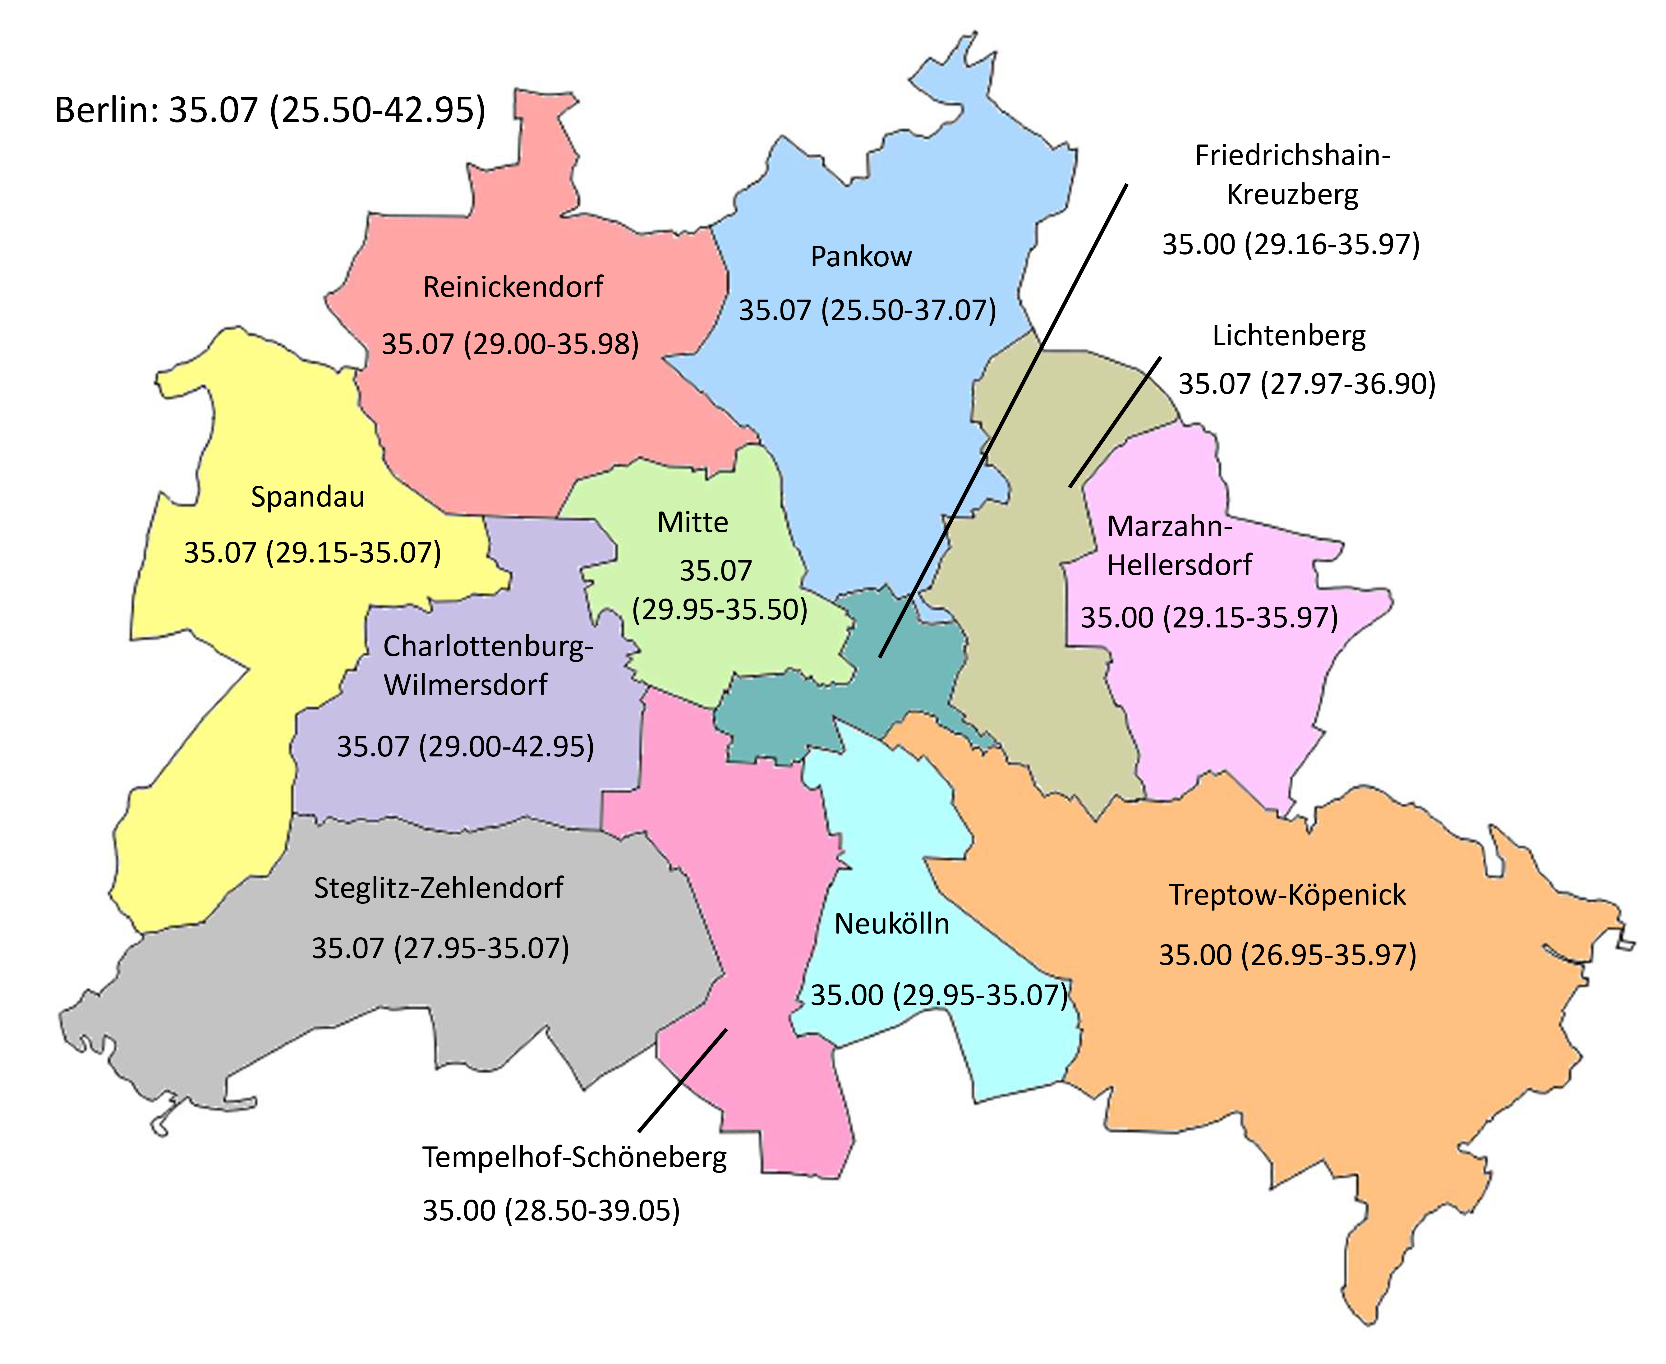

Additional file 2: Price of UPA generics (n=50) by district, median price (minimum price - maximum price).
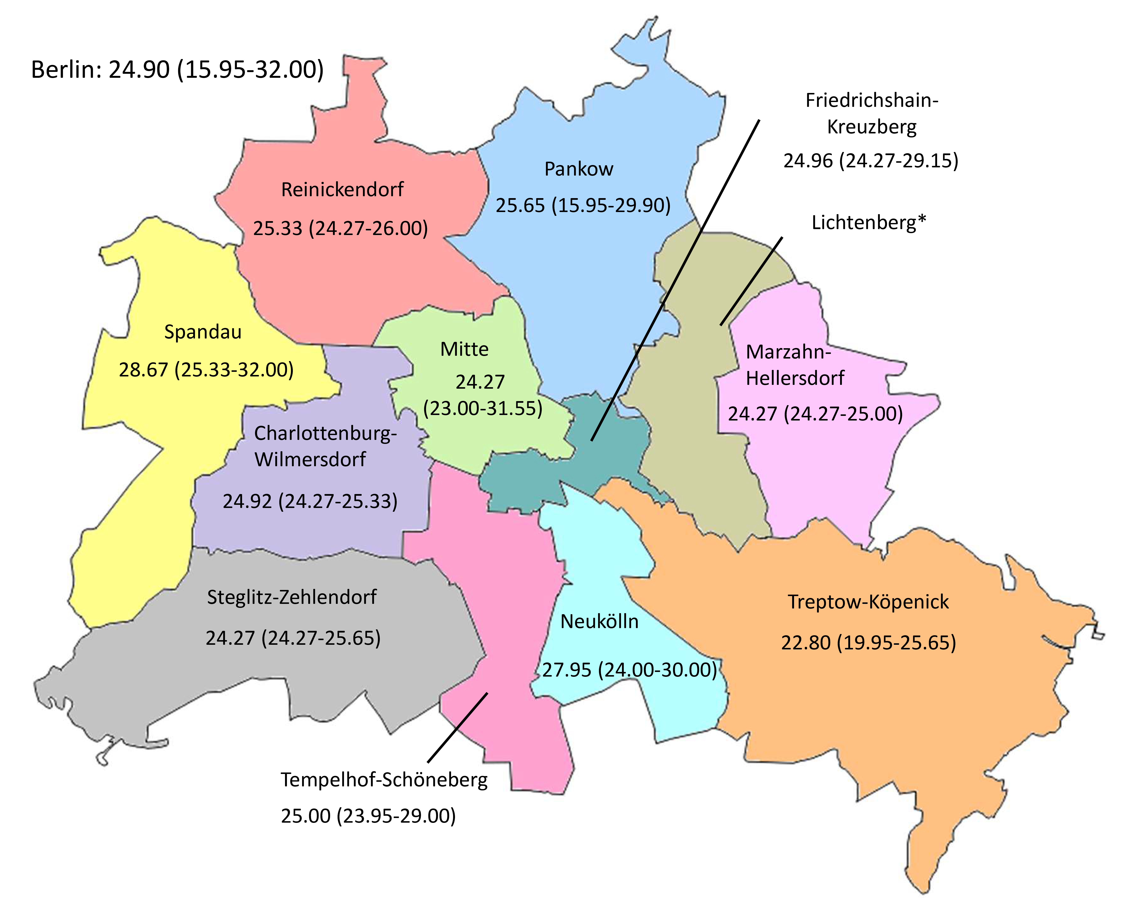
Note: * not calculable due to n = 1.

Additional file 2: Price of LNG medications (n = 160) by district, median price (minimum price - maximum price)
