Presence of microplastics in drinking water from different freshwater sources in Flanders (Belgium), an urbanized region in Europe - Supplementary Material
Ilias Semmouri^{a,1}, Maaike Vercauteren^{a.1}, Emmanuel Van Ackerª, Emmy Pequeurª, Jana Asselman^{b,2}, Colin R. Janssen^{a,b,2}
ª Ghent University, Laboratory of Environmental Toxicology and Aquatic Ecology, Faculty of Bioscience Engineering, 9000 Ghent, Belgium
^{b} Blue Growth Research Lab, Ghent University, Bluebridge, Wetenschapspark 1, 8400 Ostend, Belgium
contact corresponding author: ilias.semmouri@ugent.be
¹ Ilias Semmouri and Maaike Vercauteren contributed equally to this paper
² Jana Asselman and Colin Janssen contributed equally to this paper
Present address: Ghent University, Laboratory of Environmental Toxicology and Aquatic Ecology, Campus Coupure, Building F – 2nd Floor, Coupure Links 653 – B-9000 Ghent – Belgium
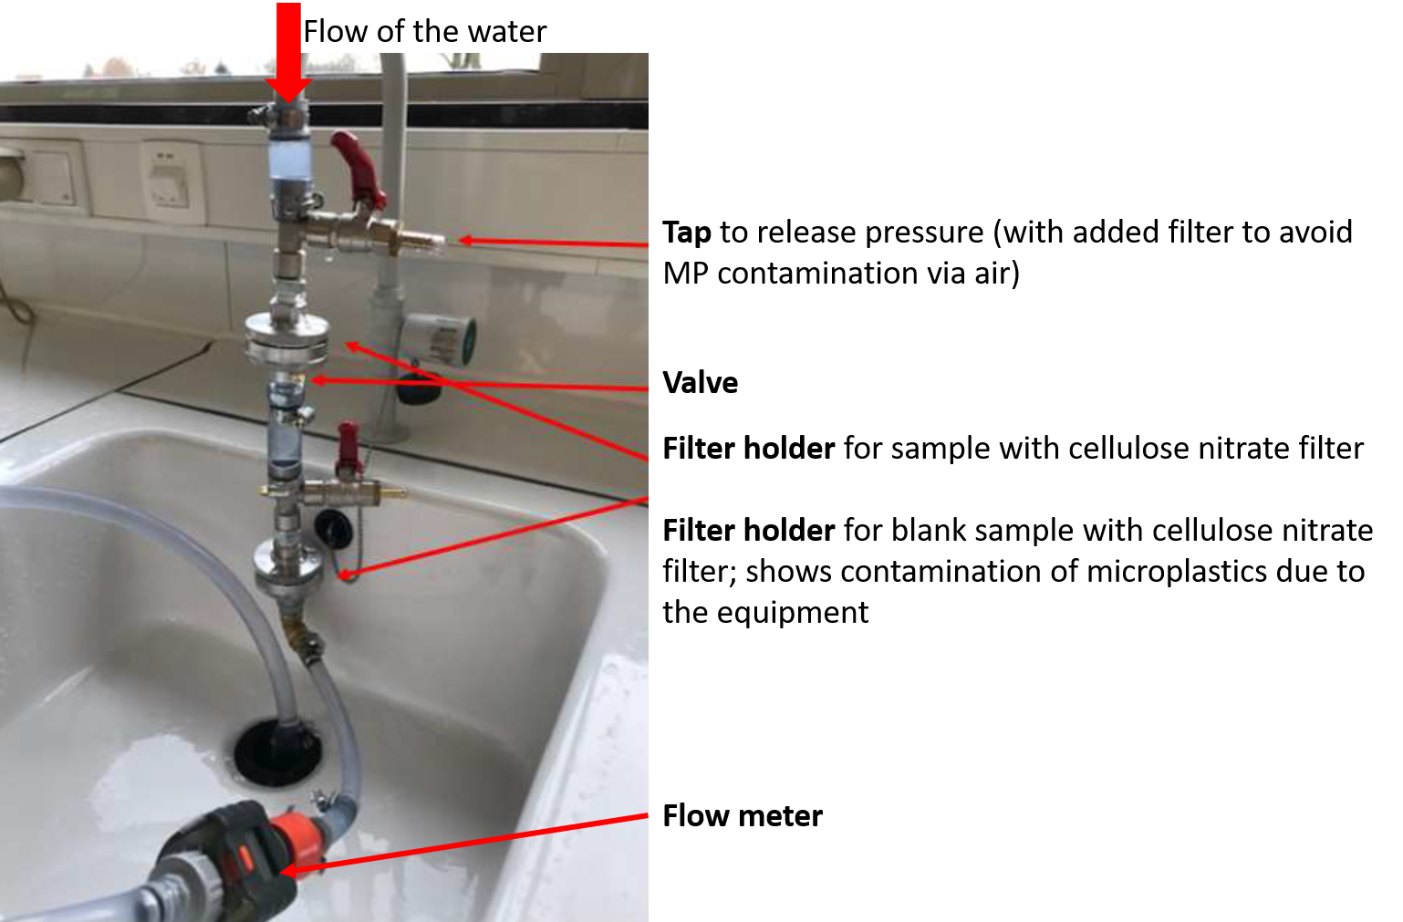
Supplementary Figure S1: Set up of filtration system for drinking water samples.
Supplementary table S1: Limit of detection (LOD) and limit of quantification (LOQ) values for the drinking water sampling method.
 | LOD  (particles per L) | LOQ  (particles per L)
Polyethylene | 0.00 | 0.00
Polypropylene | 0.01 | 0.01
Polyethylene terephthalate | 0.01 | 0.01
Polystyrene | 0.00 | 0.00
Other polymer types | 0.01 | 0.01

Supplementary table S2: Detailed information on the microplastic contamination in drinking water treatment plants (DWTP). Water sources are: groundwater (GW), surface water (SW) or purified effluent water from a waste water treatment plant (WWTP).
DWTP | Latitude N | Longitude E | Location | Date of Sampling | Source of water | Sampling code | Polymer type | MP concentration (particles per L)
Essen | 51.4272 | 4.42956 | Essen | 31/01/2020 11:50 - 13:00 | GW | WPC-001 | PE | 0
Essen | 51.4272 | 4.42956 | Essen | 31/01/2020 11:50 - 13:00 | GW | WPC-001 | PP | 0
Essen | 51.4272 | 4.42956 | Essen | 31/01/2020 11:50 - 13:00 | GW | WPC-001 | PET | 0
Essen | 51.4272 | 4.42956 | Essen | 31/01/2020 11:50 - 13:00 | GW | WPC-001 | PS | 0
Essen | 51.4272 | 4.42956 | Essen | 31/01/2020 11:50 - 13:00 | GW | WPC-001 | Others | 0
Essen - total |  |  |  |  |  |  |  | 0 MP per L
Kluizen | 51.1538 | 3.72092 | Evergem | 10/02/2020 10:04 - 12:05 | SW | WPC-005 | PE | 0
Kluizen | 51.1538 | 3.72092 | Evergem | 10/02/2020 10:04 - 12:05 | SW | WPC-005 | PP | 0
Kluizen | 51.1538 | 3.72092 | Evergem | 10/02/2020 10:04 - 12:05 | SW | WPC-005 | PET | 0
Kluizen | 51.1538 | 3.72092 | Evergem | 10/02/2020 10:04 - 12:05 | SW | WPC-005 | PS | 0
Kluizen | 51.1538 | 3.72092 | Evergem | 10/02/2020 10:04 - 12:05 | SW | WPC-005 | Others | <LOQ
Kluizen total |  |  |  |  |  |  |  | 0 MP per L
Egenhove | 50.8616 | 4.65406 | Egenhove | 22/01/2020 9:15 - 11:45 | GW | WPC-009 | PE | 0
Egenhove | 50.8616 | 4.65406 | Egenhove | 22/01/2020 9:15 - 11:45 | GW | WPC-009 | PP | 0
Egenhove | 50.8616 | 4.65406 | Egenhove | 22/01/2020 9:15 - 11:45 | GW | WPC-009 | PET | 0
Egenhove | 50.8616 | 4.65406 | Egenhove | 22/01/2020 9:15 - 11:45 | GW | WPC-009 | PS | 0
Egenhove | 50.8616 | 4.65406 | Egenhove | 22/01/2020 9:15 - 11:45 | GW | WPC-009 | Others | 0
Egenhove total |  |  |  |  |  |  |  | 0 MP per L
Oelegem | 51.2130 | 4.58311 | Ranst | 14/02/2020 10:20 - 12:20 | SW | WPC-013 | PE | 0
Oelegem | 51.2130 | 4.58311 | Ranst | 14/02/2020 10:20 - 12:20 | SW | WPC-013 | PP | 0.01
Oelegem | 51.2130 | 4.58311 | Ranst | 14/02/2020 10:20 - 12:20 | SW | WPC-013 | PET | 0
Oelegem | 51.2130 | 4.58311 | Ranst | 14/02/2020 10:20 - 12:20 | SW | WPC-013 | PS | 0
Oelegem | 51.2130 | 4.58311 | Ranst | 14/02/2020 10:20 - 12:20 | SW | WPC-013 | Others | 0
Oelegem total |  |  |  |  |  |  |  | 0.01 MP per L
Puttebos | 50.8384 | 4.57556 | Leefdaal | 17/01/2019 11:10 - 12:26 | GW | WPC-015 | PE | 0
Puttebos | 50.8384 | 4.57556 | Leefdaal | 17/01/2019 11:10 - 12:26 | GW | WPC-015 | PP | <LOQ
Puttebos | 50.8384 | 4.57556 | Leefdaal | 17/01/2019 11:10 - 12:26 | GW | WPC-015 | PET | 0
Puttebos | 50.8384 | 4.57556 | Leefdaal | 17/01/2019 11:10 - 12:26 | GW | WPC-015 | PS | 0
Puttebos | 50.8384 | 4.57556 | Leefdaal | 17/01/2019 11:10 - 12:26 | GW | WPC-015 | Others | 0
Puttebos total |  |  |  |  |  |  |  | 0 MP per L
Torreele | 51.1222 | 2.66041 | Koksijde | 24/01/2020 9:30 - 10:35 | WWTP | WPC-017a | PE | 0
Torreele | 51.1222 | 2.66041 | Koksijde | 24/01/2020 9:30 - 10:35 | WWTP | WPC-017a | PP | 0.06
Torreele | 51.1222 | 2.66041 | Koksijde | 24/01/2020 9:30 - 10:35 | WWTP | WPC-017a | PET | 0
Torreele | 51.1222 | 2.66041 | Koksijde | 24/01/2020 9:30 - 10:35 | WWTP | WPC-017a | PS | 0
Torreele | 51.1222 | 2.66041 | Koksijde | 24/01/2020 9:30 - 10:35 | WWTP | WPC-017a | Others | 0
Torreele | 51.1222 | 2.66041 | Koksijde | 26/02/2020 8:15 - 9:40 | WWTP | WPC-017b | PE | 0.02
Torreele | 51.1222 | 2.66041 | Koksijde | 26/02/2020 8:15 - 9:40 | WWTP | WPC-017b | PP | 0.01
Torreele | 51.1222 | 2.66041 | Koksijde | 26/02/2020 8:15 - 9:40 | WWTP | WPC-017b | PET | 0
Torreele | 51.1222 | 2.66041 | Koksijde | 26/02/2020 8:15 - 9:40 | WWTP | WPC-017b | PS | 0
Torreele | 51.1222 | 2.66041 | Koksijde | 26/02/2020 8:15 - 9:40 | WWTP | WPC-017b | Others | 0
Torreele total |  |  |  |  |  |  |  | 0.05 MP per L
Blankaert | 50.9870 | 2.83743 | Diksmuide | 18/02/2020 10:15 - 11:50 | SW | WPC-050 | PE | 0
Blankaert | 50.9870 | 2.83743 | Diksmuide | 18/02/2020 10:15 - 11:50 | SW | WPC-050 | PP | 0.05
Blankaert | 50.9870 | 2.83743 | Diksmuide | 18/02/2020 10:15 - 11:50 | SW | WPC-050 | PET | 0
Blankaert | 50.9870 | 2.83743 | Diksmuide | 18/02/2020 10:15 - 11:50 | SW | WPC-050 | PS | 0
Blankaert | 50.9870 | 2.83743 | Diksmuide | 18/02/2020 10:15 - 11:50 | SW | WPC-050 | Others | 0
Blankaert total |  |  |  |  |  |  |  | 0.05 MP per L
De Gavers | 50.8303 | 3.32310 | Harelbeke | 19/02/2020 9:30 - 11:20 | SW | WPC-070 | PE | 0
De Gavers | 50.8303 | 3.32310 | Harelbeke | 19/02/2020 9:30 - 11:20 | SW | WPC-070 | PP | 0
De Gavers | 50.8303 | 3.32310 | Harelbeke | 19/02/2020 9:30 - 11:20 | SW | WPC-070 | PET | 0
De Gavers | 50.8303 | 3.32310 | Harelbeke | 19/02/2020 9:30 - 11:20 | SW | WPC-070 | PS | 0
De Gavers | 50.8303 | 3.32310 | Harelbeke | 19/02/2020 9:30 - 11:20 | SW | WPC-070 | Others | 0
De Gavers total |  |  |  |  |  |  |  | 0 MP per L

Supplementary table S3: Detailed information on the microplastic contamination in tap water (TW). Water sources are : groundwater (GW) or surface water (SW).
TW | Latitude N | Longitude E | Date of Sampling | Source of water | Sampling code | Polymer type | MP concentration (particles per L)
Sint-Denijs-Westrem | 51.0278 | 3.69702 | 31/01/2020 11:10 - 12:26 | GW | SWK-001 | PE | 0
Sint-Denijs-Westrem | 51.0278 | 3.69702 | 31/01/2020 11:10 - 12:26 | GW | SWK-001 | PP | 0
Sint-Denijs-Westrem | 51.0278 | 3.69702 | 31/01/2020 11:10 - 12:26 | GW | SWK-001 | PET | 0
Sint-Denijs-Westrem | 51.0278 | 3.69702 | 31/01/2020 11:10 - 12:26 | GW | SWK-001 | PS | 0
Sint-Denijs-Westrem | 51.0278 | 3.69702 | 31/01/2020 11:10 - 12:26 | GW | SWK-001 | Others | 0
Sint-Denijs-Westrem total |  |  |  |  |  |  | 0 MP per L
Oostende | 51.2116 | 2.95459 | 21/02/2020 9:15 - 11:45 | SW | SWK-050 | PE | 0
Oostende | 51.2116 | 2.95459 | 21/02/2020 9:15 - 11:45 | SW | SWK-050 | PP | 0
Oostende | 51.2116 | 2.95459 | 21/02/2020 9:15 - 11:45 | SW | SWK-050 | PET | 0
Oostende | 51.2116 | 2.95459 | 21/02/2020 9:15 - 11:45 | SW | SWK-050 | PS | 0
Oostende | 51.2116 | 2.95459 | 21/02/2020 9:15 - 11:45 | SW | SWK-050 | Others | 0
Oostende total |  |  |  |  |  |  | 0 MP per L
Herentals | 51.1793 | 4.83453 | 6/03/2020 9:30 - 10:35 | GW | SWK-003 | PE | 0
Herentals | 51.1793 | 4.83453 | 6/03/2020 9:30 - 10:35 | GW | SWK-003 | PP | 0
Herentals | 51.1793 | 4.83453 | 6/03/2020 9:30 - 10:35 | GW | SWK-003 | PET | 0
Herentals | 51.1793 | 4.83453 | 6/03/2020 9:30 - 10:35 | GW | SWK-003 | PS | 0
Herentals | 51.1793 | 4.83453 | 6/03/2020 9:30 - 10:35 | GW | SWK-003 | Others | 0
Herentals total |  |  |  |  |  |  | 0 MP per L
Ghent - Coupure | 51.0539 | 3.70741 | 16/03/2021 14:27 – 15:54; | SW | SWK-004 | PE | 0.003
Ghent - Coupure | 51.0539 | 3.70741 | 16/03/2021 14:27 – 15:54; | SW | SWK-004 | PP | 0.02
Ghent - Coupure | 51.0539 | 3.70741 | 16/03/2021 14:27 – 15:54; | SW | SWK-004 | PET | 0.01
Ghent - Coupure | 51.0539 | 3.70741 | 16/03/2021 14:27 – 15:54; | SW | SWK-004 | PS | 0.00
Ghent - Coupure | 51.0539 | 3.70741 | 16/03/2021 14:27 – 15:54; | SW | SWK-004 | Others | 0.01
Ghent - Coupure | 51.0539 | 3.70741 | 23/03/2021 9:41 – 11:07; | SW | SWK-005 | PE | 0
Ghent - Coupure | 51.0539 | 3.70741 | 23/03/2021 9:41 – 11:07; | SW | SWK-005 | PP | <LOQ
Ghent - Coupure | 51.0539 | 3.70741 | 23/03/2021 9:41 – 11:07; | SW | SWK-005 | PET | <LOQ
Ghent - Coupure | 51.0539 | 3.70741 | 23/03/2021 9:41 – 11:07; | SW | SWK-005 | PS | 0
Ghent - Coupure | 51.0539 | 3.70741 | 23/03/2021 9:41 – 11:07; | SW | SWK-005 | Others | 0
Ghent - Coupure | 51.0539 | 3.70741 | 23/03/2021 11:16 – 13:30 | SW | SWK-006 | PE | 0
Ghent - Coupure | 51.0539 | 3.70741 | 23/03/2021 11:16 – 13:30 | SW | SWK-006 | PP | <LOQ
Ghent - Coupure | 51.0539 | 3.70741 | 23/03/2021 11:16 – 13:30 | SW | SWK-006 | PET | 0
Ghent - Coupure | 51.0539 | 3.70741 | 23/03/2021 11:16 – 13:30 | SW | SWK-006 | PS | 0
Ghent - Coupure | 51.0539 | 3.70741 | 23/03/2021 11:16 – 13:30 | SW | SWK-006 | Others | 0
Ghent total |  |  |  |  |  |  | 0.018 MP per L
Kortrijk | 50.8249 | 3.25133 | 22/03/2021, 10:12– 11:39 | GW | SWK-007 | PE | 0
Kortrijk | 50.8249 | 3.25133 | 22/03/2021, 10:12– 11:39 | GW | SWK-007 | PP | <LOQ
Kortrijk | 50.8249 | 3.25133 | 22/03/2021, 10:12– 11:39 | GW | SWK-007 | PET | <LOQ
Kortrijk | 50.8249 | 3.25133 | 22/03/2021, 10:12– 11:39 | GW | SWK-007 | PS | 0
Kortrijk | 50.8249 | 3.25133 | 22/03/2021, 10:12– 11:39 | GW | SWK-007 | Others | 0
Kortrijk | 50.8249 | 3.25133 | 22/03/2021, 12:36 – 13:50 | GW | SWK-008 | PE | 0
Kortrijk | 50.8249 | 3.25133 | 22/03/2021, 12:36 – 13:50 | GW | SWK-008 | PP | 0.01
Kortrijk | 50.8249 | 3.25133 | 22/03/2021, 12:36 – 13:50 | GW | SWK-008 | PET | <LOQ
Kortrijk | 50.8249 | 3.25133 | 22/03/2021, 12:36 – 13:50 | GW | SWK-008 | PS | 0.003
Kortrijk | 50.8249 | 3.25133 | 22/03/2021, 12:36 – 13:50 | GW | SWK-008 | Others | <LOQ
Kortrijk | 50.8249 | 3.25133 | 22/03/2021 13:58 – 14:55 | GW | SWK-009 | PE | 0
Kortrijk | 50.8249 | 3.25133 | 22/03/2021 13:58 – 14:55 | GW | SWK-009 | PP | <LOQ
Kortrijk | 50.8249 | 3.25133 | 22/03/2021 13:58 – 14:55 | GW | SWK-009 | PET | 0.02
Kortrijk | 50.8249 | 3.25133 | 22/03/2021 13:58 – 14:55 | GW | SWK-009 | PS | 0
Kortrijk | 50.8249 | 3.25133 | 22/03/2021 13:58 – 14:55 | GW | SWK-009 | Others | 0
Kortrijk total |  |  |  |  |  |  | 0.012 MP per L

