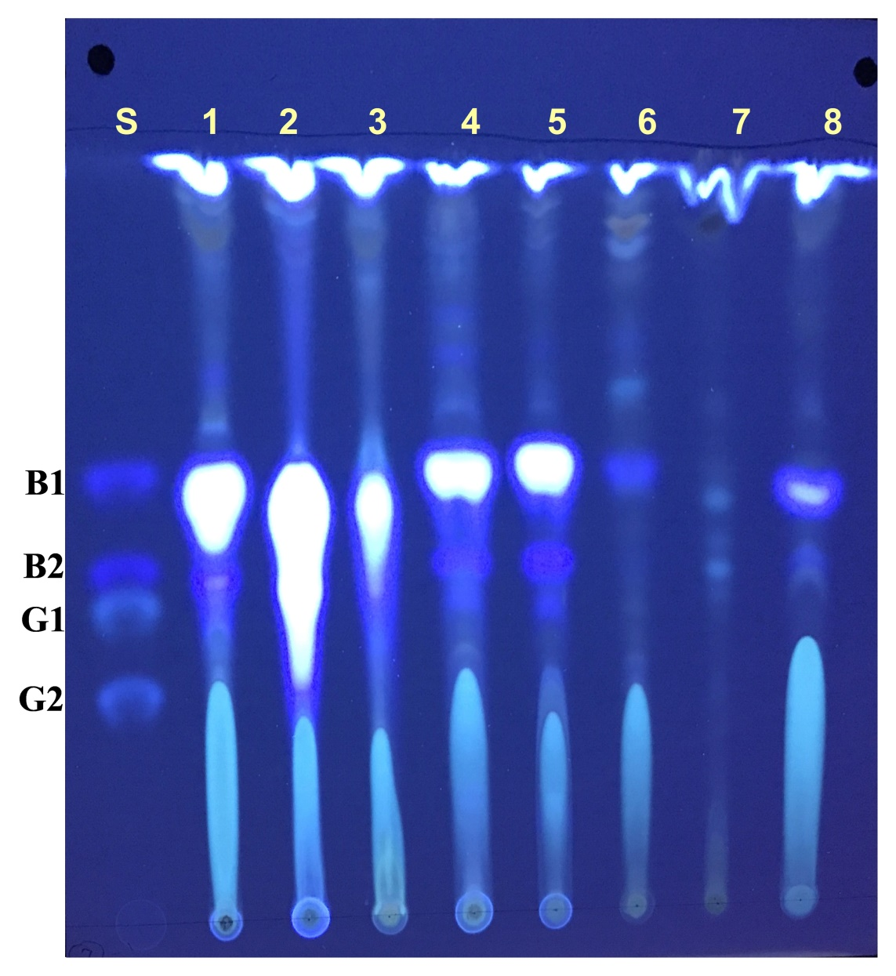
Supplementary information S1:- TLC plate representing S:standards B₁(1 µg/mL), B₂(0.5 µg/mL), G₁(1 µg/mL), G₂(0.5 µg/mL) and samples as follows 1:MTCC2798(Positive strain) (100 µL-load volume), 2:W7G isolate of Aspergillus section Flavi obtained from wheat sample, 3:R10G isolate of Aspergillus section Flavi obtained from rice sample, 4:C3G isolate of Aspergillus section Flavi obtained from chickpeas sample, 5:S4G isolate of Aspergillus section Flavi obtained from yellow mustard, 6:Ra2G isolate of Aspergillus section Flavi obtained from black mustard sample, 7:C4B isolate of Aspergillus section Nigri isolated from chickpeas sample (Negative strain), 8: MTCC2798(Positive strain)(20 µL-load volume)
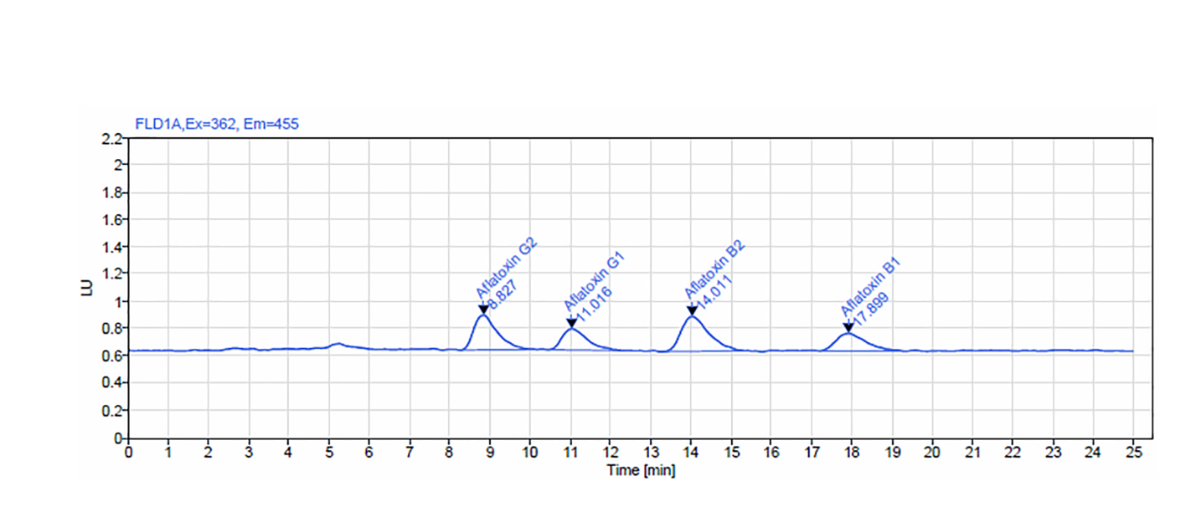
Supplementary information S2:- HPLC chromatogram of aflatoxins (AFS) standard solution contains 0.5 ppb AFB₁, 0.5 ppb AFB₂, 0.5 ppb AFG₁ and 0.5 ppb AFG₂ (2 ppb total AFS).

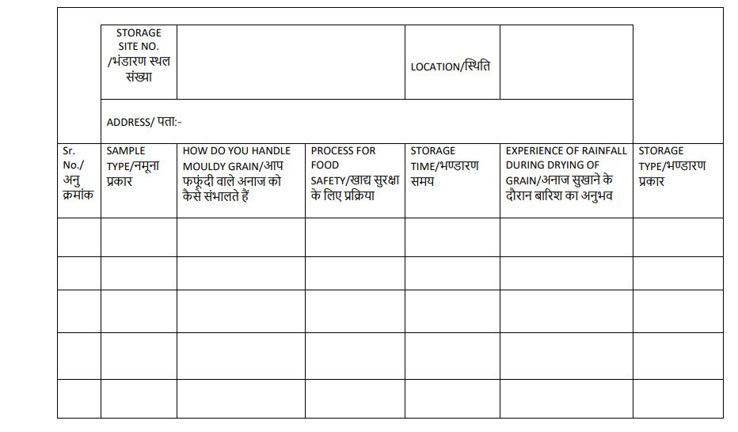
Supplementary information S3:- Proforma for sample collection

Supplementary information S4:- Aflatoxin standard calibration
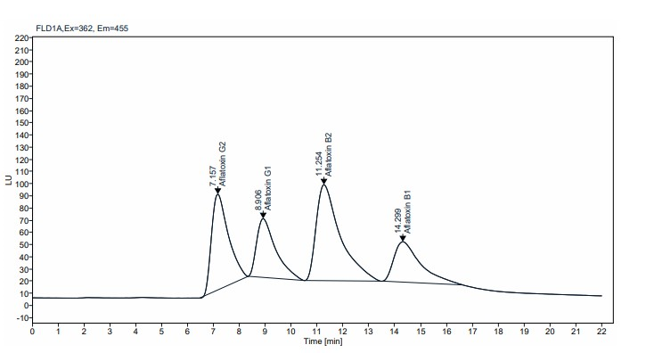

Name | RT (min) | Area | RF | Calibration Amount (µL) | Amount | Concentration (µg/kg)
Aflatoxin G2 | 7.157 | 3564.922 | 355.32 | 10 | 10.033 | 10.033
Aflatoxin G1 | 8.906 | 2482.909 | 247.689 | 10 | 10.024 | 10.0243
Aflatoxin B2 | 11.254 | 5093.516 | 506.6 | 10 | 10.054 | 10.0543
Aflatoxin B1 | 14.299 | 2382.224 | 238.792 | 10 | 9.976 | 9.9761
 | Sum | 13523.57 |  |  | 40.088 | 40.0877

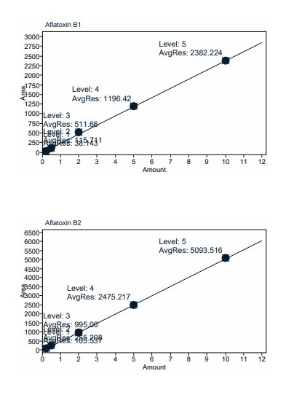
Compound: Aflatoxin B1

Signal: FLD1A
Exp. RT: 14.299
Residual: 17.61489
R: 0.99986
R^2: 0.99972
Formula: y = ax + b
a: 238.3766
b: 4.1485
c:
Aflatoxin B1 calibration
d:

Compound: Aflatoxin B2

Signal: FLD1A
Exp. RT: 11.254
Residual: 31.90825
R: 0.99990
R^2: 0.99979
Formula: y = ax + b
a: 507.5924
b: -9.9748
c:
Aflatoxin B2 calibration
d:

Compound: Aflatoxin G1

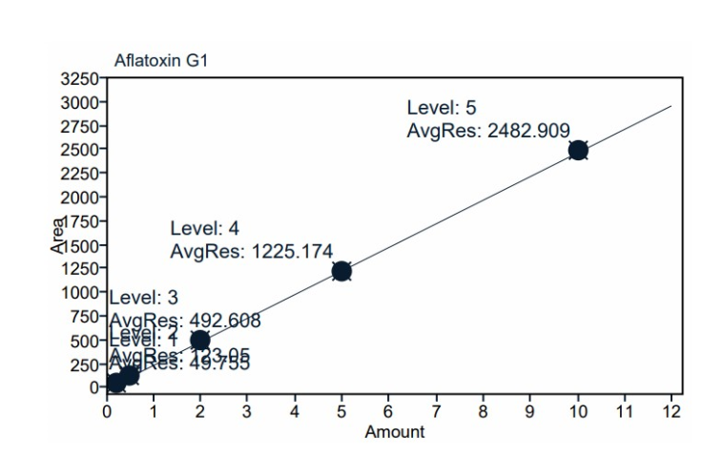
Signal: FLD1A
Exp. RT: 9.482
Residual: 7.02106
R: 0.99998
R^2: 0.99996
Formula: y = ax + b
a: 247.9383
b: -2.5021
Aflatoxin G1 calibration
c:
d:

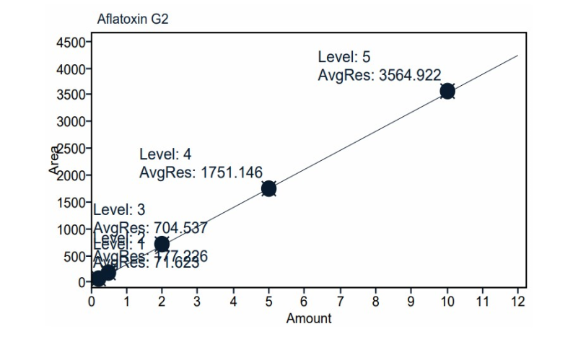
Compound: Aflatoxin G2

Signal: FLD1A
Exp. RT: 7.596
Residual: 13.61695
R: 0.99996
R^2: 0.99992
Formula: y = ax + b
a: 355.7842
b: -4.6546
Aflatoxin G2 calibration
c:
d:

