Additional Files
Operational and Structural Risk Factors Associated with Foodborne Outbreaks in Malaysian Food Service Establishments
Siti Asah Md Ali^{a,b*,} and Toru Watanabe^{c,*}
ª The United Graduate School of Agricultural Sciences, Iwate University, 18-8, Ueda 3-chome, Morioka, Iwate 020-8550, Japan
^{b} Food Safety and Quality Programme, Ministry of Health Malaysia, Menara Prisma, Precinct 3, 62675, Putrajaya, Malaysia
^{c} Department of Food, Life, and Environmental Sciences, Faculty of Agriculture, Yamagata University, 1-23 Wakaba-machi, Tsuruoka, Yamagata 997-8555, Japan
*Corresponding authors
Emails: ctasah.mdali@moh.gov.my (S.A. Md Ali); to-ru@tds1.tr.yamagata-u.ac.jp (T. Watanabe)

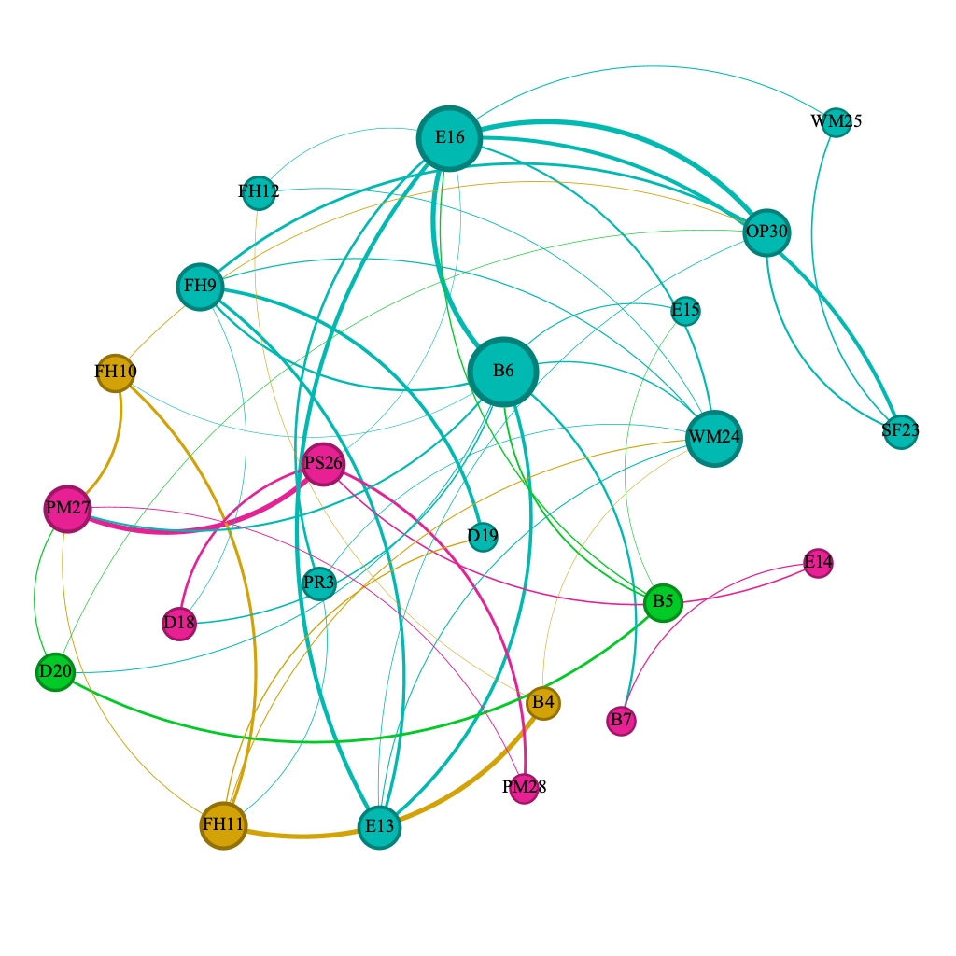
Figure S1A
Interaction network analysis of the relationships among inspection elements in routine groups derived from Lasso regression with interaction terms. A node represents an inspection element, and a directed edge denotes interactions between elements, those with non-zero coefficients. The thickness of the edge (edge weight) reflects the strength of the interaction. The size of each node is proportional to its number of connections (degree). With a modularity of 0.395 obtained from Louvain algorithm, the network clusters of the element are represented by different color nodes. Nodes within the same cluster (color-coded) represent inspection elements with similar or related contributions to demerit scores during routine inspections.
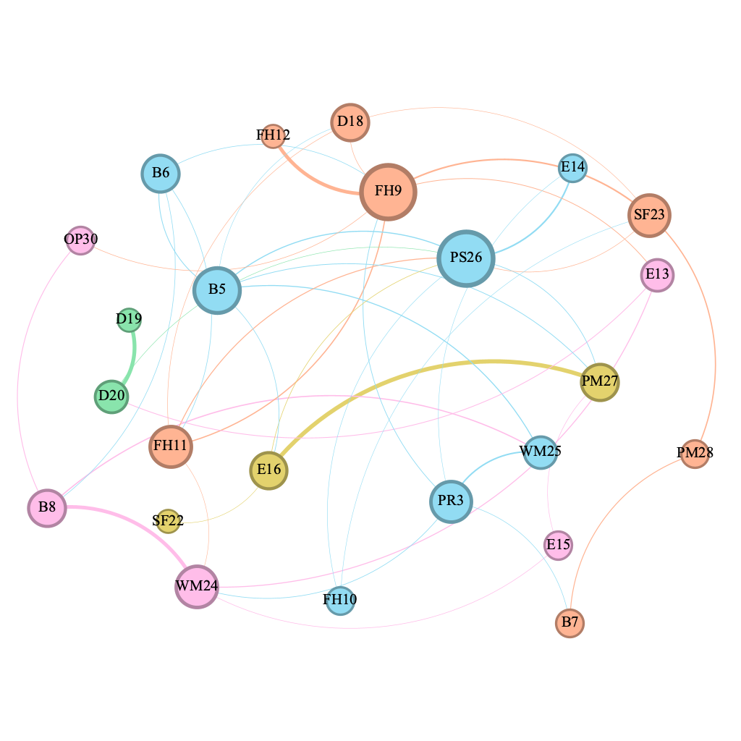
Figure S1B
Interaction network analysis of the relationships among inspection elements in control groups derived from Lasso regression with interaction terms. A node represents an inspection element, and a directed edge denotes interactions between elements, those with non-zero coefficients. The thickness of the edge (edge weight) reflects the strength of the interaction. The size of each node is proportional to its number of connections (degree). With a modularity of 0.629 obtained from Louvain algorithm, the network clusters of the element are represented by different color nodes. Nodes within the same cluster (color-coded) represent inspection elements with similar or related contributions to demerit scores during control inspections.

Table S1
Risk-based premise hygiene evaluation checklist. The checklist is divided into 14 key categories, each addressing a specific dimension of food safety, with assigned demerit scores reflecting the severity of non-compliance to grade the food business.

No. |  | Elements | Maximum demerit score | Assigned inspection score
PROCESS CONTROL |  |  | 25
1 |  | Critical Control Points (or very important process steps) controlled e.g cooking 70°C or above,high risk  foods held below 4°C or above 63°C. | 15
2 |  | Supplier specifications & visual check before use | 5
3 |  | Cross contamination prevented through adequate size, design and equipment | 5
BUILDING |  |  | 7
4 |  | Located away from contamination | 1
5 |  | Suitable and well-maintained flooring | 2
6 |  | Suitable and well-maintained walls and ceilings | 2
7 |  | Sufficient lighting | 1
8 |  | Sufficient ventilation | 1
FOOD HANDLERS |  |  | 13
9 | Anti typhoid vaccination (Including records) |  | 2
10 | Hygiene practices of food handlers (incl.restrict ill) |  | 4
11 | Protective clothing of food handlers |  | 3
12 | Training (incl. records) |  | 4
FOOD EQUIPMENT, UTENSILS AND STORAGE |  |  | 9
13 | Food contact surfaces (including equipment): maintained, easily washed and kept clean. |  | 3
14 | Surfaces are suitably designed and built, well-maintained, easily washed and kept clean. |  | 1
15 | Equipment cleaning facilities and method:  Suitably designed, built, and is properly used and maintained. |  | 3
16 | Storage: Clean, protected and FIFO |  | 2
WATER SUPPLY |  |  | 5
17 | Water supply: Safe source, clean and sufficient#  Ice made from potable sourceIce made from potable source# |  | 5
DRAINING / PIPING FACILITIES |  |  | 3
18 | Effective waste water facility/system in place (food trap) |  | 1
19 | No criss-crossing of lines, backflow, back flow |  | 1
20 | Installed and in good working order |  | 1
SANITATION FACILITIES |  |  | 6
21 | Sufficient and well-maintained toilets (or access to) |  | 1
22 | Sufficient bathrooms, changing facilities |  | 2
23 | Hand washing facilities: Sufficient and appropriate access, hand dryers or disposable towels, soap |  | 3
WASTE MANAGEMENT |  |  | 2
24 | Adequate and clean waste containers (foot operated), scheduled disposal |  | 1
25 | Adequate maintenance of waste collection area outside the premises |  | 1
PEST CONTROL |  |  | 3
26 | Adequate & effective control system in place |  | 3
PREMISES CLEANING & MAINTENANCE PROGRAMME |  |  | 2
27 | Scheduled cleaning and maintenance (incl. removal of disused equipment) |  | 1
28 | Storage of cleaning agents away from foodStorage of cleaning agents away from food |  | 1
TRANSPORT AND DISTRIBUTION |  |  | 1
29 | Adequate cleaning, temperature control and maintenance |  | 1
OTHER OPERATIONS |  |  | 1
30 | Documentation/Notices |  | 1
NON-PROCESS RELATED TO PUBLIC HEALTH RISK |  |  | 10
31 | Minus an additional 10 points where any non-process issue may cause a serious risk |  | 10
FOOD FACTORY OPERATIONS ONLY |  |  | 35
32 | Food Safety Assurance Programme in place |  | 30
33 | Traceability |  | 5

Table S2
Key network metrics for inspection elements across outbreak, routine, and control groups. The degree metric reflects the number of direct connections an element has with other nodes, highlighting its connectivity within the network. Betweenness centrality indicates the extent to which an element acts as a bridge within the network, connecting different clusters or groups, and modularity class color-coded groupings based on community detection in Figures 2, S1A, and S1B.
Inspection elements | Outbreak |  |  |  | Routine |  |  |  | Control
Inspection elements | Degree | Betweenness centrality | Modularity class |  | Degree | Betweenness centrality | Modularity class |  | Degree | Betweenness centrality | Modularity class
PR1 | 6 | 28.27 |  |  | NA | NA | NA |  | NA | NA | NA
PR2 | 4 | 13.67 |  |  | NA | NA | NA |  | NA | NA | NA
PR3 | 4 | 6.07 |  |  | 3 | 1.81 |  |  | 5 | 33.63
B4 | 3 | 6.64 |  |  | 3 | 1.23 |  |  | NA | NA | NA
B5 | 7 | 51.90 |  |  | 4 | 4.24 |  |  | 6 | 31.00
B6 | 10 | 122.05 |  |  | 11 | 65.01 |  |  | 4 | 10.77
B7 | 1 | 0.00 |  |  | 2 | 5.58 |  |  | 2 | 4.50
B8 | 2 | 1.59 |  |  | NA | NA | NA |  | 4 | 8.17
FH9 | 3 | 4.51 |  |  | 6 | 16.79 |  |  | 8 | 59.73
FH10 | 4 | 35.42 |  |  | 4 | 4.49 |  |  | 2 | 0.00
FH11 | 1 | 0.00 |  |  | 6 | 17.57 |  |  | 5 | 15.59
FH12 | 8 | 81.19 |  |  | 3 | 2.62 |  |  | 1 | 0.00
E13 | 3 | 7.32 |  |  | 5 | 1.84 |  |  | 3 | 16.03
E14 | 3 | 20.18 |  |  | 2 | 1.50 |  |  | 2 | 5.42
E15 | 1 | 0.00 |  |  | 2 | 0.00 |  |  | 2 | 3.70
E16 | 3 | 31.33 |  |  | 10 | 63.31 |  |  | 4 | 22.00
W17 | 3 | 1.96 |  |  | NA | NA | NA |  | NA | NA | NA
D18 | 4 | 16.99 |  |  | 3 | 3.42 |  |  | 4 | 6.38
D19 | 1 | 0.00 |  |  | 2 | 0.67 |  |  | 1 | 0.00
D20 | 5 | 55.32 |  |  | 4 | 3.27 |  |  | 3 | 26.67
SF21 | NA | NA | NA |  | NA | NA | NA |  | NA | NA | NA
SF22 | NA | NA | NA |  | NA | NA | NA |  | 1 | 0.00
SF23 | 3 | 27.49 |  |  | 3 | 1.43 |  |  | 5 | 30.14
WM24 | 2 | 6.60 |  |  | 8 | 25.75 |  |  | 5 | 24.18
WM25 | 2 | 26.00 |  |  | 2 | 0.00 |  |  | 3 | 9.43
PS26 | 3 | 9.79 |  |  | 5 | 26.37 |  |  | 8 | 69.85
PM27 | 2 | 3.82 |  |  | 6 | 22.03 |  |  | 4 | 10.31
PM28 | 4 | 16.40 |  |  | 2 | 0.00 |  |  | 2 | 4.42
TD29 | NA | NA | NA |  | NA | NA | NA |  | NA | NA | NA
OP30 | 5 | 27.45 |  |  | 6 | 12.09 |  |  | 2 | 2.08
PH31 | 5 | 36.06 |  |  | NA | NA | NA |  | NA | NA | NA

Notes: Not Applicable (NA) indicates elements not present or connected in the network analysis for the respective group.
Table S3A
Strength of connections (edge weights) between inspection elements in the outbreak network. Edges were identified using Lasso regression and visualized through network mapping in Gephi.
Inspection elements |  | Weight
Source | Target | Weight
B5 | E15 | 1.61
PR3 | D20 | 0.90
B7 | WM25 | 0.82
E16 | PS26 | 0.76
B5 | B6 | 0.70
D18 | D20 | 0.55
FH9 | OP30 | 0.53
PR1 | PS26 | 0.47
FH11 | SF23 | 0.47
B5 | PH31 | 0.42
B6 | FH12 | 0.36
FH12 | E13 | 0.33
FH10 | SF23 | 0.29
B8 | WM24 | 0.26
B6 | PH31 | 0.24
B5 | OP30 | 0.23
OP30 | PH31 | 0.22
E16 | D19 | 0.22
PR1 | W17 | 0.22
B6 | D20 | 0.20
Table S3B
Strength of connections (edge weights) between inspection elements in the routine network. Edges were identified using Lasso regression and visualized through network mapping in Gephi.
Inspection elements |  | Weight
Source | Target | Weight
PS26 | PM27 | 0.46
E16 | OP30 | 0.45
B4 | FH11 | 0.44
B6 | E16 | 0.43
E13 | E16 | 0.36
E16 | SF23 | 0.32
FH9 | D19 | 0.30
B6 | E13 | 0.28
FH9 | E13 | 0.26
FH10 | FH11 | 0.24
FH10 | PM27 | 0.23
PS26 | PM28 | 0.23
FH9 | OP30 | 0.22
B5 | D20 | 0.21
D18 | PS26 | 0.20

Table S3C
Strength of connections (edge weights) between inspection elements in the control network. Edges were identified using Lasso regression and visualized through network mapping in Gephi.
Inspection elements |  | Weight
Source | Target | Weight
E16 | PM27 | 0.24
D19 | D20 | 0.22
B8 | WM24 | 0.21
FH9 | FH12 | 0.20

