Additional File 3
Example of each rehabilitation level

These charts were used in the training among medical staffs including ICU physicians, ICU nurses, and physical therapists during the training period.

[level 1]
No mobilization
Bed exercise such as passive range of motion were provided by a physical therapist. Passive transfer to chair is conducted by a physical therapist and ICU nurses.

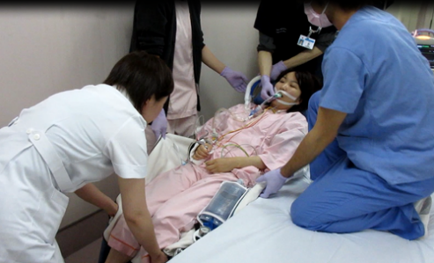 Passive transfer to chair

[Level 2]
Sitting position in bed were performed by a ICU nurse.
Active range of motion were performed by a physical therapist.
Cycling ergometer were performed by a physical therapist and a ICU nurse. If there was the ECMO device with the patient, the ICU physician monitor the ECMO device and cannula.

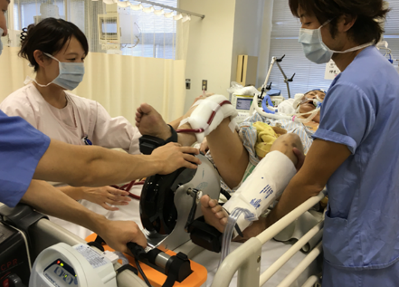 Cycling ergometer

[Level 3]
Sitting on edge of bed is performed by a ICU physician, a nurse, and a physical therapist basically.
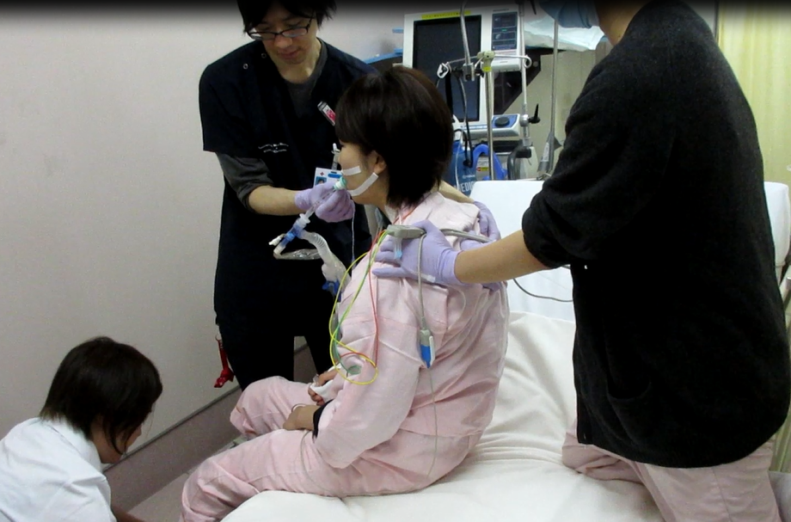 Sitting on edge of bed

[Level 4]
Active transfer to chair is performed by a ICU physician, a nurse, and a physical therapist basically.

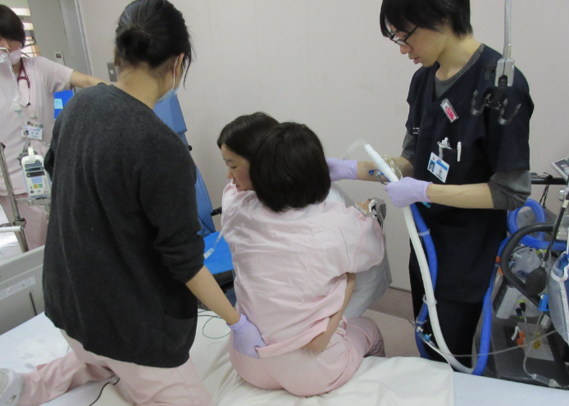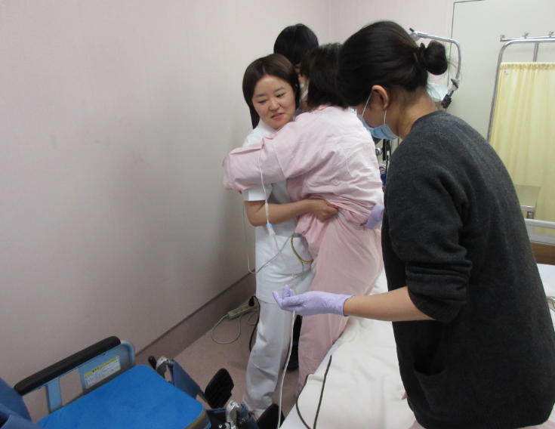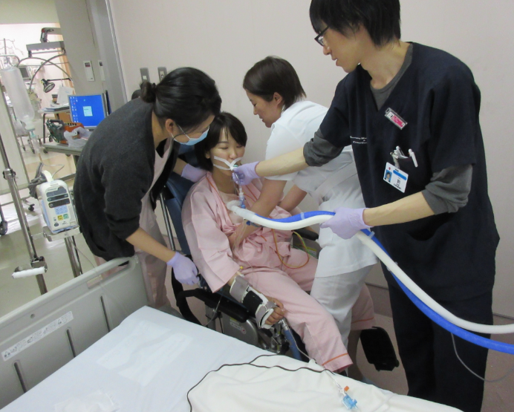
Active transfer to chair

[Level 5]
Standing, stepping in place is performed by a ICU physician, a nurse, and a physical therapist basically.
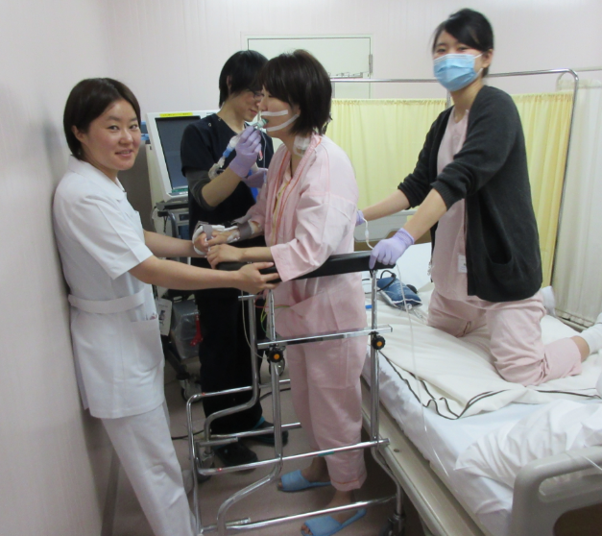 Standing, stepping in place

Ambulating is performed by a ICU physician, a nurse, and a physical therapist basically. If another nurse has time, she may help and participate in the ambulating.
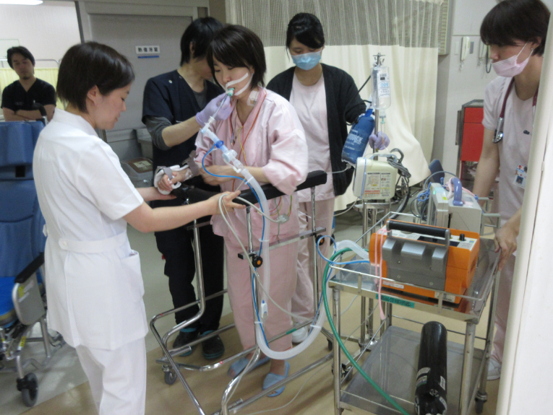 Ambulating

