Additional file 1

1 – Complete Eligibility Criteria for the IRONMAN RCT

Inclusion criteria
- Admitted to an ICU for less than 48 hours
- Anticipated to require ICU care beyond the next calendar day
- Hb less than 100 g/L at any time during the preceding 24 hours
- Age 18 years or greater

Exclusion criteria
- Suspected or confirmed severe sepsis (two or more Systemic Inflammatory Response Syndrome (SIRS) criteria, suspected or confirmed infection, and one or more organ system failure)
- Serum ferritin greater than 1200ng/ml or transferrin saturation greater than 50%
- History of haemochromatosis or aceruloplasminaemia
- Known prior administration of IV iron in the preceding 3 months
- Jehovah’s Witness or other documented exclusion to receiving blood products
- Receiving ESA (e.g. epoetin or darbepoeitin) in the 3 months prior to ICU admission
- Known hypersensitivity to intravenous iron
- Pregnancy
- Treatment intent is palliative
- Death is deemed imminent and inevitable
- Weight less than 40kg
- Participating in competing study

2. Correlation between hepcidin and other baseline values
Hb -0.09, P=0.308. Ferritin 0.13, P=128. Transferrin saturation -0.15, P=0.09. Soluble transferrin receptor -0.15, P=0.10. C reactive protein -0.09, P= 0.308.

3. Table S1. Iron indices according to hepcidin levels

 | lowest two hepcidin tertiles | Highest hepcidin tertile | P value
Iron | 3 (2-7) | 3 (2-6) | 0.363
Transferrin saturation | 9 (6-17) | 8 (6-16) | 0.649
Ferritin | 247 (152-424) | 263 (177-463) | 0.291
Soluble transferrin receptors | 1.82 (1.34-2.54) | 1.63 (1.24-2.13) | 0.225
C reactive Protein | 110 (63-170) | 70 (36-150) | 0.100
Median and interquartile range unless otherwise specified

4. Table S2. Univariate analysis of variables associated with risk of RBC transfusion

Characteristic*  (n=133) | Coefficient (95%CI) | P Value
Age | -0.013 (-0.026 - -0.002) | 0.027
Male gender | 0.148 (-0.401 – 0.697) | 0.530
ICU admission type – trauma vs non trauma | 0.997 (0.508 – 1.487) | <0.001
APACHE II score | -0.001 (-0.40 – 0.038) | 0.954
SOFA Score | 0.051 (-0.021 – 0.124) | 0.165
Renal replacement therapy | 0.382 (-0.665 – 1.429) | 0.475
Prior RBC transfusion | 0.571 (-0.008 – 1.149) | 0.053
Haemoglobin | -0.016 (-0.038 – 0.006) | 0.145
Mean corpuscular volume | 0.003 (-0.039 – 0.045) | 0.901
C Reactive protein | 0 (-0.003 – 0.002) | 0.823
Iron | 0.061 (0.007 – 0.115) | 0.027
Ferritin | 0.001 (-0.0 – 0.002) | 0.257
Transferrin | -0.043 (-0.085 - -0.0) | 0.049
Transferrin saturation | 0.031 (0.010 – 0.051) | 0.003
Soluble transferrin receptor | -0.013 (-0.163 – 0.136) | 0.860
Thomas plot (soluble transferrin receptor/log ferritin) | -0.183 (-1.028-0.663) | 0.672
Hepcidin (mcg/L) | 0.003 (-0.003 – 0.010) | 0.286
Received IV iron | -0.338 | 0.188
CI confidence interval, ICU intensive care unit, APACHE acute physiology and chronic health evaluation, SOFA sequential organ failure assessment. Variables in bold added to the initial multivariable model.

Figure S1 Relationship between Hepcidin concentration and RBC transfusion moderated by haemoglobin concentration

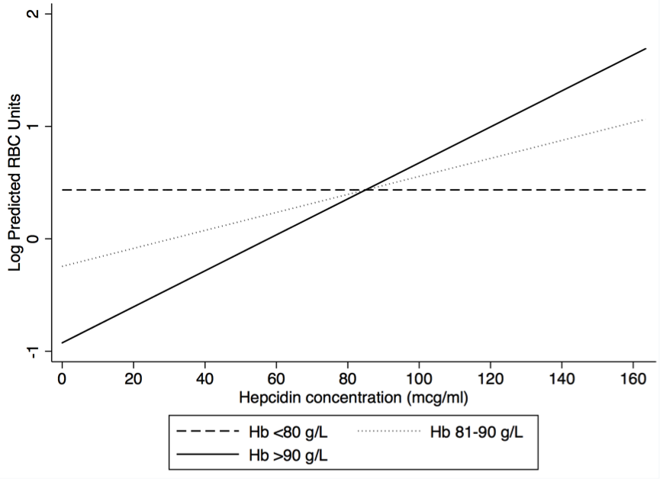

Hb Haemoglobin, RBC red blood cell

