ADDITIONAL FILE 6. Funnel plots for asymmetry.
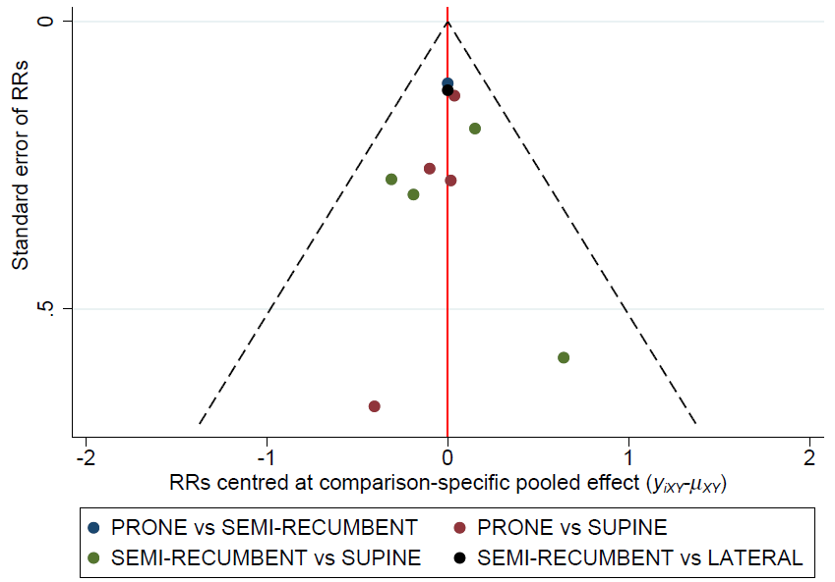
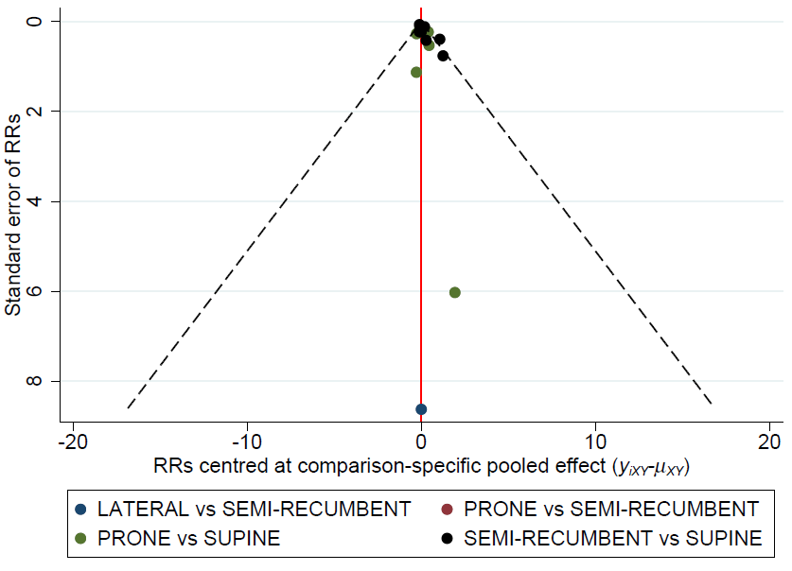
MORTALITY
VAP

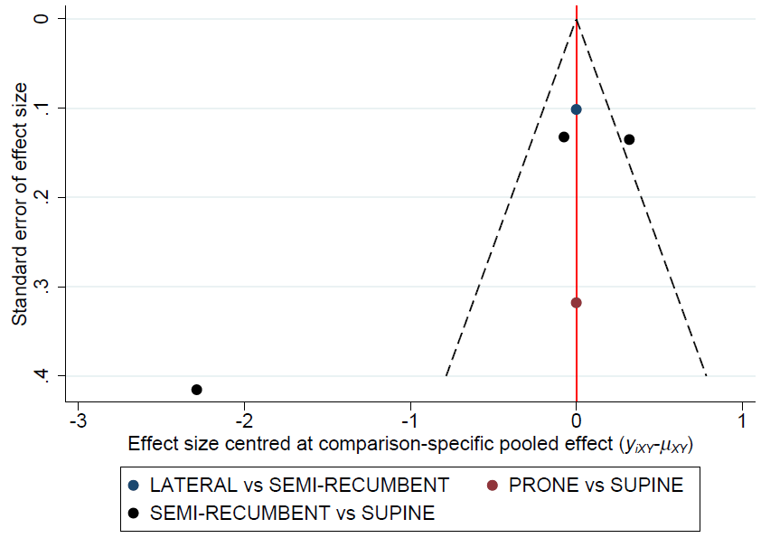
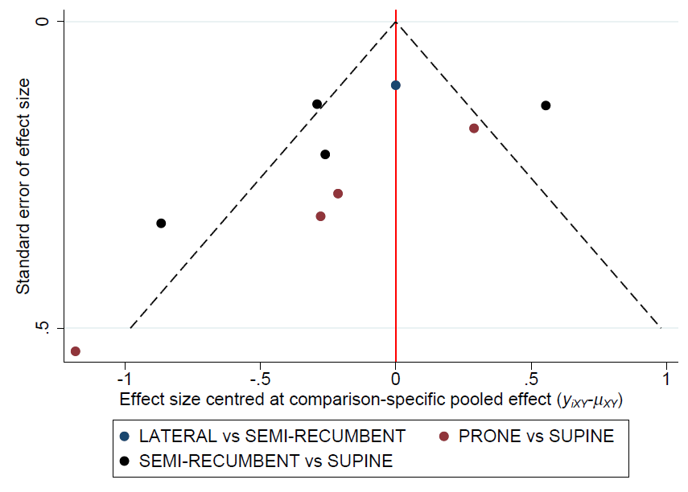
HOSPITAL LENGTH OF STAY
ICU LENGTH OF STAY

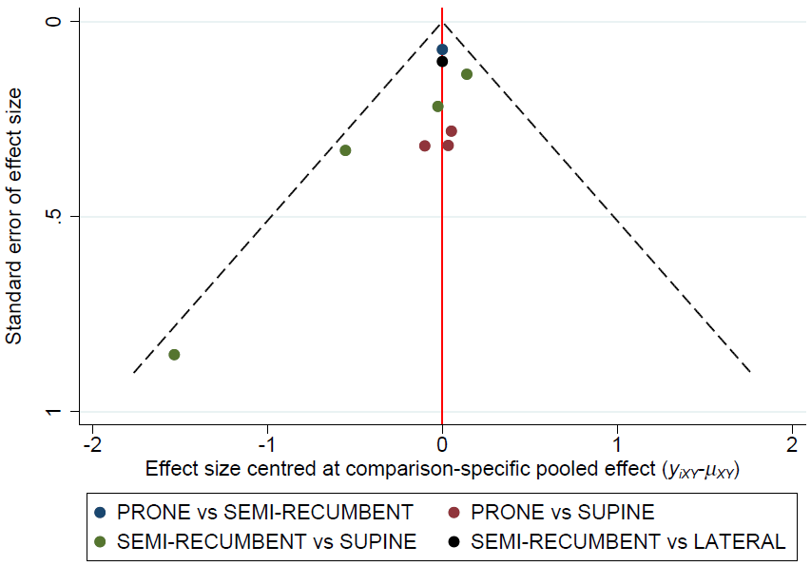
DURATION OF MECHANICAL VENTILATION

