Fig S1: Subgroup analyses for hospital/long-term mortality, and incidence of pneumonia, as well as length of hospital stay, and mechanical ventilation days according to characteristic levels of the study patients regardless of the kinds of FI definitions
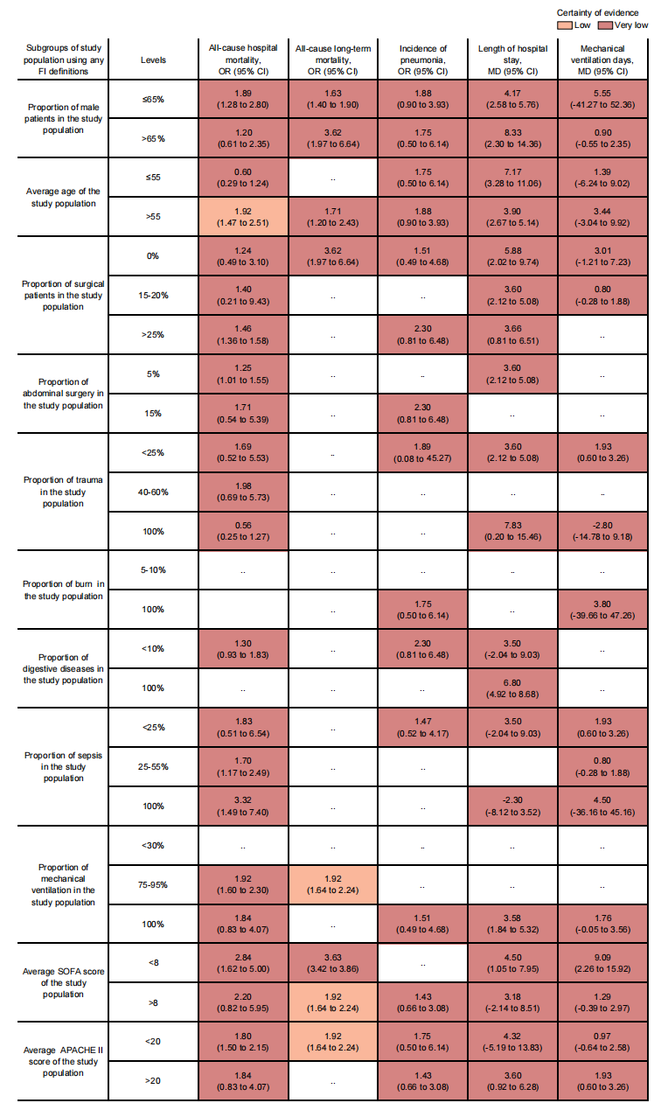
The certainty of the evidence was rated by the Grading of Recommendations Assessment, Development, and Evaluation criteria. FI=feeding intolerance, SOFA=Sequential Organ Failure Assessment, APACHE II=Acute Physiology, and Chronic Health Evaluation II, OR=odds ratio, MD=mean difference, CI=confidence interval.

