Supplementary Fig. 2 Patient flow diagram.

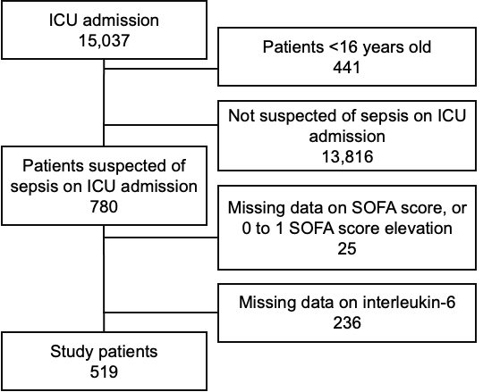

ICU, intensive care unit; SOFA, Sequential Organ Failure Assessment.

