Additional file 2
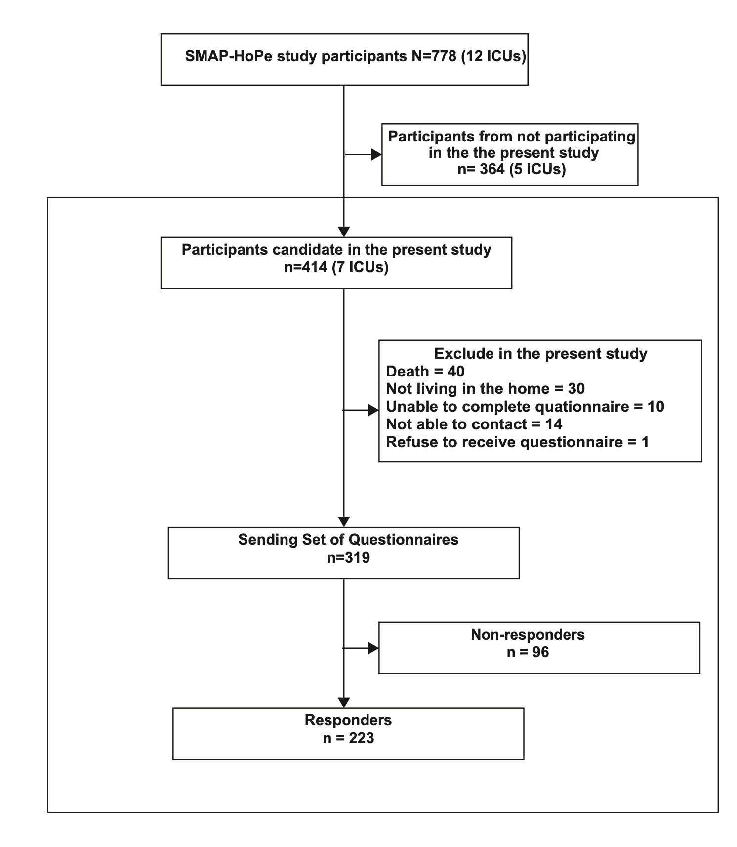
Participants’ recruitment flow chart

ICU, intensive care unit.

