Additional file 6
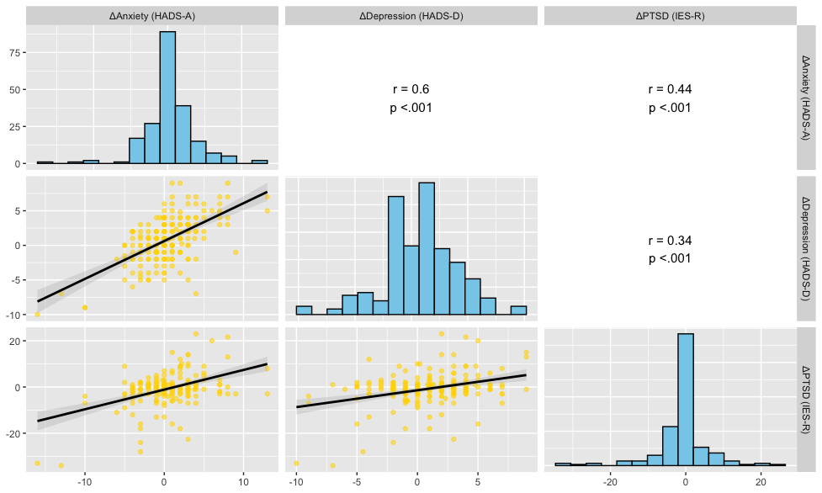
Correlation analysis of changes in mental health symptoms between 1 and 4 years after ICU discharge. The figure shows pairwise correlations between change scores (4-year minus 1-year scores) for anxiety (HADS-A), depression (HADS-D), and PTSD (IES-R) symptoms. The upper triangle displays correlation coefficients and p-values, while the lower triangle shows scatter plots with regression lines and 95% confidence intervals. Histograms along the diagonal represent the distribution of change scores for each symptom domain.

HADS-A, Hospital Anxiety and Depression Scale - Anxiety subscale; HADS-D, Hospital Anxiety and Depression Scale - Depression subscale; IES-R, Impact of Event Scale-Revised; ICU, intensive care unit.

