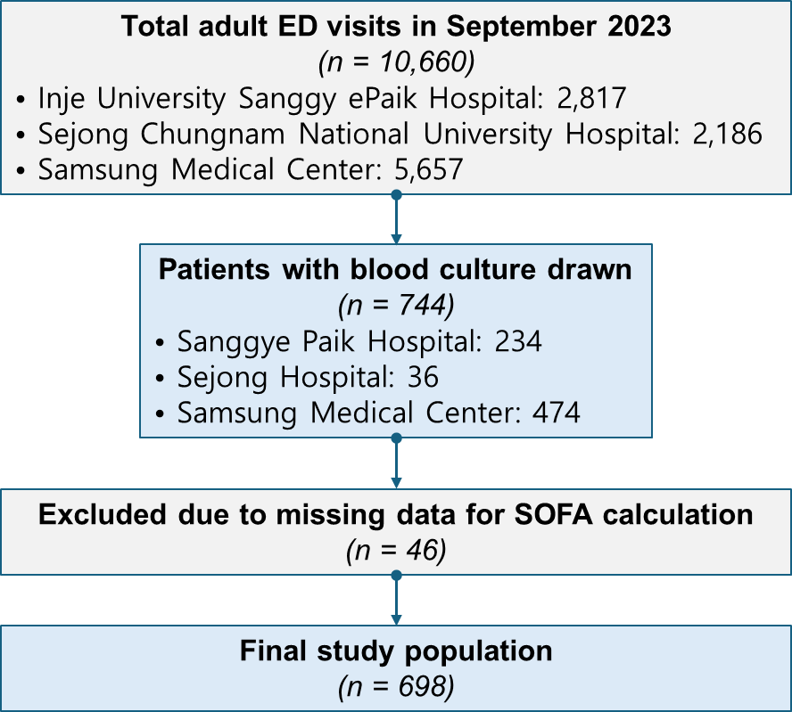

Supplementary figure 1. Flow diagram of the study population.
Among 10,660 adult patients who visited the emergency departments (EDs) of three participating hospitals in September 2023, 744 underwent blood culture testing based on clinical suspicion of infection. After excluding 46 patients with missing data required for SOFA calculation, 698 patients were included in the final analysis.
Abbreviations: ED, emergency department; SOFA, Sequential Organ Failure Assessment.
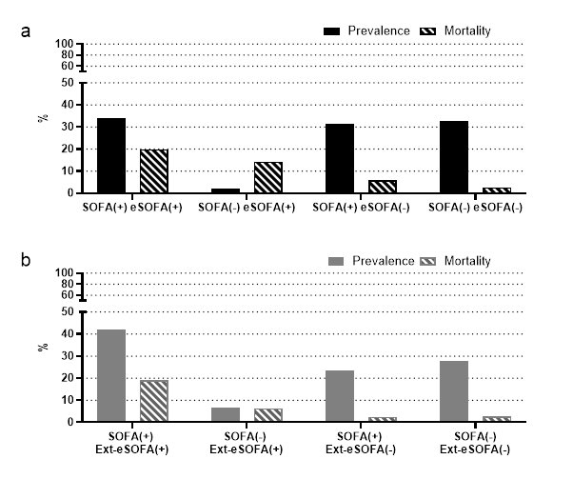
Supplementary Figure 2. Prevalence and in-hospital mortality by SOFA, eSOFA, and extended eSOFA criteria
(a) Distribution of prevalence and in-hospital mortality among patient subgroups defined by SOFA and eSOFA
(b) Distribution of prevalence and in-hospital mortality among patient subgroups defined by SOFA and extended eSOFA (Ext-eSOFA)
Abbreviations: SOFA, Sequential Organ Failure Assessment; eSOFA, electronic Sequential Organ Failure Assessment; Ext-eSOFA, extended eSOFA including isolated lactate elevation

