Supplementary Table 1. Baseline characteristics and EIT parameters of all patients
Variables | PSV-SBT success  N=60 |  | PSV-SBT failure  N=7 | P
Age, y |  | 58±13 | 71±7 | 0.006
Sex, M (%) |  | 33 (55.0) | 3 (42.9) | 0.31
BMI, Kg/m² |  | 24.1±3.2 | 24.8±3.1 | 0.53
APACHE II Score |  | 12±4 | 16±2 | 0.011
Chronic respiratory disease, n(%) |  | 11 (18.3) | 2 (28.6) | 0.17
Pre-operative EF value |  | 63 [55,67] | 64 [55,66] | 0.33
Type of sugery
CABG, n(%) |  | 19 (31.7) | 3 (42.9) | 0.34
Valve surgery, n(%) |  | 20 (33.3) | 2 (28.6) | 0.58
Others, n(%) |  | 21 (35.0) | 2 (28.6) | 0.26
Sugery process
CPB time |  | 133±38 | 155±30 | 0.12
AOC time |  | 89±33 | 117±12 | 0.003
P/F, mmHg |  | 339 [272, 416] | 321 [253, 406] | 0.58
HR, bpm |  | 90 [84, 96] | 87 [80,92] | 0.37
MAP, mmHg |  | 88 [79, 95] | 82 [72, 94] | 0.39
RR, min⁻¹ |  | 15 [12, 18] | 18 [15, 20] | 0.12
SpO₂, % |  | 99 [98, 100] | 98 [97, 100] | 0.21
NE dose, ug/kg/min |  | 0.01 [0.00, 0.12] | 0.08 [0.00, 0.17] | 0.46
ROI 1+2 (%) |  | 44 [53, 58] | 56 [53, 60] | 0.39
ROI 3+4 (%) |  | 45 [42, 47] | 44 [40, 47] | 0.39
CoV |  | 49.3 [47.6, 51.1] | 48.2 [46.7, 49.8] | 0.14
GI |  | 0.34 [0.32, 0.36] | 0.34 [0.33, 0.37] | 0.51
Pendelluft (%) |  | 11 (18.3) | 1 (14.3) | 0.15
Extubation within 24h, n(%) |  | 38 (63.3) | 0 (0.0) | <0.001
IMV days in total* |  | 5 [4, 6] | 7 [6, 9] | 0.018
VFDs at day 28 |  | 23 [22, 24] | 21 [19, 22] | 0.013
ICU stay, days |  | 7 [6, 8] | 10 [8, 12] | 0.008
Reintubation more than 24h, n(%) |  | 0 (0.0) | 0 (0.0) | /
BMI, body mass index; APACHE, acute physiology and chronic health evaluation; EF, ejection fraction; CABG, coronary artery bypass grafting; CPB, cardiopulmonary bypass; AOC, aortic Cross-Clamping; P/F, arterial partial pressure of oxygen to inspired fraction of oxygen ratio; HR, heart rate; MAP, mean arterial pressure; RR, respiratory rate; NE, Norepinephrine; SpO₂, peripheral oxygen saturation; PSV, pressure support ventilation; SBT, spontaneous breathing trial; EIT, Electrical impedance tomography; GI, global inhomogeneity; COV, center of ventilation; ROI, regions of interest; RVD, regional ventilation delay; IMV, invasive mechanical ventilation; VFD, ventilator-free day; ICU, intensive care unit; *represents the period from the admission in ICU with mechanical ventilation to completely discontinuing mechanical ventilation, including the duration of reinitiating mechanical ventilation after SBT failure. Boldface indicates signiﬁcant P values.

Supplementary Table 2. Multivariate logistic regression analysis for T-piece SBT failure.
Variables | B | S.E. | Wald | OR [95% CI] | P
T-volume loss | 2.287 | 0.834 | 7.519 | 9.847 [1.920, 50.494] | 0.006
Age | 0.035 | 0.031 | 1.277 | 1.035 [0.975, 1.099] | 0.26
APACHE II | 0.227 | 0.118 | 3.673 | 1.255 [0.995, 1.583] | 0.06
CPB time | 0.033 | 0.020 | 2.674 | 1.034 [0.993, 1.076] | 0.10
AOC time | -0.026 | 0.023 | 1.273 | 0.975 [0.933, 1.019] | 0.26
SBT, spontaneous breathing trial; APACHE, acute physiology and chronic health evaluation; CPB, cardiopulmonary bypass; AOC, aortic Cross-Clamping; OR, odds ratio; S.E. standard error; CI, Confidence Interval.

Supplementary Table 3. Multivariate logistic regression analysis for T-volume loss.
Variables | B | S.E. | Wald | OR [95% CI] | P
Dorsal ventilation | -0.216 | 0.082 | 6.979 | 0.805 [0.686, 0.946] | 0.008
Age | 0.056 | 0.033 | 2.924 | 1.058 [0.992, 1.128] | 0.09
APACHE II | -0.065 | 0.092 | 0.510 | 0.937 [0.783, 1.121] | 0.48
CPB time | 0.006 | 0.013 | 0.262 | 1.006 [0.982, 1.032] | 0.61
AOC time | 0.004 | 0.013 | 0.105 | 1.004 [0.979, 1.030] | 0.75
APACHE, acute physiology and chronic health evaluation; CPB, cardiopulmonary bypass; AOC, aortic Cross-Clamping; OR, odds ratio; S.E. standard error; CI, Confidence Interval.

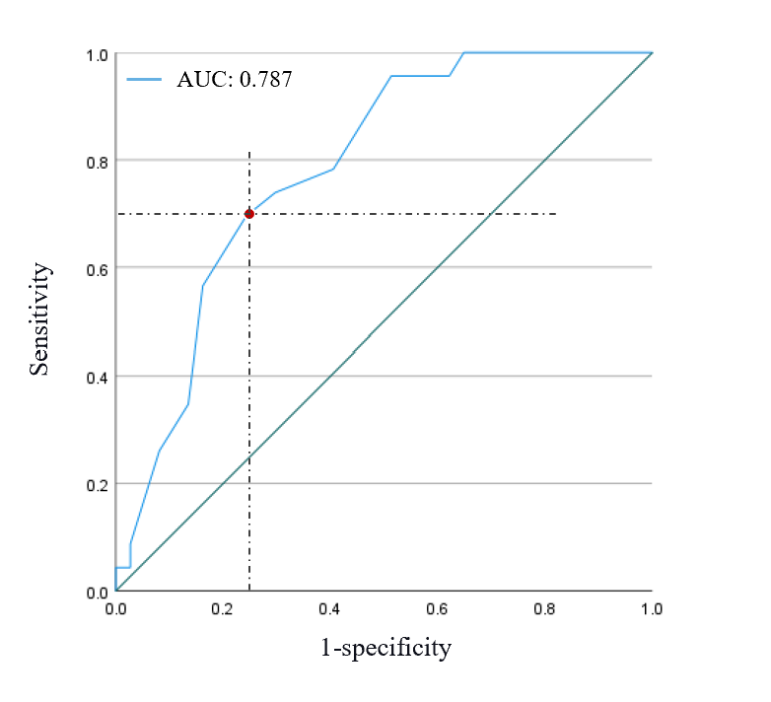
Supplementary Figure 1. ROC curve of baseline dorsal ventilation associated with T-volume loss.
ROC, receiver operating characteristic.

