Supplementary table 1. Baseline characteristics after propensity score matching
 | Total (n=898) | Laxative (n=449) | Non-laxative (n=449) | P-value
Female, n (%) | 286 (31.8) | 140 (31.2) | 146 (32.5) | 0.720
Age, year, median (IQR) | 65 (53-76) | 65 (52-75) | 65 (54-77) | 0.206
BMI, kg/m², | 29 (26-31) | 30 (25-32) | 29 (26-31) | 0.665
Smoke, n (%) | 222 (24.7) | 115 (25.6) | 107 (23.8) | 0.588
Race |  |  |  | 0.739
White, n (%) | 575 (64.0) | 293 (65.3) | 282 (62.8)
Black, n (%) | 84 (9.4) | 40 (8.9) | 44 (9.8)
Other, n (%) | 239 (26.6) | 116 (25.8) | 123 (27.4)
Comorbidities
Heart failure, n (%) | 439 (48.9) | 220 (49.0) | 219 (48.8) | 1.000
Myocardial infarction, n (%) | 305 (34.0) | 150 (33.4) | 155 (34.5) | 0.778
Stroke*, n (%) | 110 (12.2) | 59 (13.1) | 51 (11.4) | 0.476
Diabetes mellitus, n (%) | 323 (36.0) | 168 (37.4) | 155 (34.5) | 0.404
Renal dysfunction, n (%) | 258 (28.7) | 130 (29.0) | 128 (28.5) | 0.941
Charlson Comorbidity Index, median (IQR) | 5 (3-8) | 5 (3-7) | 5 (3-8) | 0.819
OHCA, n (%) | 710 (79.1) | 356 (79.3) | 354 (78.8) | 0.935
Bystander CPR, n (%) | 118 (13.1) | 58 (12.9) | 60 (13.4) | 0.921
Initial rhythm shockable, n (%) | 357 (39.8) | 185 (41.2) | 172 (38.3) | 0.413
ECPR, n (%) | 3 (0.3) | 1 (0.2) | 2 (0.4) | 1.000
Heart rate, bpm, median (IQR) | 85 (73-97) | 84 (74-98) | 85 (72-97) | 0.672
MAP, mmHg, median (IQR) | 80 (74-87) | 80 (74-86) | 80 (74-87) | 0.440
Lactate, mmol/L, median (IQR) | 3.7 (2.4-5.2) | 3.7 (2.3-5.3) | 3.7 (2.4-5.2) | 0.780
pH, median (IQR) | 7.28 (7.23-7.32) | 7.28 (7.23-7.32) | 7.28 (7.22-7.33) | 0.924
Hypothermia, n (%) | 129 (14.4) | 62 (13.8) | 67 (14.9) | 0.704
Invasive ventilator, n (%) | 570 (63.5) | 281 (62.6) | 289 (64.4) | 0.628
Coronary arteriography or percutaneous coronary intervention, n (%) | 51 (5.7) | 28 (6.2) | 23 (5.1) | 0.565
CRRT, n (%) | 101 (11.2) | 51 (11.4) | 50 (11.1) | 1.000
MCS#, n (%) | 53 (5.9) | 26 (5.8) | 27 (6.0) | 1.000
Early enteral nutrition$, n (%) | 227 (25.3) | 118 (26.3) | 109 (24.3) | 0.539
Medications
Epinephrine, n (%) | 108 (12.0) | 54 (12.0) | 54 (12.0) | 1.000
Norepinephrine, n (%) | 409 (45.5) | 207 (46.1) | 202 (45.0) | 0.789
Dopamine, n (%) | 88 (9.8) | 43 (9.6) | 45 (10.0) | 0.911
Dobutamine, n (%) | 146 (16.3) | 71 (15.8) | 75 (16.7) | 0.786
Milrinone, n (%) | 25 (2.8) | 14 (3.1) | 11 (2.4) | 0.686
Muscle relaxants, n (%) | 121 (13.5) | 60 (13.4) | 61 (13.6) | 1.000
Vasoactive inotropic score, median (IQR) | 4 (0-12) | 3 (0-12) | 4 (0-13) | 0.412
SOFA score, median (IQR) | 7 (3-10) | 7 (3-9) | 7 (4-10) | 0.578
SAPSII score, median (IQR) | 42 (32-53) | 40 (31-52) | 43 (33-54) | 0.089
APSIII score, median (IQR) | 52 (37-70) | 52 (36-71) | 54 (38-69) | 0.831
OASIS score, median (IQR) | 35 (30-42) | 35 (29-42) | 35 (30-42) | 0.641
APS-III: acute physiology score III; BMI: body mass index; CPR: cardiopulmonary resuscitation; CRRT: continuous renal replacement therapy; ECPR: extracorporeal cardiopulmonary resuscitation; IQR: interquartile range; MAP: mean arterial pressure; MCS: mechanical circulation support; SAPS-II: simplified acute physiology score Ⅱ; SOFA: sequential organ failure assessment; OASIS: Oxford acute severity of illness score; OHCA: out-of-hospital cardiac arrest.
*stroke includes ischemic and hemorrhagic stroke.
#MCS includes intra-aortic ballon pump, TandemHeart, Impella and extracorporeal membrane oxygenation.
$early enteral nutrition means patients receiving enteral nutrition within 48 hours after return of spontaneous circulation.

Supplementary figure 1. Kaplan-Meier curve 90-day survival
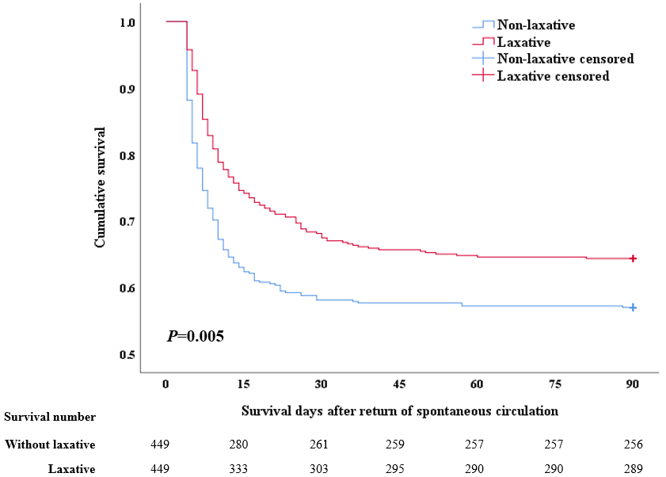

Supplementary figure 2. Kaplan-Meier curve for 180-day survival
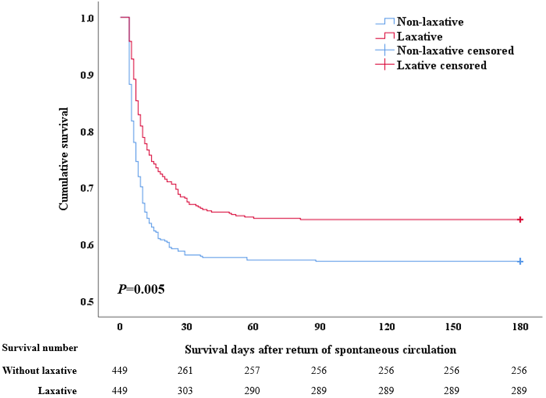

Supplementary table 2. Baseline characteristics for different laxatives
 | Senna  (n=197) | Lactulose  (n=81) | Polyethylene Glycol  (n=358) | Docusate Sodium  (n=807) | P-value
Female, n (%) | 76 (38.6) | 27 (33.3) | 130 (36.3) | 291 (36.1) | 0.856
Age, year, median (IQR) | 67 (54-75) | 60 (52-70) | 68 (58-78) | 68 (56-79) | <0.001
BMI, kg/m², | 30 (26-32) | 30 (28-33) | 29 (26-32) | 30 (26-31) | 0.028
Smoke, n (%) | 49 (24.9) | 24 (29.6) | 88 (24.6) | 191 (23.7) | 0.690
Race |  |  |  |  | <0.001
White, n (%) | 106 (53.8) | 57 (70.4) | 174 (48.6) | 525 (65.1)
Black, n (%) | 26 (13.2) | 3 (3.7) | 62 (17.3) | 68 (8.4)
Other, n (%) | 65 (33.0) | 21 (25.9) | 122 (34.1) | 214 (26.5)
Comorbidities
Heart failure, n (%) | 89 (45.2) | 35 (43.2) | 179 (50) | 366 (45.4) | 0.445
Myocardial infarction, n (%) | 77 (39.1) | 23 (28.4) | 133 (37.2) | 289 (35.8) | 0.385
Stroke*, n (%) | 35 (17.8) | 14 (17.3) | 54 (15.1) | 111 (13.8) | 0.477
Diabetes mellitus, n (%) | 68 (34.5) | 28 (34.6) | 116 (32.4) | 295 (36.6) | 0.587
Renal dysfunction, n (%) | 52 (26.4) | 23 (28.4) | 105 (29.3) | 229 (27.6) | 0.891
Charlson Comorbidity Index, median (IQR) | 5 (3-8) | 6 (3-8) | 5 (4-7) | 5 (3-7) | 0.415
OHCA, n (%) | 141 (71.6) | 66 (81.5) | 257 (71.8) | 671 (83.1) | <0.001
Bystander CPR, n (%) | 11 (5.6) | 20 (24.7) | 10 (2.8) | 171 (21.2) | <0.001
Initial rhythm shockable, n (%) | 88 (44.7) | 24 (29.6) | 151 (42.2) | 305 (37.8) | 0.056
ECPR, n (%) | 8 (4.1) | 2 (2.5) | 8 (2.2) | 18 (2.2) | 0.509
Heart rate, bpm, median (IQR) | 84 (73-99) | 93 (83-105) | 82 (73-94) | 81 (72-93) | <0.001
MAP, mmHg, median (IQR) | 80 (74-87) | 75 (70-83) | 79 (74-88) | 79 (73-87) | 0.001
Lactate, mmol/L, median (IQR) | 3.9 (2.6-4.9) | 4.6 (2.8-6.1) | 3.7 (2.5-4.9) | 3.7 (2.1-4.8) | 0.002
pH, median (IQR) | 7.27 (7.24-7.30) | 7.27 (7.21-7.36) | 7.28 (7.25-7.32) | 7.28 (7.23-7.33) | 0.150
Hypothermia, n (%) | 19 (9.6) | 12 (14.8) | 41 (11.5) | 95 (11.8) | 0.663
Invasive ventilator, n (%) | 125 (63.5) | 46 (56.8) | 203 (56.7) | 467 (57.9) | 0.447
Coronary arteriography or percutaneous coronary intervention, n (%) | 3 (1.5) | 2 (2.5) | 4 (1.1) | 84 (10.4) | <0.001
CRRT, n (%) | 25 (12.7) | 12 (14.8) | 34 (9.5) | 78 (9.7) | 0.308
MCS#, n (%) | 19 (9.6) | 3 (3.7) | 19 (5.3) | 80 (9.9) | 0.022
Early enteral nutrition$, n (%) | 37 (18.8) | 43 (53.1) | 98 (27.4) | 253 (31.4) | <0.001
Medications
Epinephrine, n (%) | 19 (9.6) | 24 (29.6) | 43 (12.0) | 126 (15.6) | <0.001
Norepinephrine, n (%) | 62 (31.5) | 54 (66.7) | 133 (37.2) | 339 (42.0) | <0.001
Dopamine, n (%) | 8 (4.1) | 7 (8.6) | 10 (2.8) | 127 (15.7) | <0.001
Dobutamine, n (%) | 40 (20.3) | 12 (14.8) | 65 (18.2) | 144 (17.8) | 0.736
Milrinone, n (%) | 2 (1.0) | 8 (9.9) | 11 (3.1) | 56 (6.9) | <0.001
Muscle relaxants, n (%) | 9 (4.6) | 6 (7.4) | 20 (5.6) | 120 (14.9) | <0.001
Vasoactive inotropic score, median (IQR) | 0 (0-8) | 10 (0-21) | 0 (0-10) | 4 (0-13) | <0.001
SOFA score, median (IQR) | 7 (4-9) | 10 (8-14) | 6 (4-10) | 6 (2-9) | <0.001
SAPSII score, median (IQR) | 43 (32-52) | 46 (37-59) | 41 (32-53) | 39 (29-50) | <0.001
APSIII score, median (IQR) | 53 (34-72) | 73 (50-91) | 48 (37-63) | 47 (32-65) | <0.001
OASIS score, median (IQR) | 35 (29-42) | 37 (30-45) | 34 (27-41) | 34 (27-40) | 0.007
APS-III: acute physiology score III; BMI: body mass index; CPR: cardiopulmonary resuscitation; CRRT: continuous renal replacement therapy; ECPR: extracorporeal cardiopulmonary resuscitation; IQR: interquartile range; MAP: mean arterial pressure; MCS: mechanical circulation support; SAPS-II: simplified acute physiology score Ⅱ; SOFA: sequential organ failure assessment; OASIS: Oxford acute severity of illness score; OHCA: out-of-hospital cardiac arrest.
*stroke includes ischemic and hemorrhagic stroke.
#MCS includes intra-aortic ballon pump, TandemHeart, Impella and extracorporeal membrane oxygenation.
$early enteral nutrition means patients receiving enteral nutrition within 48 hours after return of spontaneous circulation.

Supplementary figure 3. Different laxatives Kaplan-Meier curve for 30-day survival
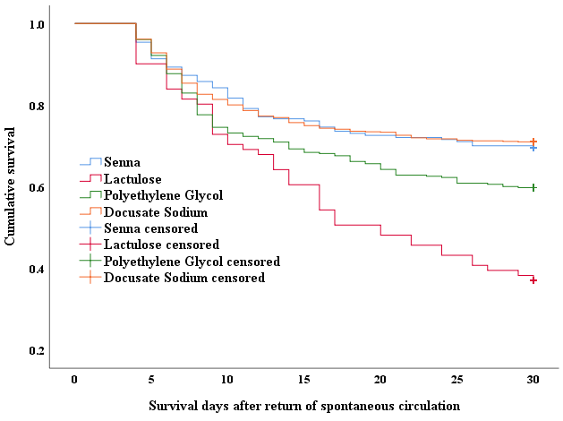
P<0.001

Supplementary figure 4. Different laxatives Kaplan-Meier curve for 90-day survival
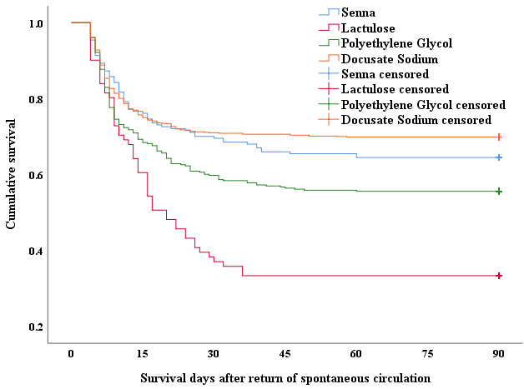
P<0.001
Supplementary figure 5. Different laxatives Kaplan-Meier curve for 180-day survival
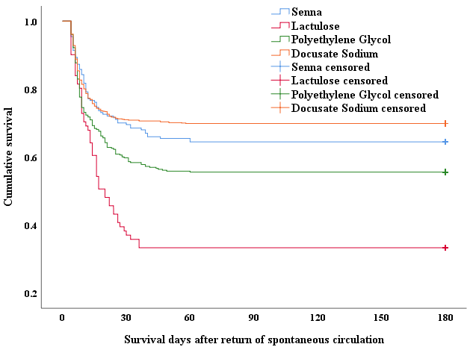
P<0.001

Supplementary table 3. Results of mortality risk analysis for different laxatives
 | Hazard Ratio | 95% CI | P-value
30-day mortality risk
Univariate analysis
Senna | Ref. | Ref. | Ref.
Lactulose | 2.348 | 1.616-3.412 | <0.001
Polyethylene Glycol | 1.395 | 1.032-1.885 | <0.001
Docusate Sodium | 0.956 | 0.720-1.270 | 0.758
Model 1
Senna | Ref. | Ref. | Ref.
Lactulose | 2.270 | 1.550-3.323 | <0.001
Polyethylene Glycol | 1.356 | 1.001-1.839 | 0.049
Docusate Sodium | 0.871 | 0.651-1.166 | 0.353
Model 2
Senna | Ref. | Ref. | Ref.
Lactulose | 1.637 | 1.098-2.441 | 0.016
Polyethylene Glycol | 1.406 | 1.037-1.908 | 0.028
Docusate Sodium | 0.892 | 0.664-1.200 | 0.451
Model 3
Senna | Ref. | Ref. | Ref.
Lactulose | 1.575 | 1.044-2.376 | 0.030
Polyethylene Glycol | 1.396 | 1.027-1.898 | 0.033
Docusate Sodium | 0.836 | 0.618-1.131 | 0.246
90-day mortality risk
Univariate analysis
Senna | Ref. | Ref. | Ref.
Lactulose | 2.199 | 1.542-3.138 | <0.001
Polyethylene Glycol | 1.330 | 1.004-1.761 | 0.047
Docusate Sodium | 0.848 | 0.650-1.106 | 0.224
Model 1
Senna | Ref. | Ref. | Ref.
Lactulose | 2.165 | 1.506-3.112 | <0.001
Polyethylene Glycol | 1.286 | 0.968-1.708 | 0.083
Docusate Sodium | 0.775 | 0.590-1.019 | 0.068
Model 2
Senna | Ref. | Ref. | Ref.
Lactulose | 1.502 | 1.062-2.199 | 0.037
Polyethylene Glycol | 1.333 | 1.002-1.772 | 0.048
Docusate Sodium | 0.798 | 0.603-1.054 | 0.112
Model 3
Senna | Ref. | Ref. | Ref.
Lactulose | 1.467 | 0.991-2.172 | 0.056
Polyethylene Glycol | 1.322 | 0.992-1.762 | 0.057
Docusate Sodium | 0.753 | 0.566-1.000 | 0.050
Continued supplementary table 3.
 | Hazard Ratio | 95% CI | P-value
180-day mortality risk
Univariate analysis
Senna | Ref. | Ref. | Ref.
Lactulose | 2.199 | 1.542-3.138 | <0.001
Polyethylene Glycol | 1.330 | 1.004-1.761 | 0.047
Docusate Sodium | 0.848 | 0.650-1.106 | 0.224
Model 1
Senna | Ref. | Ref. | Ref.
Lactulose | 2.165 | 1.506-3.112 | <0.001
Polyethylene Glycol | 1.286 | 0.968-1.708 | 0.083
Docusate Sodium | 0.775 | 0.590-1.019 | 0.068
Model 2
Senna | Ref. | Ref. | Ref.
Lactulose | 1.502 | 1.026-2.199 | 0.037
Polyethylene Glycol | 1.333 | 1.002-1.772 | 0.048
Docusate Sodium | 0.798 | 0.603-1.054 | 0.112
Model 3
Senna | Ref. | Ref. | Ref.
Lactulose | 1.467 | 0.991-2.172 | 0.056
Polyethylene Glycol | 1.322 | 0.992-1.762 | 0.057
Docusate Sodium | 0.753 | 0.566-1.000 | 0.050
Model 1 adjusts prehospital variables which include gender, age, BMI, smoke, race, comorbidities, Charlson Comorbidity Index, OHCA, lay securer CPR and initial rhythm shockable.
Model 2 adjusts hospitalization variables which include ECPR, vital signs, hypothermia, invasive ventilator, CAG/PCI, CRRT, MCS, early enteral nutrition, medications, vasoactive inotropic score and risk scoring.
Model 3 adjusts both prehospital and hospitalization variables.

Supplementary table 4. Model 3 adjusted analysis results of secondary and safety endpoints for different laxatives
 | Odds ratio | 95% CI | P-value
CPC 3-5 at discharge
Senna | Ref. | Ref. | Ref.
Lactulose | 2.361 | 1.148-4.859 | 0.020
Polyethylene Glycol | 1.384 | 0.882-2.172 | 0.158
Docusate Sodium | 0.534 | 0.344-0.829 | 0.005
Sepsis
Senna | Ref. | Ref. | Ref.
Lactulose | 0.819 | 0.414-1.617 | 0.565
Polyethylene Glycol | 1.179 | 0.737-1.888 | 0.492
Docusate Sodium | 0.350 | 0.216-0.566 | <0.001
Unrecovered bowel sounds
Senna | Ref. | Ref. | Ref.
Lactulose | 14.165 | 1.496-134.132 | 0.021
Polyethylene Glycol | 0.833 | 0.069-10.111 | 0.886
Docusate Sodium | 3.232 | 0.394-26.600 | 0.275
ICU-free day (day)*
Senna | Ref. | Ref. | Ref.
Lactulose | -3.290# | -2.331- -0.589 | 0.001
Polyethylene Glycol | -0.437# | -2.850-1.824 | 0.667
Docusate Sodium | 2.450# | 1.544-4.910 | 0.014
*ICU-free day waw analyzed by using linear regression.
#adjusted mean difference

Supplementary table 5. Results of sensitive analysis for different laxatives
Subgroup | Mortality/total number | Hazard ratio | 95% CI | P-value
Age, year
≥60
Senna | 59/129 | Ref. | Ref. | Ref.
Lactulose | 28/41 | 1.457 | 0.869-2.442 | 0.153
Polyethylene Glycol | 108/257 | 1.134 | 0.804-1.600 | 0.473
Docusate Sodium | 179/565 | 0.687 | 0.490-0.964 | 0.030
<60
Senna | 10/68 | Ref. | Ref. | Ref.
Lactulose | 23/40 | 2.156 | 0.937-4.959 | 0.071
Polyethylene Glycol | 36/101 | 2.610 | 1.209-5.638 | 0.015
Docusate Sodium | 55/242 | 1.209 | 0.540-2.704 | 0.644
Gender
Male
Senna | 40/121 | Ref. | Ref. | Ref.
Continued supplementary table 5.
Subgroup | Mortality/total number | Hazard ratio | 95% CI | P-value
Lactulose | 30/54 | 1.281 | 0.756-2.169 | 0.357
Polyethylene Glycol | 92/228 | 1.225 | 0.835-1.796 | 0.300
Docusate Sodium | 134/516 | 0.673 | 0.459-0.989 | 0.044
Female
Senna | 20/76 | Ref. | Ref. | Ref.
Lactulose | 21/27 | 1.772 | 0.852-3.687 | 0.126
Polyethylene Glycol | 52/103 | 1.502 | 0.862-2.615 | 0.151
Docusate Sodium | 100/219 | 1.055 | 0.622-1.789 | 0.151
OHCA
Yes
Senna | 41/141 | Ref. | Ref. | Ref.
Lactulose | 43/66 | 1.510 | 0.941-2.425 | 0.088
Polyethylene Glycol | 101/257 | 1.424 | 0.983-2.065 | 0.062
Docusate Sodium | 199/671 | 0.887 | 0.622-1.264 | 0.506
No
Senna | 19/56 | Ref. | Ref. | Ref.
Lactulose | 8/15 | 1.281 | 0.475-3.456 | 0.624
Polyethylene Glycol | 43/101 | 1.121 | 0.609-2.063 | 0.714
Docusate Sodium | 35/136 | 0.558 | 0.283-1.101 | 0.093
Initial shockable rhythm
Yes
Senna | 20/88 | Ref. | Ref. | Ref.
Lactulose | 12/24 | 1.190 | 0.503-2.816 | 0.692
Polyethylene Glycol | 41/151 | 1.301 | 0.724-2.336 | 0.379
Docusate Sodium | 57/305 | 0.707 | 0.389-1.285 | 0.255
No
Senna | 40/109 | Ref. | Ref. | Ref.
Lactulose | 39/57 | 1.668 | 1.031-2.765 | 0.037
Polyethylene Glycol | 103/207 | 1.456 | 1.000-2.119 | 0.050
Docusate Sodium | 117/502 | 0.925 | 0.640-1.336 | 0.677
Lay rescuer CPR
Yes
Senna | 2/11 | Ref. | Ref. | Ref.
Lactulose | 16/20 | 3.707 | 0.707-19.420 | 0.121
Polyethylene Glycol | 4/10 | 1.434 | 0.203-10.116 | 0.718
Docusate Sodium | 72/171 | 1.749 | 0.367-8.337 | 0.483
No
Senna | 58/168 | Ref. | Ref. | Ref.
Lactulose | 35/61 | 1.369 | 0.860-2.179 | 0.186
Polyethylene Glycol | 140/348 | 1.303 | 0.951-1.784 | 0.099
Docusate Sodium | 162/636 | 0.722 | 0.523-0.996 | 0.047
Continued supplementary table 5.
Subgroup | Mortality/total number | Hazard ratio | 95% CI | P-value
Hypothermia
Yes
Senna | 8/19 | Ref. | Ref. | Ref.
Lactulose | 6/12 | 0.763 | 0.193-3.016 | 0.699
Polyethylene Glycol | 23/41 | 1.134 | 0.467-2.753 | 0.782
Docusate Sodium | 40/95 | 0.896 | 0.337-2.381 | 0.825
No
Senna | 52/178 | Ref. | Ref. | Ref.
Lactulose | 45/69 | 1.566 | 0.996-2.462 | 0.052
Polyethylene Glycol | 121/317 | 1.358 | 0.973-1.896 | 0.072
Docusate Sodium | 194/712 | 0.809 | 0.583-1.123 | 0.206
MCS
Yes
Senna | 6/19 | Ref. | Ref. | Ref.
Lactulose | 0/3 | - | - | 0.970
Polyethylene Glycol | 9/19 | 0.942 | 0.193-4.601 | 0.941
Docusate Sodium | 32/80 | 0.318 | 0.067-1.501 | 0.148
No
Senna | 54/178 | Ref. | Ref. | Ref.
Lactulose | 51/78 | 1.705 | 1.120-2.594 | 0.013
Polyethylene Glycol | 135/339 | 1.367 | 0.991-1.886 | 0.057
Docusate Sodium | 202/727 | 0.847 | 0.667-1.164 | 0.306
Early enteral nutrition
Yes
Senna | 16/37 | Ref. | Ref. | Ref.
Lactulose | 22/43 | 1.087 | 0.536-2.202 | 0.817
Polyethylene Glycol | 52/98 | 1.673 | 0.914-3.061 | 0.095
Docusate Sodium | 187/431 | 0.991 | 0.556-1.765 | 0.975
No
Senna | 44/160 | Ref. | Ref. | Ref.
Lactulose | 29/38 | 1.676 | 0.952-2.950 | 0.074
Polyethylene Glycol | 92/260 | 1.149 | 0.793-1.664 | 0.463
Docusate Sodium | 137/554 | 0.693 | 0.477-1.005 | 0.053
Invasive ventilator
Yes
Senna | 36/125 | Ref. | Ref. | Ref.
Lactulose | 24/46 | 1.718 | 0.971-3.037 | 0.063
Polyethylene Glycol | 88/203 | 1.568 | 1.053-2.335 | 0.027
Docusate Sodium | 164/467 | 1.098 | 0.741-1.628 | 0.641
No
Senna | 24/72 | Ref. | Ref. | Ref.
Continued supplementary table 5.
Subgroup | Mortality/total number | Hazard ratio | 95% CI | P-value
Lactulose | 27/35 | 1.525 | 0.795-2.927 | 0.205
Polyethylene Glycol | 56/155 | 1.024 | 0.612-1.713 | 0.928
Docusate Sodium | 70/340 | 0.545 | 0.325-0.915 | 0.022
SOFA
≥7
Senna | 34/100 | Ref. | Ref. | Ref.
Lactulose | 45/67 | 1.857 | 1.133-3.042 | 0.014
Polyethylene Glycol | 88/179 | 1.591 | 1.054-2.401 | 0.027
Docusate Sodium | 141/357 | 1.048 | 0.695-1.579 | 0.824
<7
Senna | 26/97 | Ref. | Ref. | Ref.
Lactulose | 6/14 | 1.006 | 0.354-2.864 | 0.991
Polyethylene Glycol | 56/179 | 1.347 | 0.804—2.254 | 0.258
Docusate Sodium | 93/450 | 0.684 | 0.410-1.139 | 0.144
Vasoactive inotropic score
≥4
Senna | 33/72 | Ref. | Ref. | Ref.
Lactulose | 40/57 | 1.208 | 0.729-2.002 | 0.463
Polyethylene Glycol | 74/150 | 1.095 | 0.710-1.687 | 0.681
Docusate Sodium | 169/412 | 0.788 | 0.525-1.181 | 0.248
<4
Senna | 27/125 | Ref. | Ref. | Ref.
Lactulose | 11/24 | 1.872 | 0.830-4.223 | 0.131
Polyethylene Glycol | 70/208 | 1.874 | 1.167-3.011 | 0.009
Docusate Sodium | 65/395 | 0.915 | 0.551-1.517 | 0.729

Supplementary table 6. Standardized mean differences (SMD) before and after propensity score matching
 | Before PSM  SMD | After PSM  SMD
Female, n (%) | 0.025 | 0.031
Age, year, median (IQR) | 0.874 | 0.022
BMI, kg/m², | 0.358 | 0.029
Smoke, n (%) | 0.022 | 0.029
Race | 0.046 | 0.048
Comorbidities
Heart failure, n (%) | 0.026 | 0.033
Myocardial infarction, n (%) | 0.025 | 0.032
Stroke*, n (%) | 0.117 | 0.022
Diabetes mellitus, n (%) | 0.025 | 0.032
Renal dysfunction, n (%) | 0.023 | 0.030
Charlson Comorbidity Index, median (IQR) | 0.155 | 0.035
OHCA, n (%) | 0.022 | 0.027
Bystander CPR, n (%) | 0.018 | 0.023
Initial rhythm shockable, n (%) | 0.025 | 0.033
ECPR, n (%) | 0.005 | 0.004
Heart rate, bpm, median (IQR) | 0.884 | 0.017
MAP, mmHg, median (IQR) | 0.579 | 0.035
Lactate, mmol/L, median (IQR) | 0.159 | 0.021
pH, median (IQR) | 0.006 | 0.001
Hypothermia, n (%) | 0.061 | 0.023
Invasive ventilator, n (%) | 0.085 | 0.032
Coronary arteriography or percutaneous coronary intervention, n (%) | 0.012 | 0.015
CRRT, n (%) | 0.016 | 0.021
MCS#, n (%) | 0.031 | 0.016
Early enteral nutrition$, n (%) | 0.059 | 0.029
Medications
Epinephrine, n (%) | 0.077 | 0.022
Norepinephrine, n (%) | 0.026 | 0.033
Dopamine, n (%) | 0.016 | 0.020
Dobutamine, n (%) | 0.019 | 0.025
Milrinone, n (%) | 0.009 | 0.011
Muscle relaxants, n (%) | 0.018 | 0.023
Vasoactive inotropic score, median (IQR) | 0.064 | 0.026
SOFA score, median (IQR) | 0.212 | 0.037
SAPSII score, median (IQR) | 0.822 | 0.035
APSIII score, median (IQR) | 0.653 | 0.032
OASIS score, median (IQR) | 0.460 | 0.019

Supplementary table 7. Results of Schoenfeld residual analysis for covariates in the Cox regression models
Covariate | Pearson correlation coefficient | P-value
laxative | 0.205 | <0.001
Female | 0.079 | 0.148
Age, year | 0.073 | 0.186
BMI | -0.051 | 0.356
Smoke | 0.096 | 0.080
Race | 0.026 | 0.641
Comorbidities
Heart failure | 0.049 | 0.374
Myocardial infarction | -0.017 | 0.761
Stroke | -0.028 | 0.612
Diabetes mellitus | -0.027 | 0.628
Renal dysfunction | -0.050 | 0.367
Charlson Comorbidity Index | 0.017 | 0.756
OHCA | -0.090 | 0.102
Bystander CPR | 0.025 | 0.651
Initial rhythm shockable | -0.007 | 0.892
ECPR | 0.096 | 0.079
Heart rate | 0.126 | 0.021
MAP | -0.117 | 0.033
Lactate | 0.053 | 0.336
pH | -0.003 | 0.952
Hypothermia | -0.056 | 0.251
Invasive ventilator | -0.092 | 0.093
CAG/PCI | 0.028 | 0.583
CRRT | 0.070 | 0.200
MCS | 0.056 | 0.311
Early enteral nutrition | 0.063 | 0.287
Medications
Epinephrine | 0.060 | 0.273
Norepinephrine | 0.106 | 0.052
Dopamine | -0.009 | 0.865
Dobutamine | -0.048 | 0.385
Milrinone | 0.025 | 0.644
Muscle relaxants | 0.036 | 0.518
Vasoactive inotropic score | 0.003 | 0.954
SOFA score | 0.066 | 0.227
SAPSII score | 0.106 | 0.053
APSIII score | 0.098 | 0.076
OASIS score | 0.020 | 0.710
Note: compliance with the proportional hazards (PH) assumption was assessed via bivariate Pearson correlation analysis between the partial residuals of covariates and the rank of the time variable. A resulting P<0.05 indicates violation of the PH assumption for that covariate, necessitating further adjustment.

