Supplementary Table 1: Sensitivity Analyses using different PICS definitions and individual components

Variable | Bootstrap Inclusion Frequency
AKI (yes/no) | 92%
Vasopressor-free days (0–30) | 69%
Duration of index surgery (min) | 60%
Delirium | 27%
Hypoxemia | 21%
Hemodynamic instability | 18%
Acute liver injury | 14%
ICU-acquired infection | 11%
Supplementary Table 2: Bootstrap Inclusion Frequencies

Characteristic | 0–2 Dysfunctions (n=89) | ≥3 Dysfunctions (n=70)
Age, mean (SD) | 56 (17.5) | 62 (13.0)
Male sex, n (%) | 64 (71.9%) | 52 (74.3%)
BMI, mean (SD) | 27.8 (6.4) | 27.8 (5.3)
Hypertension, n (%) | 49 (55.1%) | 44 (62.9%)
Diabetes, n (%) | 17 (19.1%) | 16 (22.9%)
Depression, n (%) | 7 (7.9%) | 7 (10%)
CKD, n (%) | 5 (5.6%) | 6 (8.6%)
COPD, n (%) | 5 (5.6%) | 7 (10%)
Solid tumor, n (%) | 17 (19.1%) | 12 (17.1%)
PICS at 12 months, n (%) | 8 (9.0%) | 41 (58.6%)
Supplementary Table 3: Characteristics by Organ Dysfunction Count

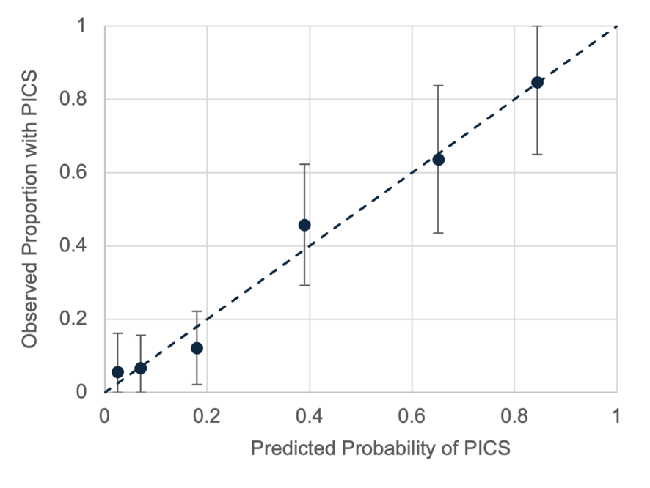
Supplementary Figure 1: Calibration plot for the primary organ dysfunction count model. Each point represents one level of the organ dysfunction count (0–5). The x-axis shows the model-predicted probability of PICS; the y-axis shows the observed proportion. Error bars represent 95% confidence intervals. The dashed line represents perfect calibration. Optimism-corrected calibration slope = 0.96; intercept = -0.02.
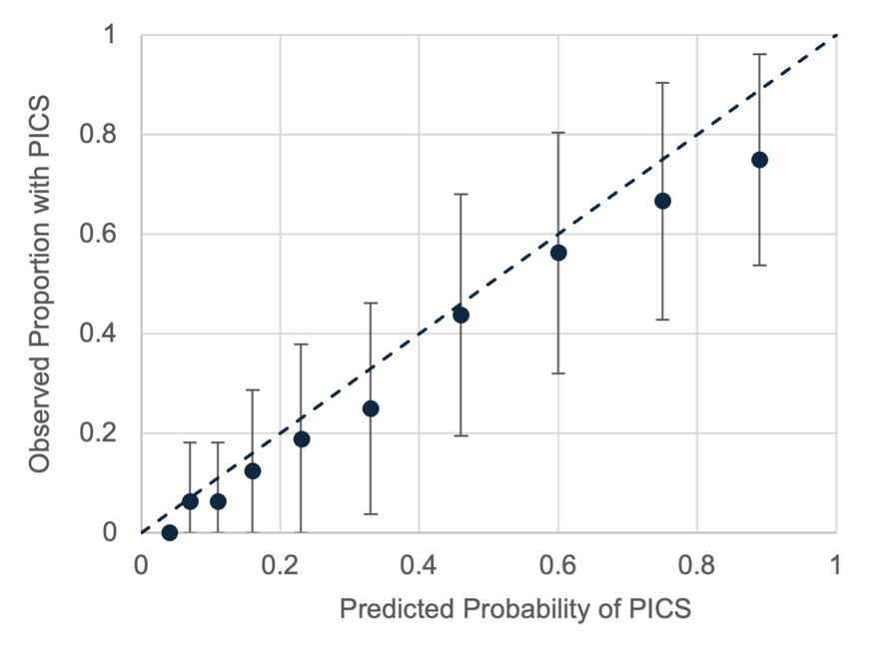
Supplementary Figure 2: Calibration plot for the exploratory three-variable model. Patients grouped into deciles of predicted risk. Optimism-corrected calibration slope = 0.80; intercept = 0.07. Deviation from the diagonal indicates overfitting, consistent with the borderline Hosmer-Lemeshow result (p = 0.049).

