Supplementary figure 1: Direct acyclic graph
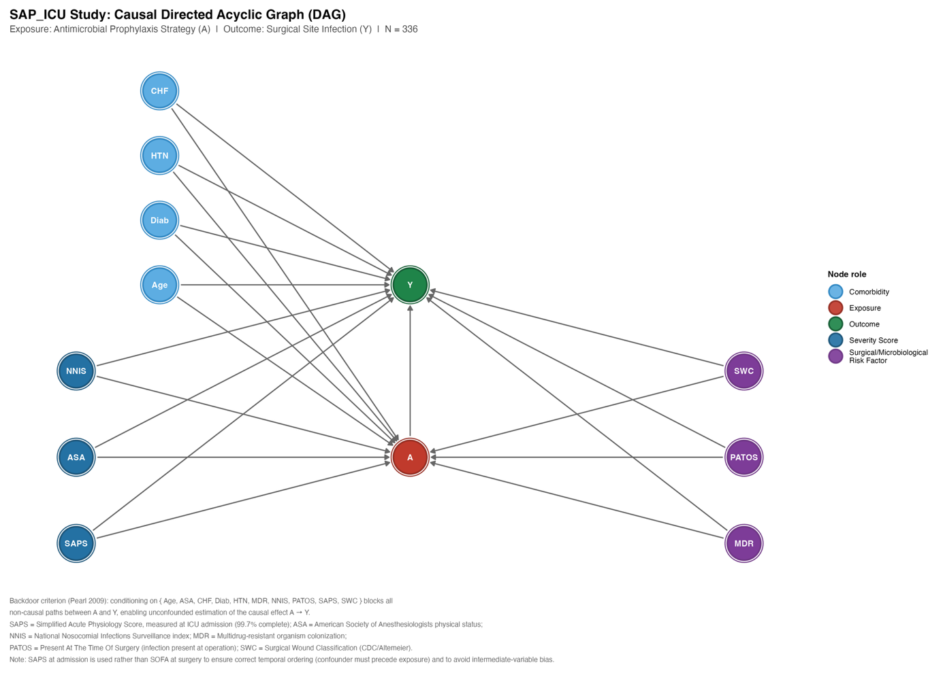
Supplementary table S1: Complete GEE model output

