Supplementary material for:EIT-assessed ventilation–perfusion responses to prone positioning and inhaled nitric oxide in mechanically ventilated COVID-19-related ARDS: a prospective sequential study

Yuxian Wang1#, Yuyang Dai1#, Xin Zheng1#, Yaxiaerjiang Muhetaer1, Ling Zhu1, Zhanqi Zhao2,3,4*, Kai Liu1*, Ming Zhong1,5*

Table S1. Hemodynamic variables across four sequential study conditions
Variable | SPV | SPV+iNO | PPV | PPV+iNO | SPV+iNO vs SPV |  | PPV+iNO vs PPV |  | PPV vs SPV |  | PPV+iNO vs SPV+iNO |  | Exploratory DiD
 |  |  |  |  | mean diff (95% CI) | q | mean diff (95% CI) | q | mean diff (95% CI) | q | mean diff (95% CI) | q | Mean diff (95% CI) | q
Heart rate, beats/min | 83.68±21.78 | 84.76±17.88 | 83.40±19.76 | 81.80±21.14 | +1.08 (-4.43, +6.59) | 0.690 | -1.60 (-6.65, +3.45) | 0.520 | -0.28 (-4.89, +4.33) | 0.901 | -2.96 (-8.20, +2.28) | 0.255 | -2.68(-9.92, +4.56) | 0.453
MAP, mmHg | 85.96±13.45 | 90.00±15.52 | 88.12±18.95 | 87.28±11.96 | +4.04 (-0.69, +8.77) | 0.090 | -0.84 (-7.25, +5.57) | 0.789 | +2.16 (-5.06, +9.38) | 0.543 | -2.72 (-9.50, +4.06) | 0.416 | -4.88(-13.16,+3.40) | 0.236
Norepinephrine, µg/kg/min | 0.06±0.11 | 0.06±0.11 | 0.05±0.10 | 0.05±0.10 | +0.00 (-0.00, +0.01) | 0.515 | -0.00 (-0.02, +0.01) | 0.403 | -0.00 (-0.01, +0.01) | 0.762 | -0.01 (-0.03, +0.01) | 0.314 | -0.01(-0.020,+0.01) | 0.300
Values are mean ± SD. Mean differences are paired within-patient differences with 95% confidence intervals.
CI, confidence interval; iNO, inhaled nitric oxide; MAP, mean arterial pressure; PPV, prone position ventilation; q, false discovery rate-adjusted p-value; SD, standard deviation; SPV, supine position ventilation.
q values are Benjamini–Hochberg false-discovery-rate-adjusted p values within the hemodynamic outcome family. Bold q values indicate q < 0.05.

Table S2. Regional EIT-derived ventilation/perfusion variables across four sequential study conditions
Variable | Study condition (Mean ± SD) |  |  |  | SPV+iNO vs SPV |  | PPV+iNO vs PPV |  | PPV vs SPV |  | PPV+iNO vs SPV+iNO |  | Exploratory DiD
 | SPV | SPV+iNO | PPV | PPV+iNO | Mean diff (95% CI) | q | Mean diff (95% CI) | q | Mean diff (95% CI) | q | Mean diff (95% CI) | q | Mean diff (95% CI) | q
Ventral V, % | 58.95 ± 12.00 | 59.43 ± 10.16 | 59.79 ± 16.07 | 59.20 ± 14.97 | +0.48 (-2.79, 3.76) | 0.765 | -0.59 (-2.92, 1.75) | 0.611 | +0.84 (-6.05, 7.74) | 0.804 | -0.22 (-4.63, 4.18) | 0.917 | -1.07 (-4.99, 2.85) | 0.581
Dorsal V, % | 41.05 ± 12.00 | 40.57 ± 10.16 | 40.21 ± 16.07 | 40.80 ± 14.97 | -0.48 (-3.76, 2.79) | 0.765 | +0.59 (-1.75, 2.92) | 0.611 | -0.84 (-7.74, 6.05) | 0.804 | +0.22 (-4.18, 4.63) | 0.917 | +1.07 (-2.85, 4.99) | 0.581
Ventral Q, % | 54.69 ± 14.81 | 53.62 ± 12.32 | 53.67 ± 13.16 | 53.64 ± 11.14 | -1.06 (-4.19, 2.06) | 0.490 | -0.03 (-4.02, 3.96) | 0.987 | -1.02 (-7.25, 5.22) | 0.740 | +0.01 (-3.75, 3.78) | 0.994 | +1.03 (-4.03, 6.09) | 0.679
Dorsal Q, % | 45.31 ± 14.81 | 46.38 ± 12.32 | 46.33 ± 13.16 | 46.36 ± 11.14 | +1.06 (-2.06, 4.19) | 0.490 | +0.03 (-3.96, 4.02) | 0.987 | +1.02 (-5.22, 7.25) | 0.740 | -0.01 (-3.78, 3.75) | 0.994 | -1.03 (-6.09, 4.03) | 0.679
Non-ventilated (ventral), % | 4.71 ± 5.46 | 3.69 ± 4.11 | 5.77 ± 6.15 | 5.54 ± 4.68 | -1.02 (-2.57, 0.53) | 0.188 | -0.23 (-2.48, 2.02) | 0.837 | +1.06 (-2.00, 4.11) | 0.484 | +1.85 (-0.25, 3.95) | 0.082 | +0.79 (-2.29, 3.87) | 0.602
Low V/Q (ventral), % | 23.09 ± 11.01 | 24.31 ± 13.10 | 25.75 ± 15.34 | 26.98 ± 12.19 | +1.22 (-2.91, 5.34) | 0.550 | +1.23 (-4.30, 6.76) | 0.652 | +2.66 (-3.97, 9.28) | 0.418 | +2.67 (-1.48, 6.82) | 0.198 | +0.01 (-6.21, 6.24) | 0.996
Normal V/Q (ventral), % | 8.91 ± 6.40 | 10.88 ± 7.89 | 8.67 ± 6.55 | 8.43 ± 6.00 | +1.97 (-0.90, 4.84) | 0.171 | -0.24 (-3.10, 2.62) | 0.864 | -0.24 (-3.46, 2.98) | 0.879 | -2.45 (-5.32, 0.43) | 0.092 | -2.21 (-5.08, 0.67) | 0.127
High V/Q (ventral), % | 6.40 ± 7.86 | 7.31 ± 9.33 | 5.60 ± 6.02 | 5.14 ± 7.07 | +0.90 (-1.98, 3.79) | 0.526 | -0.46 (-2.88, 1.96) | 0.701 | -0.80 (-4.09, 2.48) | 0.620 | -2.17 (-5.02, 0.69) | 0.131 | -1.36 (-4.49, 1.76) | 0.379
Non-perfused (ventral), % | 10.73 ± 7.48 | 6.98 ± 6.70 | 6.04 ± 5.01 | 4.92 ± 4.37 | -3.75 (-6.19, -1.31) | 0.004 | -1.11 (-3.38, 1.16) | 0.323 | -4.69 (-8.00, -1.38) | 0.007 | -2.05 (-4.86, 0.75) | 0.145 | +2.64 (-0.74, 6.01) | 0.121
Non-ventilated (dorsal), % | 7.29 ± 6.26 | 7.46 ± 5.39 | 7.91 ± 8.91 | 8.26 ± 7.92 | +0.17 (-1.99, 2.33) | 0.870 | +0.34 (-2.56, 3.25) | 0.810 | +0.63 (-3.60, 4.86) | 0.763 | +0.80 (-2.24, 3.84) | 0.594 | +0.17 (-3.55, 3.89) | 0.926
Low V/Q (dorsal), % | 23.83 ± 13.60 | 27.17 ± 13.77 | 27.63 ± 13.69 | 31.64 ± 13.02 | +3.34 (-0.44, 7.12) | 0.081 | +4.01 (0.32, 7.70) | 0.034 | +3.80 (-0.54, 8.13) | 0.084 | +4.47 (0.78, 8.15) | 0.019 | +0.67 (-4.81, 6.15) | 0.804
Normal V/Q (dorsal), % | 4.94 ± 4.03 | 5.78 ± 5.52 | 6.39 ± 7.49 | 4.00 ± 5.18 | +0.84 (-0.72, 2.39) | 0.278 | -2.39 (-5.34, 0.57) | 0.109 | +1.45 (-1.41, 4.31) | 0.306 | -1.77 (-4.00, 0.45) | 0.114 | -3.23 (-6.72, 0.26) | 0.069
High V/Q (dorsal), % | 2.96 ± 3.96 | 2.83 ± 5.90 | 3.16 ± 6.67 | 2.46 ± 5.12 | -0.12 (-2.21, 1.96) | 0.904 | -0.70 (-2.66, 1.26) | 0.470 | +0.20 (-1.85, 2.25) | 0.842 | -0.37 (-2.55, 1.80) | 0.727 | -0.58 (-3.60, 2.45) | 0.699
Non-perfused (dorsal), % | 7.13 ± 6.21 | 3.61 ± 3.07 | 3.06 ± 3.07 | 2.62 ± 3.36 | -3.53 (-5.48, -1.57) | 0.001 | -0.44 (-2.03, 1.14) | 0.571 | -4.07 (-6.50, -1.65) | 0.002 | -0.99 (-2.72, 0.75) | 0.254 | +3.08 (0.82, 5.35) | 0.009
Wasted ventilation (ventral), % | 12.00 ± 8.43 | 7.61 ± 6.01 | 7.75 ± 7.53 | 6.07 ± 6.12 | -4.39 (-7.11, -1.68) | 0.003 | -1.68 (-4.50, 1.14) | 0.232 | -4.25 (-8.34, -0.16) | 0.042 | -1.54 (-3.49, 0.42) | 0.119 | +2.71 (-1.50, 6.93) | 0.197
Wasted ventilation (dorsal), % | 6.57 ± 11.72 | 2.82 ± 4.24 | 2.86 ± 4.62 | 2.29 ± 4.17 | -3.75 (-6.94, -0.56) | 0.023 | -0.57 (-2.41, 1.27) | 0.530 | -3.71 (-8.40, 0.97) | 0.115 | -0.54 (-2.79, 1.72) | 0.629 | +3.18 (-0.54, 6.90) | 0.091
Wasted perfusion (ventral), % | 15.32 ± 8.11 | 11.89 ± 6.35 | 14.96 ± 7.57 | 14.39 ± 5.40 | -3.43 (-5.67, -1.19) | 0.004 | -0.57 (-3.72, 2.57) | 0.712 | -0.36 (-4.59, 3.87) | 0.864 | +2.50 (0.24, 4.76) | 0.031 | +2.86 (-0.82, 6.54) | 0.123
Wasted perfusion (dorsal), % | 17.79 ± 9.32 | 15.32 ± 7.77 | 15.86 ± 8.83 | 15.86 ± 7.18 | -2.46 (-4.78, -0.15) | 0.038 | +0.00 (-3.37, 3.37) | 1.000 | -1.93 (-6.42, 2.56) | 0.386 | +0.54 (-1.83, 2.91) | 0.647 | +2.46 (-1.10, 6.03) | 0.167
Values are mean ± SD.
CI, confidence interval; DiD, difference-in-differences; EIT, electrical impedance tomography; GIper, global inhomogeneity index for perfusion; GIven, global inhomogeneity index for ventilation; GIvq, global inhomogeneity index for ventilation/perfusion matching; iNO, inhaled nitric oxide; PPV, prone position ventilation; q, false discovery rate-adjusted p-value; Q, perfusion; SD, standard deviation; SPV, supine position ventilation; V, ventilation; V/Q, ventilation-to-perfusion ratio.
q values are Benjamini–Hochberg adjusted p values within this table. Bold q values indicate q < 0.05.

Supplementary Figure 1. Heatmap of paired effect sizes across prespecified between-condition contrasts for selected EIT-derived variables.
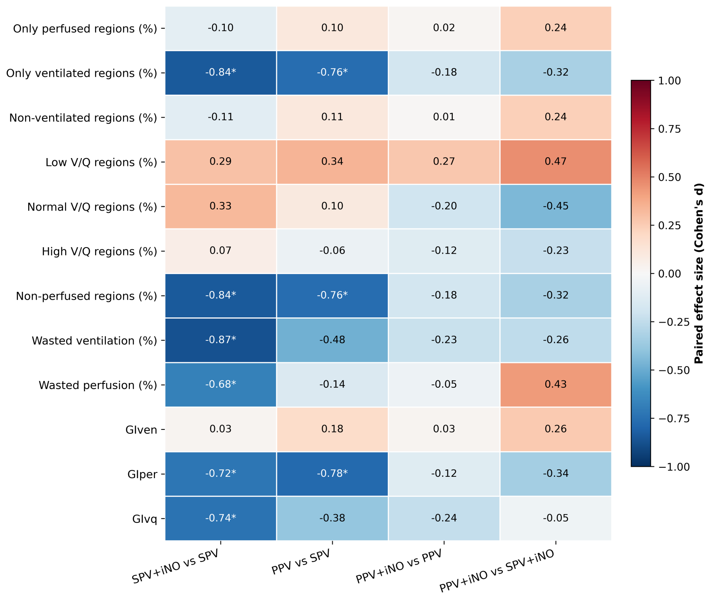
The heatmap summarizes the direction and magnitude of changes in selected EIT-derived variables across prespecified within-patient contrasts among the four sequential study conditions. Cell values indicate paired effect sizes, and asterisks denote comparisons remaining significant after false-discovery-rate adjustment. Warmer and cooler colors indicate opposite directions of effect according to the scale shown. This figure is intended to provide an overview of response patterns across variables rather than a standalone basis for statistical inference.

Supplementary Figure 2. Regional wasted perfusion across the four sequential study conditions.
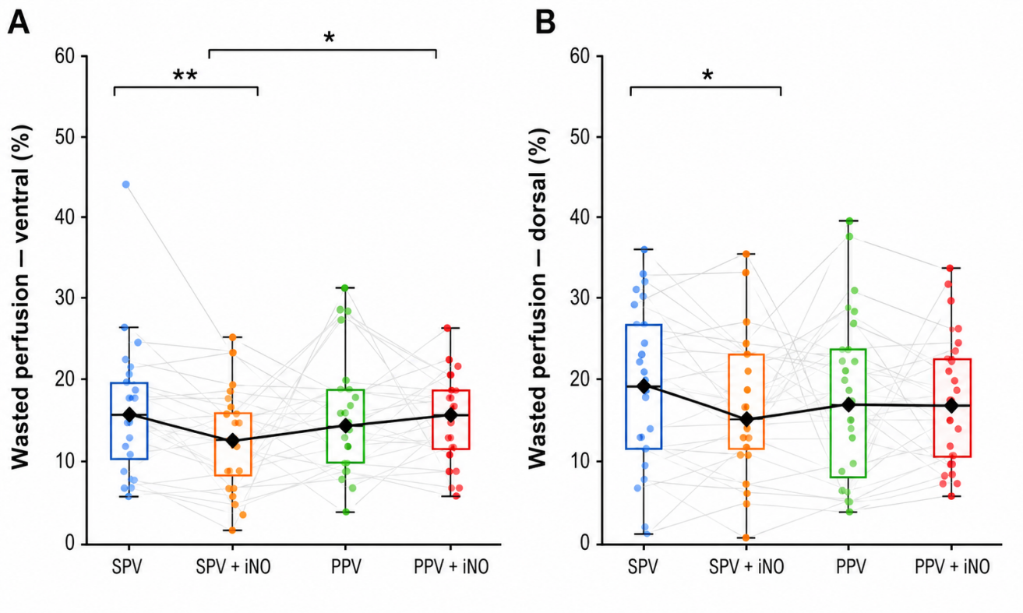
Wasted perfusion in ventral (A) and dorsal (B) lung regions across SPV, SPV + iNO, PPV, and PPV + iNO conditions. Data are presented as individual paired observations overlaid on box plots (median and interquartile range; whiskers indicate range). Colored dots represent individual patient measurements, and gray lines indicate within-subject paired changes across sequential conditions. Black diamonds connected by a solid line indicate group medians.

To ensure visual comparability, the y-axis scale is identical in panels A and B (0–60%).

Statistical analysis was performed using prespecified within-patient paired comparisons across the four sequential conditions (SPV, SPV+iNO, PPV, PPV+iNO). Continuous variables were analyzed using paired mean differences with 95% confidence intervals. Because of multiple comparisons across outcome domains, false discovery rate (FDR) correction using the Benjamini–Hochberg method was applied, with adjusted q values < 0.05 considered statistically significant. Given the fixed sequential study design, all comparisons should be interpreted as exploratory physiological analyses rather than causal effects.

