Contents
Supplemental Table 1: ICD10 Codes Used 2
Supplemental Table 2: Cohort Characteristics and Missingness 5
Supplemental Figure 1: Hemoglobin Trajectories Overall 7
Supplemental Figure 2: Hemoglobin Trajectories by Arrest Type 8
Supplemental Figure 3: Hemoglobin Scatterplot by Arrest Type 9
Supplemental Figure 4: Hemoglobin Trajectories by Outcome 10
Supplemental Figure 5: Hemoglobin Scatterplot by Outcome 11
Supplemental Figure 6: Hemoglobin Trajectory by Initial Hemoglobin 12
Supplemental Figure 7: Hemoglobin Scatterplot by Initial Hemoglobin 13
Supplemental Figure 8: Patient Transfusions 14
Supplemental Table 3: ICD10 Codes and Transfusion Status 15
Supplemental Figure 9: Hemoglobin Trajectory Centered on First Transfusion 16
Supplemental Table 4: Outcomes 17
Supplemental Table 5: Initial Post-ROSC Hemoglobin Outcomes 18
Supplemental Figure 10: Predicted Probabilities of Death for Initial Hemoglobin 20
Supplemental Table 6: Organ Failure Analyses 21
Supplemental Figure 11: Outcomes Analysis Excluding Patients with Major Bleeding 22
Supplemental Figure 12: Outcomes Analysis Adjusted for Time-Varying SOFA Scores 23

Supplemental Table 1: ICD10 Codes Used
Supplemental Table 1: List of ICD10 Codes Used
ICD10 Code | Name
Gastrointestinal bleeding
I85.0 | Esophageal varices with hemorrhage
K22.6 | Gastro-esophageal laceration-hemorrhage syndrome
K25.0 | Acute gastric ulcer with hemorrhage
K25.1 | Acute gastric ulcer with perforation
K25.2 | Acute gastric ulcer with both hemorrhage and perforation
K25.4 | Chronic or unspecified gastric ulcer with hemorrhage
K25.5 | Chronic or unspecified gastric ulcer with perforation
K25.6 | Chronic or unspecified gastric ulcer with both hemorrhage and perforation
K26.0 | Acute duodenal ulcer with hemorrhage
K26.1 | Acute duodenal ulcer with perforation
K26.2 | Acute duodenal ulcer with both hemorrhage and perforation
K26.4 | Chronic or unspecified duodenal ulcer with hemorrhage
K26.5 | Chronic or unspecified duodenal ulcer with perforation
K26.6 | Chronic or unspecified duodenal ulcer with both hemorrhage and perforation
K27.0 | Acute peptic ulcer, site unspecified, with hemorrhage
K27.1 | Acute peptic ulcer, site unspecified, with perforation
K27.2 | Acute peptic ulcer, site unspecified, with both hemorrhage and perforation
K27.4 | Chronic or unspecified peptic ulcer, site unspecified, with hemorrhage
K27.5 | Chronic or unspecified peptic ulcer, site unspecified, with perforation
K27.6 | Chronic or unspecified peptic ulcer, site unspecified, with both hemorrhage and perforation
K28.0 | Acute gastrojejunal ulcer with hemorrhage
K28.1 | Acute gastrojejunal ulcer with perforation
K28.2 | Acute gastrojejunal ulcer with both hemorrhage and perforation
K28.4 | Chronic or unspecified gastrojejunal ulcer with hemorrhage
K28.5 | Chronic or unspecified gastrojejunal ulcer with perforation
K28.6 | Chronic or unspecified gastrojejunal ulcer with both hemorrhage and perforation
K29.0 | Acute gastritis
K29.21 | Alcoholic gastritis with bleeding
K29.31 | Chronic superficial gastritis with bleeding
K29.41 | Chronic atrophic gastritis with bleeding
K29.51 | Unspecified chronic gastritis with bleeding
K29.61 | Other gastritis with bleeding
K29.71 | Gastritis, unspecified, with bleeding
K29.81 | Duodenitis with bleeding
K29.91 | Gastroduodenitis, unspecified, with bleeding
K31.82 | Dieulafoy lesion (hemorrhagic) of stomach and duodenum
K57.11 | Diverticulosis of small intestine without perforation or abscess with bleeding
K57.13 | Diverticulitis of small intestine without perforation or abscess with bleeding
K57.21 | Diverticulitis of large intestine with perforation and abscess with bleeding
K57.31 | Diverticulosis of large intestine without perforation or abscess with bleeding
K57.33 | Diverticulitis of large intestine without perforation or abscess with bleeding
K57.41 | Diverticulitis of both small and large intestine with perforation and abscess with bleeding
K57.51 | Diverticulosis of both small and large intestine without perforation or abscess with bleeding
K57.53 | Diverticulitis of both small and large intestine without perforation or abscess with bleeding
K57.81 | Diverticulitis of intestine, part unspecified, with perforation and abscess with bleeding
K57.91 | Diverticulosis of intestine, part unspecified, without perforation or abscess with bleeding
K57.93 | Diverticulitis of intestine, part unspecified, without perforation or abscess with bleeding
K62.5 | Hemorrhage of anus and rectum
K92.0 | Hematemesis
K92.1 | Melena
Thoracic bleeding
I31.2 | Hemopericardium, not elsewhere classified
J94.2 | Hemothorax
R04 | Hemorrhage from respiratory passages
S27.1 | Traumatic hemothorax
Intra-abdominal bleeding
K66.1 | Hemoperitoneum
K68.3 | Retroperitoneal hematoma
Other bleeding
M25.0 | Hemarthrosis
O67 | Labor and delivery complicated by intrapartum hemorrhage, not elsewhere classified
O72.0 | Third-stage hemorrhage
O72.1 | Other immediate postpartum hemorrhage
O72.2 | Delayed and secondary postpartum hemorrhage
R31 | Hematuria
R58 | Hemorrhage, not elsewhere classified

Supplemental Table 2: Cohort Characteristics and Missingness
Supplemental Table 2: Cohort Characteristics and Missingness
Variable | Full Cohort  958 patients | Initial Hemoglobin < 9 g/dL  417 patients | Initial Hemoglobin ≥ 9 g/dL  541 patients | Missing Proportion  n (%)
Age in years, mean (SD) | 66.9 (14.3) | 67.5 (14.3) | 66.5 (14.2) | 0 (0)
Female sex, n (%) | 424 (44.3) | 195 (46.8) | 229 (42.3) | 0 (0)
Race, n (%) |  |  |  | 0 (0)
White | 122 (12.7) | 39 (9.4) | 83 (15.3)
Black | 387 (40.4) | 195 (46.8) | 192 (35.5)
Other | 381 (39.8) | 164 (39.3) | 217 (40.1)
Unknown | 68 (7.1) | 19 (4.6) | 49 (9.1)
Arrest type, n (%) |  |  |  | 0 (0)
OHCA | 152 (15.9) | 40 (9.6) | 112 (20.7)
IHCA | 806 (84.1) | 377 (90.4) | 429 (79.3)
Charlson comorbidity score, mean (SD) | 5.2 (3.0) | 5.7 (3.0) | 4.8 (3.0) | 0 (0)
Days from admission to arrest for IHCA, median (IQR) | 2.9 (0.3, 10.7) | 6.3 (0.9, 16.7) | 1.8 (0.1, 6.8) | 0 (0)
Arrest location, n (%) |  |  |  | 0 (0)
Intensive care unit | 188 (19.6) | 71 (17.0) | 177 (21.6)
Emergency department | 389 (40.6) | 170 (40.8) | 219 (40.5)
Procedural area | 59 (6.2) | 31 (7.4) | 28 (5.2)
Hospital ward | 322 (33.6) | 145 (34.8) | 177 (32.7)
Pre-arrest hemoglobin value in g/dL for IHCA, mean (SD) | 9.51 (2.18) | 8.24 (1.26) | 10.85 (2.15) | 181/806 (22.5)
Initial post-arrest hemoglobin |  |  |  | 0 (0)
Value in g/dL, mean (SD) | 9.75 (2.60) | 7.45 (1.14) | 11.51 (1.95)
Number of patients who received a red blood cell transfusion in the 30 days post-arrest, n (%) | 369 (38.5) | 220 (52.8) | 149 (27.5) | 0 (0)

Supplemental Figure 1: Hemoglobin Trajectories Overall
Supplemental Figure 1: Hemoglobin Trajectories for the Total Cohort Overall After Cardiac Arrest
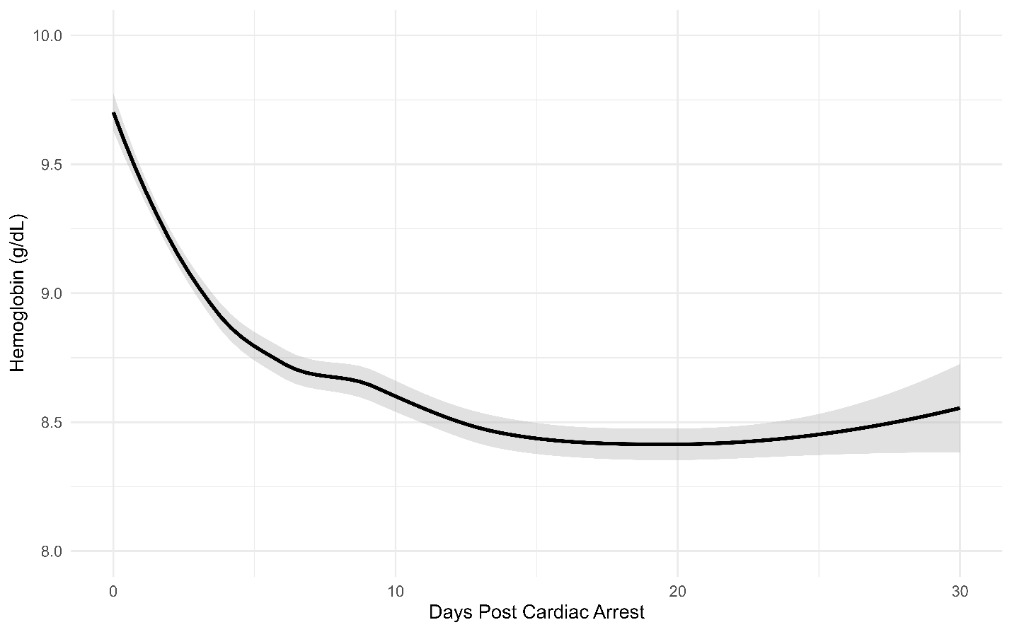
Shaded areas indicate 95% confidence intervals around the LOESS-smoothed mean trajectory.

Supplemental Figure 2: Hemoglobin Trajectories by Arrest Type
Supplemental Figure 2: Hemoglobin Trajectories After Cardiac Arrest by Arrest Type
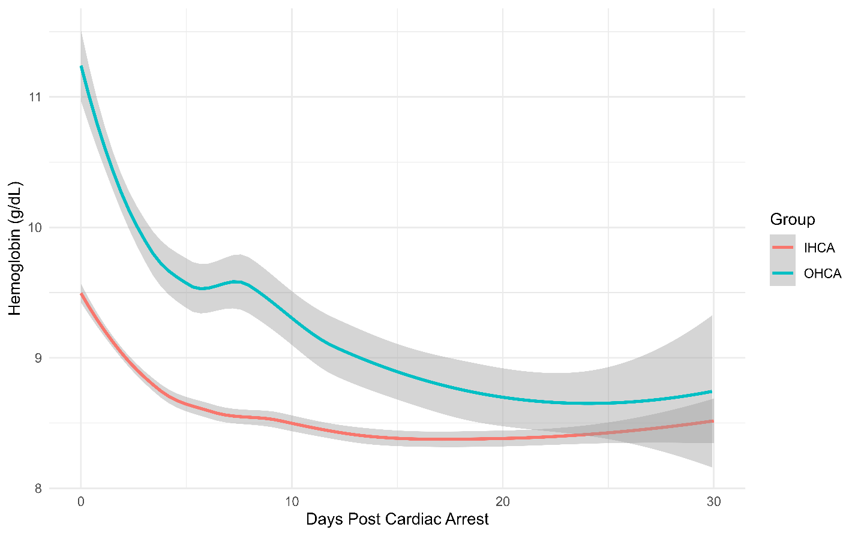
Shaded areas indicate 95% confidence intervals around the LOESS-smoothed mean trajectory.

Supplemental Figure 3: Hemoglobin Scatterplot by Arrest Type
Supplemental Figure 3: Scatterplot of All Post-Arrest Hemoglobin Values by Arrest Type
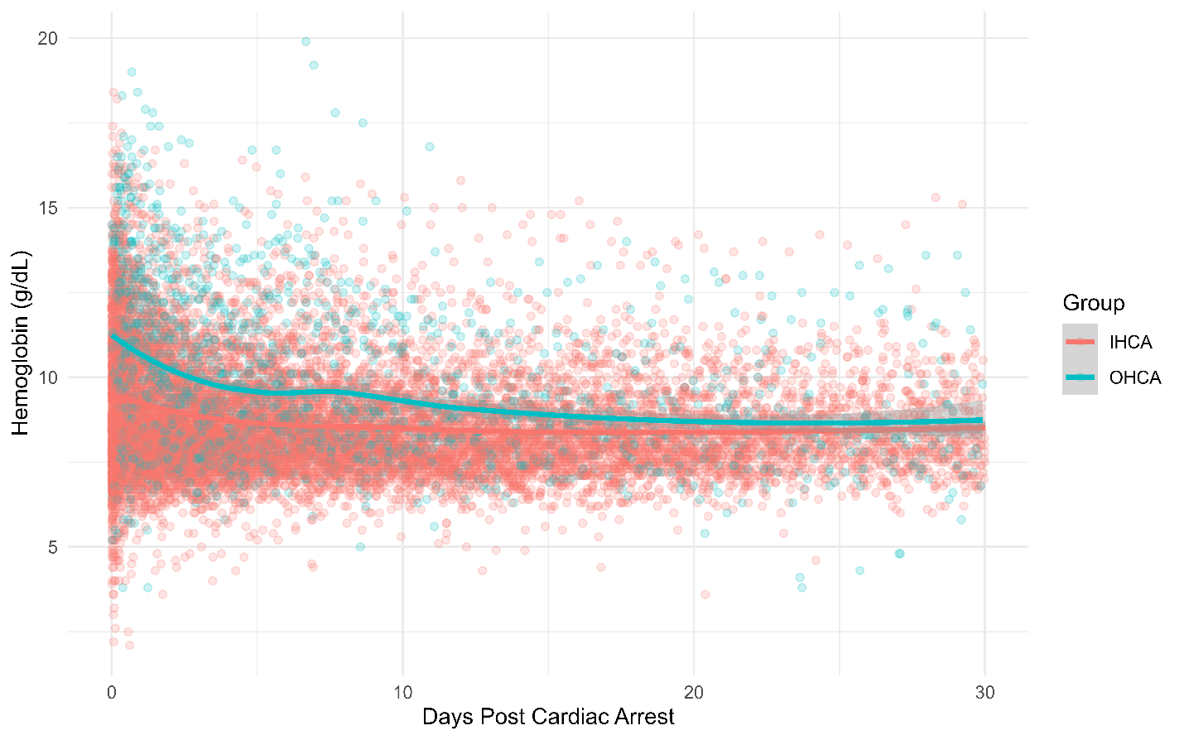
Shaded areas indicate 95% confidence intervals around the LOESS-smoothed mean trajectory.

Supplemental Figure 4: Hemoglobin Trajectories by Outcome
Supplemental Figure 4: Hemoglobin Trajectories After Cardiac Arrest by Outcome
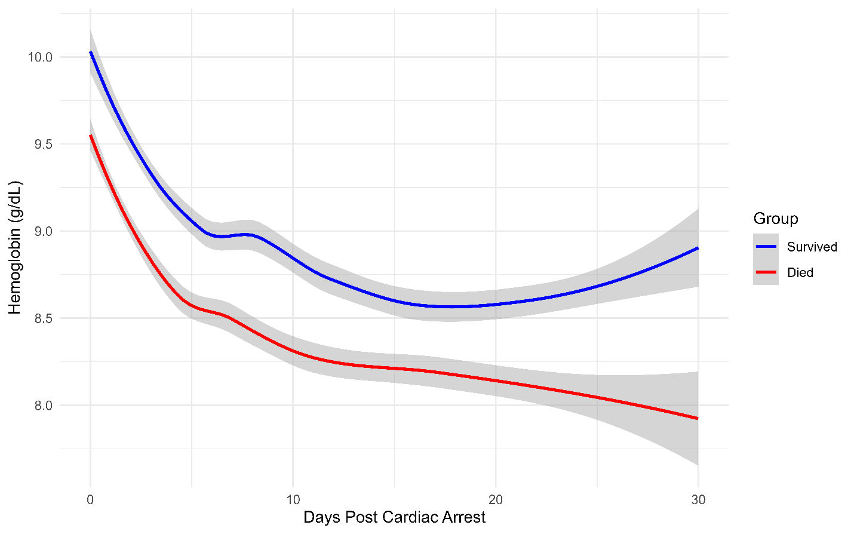
Shaded areas indicate 95% confidence intervals around the LOESS-smoothed mean trajectory.

Supplemental Figure 5: Hemoglobin Scatterplot by Outcome
Supplemental Figure 5: Scatterplot of All Post-Arrest Hemoglobin Values by Outcome
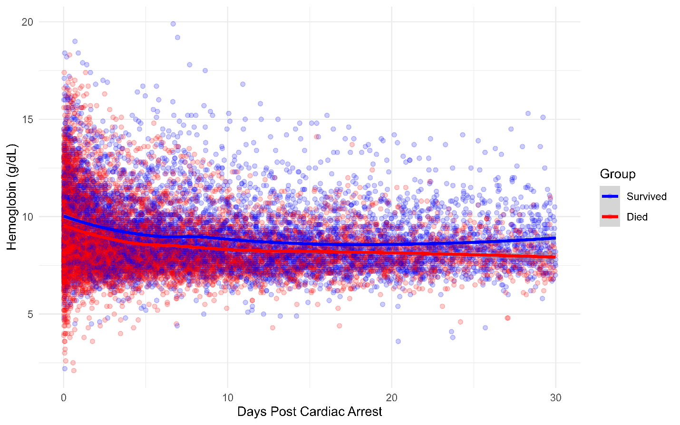
Shaded areas indicate 95% confidence intervals around the LOESS-smoothed mean trajectory.

Supplemental Figure 6: Hemoglobin Trajectory by Initial Hemoglobin
Supplemental Figure 6: Hemoglobin Trajectories After Cardiac Arrest by the Initial Post-Arrest Hemoglobin
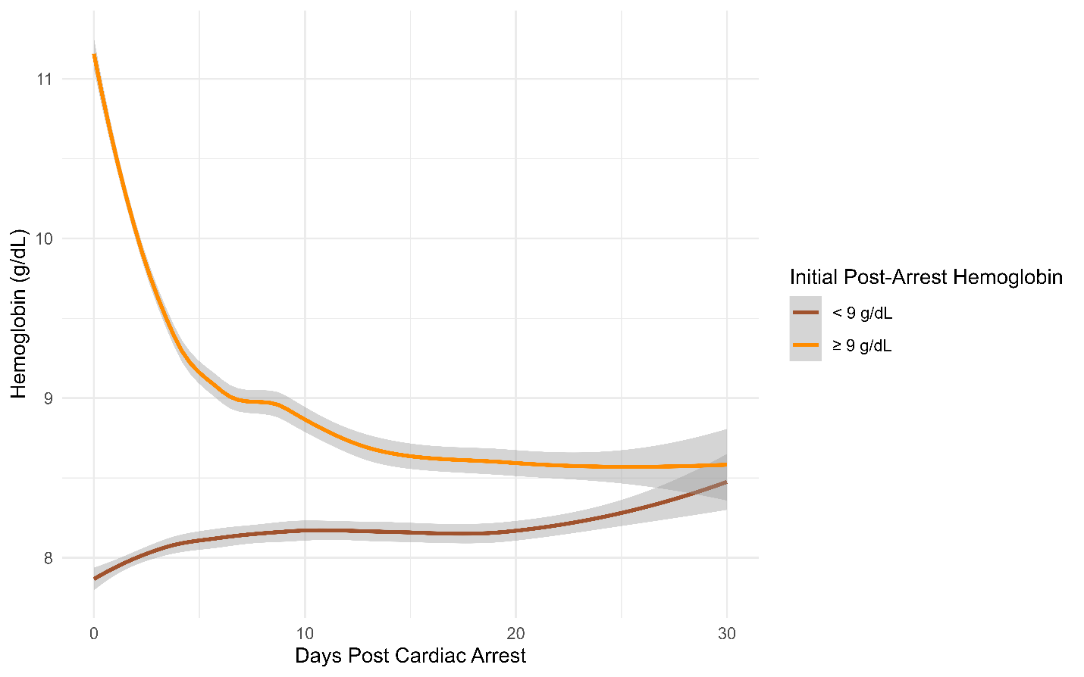
Shaded areas indicate 95% confidence intervals around the LOESS-smoothed mean trajectory.

Supplemental Figure 7: Hemoglobin Scatterplot by Initial Hemoglobin
Supplemental Figure 7: Scatterplot of All Post-Arrest Hemoglobin Values by the Initial Post-Arrest Hemoglobin
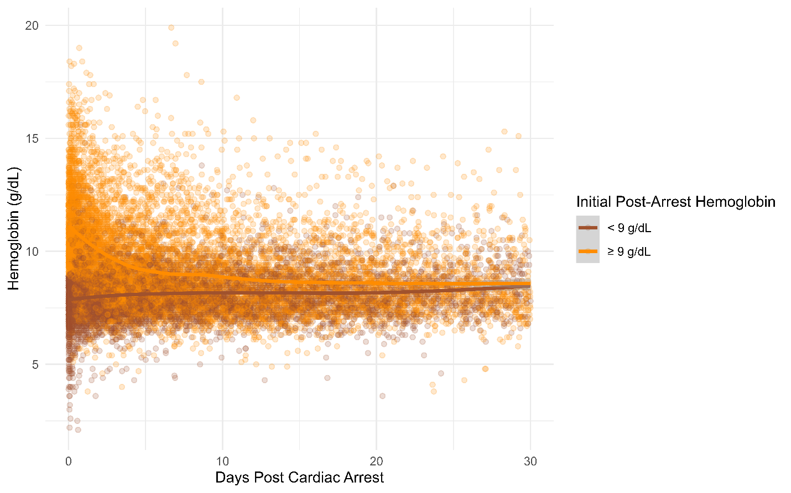
Shaded areas indicate 95% confidence intervals around the LOESS-smoothed mean trajectory.

Supplemental Figure 8: Patient Transfusions
Supplemental Figure 8: Distribution of Transfusions Per Patient
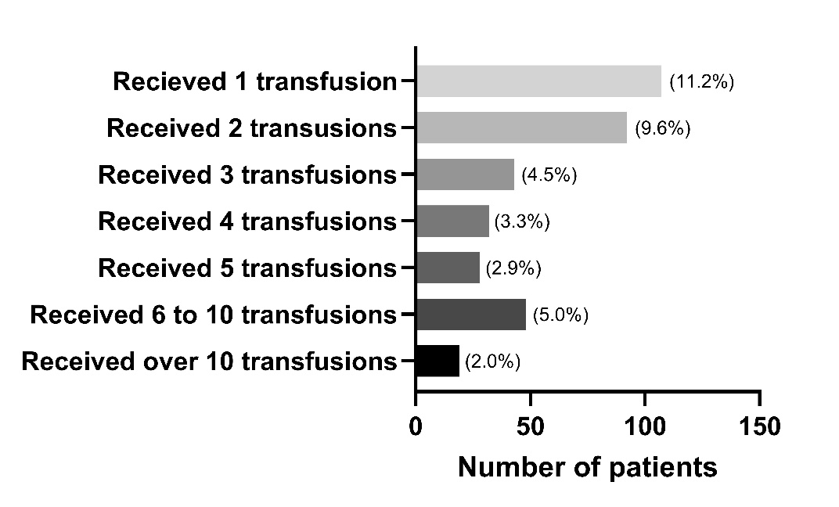

Supplemental Table 3: ICD10 Codes and Transfusion Status
Supplemental Table 3: Bleeding Codes by Transfusion Status
Bleeding Type | Overall  958 patients | No Transfusion  589 patients | Received Transfusion  369 patients | Post-Arrest Hemoglobin < 9 g/dL  417 patients | Post-arrest Hemoglobin ≥ 9 g/dL  541 patients
Any ICD10 code for major bleeding | 62 (6.5%) | 25 (4.2%) | 37 (10.0%) | 33 (7.9%) | 29 (5.4%)
ICD10 code for GI bleeding | 53 (5.5%) | 24 (4.1%) | 29 (7.9%) | 27 (6.5%) | 26 (4.8%)
ICD10 code for thoracic bleeding | 6 (0.6%) | 1 (0.2%) | 5 (1.4%) | 4 (1.0%) | 2 (0.4%)
ICD10 code for intra-abdominal bleeding | 2 (0.2%) | 1 (0.2%) | 1 (0.3%) | 2 (0.5%) | 0 (0%)
Other ICD10 code for bleeding | 2 (0.2%) | 0 (0%) | 2 (0.5%) | 1 (0.2%) | 1 (0.2%)

Supplemental Figure 9: Hemoglobin Trajectory Centered on First Transfusion
Supplemental Figure 9a: Scatterplot With Hemoglobin Trajectory Before and After Initial Blood Transfusion After Cardiac Arrest
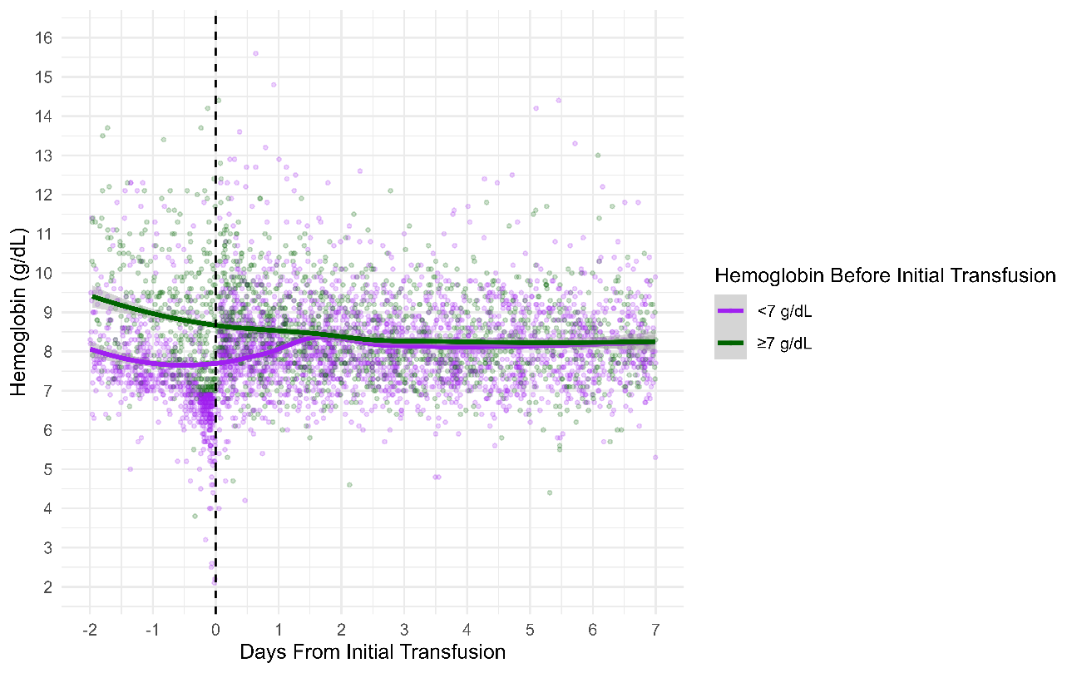
Only those who received a blood transfusion (369 patients) included. Only first transfusion performed post-arrest included. Shaded areas indicate 95% confidence intervals around the LOESS-smoothed mean trajectory.
Supplemental Figure 9b: Spaghetti Plot With Hemoglobin Trajectory Before and After Initial Blood Transfusion After Cardiac Arrest
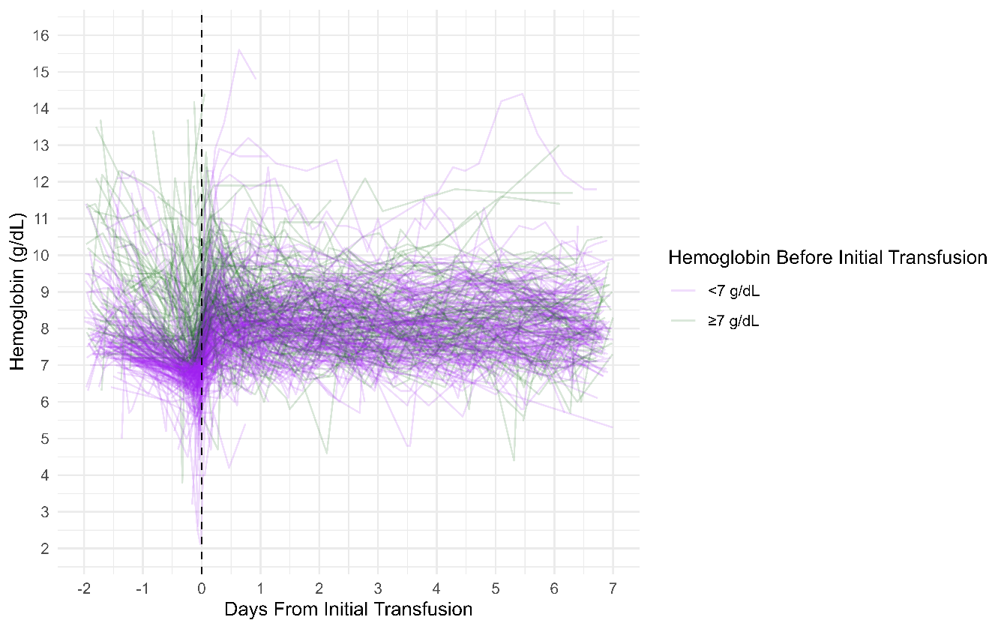
Only those who received a blood transfusion (369 patients) included. Only first transfusion performed post-arrest included.

Supplemental Table 4: Outcomes
Supplemental Table 4: Cohort Outcomes
Initial Post-Arrest Hemoglobin
Outcome | Overall  958 patients | Initial Post-Arrest Hemoglobin < 9 g/dL  417 patients | Initial Post-Arrest Hemoglobin ≥ 9 g/dL  541 patients
Discharge disposition
Deceased | 699 (73.0%) | 328 (78.7%) | 371 (68.6%)
Home | 88 (9.2%) | 25 (6.0%) | 63 (11.7%)
Rehabilitation facility | 23 (2.4%) | 7 (1.7%) | 16 (3.0%)
Nursing facility | 121 (12.6%) | 49 (11.8%) | 72 (13.3%)
Hospice | 19 (2.0%) | 7 (1.7%) | 12 (2.2%)
Other | 8 (0.8%) | 1 (0.2%) | 7 (1.3%)
Survival analyses
Unadjusted odds of death for initial hemoglobin ≥ 9 g/dL (compared to < 9 g/dL): 0.59
95% confidence interval: 0.44 – 0.80. p<0.01
Adjusted odds of death for initial hemoglobin ≥ 9 g/dL (compared to < 9 g/dL): 0.62
95% confidence interval: 0.46 – 0.84. p<0.01
Time-Varying Hemoglobin Values Over 30 Days Post-Arrest
Survival analysis
Hemoglobin < 9.20 g/dL
Adjusted hazard ratio for death per 1 g/dL hemoglobin increase: 0.71
95% confidence interval: 0.64 – 0.78. p<0.01
Hemoglobin ≥ 9.20 g/dL
Adjusted hazard ratio for death per 1 g/dL hemoglobin increase: 0.96
95% confidence interval: 0.87 – 1.04, p=0.31

Supplemental Table 5: Initial Post-ROSC Hemoglobin Outcomes
Supplemental Table 5: Initial Post-ROSC Hemoglobin Threshold Performance
Initial post-ROSC hemoglobin ≥ 7 g/dL (compared to < 7 g/dL)
Adjusted odds of death: 0.46, 95%CI 0.27 – 0.78, p<0.01
AUC = 0.60
Sensitivity: 54.4%
Specificity: 59.1%
Positive predictive value: 78.2%
Negative predictive value: 32.4%
Initial post-ROSC hemoglobin ≥ 8 g/dL (compared to < 8 g/dL)
Adjusted odds of death: 0.55, 95%CI 0.38 – 0.79, p<0.01
AUC = 0.60
Sensitivity: 53.2%
Specificity: 57.1%
Positive predictive value: 77.0%
Negative predictive value: 31.2%
Initial post-ROSC hemoglobin ≥ 9 g/dL (compared to < 9 g/dL)
Adjusted odds of death: 0.62, 95%CI 0.46 – 0.84, p<0.01
AUC = 0.60
Sensitivity: 56.4%
Specificity: 55.2%
Positive predictive value: 77.3%
Negative predictive value: 31.9%
Initial post-ROSC hemoglobin ≥ 10 g/dL (compared to < 10 g/dL)
Adjusted odds of death: 0.63, 95%CI 0.47 – 0.85, p<0.01
AUC = 0.60
Sensitivity: 59.4%
Specificity: 55.2%
Positive predictive value: 78.2%
Negative predictive value: 33.5%
Initial post-ROSC hemoglobin ≥ 11 g/dL (compared to < 11 g/dL)
Adjusted odds of death: 0.51, 95%CI 0.37 – 0.69, p<0.01
AUC = 0.62
Sensitivity: 64.2%
Specificity: 52.5%
Positive predictive value: 78.5%
Negative predictive value: 35.2%
Initial post-ROSC hemoglobin ≥ 12 g/dL (compared to < 12 g/dL)
Adjusted odds of death: 0.59, 95%CI 0.42 – 0.83, p<0.01
AUC = 0.60
Sensitivity: 60.7%
Specificity: 52.5%
Positive predictive value: 77.5%
Negative predictive value: 33.1%
Initial post-ROSC hemoglobin ≥ 13 g/dL (compared to < 13 g/dL)
Adjusted odds of death: 0.64, 95%CI 0.42 – 0.97, p=0.04
AUC = 0.60
Sensitivity: 60.2%
Specificity: 54.1%
Positive predictive value: 78.0%
Negative predictive value: 33.5%
Initial post-ROSC hemoglobin ≥ 14 g/dL (compared to < 14 g/dL)
Adjusted odds of death: 0.53, 95%CI 0.31 – 0.92, p=0.02
AUC = 0.59
Sensitivity: 59.7%
Specificity: 53.7%
Positive predictive value: 77.7%
Negative predictive value: 33.0%

Supplemental Figure 10: Predicted Probabilities of Death for Initial Hemoglobin
Supplemental Figure 10: Predicted Probabilities of In-Hospital Mortality with 95% Confidence Intervals
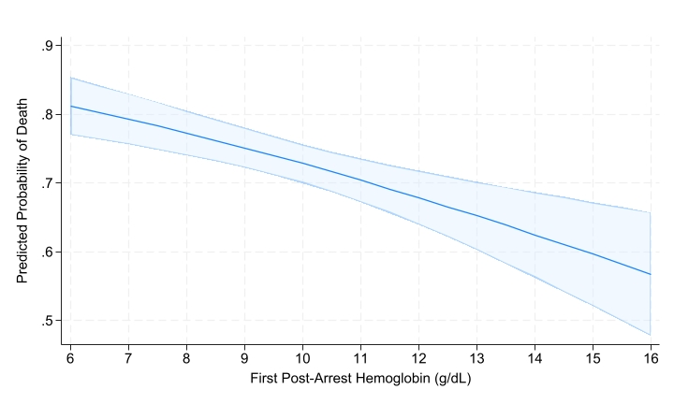
Predicted probabilities of death were estimated across the range of observed initial post-arrest hemoglobin values using marginal standardization from the adjusted multivariable regression model.

Supplemental Table 6: Organ Failure Analyses
Supplemental Table 6: Organ Failure Analyses
Alive and vasopressor-free days | Initial post-arrest hemoglobin ≥ 9 g/dL: median 0 days, IQR (0, 7)  Initial post-arrest hemoglobin < 9 g/dL: median 0 days, IQR (0, 0)  p<0.01
Alive and ventilator-free days | Initial post-arrest hemoglobin ≥ 9 g/dL: median 0 days, IQR (0, 8)  Initial post-arrest hemoglobin < 9 g/dL: median 0 days, IQR (0, 0)  p<0.01

Supplemental Figure 11: Outcomes Analysis Excluding Patients with Major Bleeding
Supplemental Figure 11: Restricted Cubic Spline Analysis of 30-Day Hemoglobin and Mortality Hazard, Excluding Patients with Major Bleeding
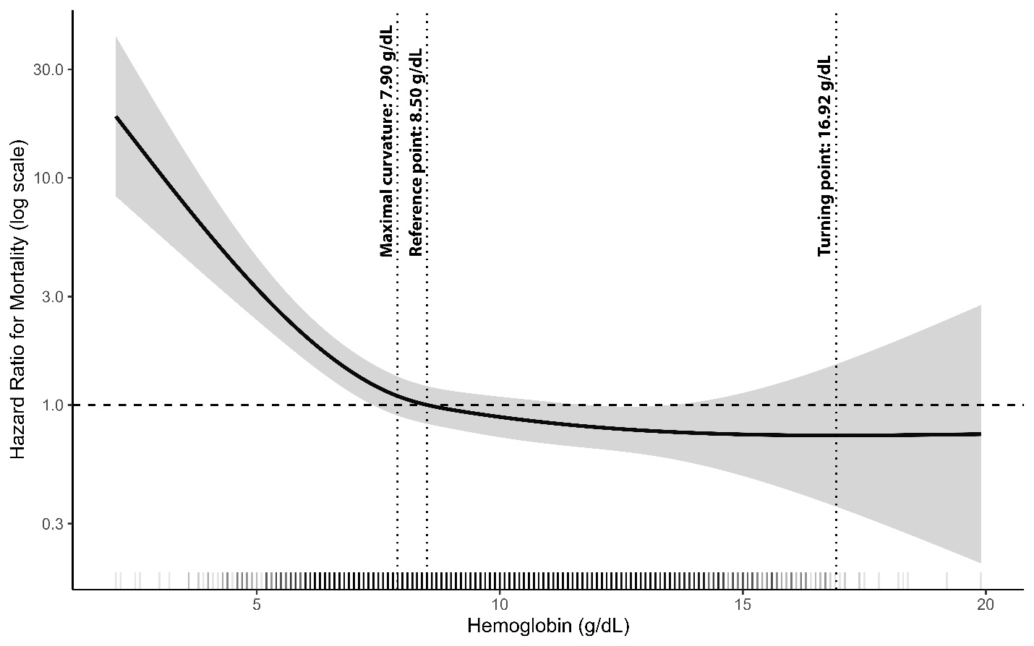
Hazard ratio with 95% confidence intervals (shaded region) relative to the median hemoglobin value as reference. The density of individual hemoglobin observations is displayed along the x-axis. There were 62 patients with an ICD10 code for major bleeding that were excluded from the analysis.

Supplemental Figure 12: Outcomes Analysis Adjusted for Time-Varying SOFA Scores
Supplemental Figure 12: Restricted Cubic Spline Analysis of 30-Day Hemoglobin and Mortality Hazard, Excluding Patients with Major Bleeding
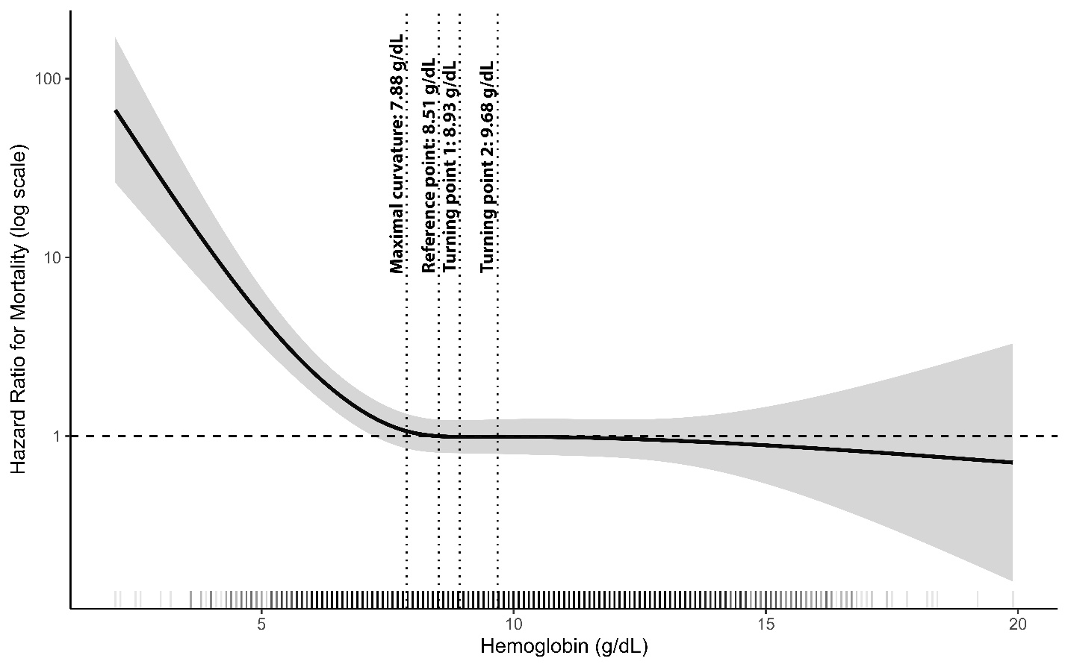
Hazard ratio with 95% confidence intervals (shaded region) relative to the median hemoglobin value as reference. The density of individual hemoglobin observations is displayed along the x-axis.

