Additional files
Figure 1
Phases of an ILS showing the investigation phase with a PhET simulation
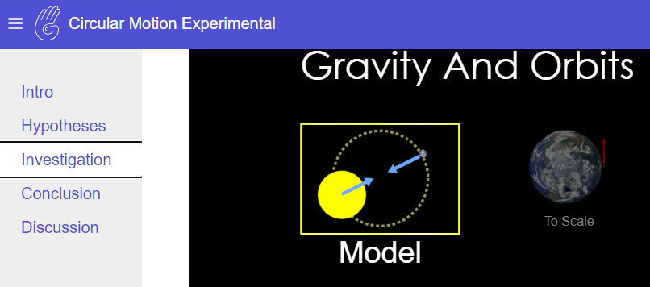

Figure 2
The hypothesis scratchpad as used in the control condition
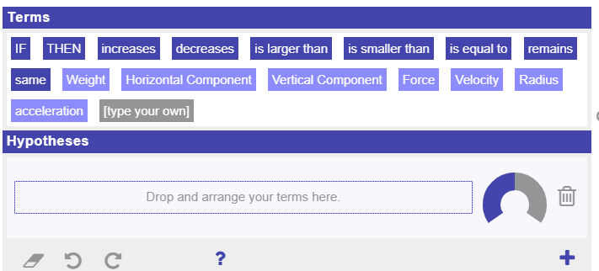
Figure 3
Padlet postings by students
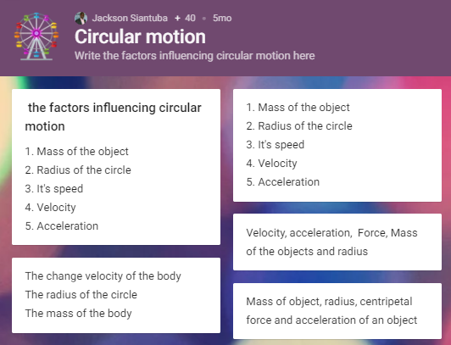

Figure 4
Display for the uniform circular motion simulation
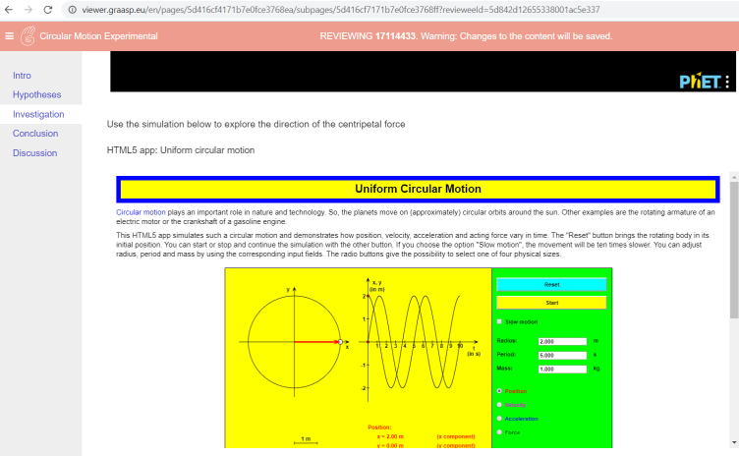

Figure 5
Box and whiskers plot of pre-test and post-test scores

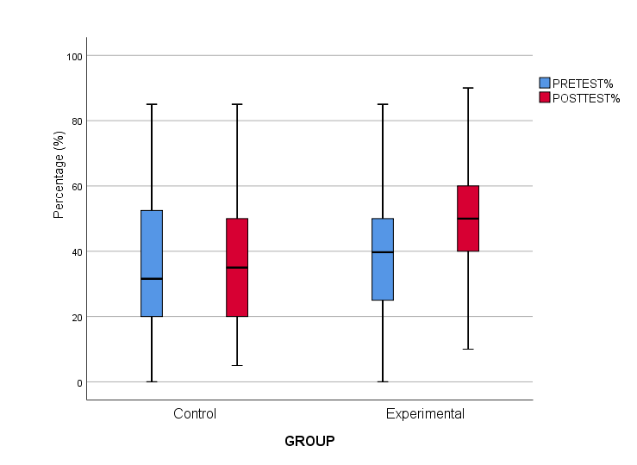

This simulation lab was designed by PhET Interactive Simulations, University of Colorado Boulder, licensed under CC-BY 4.0. https://phet.colorado.edu

