Additional material for
The partitioning of the energy transport response of Ekman flux and the atmosphere to prescribed surface forcing in a simplified GCM
Sarah M. Kang^{1*}, Yechul Shin¹, and Francis Codron²

¹School of Urban and Environmental Engineering, Ulsan National Institute of Science and Technology, Ulsan, Republic of Korea
²Laboratoire d'Océanographie et du Climat (LOCEAN/IPSL), Sorbonne - Université, Paris, France

Contents of this file
Figure S1 to S4

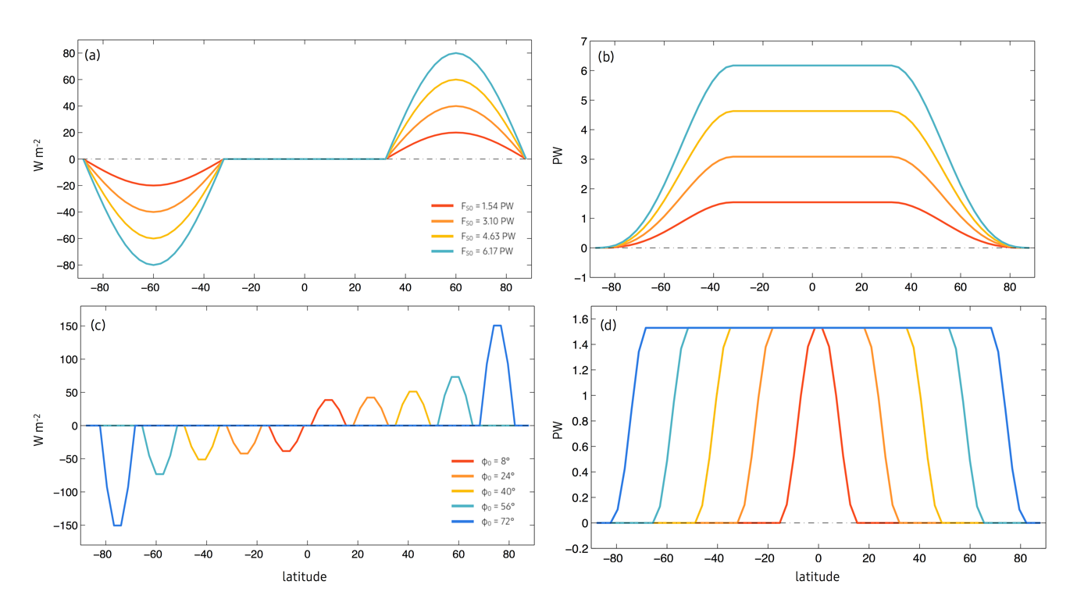
Figure S1. The prescribed surface heating ($S$; left column) and associated implied ocean heat transport ($F_{S}$; right column) in the experiments with varying (a, b) forcing amplitude $F_{S0}$ and (c, d) forced latitude band $φ_{0}$.

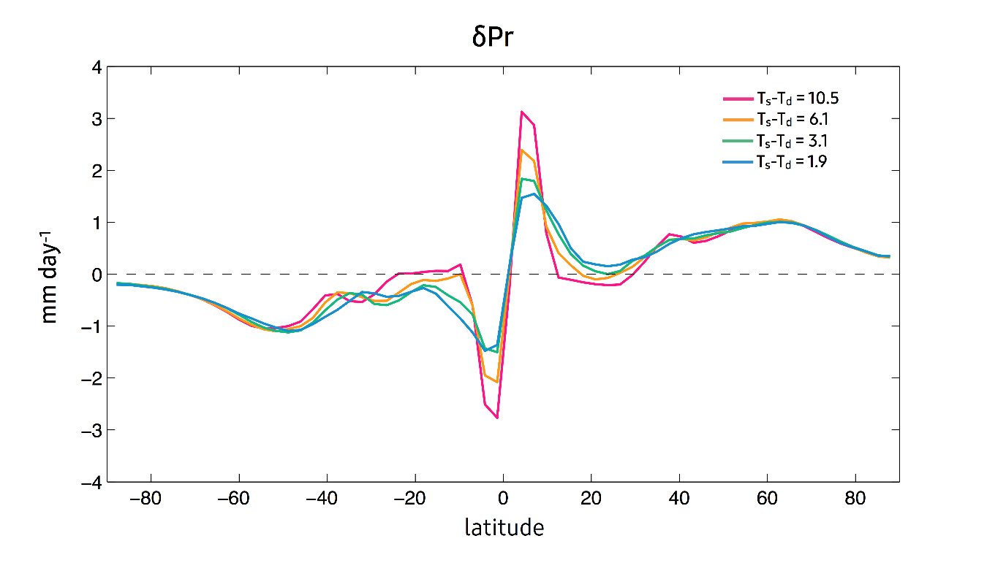 Figure S2. The zonal-mean response of precipitation in mm day⁻¹ in the experiments with extratropical perturbations with $F_{S0}$=4.6 PW.

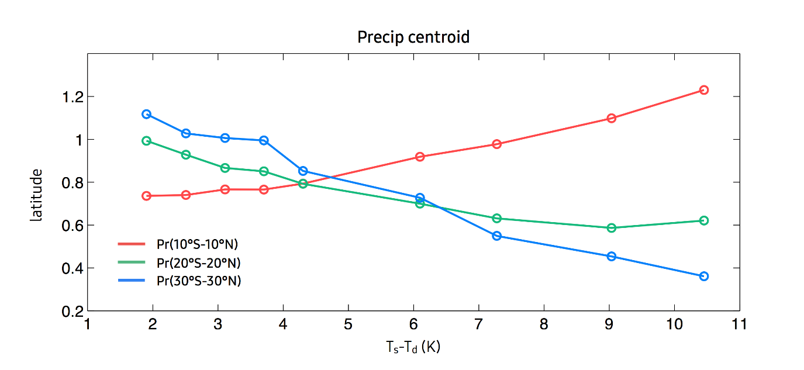 Figure S3. The precipitation centroid of zonal mean precipitation between 10°S-10°N (red), 20°S-20°N (green), and 30°S-30°N (blue) as a function of $T_{s}-T_{d}$ in the experiments with extratropical perturbations with $F_{S0}$=4.6 PW.

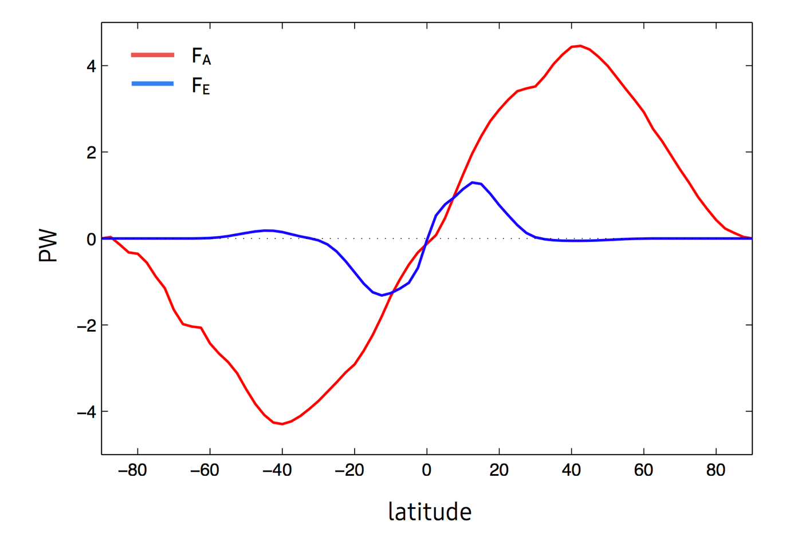
Figure S4. Atmospheric energy transport $F_{A}$ (red) and Ekman energy transport $F_{E}$ (blue) in the annual and zonal mean for 1979-2009. The atmospheric energy transport is from NCEP/NCAR reanalysis (Donohoe et al. 2014). The Ekman energy transport is computed by taking the zonal wind stress from NCEP/NCAR reanalysis with an assumption of 50m mixed layer depth and $α=0.7$ that corresponds to $T_{s}-T_{d}=9$K.

