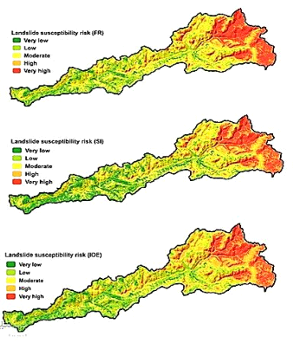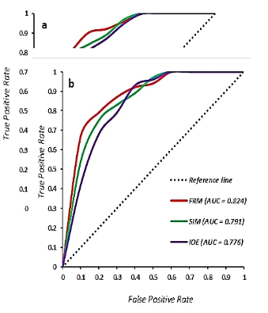

DEM

Aspect

Landsat
-
8 OLI

Climate stations

Geology
d
irectorate

Rainfall

Rivers

TWI

Curvature

Plan curvature

Profile curvature

Elevation

Lithology

Slope

R
oads

NDVI

Faults

Landslide inventory

Random Selection

Training (70%)

Test (30%)

FR, SI and IoE

ROC

Meteorological

directorate

Landslide inventory
Slope
Curvature
Aspect
Meteorological directorate

Climate stations
Landsat-8 OLI
DEM

ROC

FR, SI and IoE

Test (30%)

Training (70%)
Random Selection
Roads
Faults
Lithology

Rainfall

NDVI

TWI
Rivers
Elevation
Profile curvature

Plan curvature

Geology directorate

