Supplementary Information
SI 1. Average monthly rainfalls of July and August in Taiwan
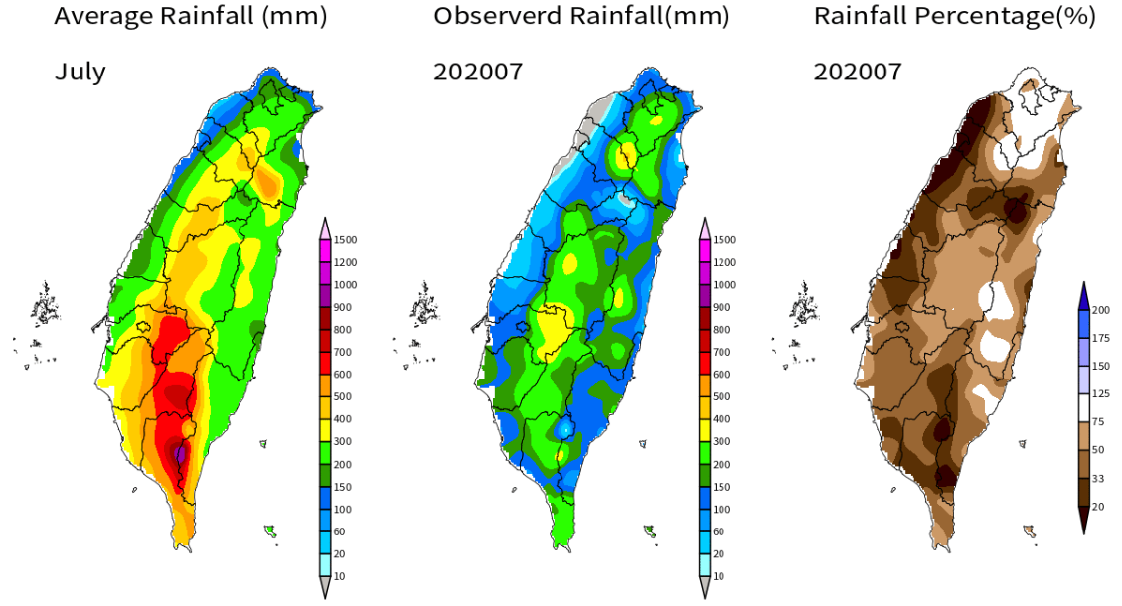
Shihmen Reservoir Watershed
Tsengwen Reservoir Watershed

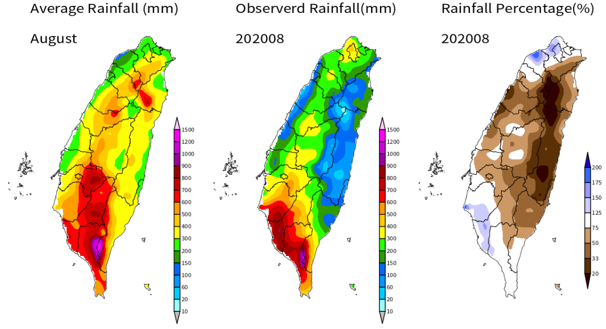
Shihmen Reservoir Watershed
Tsengwen Reservoir Watershed
NCDR, n.d. Weather and Climate Monitoring - Average Monthly Rainfall, National Science and Technology Center for Disaster Reduction, accessed 6 April 2024, https://watch.ncdr.nat.gov.tw/watch_monthlyrain

SI 2. CWA probabilistic seasonal rainfall forecasts
At the end of each month, the Central Weather Administration (CWA) of Taiwan issues PSRF for the next three months for four regions (North, Center, South, and East) in Taiwan. The following figure shows the PSRF for Jan, Feb, and March 2024, issued on Dec. 31, 2023. Tables of monthly rainfall tercile thresholds for individual months are also shown in the following table.
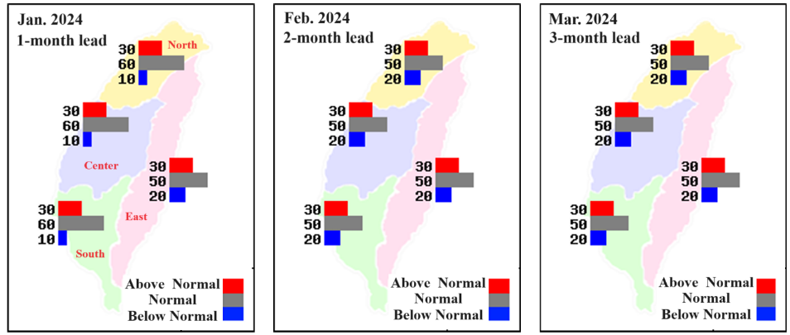
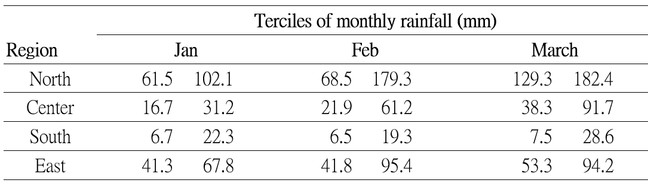
Tercile thresholds of monthly rainfalls for PSRF were determined using observed monthly rainfalls over a period of 30 years. These values are updated every 10 years. For PSRF of 2001-2010, tercile thresholds were calculated using monthly rainfalls over the 1971-2000 period, whereas, for PSRF of 2011-2020, tercile thresholds were calculated using monthly rainfalls over the 1981-2010 period.
The L-moment-ratio-based GOF test was used to choose the probability distribution type for monthly rainfall of individual months. In Taiwan, the GOF test for hydrologic frequency analysis typically requires 40 or more years of data. In our study, the performance of CWA PSRF over 2004-2020 was evaluated, and therefore, monthly rainfalls over 1981-2020 were used in the GOF test. The following figure illustrates the PSRF periods, the corresponding periods for climate tercile threshold calculation, and the period of monthly rainfalls for the GOF test.
