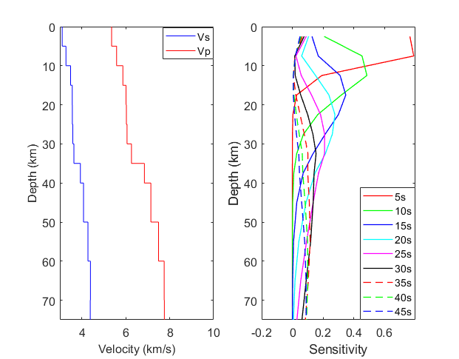
Figure A1.The 1‐D velocity model (a) and depth-sensitive kernel of Rayleigh wave phase velocity to shear wave velocity in the study area.(b)

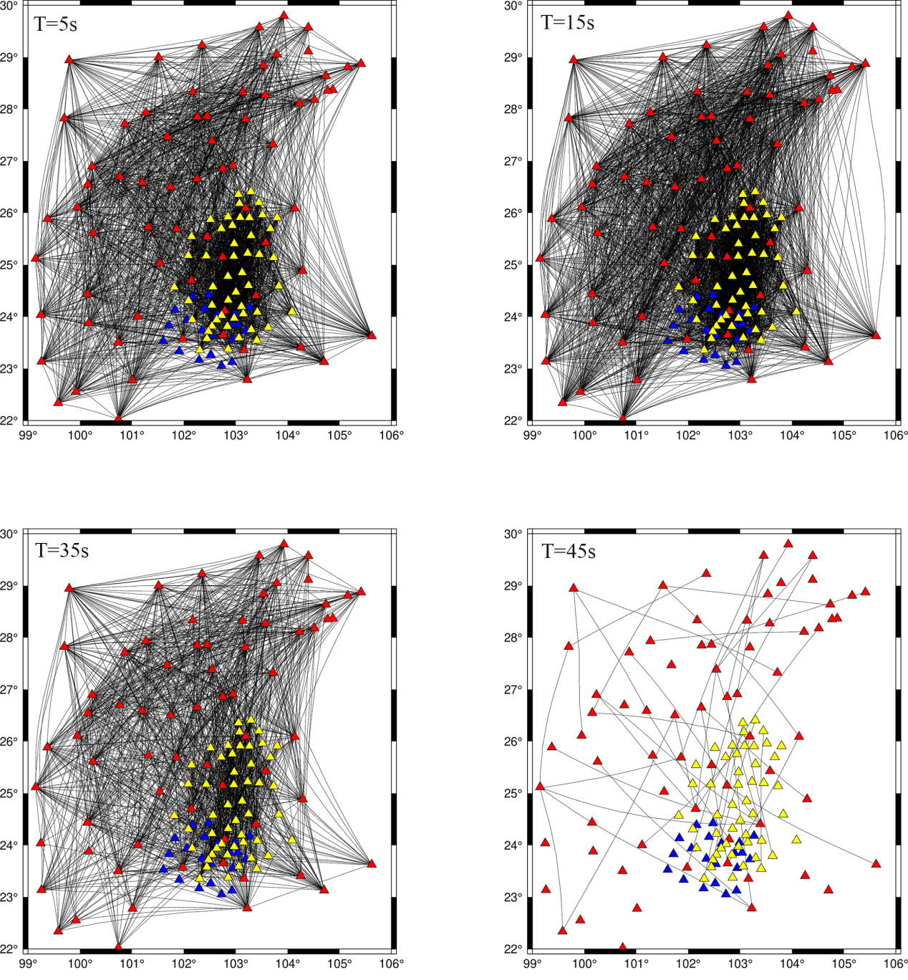
Figure A2. The ray path at the period of 5 s,25s,35s,45s(the triangles represent the station, and the black lines refer to the ray path).
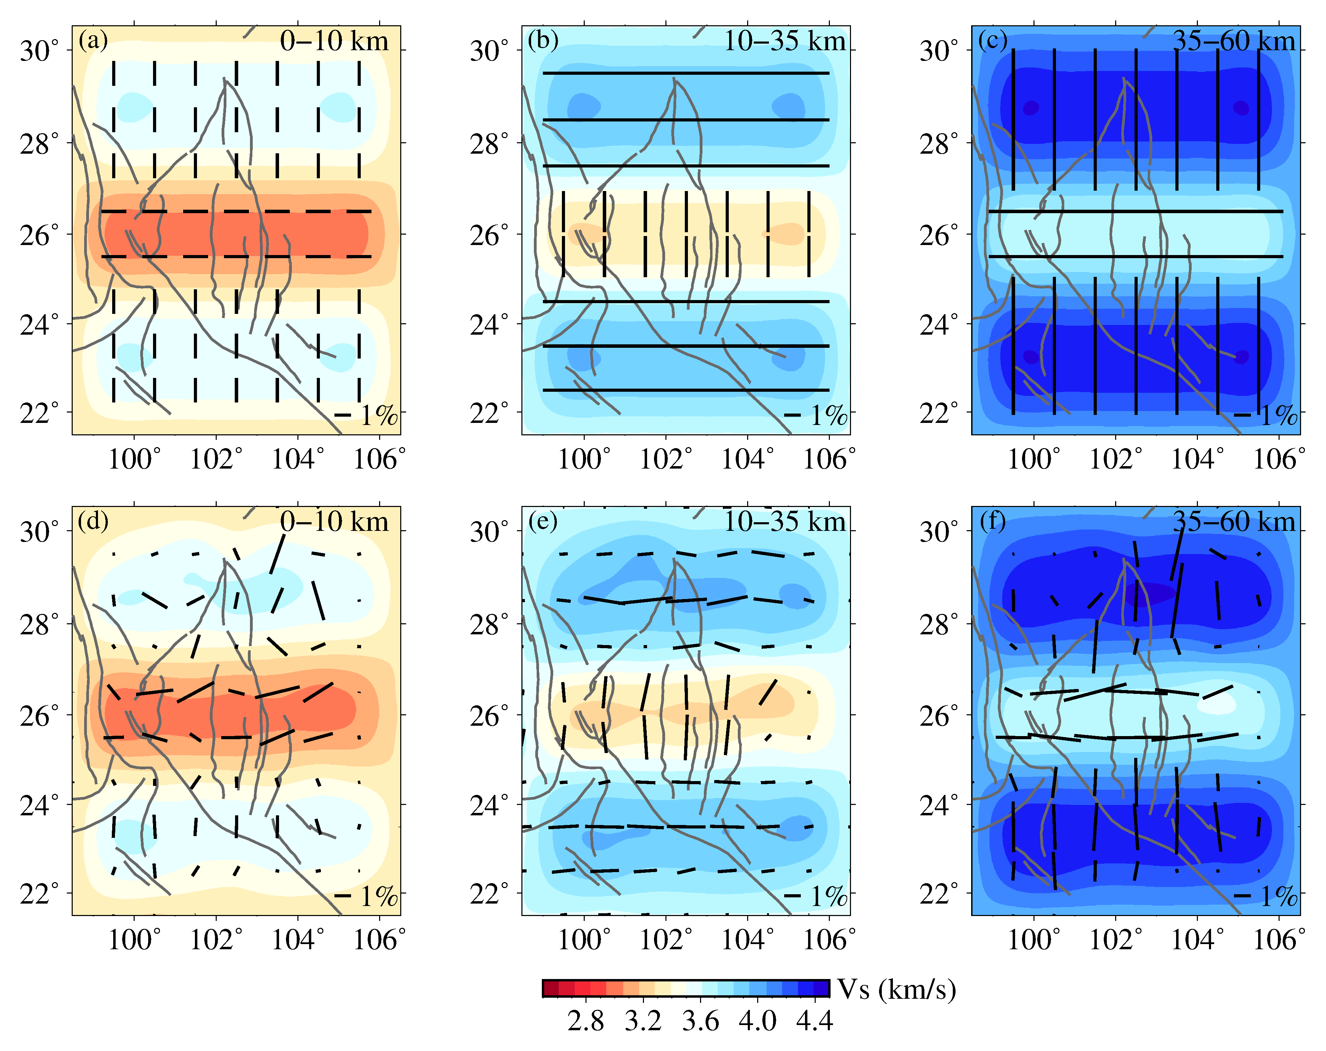
Figure A3. Input model (a-c) and the recovery of the input model (d-f).
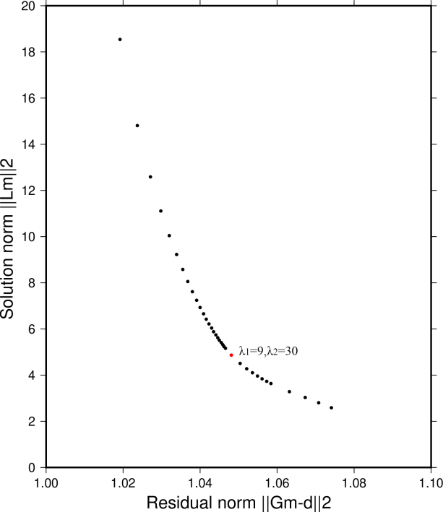
Figure A4.L-curve analysis for the direct inversion. The horizontal axis is the data residual term, and the vertical axis is the model regularization term. The parameter λ is the weighting factor, where λ₁is the isotropic weight factor, λ₂ is the anisotropic weight factor, and the point in red represents the optimal value of λ.

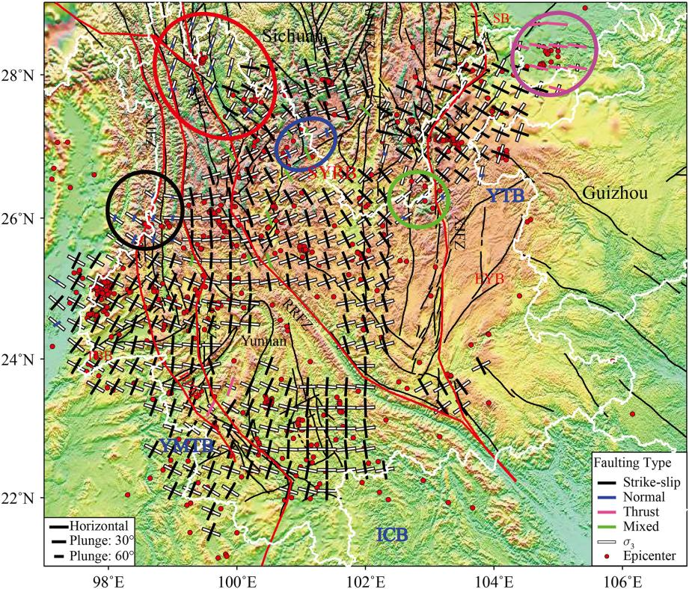
Figure A5.Result of the stress field inversion, with black, blue, magenta, and green line segments depicting the projection of the maximum principal stress axis (maximum compression σ1) and white line segments showing the projection of the minimum principal stress axis (maximum extension σ3). The black, blue, magenta, and green line segments indicate strike-slip, normal-, thrust-, and mixed-type stress environments, respectively. The directions of the line segments show the azimuths of the axes, whereas the lengths indicate the inclinations, with longer line segments showing more horizontal axes. The red dots are epicenters of earthquakes whose focal mechanisms were used in the stress field inversion. Colored ellipses highlight areas with a non-strike-slip stress field, including normal faulting near Tengchong (black), Dêqên-Zhongdian (red), Ninglang (blue), and Huize (green) and thrust faulting at the border between northeastern Yunnan and Sichuan. From Tian et al., 2019.

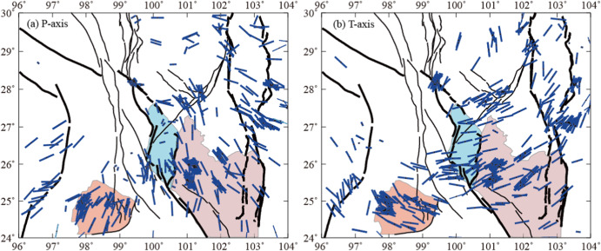
Figure S6.Horizontal projection of the P axis (a) and the T axis (b) of the focal mechanism solutions (5.0≤M ≤ 6.5). The direction of the line segment represents the azimuth angle, and the length of the line segment represents the size of the dip angle. The longer the line segment, the greater the dip angle and the shorter the line segment, the smaller the dip angle.From Wu et al.,2023.

