List of Supplementary Figures
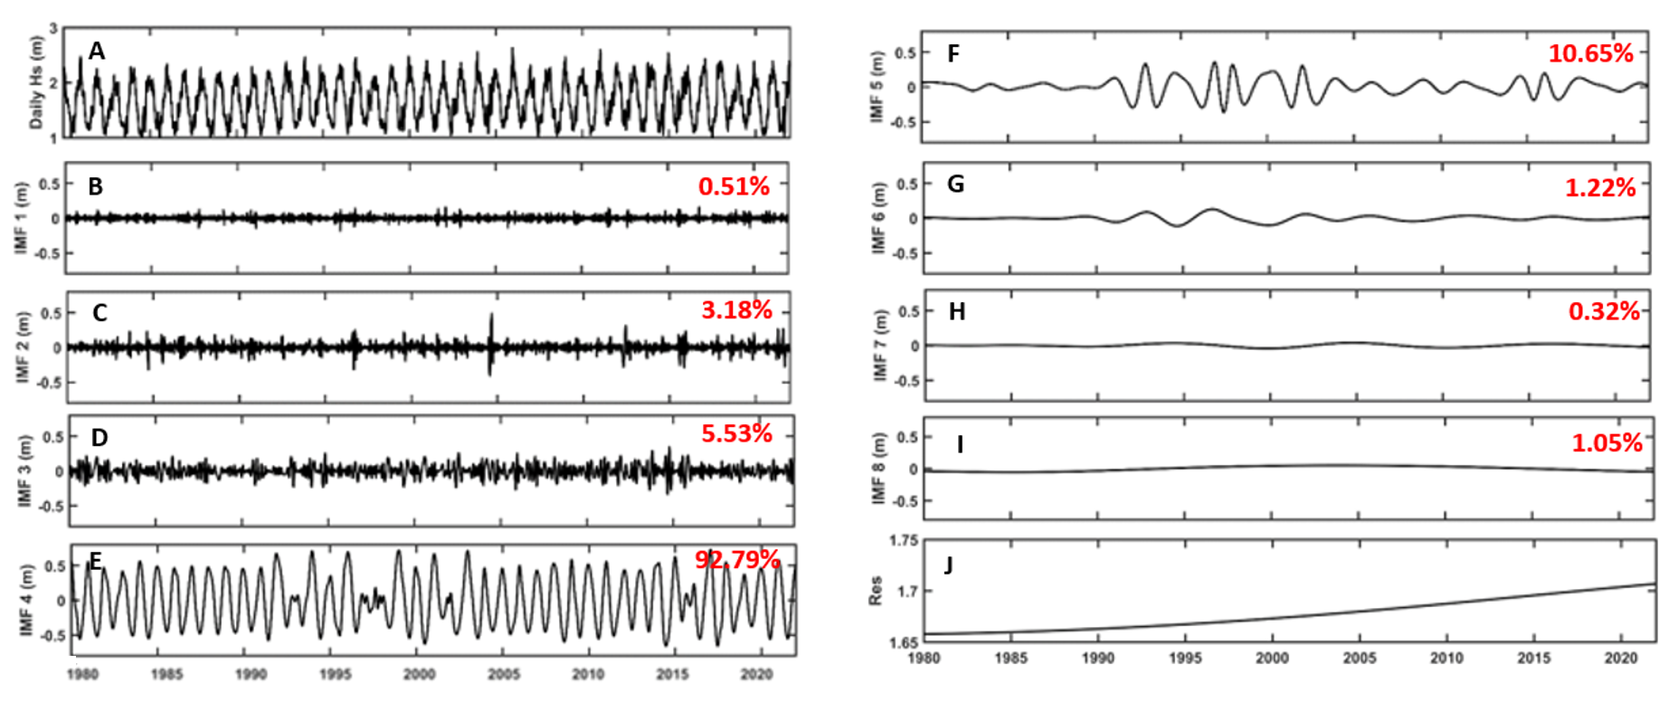
Figure S1. The Intrinsic Mode Function (IMFs:) from the decomposition of daily East Asian domain-averaged (a) using Empirical Model Decomposition (EMD) representing eight oscillations (IMF1 to IMF8; b-i) of various temporal scales. Each panel also displays the variance contribution of the corresponding IMF to the total variance of the original Hs data, with percentages indicating the relative variance explained.

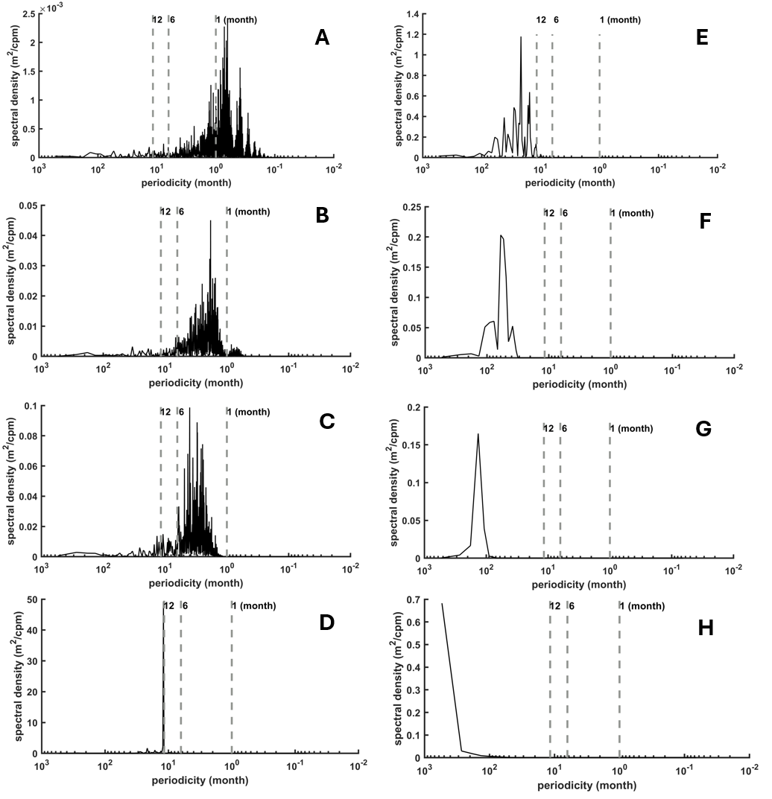
Figure S2. Power Spectral Density of Each Intrinsic Mode Function (IMF1 to IMF8 from Figure S1, for example, panel (a) corresponds to IMF1 in Figure S1 panel (b), panel (b) corresponds to IMF2 in Figure S1 panel (c) and so on), showing the dominant energy periods. Panels (a-c) correspond to IMFs with the peak with peak periods of less than 6 months, capturing sub-seasonal variations. Panel (d) shows the seasonal with energy peaks around 1 year. Panels (e-f) depict interannual variations, with dominant periods ranging from 1 to several years. Panels (g-h) highlight decadal signals, with peak periods extending beyond 10 years.

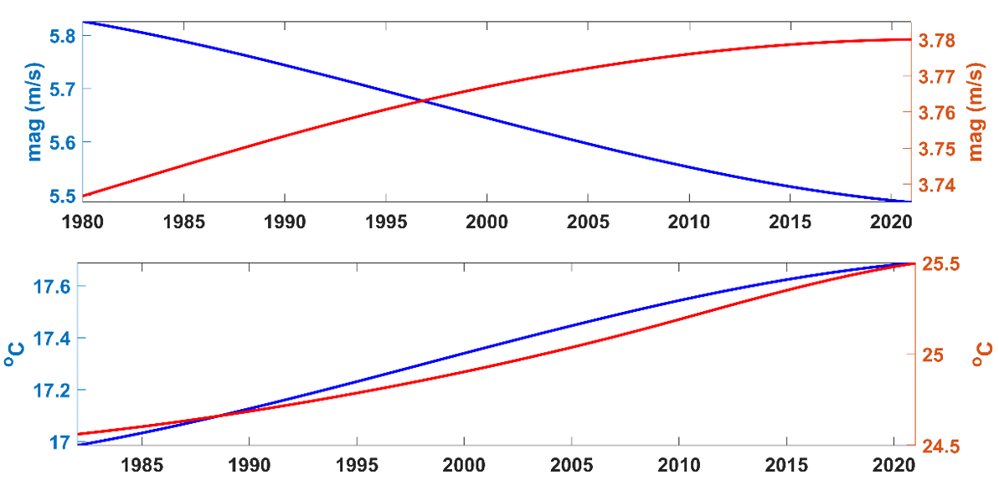
Figure S3. Seasonal long-term trend of EA domain-averaged wind speed (upper panel) and SST (lower panel). Blue and red line indicate winter and summer season respectively.

