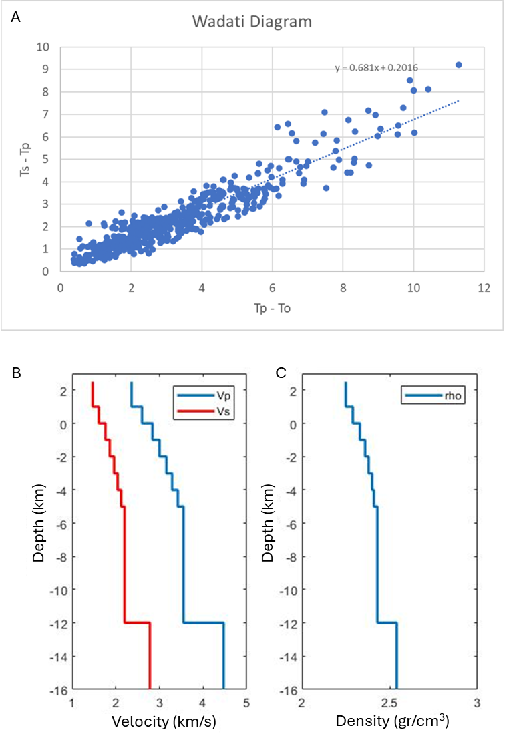
Figure 1. Input paramaters of NonLinLoc, ratio of Vp/Vs 1.68 from Wadati Diagram (A), velocity model of Vp (red) and Vs (blue) and density model generate from velocity (C)

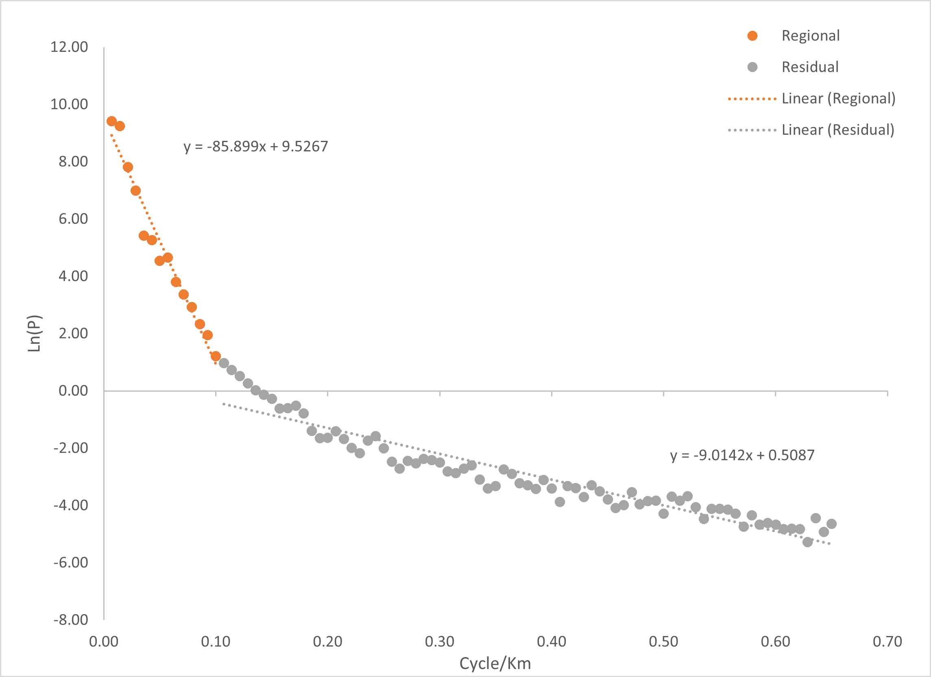
Figure 2. 2D radially average power spectrum to remove regional anomaly (orange) from residual anomaly (grey).

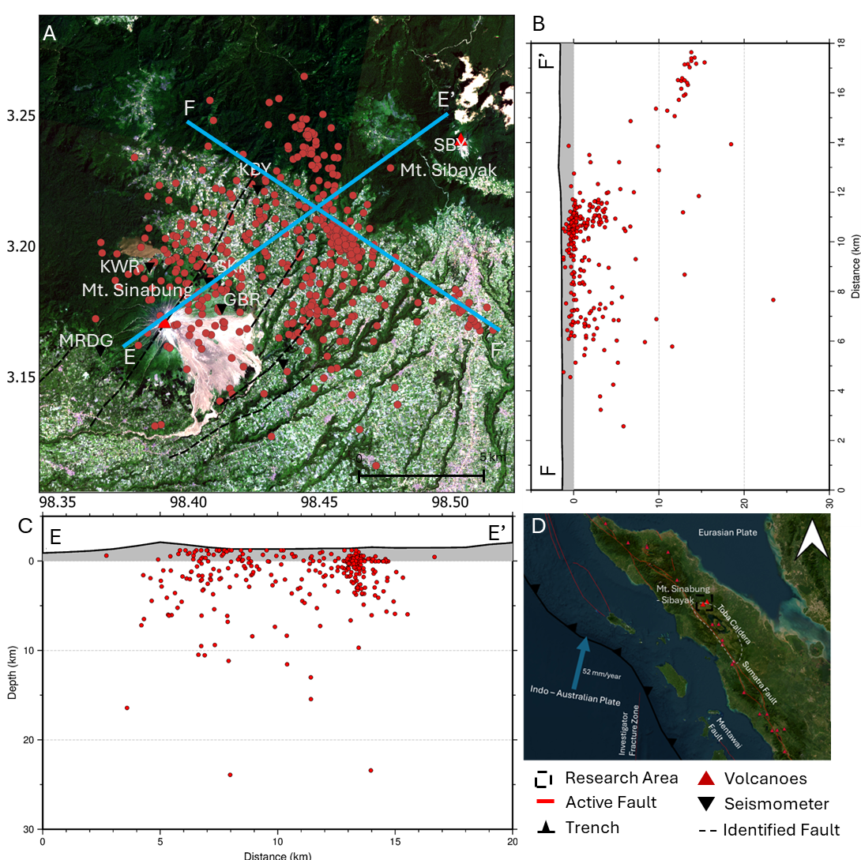
Figure 3. Earthquake hypocenter (red circle) during October 2017 – February 2018 and March – June 2019 determined using NonLinLoc (A), the black dashed line is the geological structure obtained from (Prambada et al. 2011; Afnimar et al. 2022), and the blue line represents trajectories of vertical sections E-E’ and F-F’.

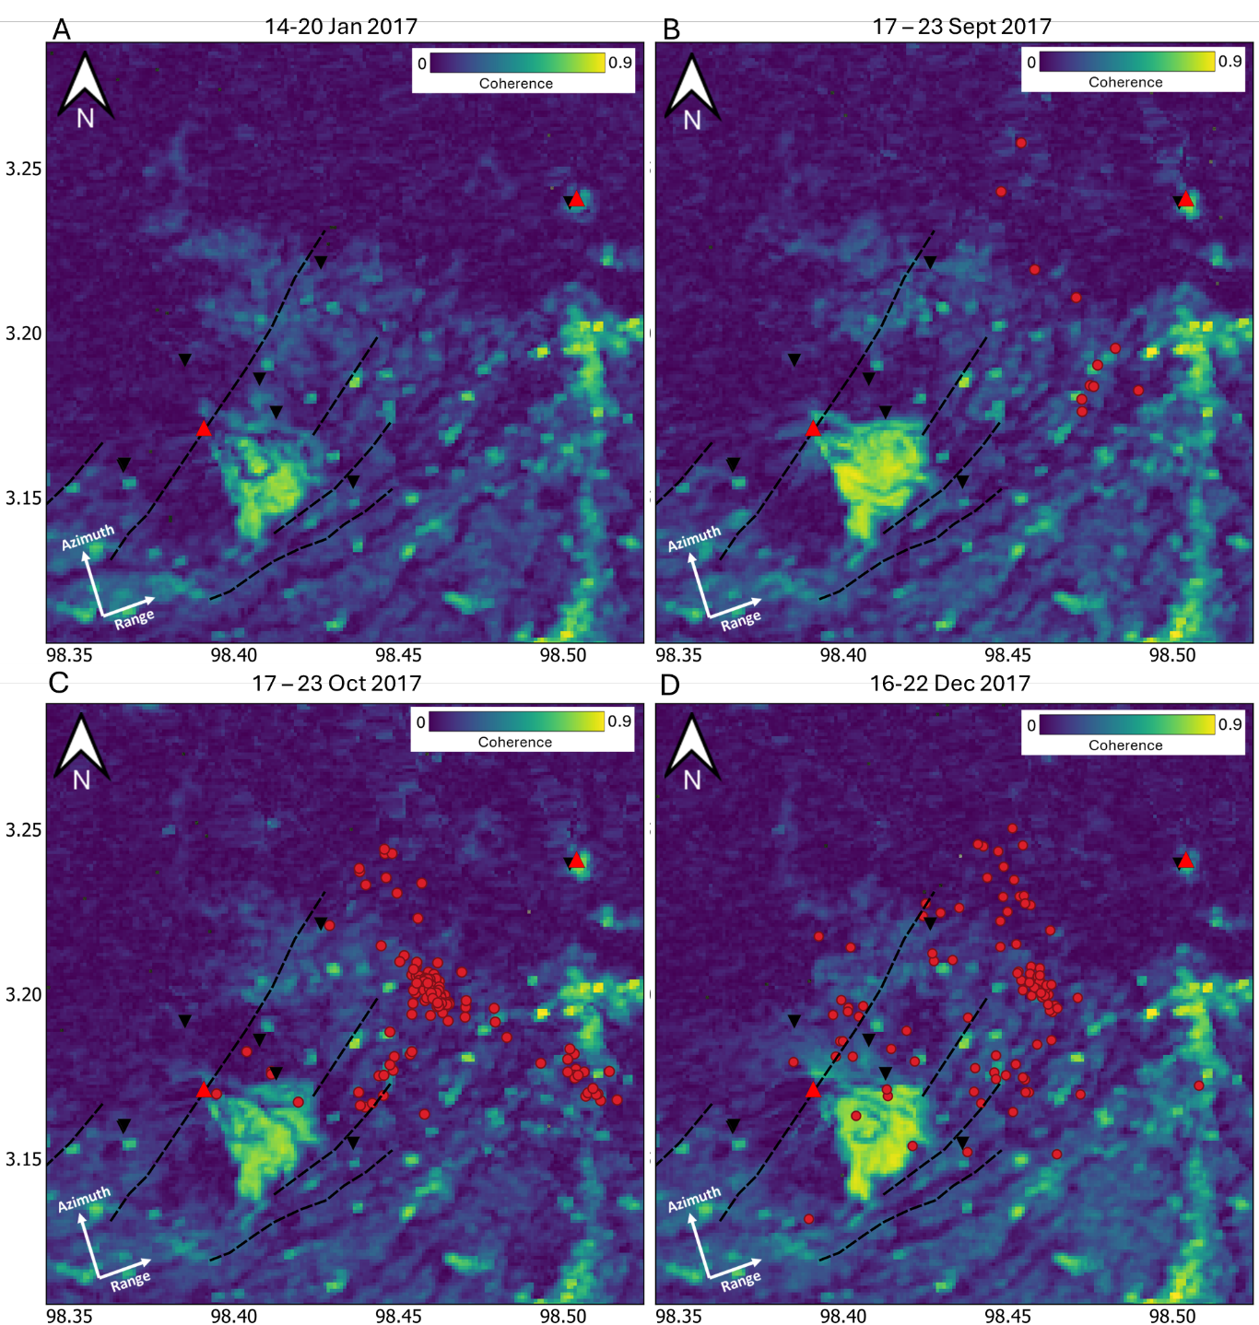
Figure 4. Coherence of ascending orbit interferogram, blue to yellow for low to high coherence. The red circle represents the epicenter of the earthquake in the selected time interval.

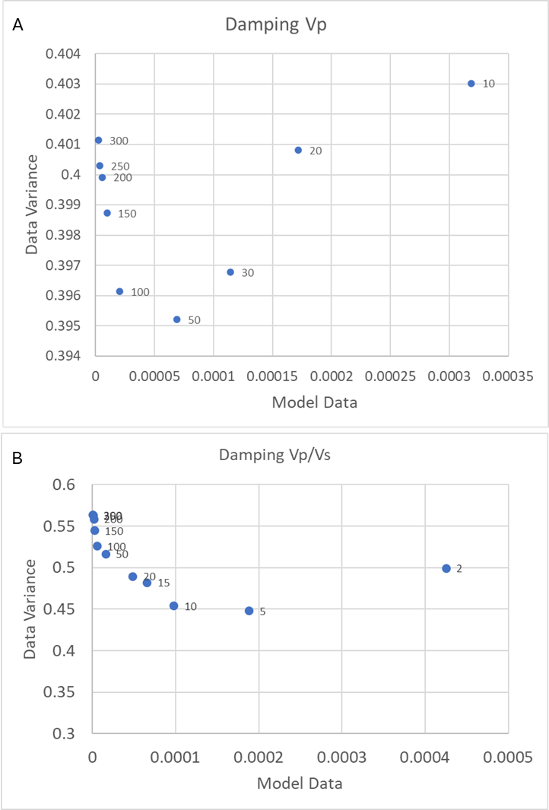
Figure 5. Damping parameters of Vp (A) and Vp/Vs (B) using on SimulPS12, the black circle indicates the best parameters.

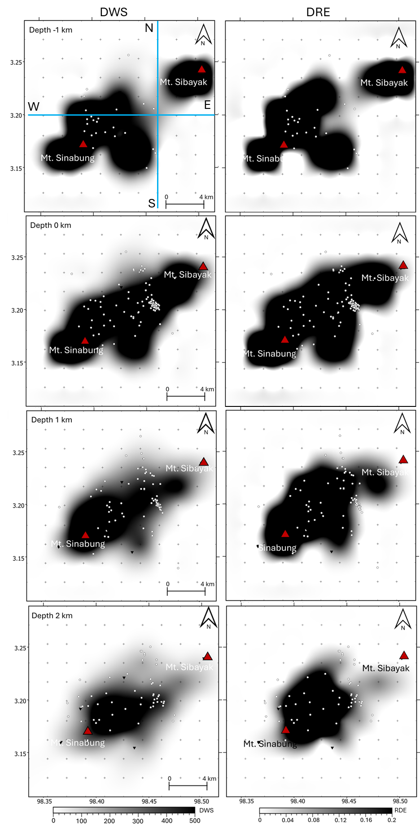
Figure 6. DWS (A-D) and RDE (E-H) resolutions tomography inversion from depth of -1 km to 2 km. The blue line represents the trajectory of the vertical section of N-S and W-E.
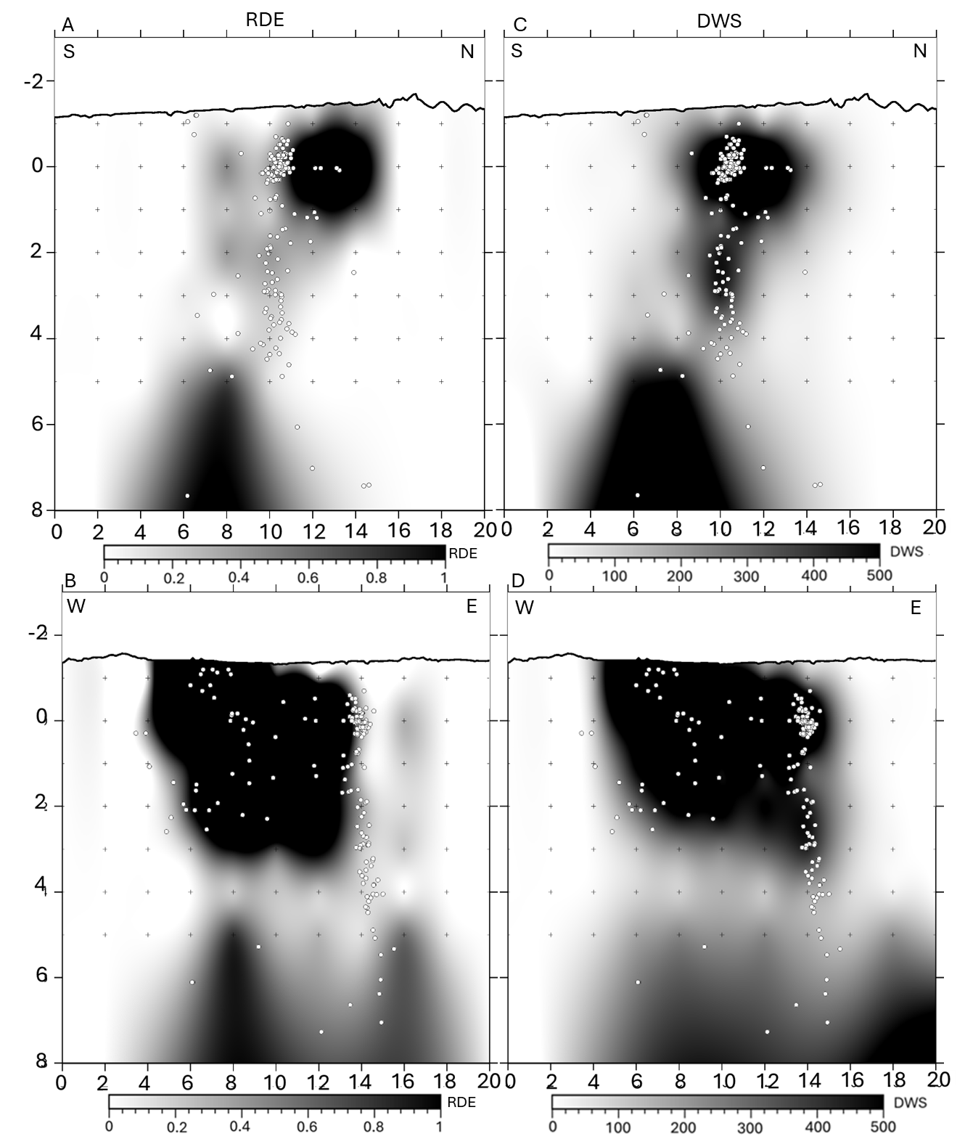
Figure 7. Vertical section of DRE (A-B) and DWS (C-D) resolutions with direction of N-S (A and C) and W-E (B and D).

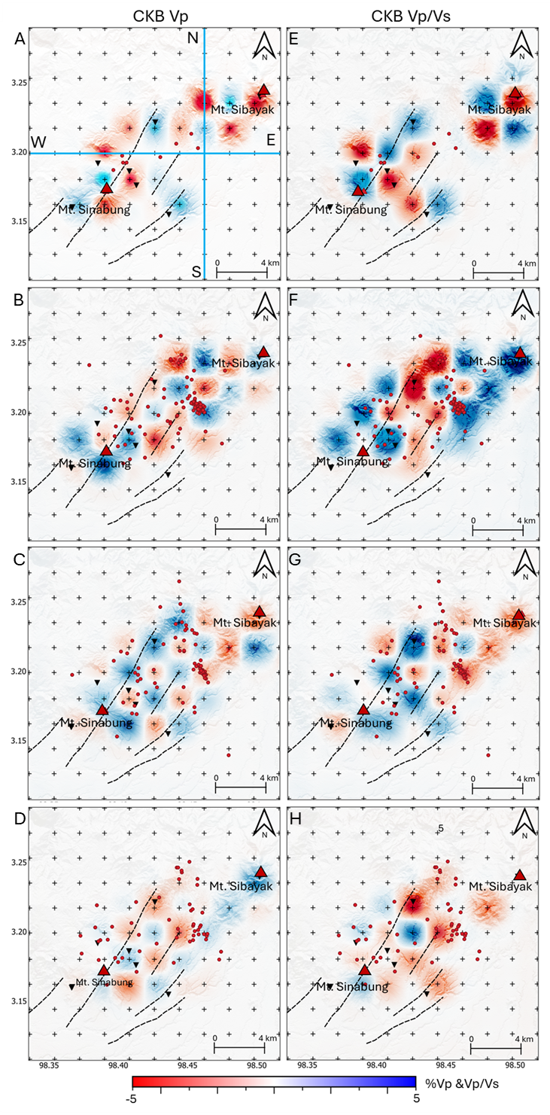
Figure 8. Checkerboard test of Vp (A-D) and Vp/Vs (E-H) with perturbation of 10%, blue color represents high and red low. The black dashed line represents geological structures, while the symbol ‘+’ represents the velocity grid model with an interval of 2 m.
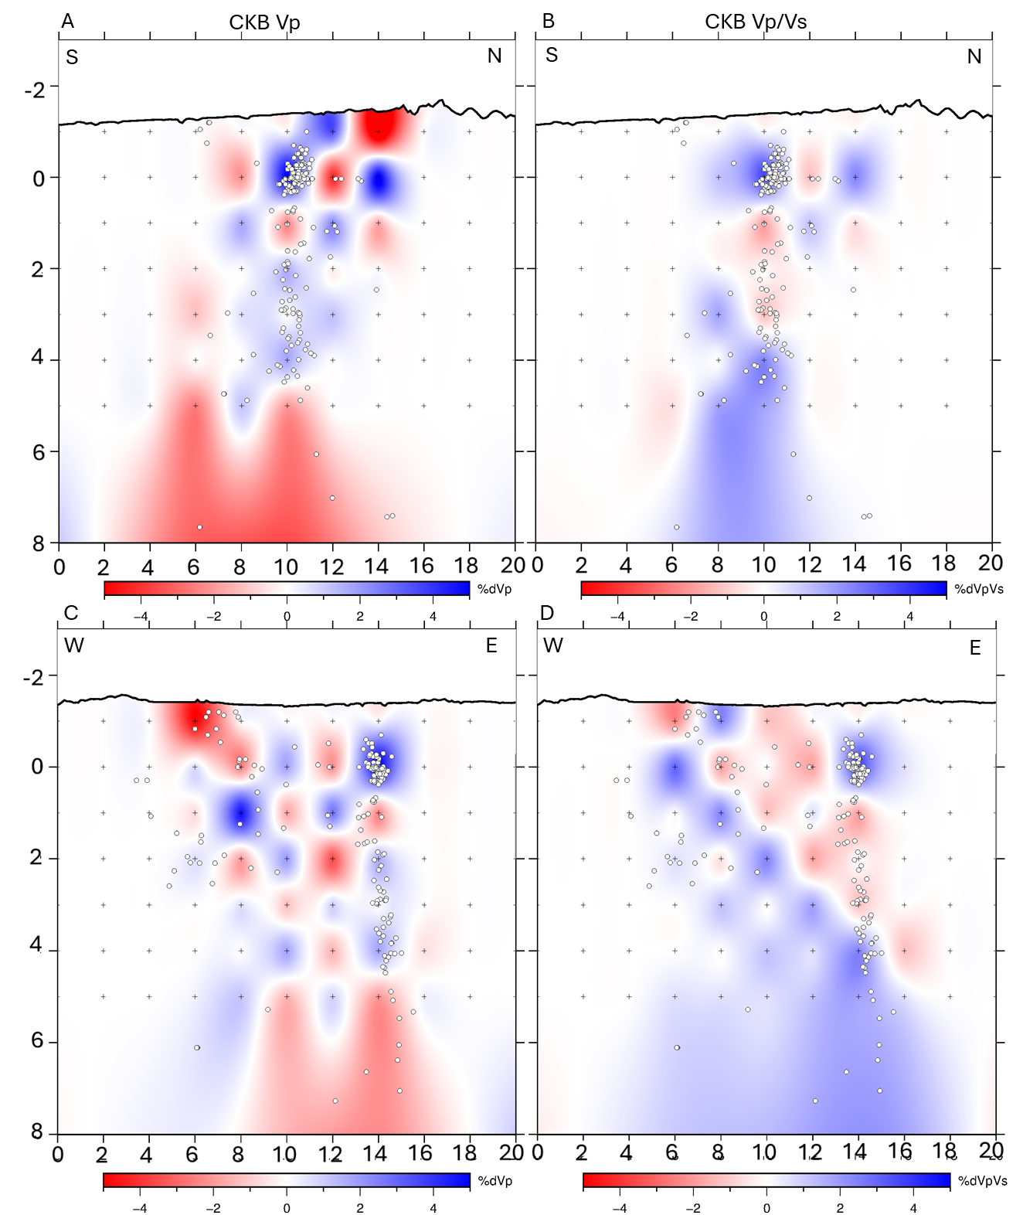
Figure 9. Vertical section checkerboard test of Vp and Vp/Vs with perturbation of 10% with orientation of S-N(A) and W-E(B), blue color represents high and red low.

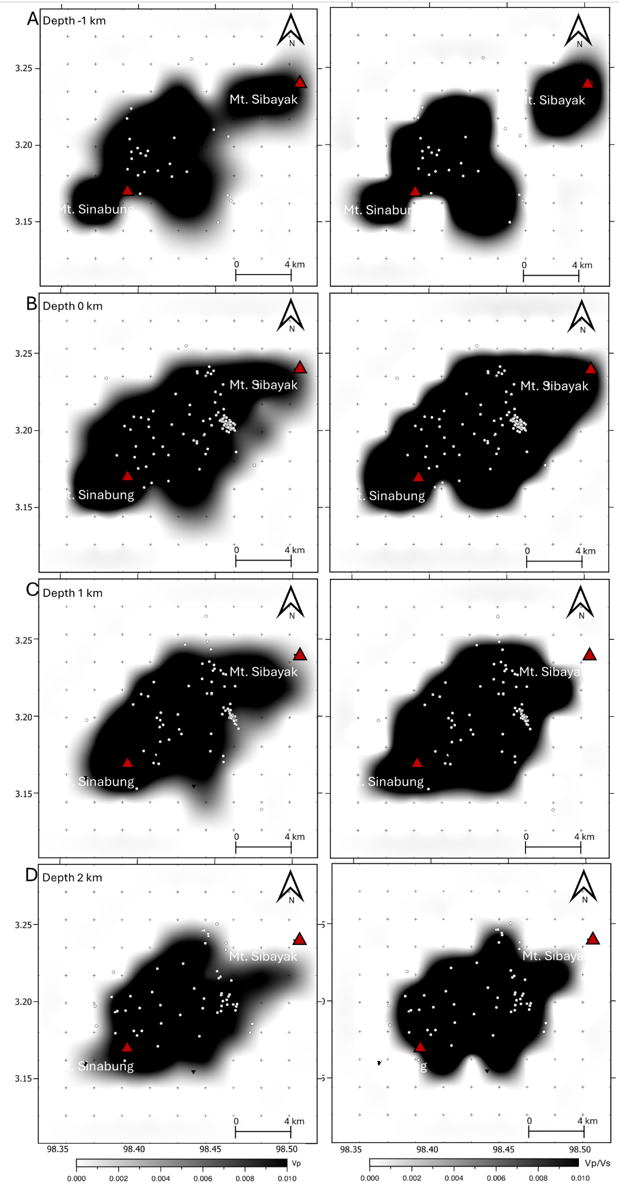
Figure 10. Velocity Vp (A) and Vp/Vs ratio (B) standard error

