Supplementary data
for
Reevaluating historical tsunami hazards from the Makran Subduction Zone and local seismic sources along the Western Indian Margin through numerical modeling
Nayan Sharma¹, Toshitaka Baba², Kenji Satake^{3,4}, Javed N. Malik^{1*}, Mahendrasinh Gadhavi⁵

¹ Active Tectonics and Paleoseismology Laboratory, Department of Earth Sciences, Indian Institute of Technology Kanpur, Kanpur 208016 Uttar Pradesh, India. Ph. +91-512-2597723; +91-9956300101.
Emails: javed@iitk.ac.in *Corresponding author; nayansh@iitk.ac.in

² Graduate School of Technology, Industrial and Social Sciences, Tokushima University, 2-1 Minami-jyosanjima-cho, Tokushima 770-8506, Japan.
Email: baba.toshi@tokushima-u.ac.jp

³National Central University, 300, Zhongda Rd., Zhongli District, Taoyuan City, 320317, Taiwan

⁴ The University of Tokyo, 7-3-1, Hongo, Bunkyo-ku, Tokyo 113-8654, Japan
Email: satake@eri.u-tokyo.ac.jp

⁵Civil Engineering Department, L. D. College of Engineering, Ahmedabad, Gujarat, India.
Email: msgadhavi@ldce.ac.in

- Uncertainties in Sea-level reconstructions
The sea-level (SL) curve reconstructed for the western Indian coast indicates that around 14,500 years BP, SL was positioned at approximately −100 m relative to the present. This was followed by a rapid transgression at a rate of ~10 m per thousand years, reaching −80 m by ~12,000 BP. Between 12,000 and 10,000 BP, the record suggests a relative stillstand punctuated by minor oscillations. Thereafter, from ~10,000 to 7,000 BP, sea level rose abruptly from −80 m to near its present position, with an estimated rate of ~18 mm/year (Kale & Rajguru, 1985; Hashimi et al., 1995) (Figure 5). During the Early to Late Holocene, the Kachchh region functioned as a navigable gulf between ~6000 and 2000 BP, before shallowing to its current state (Gaur & Vora, 1999; Malik et al., 1999a; Gaur et al., 2013; Makwana et al., 2019). In contrast, records from the Saurashtra coast, located south of the Gulf of Kachchh, show mid-Holocene SL highstands of 2–3 m between ~6500 and 4500 BP (Kale & Rajguru, 1985), with geomorphic markers and radiocarbon ages further supporting elevations of up to ~4 m (Mathur et al., 2002). Notably, coastal notches and wave-cut platforms document highstands of 4–5 m during the mid-Holocene, followed by a rapid fall around ~3000 BP (Tyagi et al., 2012; Das et al., 2017; Makwana et al., 2019) (Figure 5). This regression coincides with the florescence of Harappan centers (~2800–1800 BCE) and is further interpreted as evidence for tectonic uplift of up to ~2 m in the Saurashtra margin (Bhatt & Bhonde, 2006; Pant & Juyal, 1993).
Additional paleoenvironmental evidence, such as the presence of mangrove patches in the Banni Plain (north-central Kachchh Mainland Fault zone), points to shallow marine conditions that persisted until the onset of late Holocene regression after ~3000 BP (Tripathi et al., 2013). By ~1000 BP, SL was reconstructed at 0.53 ± 0.43 m above present levels (Sharma et al., 2021). More recent analyses, after correcting for tectonic contributions, suggest that mid-Holocene SL in the Saurashtra Peninsula was ~1 m above present (Banerji et al., 2015), corroborating earlier findings by Brückner (1989). Compared to the relatively well-documented Saurashtra coast, the tectonically active Kachchh margin remains poorly constrained, with fewer SL reconstructions anchored to a common datum (Bhattacharya et al., 2014, 2019). Limited estimates suggest that the Little Rann experienced water depths of ~4 m around ~2000 BP (Gupta, 1975), while marine sedimentation continued in the Great Rann until at least ~1500 CE (Khonde et al., 2011).
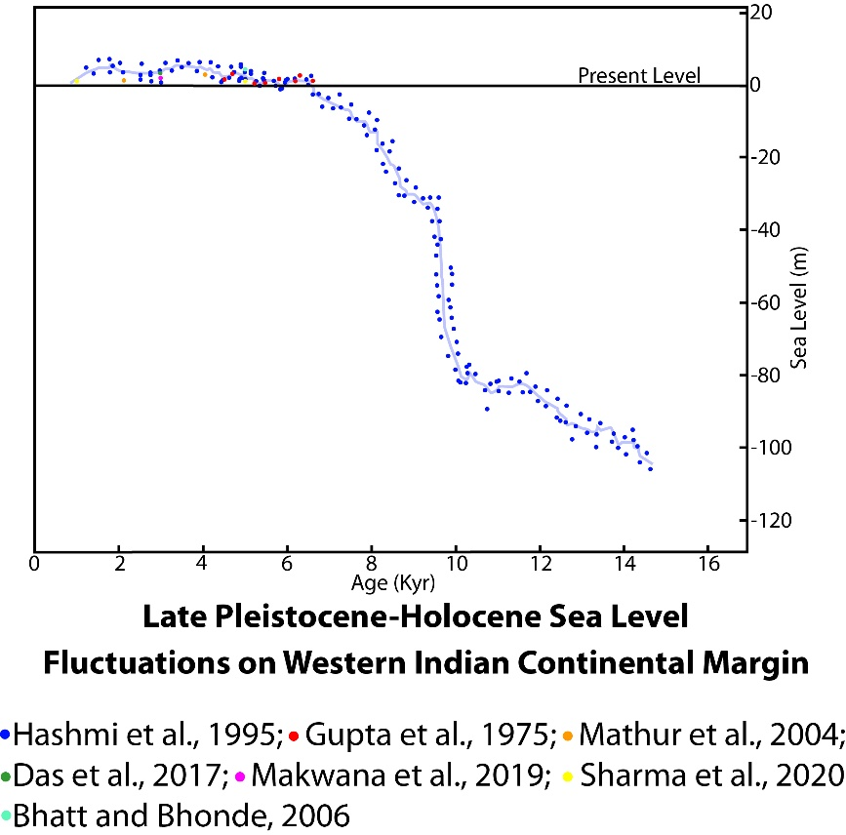
Figure S1: Relative sea-level variations along the west coast of India during the last 16 kyr BP.
Archaeological proxies shed more light on the dynamics of Holocene SL. Numerous Harappan sites in Kachchh, located 30–50 km inland from the present shoreline, preserve dockyards, stone anchors, and other indicators of maritime activity, supporting the interpretation that much of the upland region was navigable between ~2800–1800 BCE (Gaur & Vora, 1999; Gaur et al., 2013; Giosan et al., 2012) (Figure 6). Classical sources also corroborate this perspective: the Periplus of the Erythraean Sea (1st century CE) describes the region as a shallow marine gulf with seaports along the northern uplands extending up to 37 km northwest of Bhuj, which is now ~50 km from the modern shoreline (Burnes, 1834). Similarly, Sivewright (1907) proposed that the geomorphic evolution of Kachchh was influenced by seismic events, notably the 1819 earthquake, which produced coseismic uplift (6–9 m) along the northern Allah Bund and subsidence (~6 m) to the south. He further argued that the Kachchh basin was historically connected to the sea either through Kori Creek or the Gulf of Kachchh, and that navigation persisted well beyond the Arab conquest in 712 CE (Figure 6).
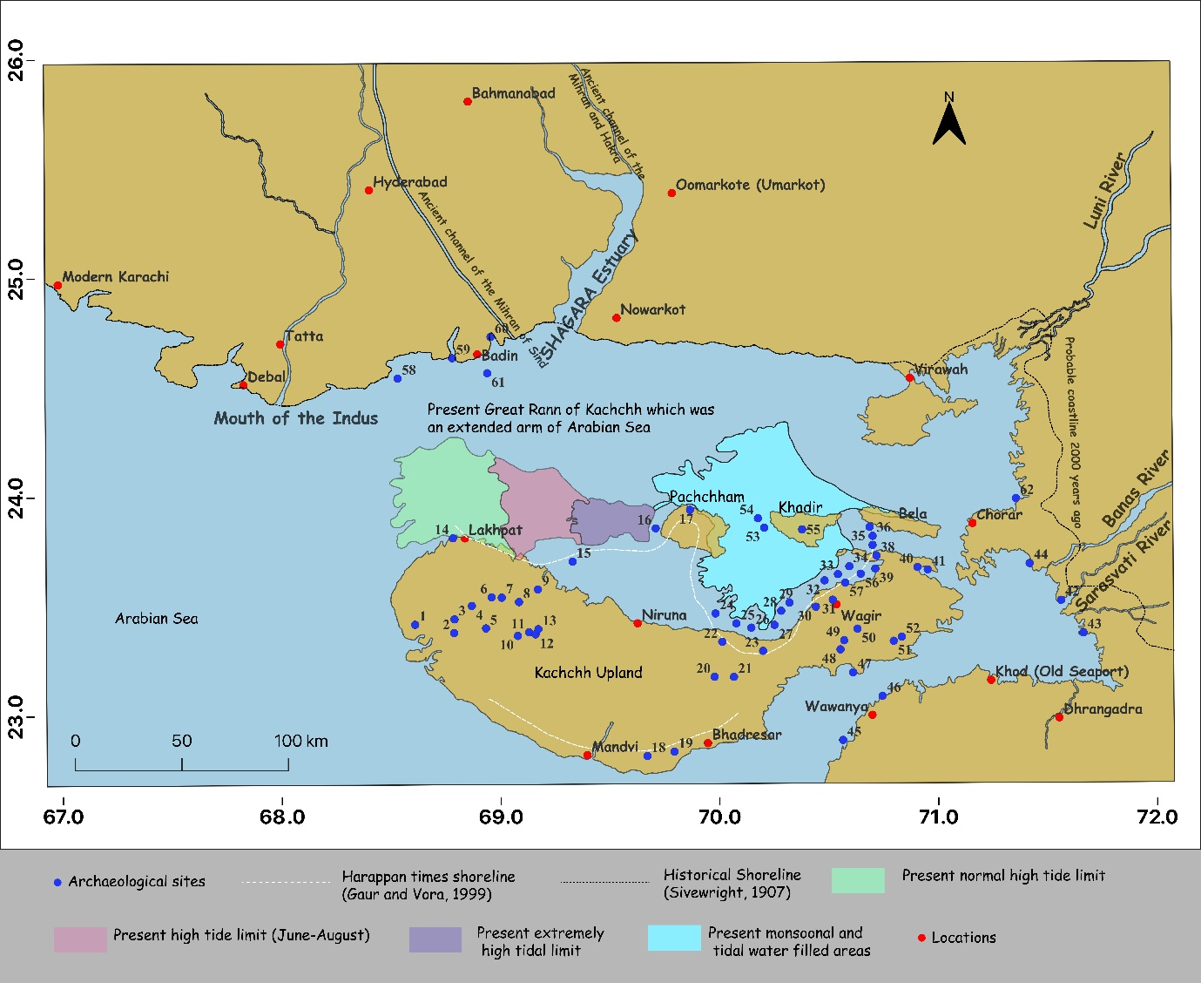
Figure S2: Land–sea configuration during AD 712 (after Sivewright, 1907). Harappan archaeological sites are shown as blue dots. Paleo-shorelines are represented by a black dashed line (Sivewright, 1907) and a white dashed line (Gaur and Vora, 1999), the latter based on the distribution of Harappan sites during the Middle to Late Holocene. Present-day tidal incursion limits for the Kachchh region are also indicated (modified after Sivewright, 1907; Srivastava et al., 2023).
Tectonic and isostatic processes further complicate interpretations of relative sea-level (RSL) history in the region. The western margin of Kachchh is structurally influenced by the Chaman Fault system, a major strike-slip boundary between the Indian and Eurasian plates (Barnhart, 2017). Neotectonic activity has been repeatedly documented, and RSL reconstructions suggest sea level up to ~4 m above present at ~6 ka. Glacio-hydro-isostatic adjustment (GIA) modelling also indicates that the western Indian coast may have experienced up to 5 m of uplift since the mid-Holocene (Milne & Mitrovica, 2008), which could account for higher SL stands in Kachchh. However, disentangling tectonic contributions from GIA remains a major challenge and lies beyond the scope of this study.
A key limitation across existing reconstructions is the lack of a consistent reference datum, coupled with insufficient consideration of the various drivers of RSL change. Such uncertainties directly affect inundation and run-up modelling, which depend critically on accurate palaeocoastline reconstructions. To address this, we adopt Sivewright (1907) documentation of coastline positions as reference markers for ~2000 BP and ~712 BP. For consistency, these shorelines were correlated with present-day coastlines by applying an elevation adjustment of +9 m for the ancient (~2000 BP) shoreline and +5 m for the medieval (~5th century to 15th century) shoreline. This approach, while necessarily simplified, provides a working framework for reconstructing palaeocoastline configurations and assessing their implications for past human occupation and coastal processes.
Table S1: Name of the archaeological sites which are shown in the Figure 1d of main manuscript.
Serial no | Name
1 | Bedi
2 | Netra
3 | Khirasara
4 | Narapa/Gharani
5 | Kalyanpur
6 | Desalpur
7 | Vada/Vigodi
8 | Jetavira
9 | Chhernani
10 | Madhapar
11 | Kotada Bhadli-I
12 | Kotada Bhadli-II
13 | Kotada Bhadli-III
14 | Lakhpat
15 | Luna
16 | Jhangar (Khavada)
17 | Juni Kuran
18 | Samaghogha
19 | Navinal
20 | Kadoi
21 | Meghpar
22 | Chandani
23 | Sevakiya/Bhachau
24 | Lodai
25 | Nenu-ni-Dhar/Sumrasar
26 | Pirwada Khetar
27 | Jhangar
28 | Manafara
29 | Ner
30 | Kanthakot
31 | Ramvav
32 | Lakhapar
33 | Jesada
34 | Lodrani
35 | Rasaji Gadhada
36 | Kotada
37 | Moruo/Jatavada
38 | Gedi
39 | Selari
40 | Babarkot
41 | Lakhagadh
42 | Vadgam
43 | Nagwada
44 | Jhekada
45 | Kuntasi
46 | Bagasra
47 | Shikarpur
48 | Rampara
49 | Chitrod
50 | Lakhasar
51 | Babarkot
52 | Lakhasar-II
53 | Dholavira
54 | Saran
55 | Gadhada Khadir
56 | Rapar
57 | Pabumath
58 | Koonj Sor
59 | Korohio Pir
60 | Markhan
61 | Kot Kori
62 | Benop
63 | Vigukot

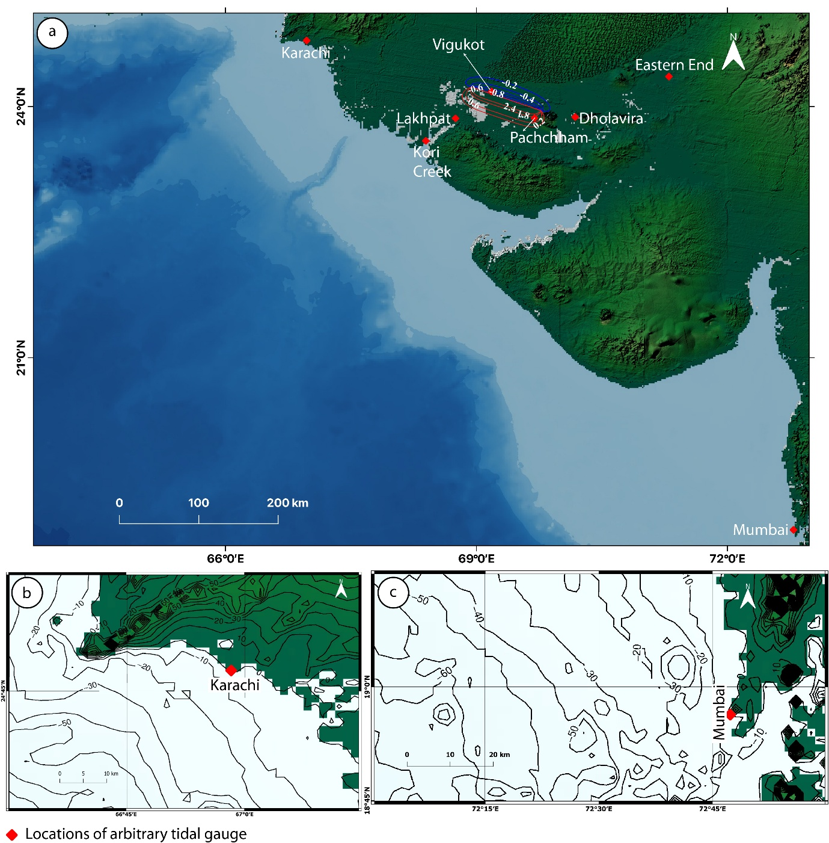
Figure S3: a) Locations of the artificial tide gauges (red polygon) and co-seismic crustal deformation associated with the 1819-type Mw 7.8 earthquake, with uplift contoured in red and subsidence in blue. b) Placement of the Karachi tide gauge along the 0 m contour (10 m contour interval). c) Placement of the Mumbai tide gauge along the 0 m contour (10 m contour interval).
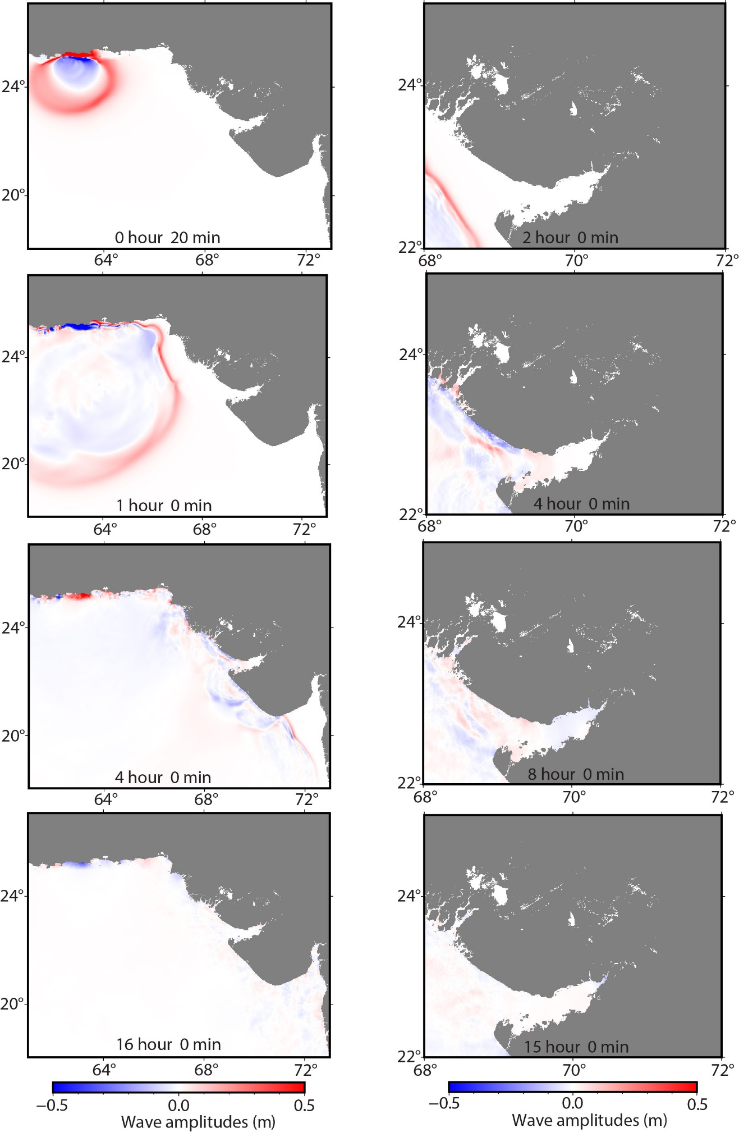
Figure S4: Snapshots of simulated tsunami propagation for the 1945 Makran earthquake.

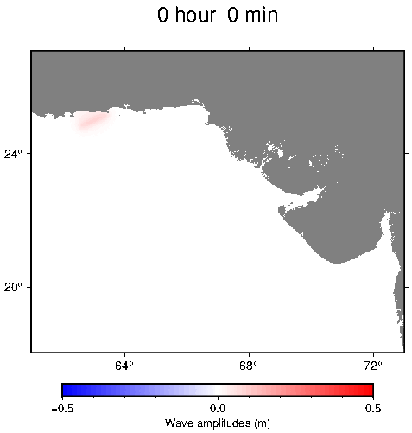
Movie S1: Simulated tsunami propagation for the 1945 Makran earthquake.
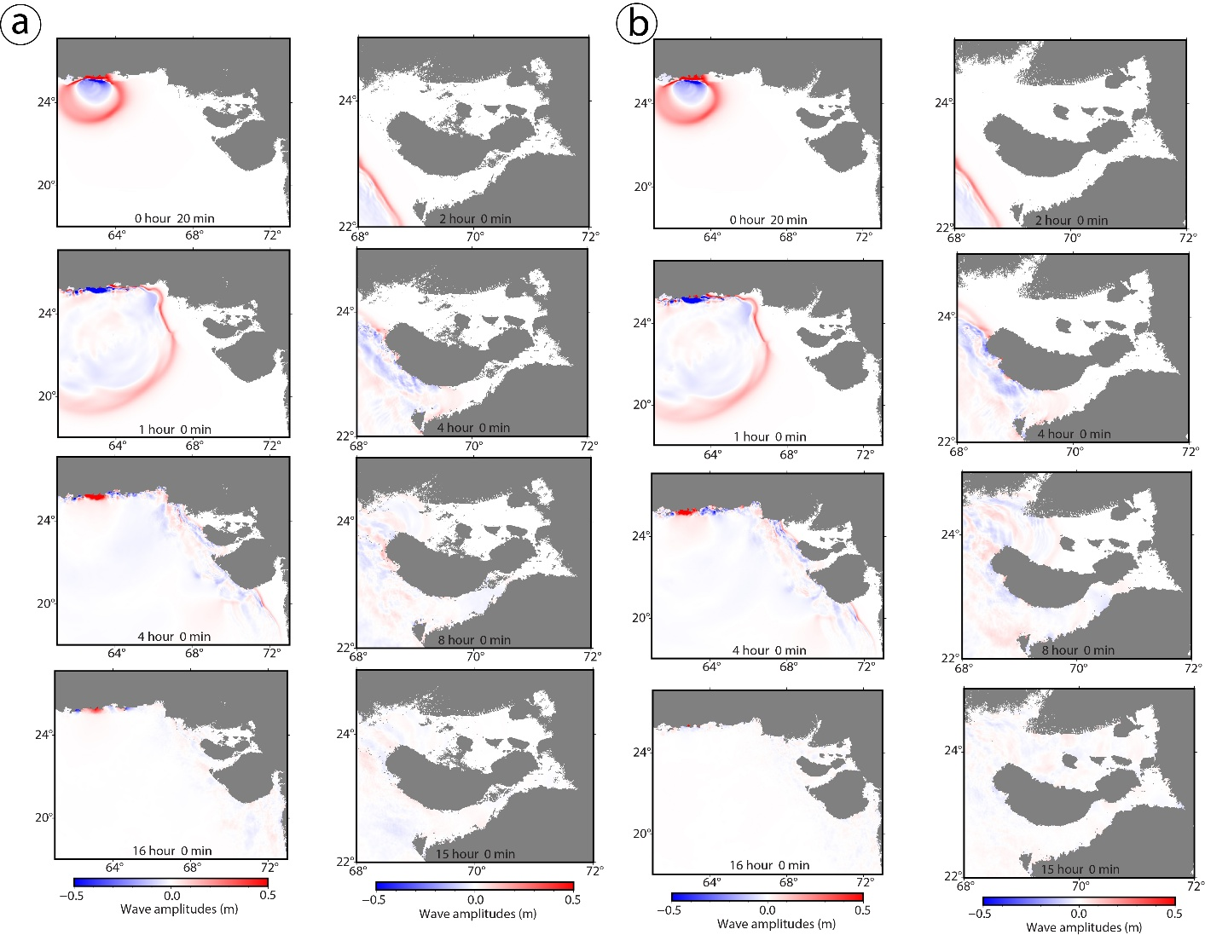
Figure S5: a) Snapshots of simulated tsunami propagation for a 1945-type Makran earthquake under a +5 m relative sea level scenario, b) Snapshots of simulated tsunami propagation for a 1945-type Makran earthquake under a +9 m relative sea level scenario

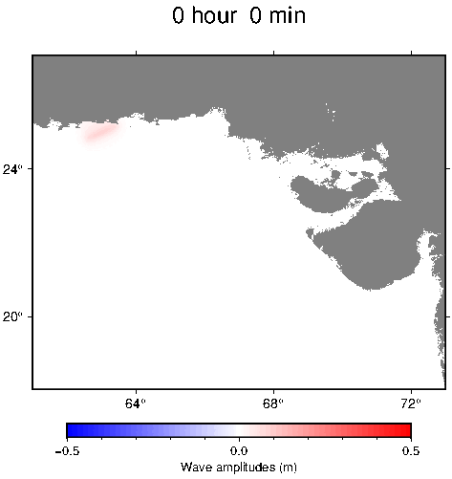
Movie S2: Simulated tsunami propagation for a 1945-type Makran earthquake under a +5 m relative sea level scenario.

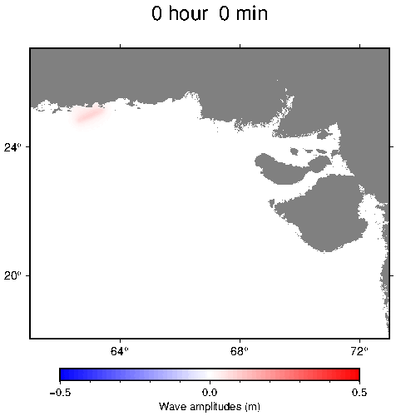
Movie S3: Simulated tsunami propagation for a 1945-type Makran earthquake under a +9 m relative sea level scenario.

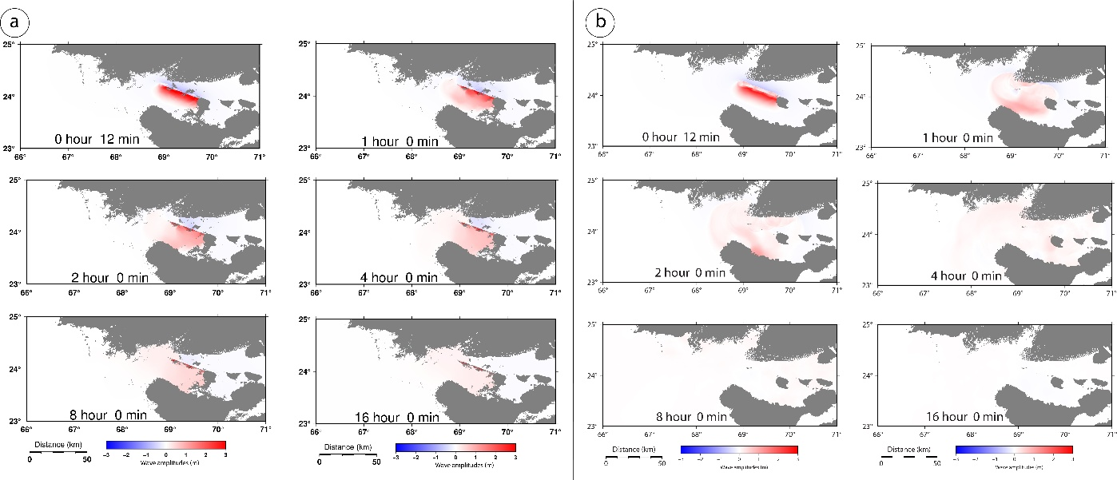
Figure S6: a) Snapshots of simulated tsunami propagation for a 1819-type under a +5 m relative sea level scenario, b) Snapshots of simulated tsunami propagation for a 1819-type under a +9 m relative sea level scenario

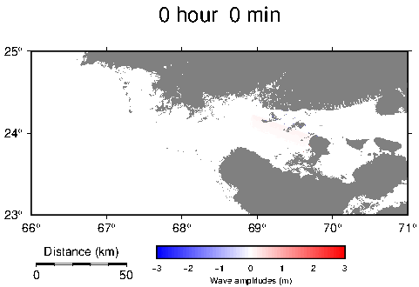
Movie S4: Simulated tsunami propagation for a 1819-type Allah Bund earthquake under a +5 m relative sea level scenario.

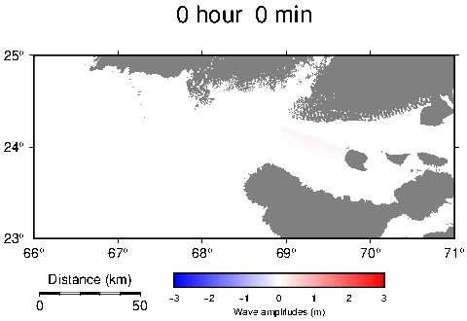
Movie S5: Simulated tsunami propagation for a 1819-type Allah Bund earthquake under a +9 m relative sea level scenario.

References
Banerji, U.S., Pandey, S., Bhushan, R. and Juyal, N., 2015. Mid-Holocene climate and land–sea interaction along the southern coast of Saurashtra, western India. J. Asian Earth Sci., 111, pp.428-439.

Barnhart, W.D., 2017. Fault creep rates of the Chaman fault (Afghanistan and Pakistan) inferred from InSAR. J. Geophys. Res. Solid Earth, 122(1), pp.372-386.

Bhattacharya, F., Rastogi, B.K., Thakkar, M.G., Patel, R.C. and Juyal, N., 2014. Fluvial landforms and their implication towards understanding the past climate and seismicity in the northern Katrol Hill Range, western India. Quat. Int., 333, pp.49-61.

Bhattacharya, F., Chauhan, G., Prasad, A.D., Patel, R.C. and Thakkar, M.G., 2019. Strike-slip faults in an intraplate setting and their significance for landform evolution in the Kachchh peninsula, Western India. Geomorphology, 328, pp.118-137.

Brückner, H., 1989. Late quaternary shorelines in India. In Late Quaternary Sea-Level Correlation and Applications: Walter S. Newman Memorial Volume (pp. 169-194). Dordrecht: Springer Netherlands.

Burnes, A., 1834. XXXVII. Memoir on the Eastern Branch of the River Indus, giving an Account of the Alterations produced on it by an Earthquake, also a Theory of the formation of the Runn, and some Conjectures on the Route of Alexander the Great; drawn up in the years 1827–1828. Trans. Roy. Asiatic Soc. G. B. Ire., 3(3), pp.550-588.

Das, A., Prizomwala, S.P., Makwana, N. and Thakkar, M.G., 2017. Late Pleistocene-Holocene climate and sea level changes inferred based on the tidal terrace sequence, Kachchh, Western India. Palaeogeogr. Palaeoclimatol. Palaeoecol., 473, pp.82-93.

Gaur, A.S. and Vora, K.H., 1999. Ancient shorelines of Gujarat, India, during the Indus civilization (Late Mid-Holocene): A study based on archaeological evidences. Curr. Sci., pp.180-185.

Gaur, A.S., Vora, K.H., Murali, S.R.M. and Jayakumar, S., 2013. Was the Rann of Kachchh navigable during the Harappan times (Mid-Holocene)? An archaeological perspective. Curr. Sci., pp.1485-1491.

Giosan, L., Clift, P.D., Macklin, M.G., Fuller, D.Q., Constantinescu, S., Durcan, J.A., Stevens, T., Duller, G.A., Tabrez, A.R., Gangal, K. and Adhikari, R., 2012. Fluvial landscapes of the Harappan civilization. PNAS, 109(26), pp.E1688-E1694.

Gupta, S.K., 1975. Silting of the Rann of Kutch during Holocene. Indian J. Earth Sci., 2(2), pp.163-175.

Hashimi, N.H., Nigam, R., Nair, R.R. and Rajagopalan, G., 1995. Holocene sea level fluctuations on Western Hndian continental margin: an update. Jour. Geol. Soc. India, 46(2), pp.157-162.

Kale, V.S. and Rajaguru, S.N., 1985. NEOGENE AND QUATERNARY TRANSGRESSIONAL AND REGRESSIONAL HISTORY OF THE WEST COAST OF INDIA:—AN OVERVIEW. BDCRI, 44, pp.153-167.

Khonde, N., Maurya, D.M., Singh, A.D., Chowksey, V. and Chamyal, L.S., 2011. Environmental significance of raised rann sediments along the margins of Khadir, Bhanjada and Kuar Bet islands in Great Rann of Kachchh, Western India. Curr. Sci., 101(11), pp.1429-1434.

Makwana, N., Prizomwala, S.P., Chauhan, G., Phartiyal, B. and Thakkar, M.G., 2019. Late Holocene palaeo-environmental change in the Banni plains, Kachchh, western India. Quat. Int., 507, pp.197-205.

Mathur, U.B., 2002. Chronology of Harappan port towns of Gujarat in the light of sea level changes during the Holocene. Man and Environment, 27(2), pp.61-67.

Milne, G.A. and Mitrovica, J.X., 2008. Searching for eustasy in deglacial sea-level histories. Quat. Sci. Rev, 27(25-26), pp.2292-2302.

Pant, R.K. and Juyal, N., 1993. Late Quaternary coastal instability and sea level changes: new evidences from Saurashtra Coast, Western India.

Sharma, S., Chauhan, G., Shukla, A.D., Nambiar, R., Bhushan, R., Desai, B.G., Pandey, S., Dabhi, M., Bhandari, S., Bhosale, S. and Lakhote, A., 2021. Causes and implications of Mid-to Late Holocene relative sea-level change in the Gulf of Kachchh, western India. Quat. Res., 100, pp.98-121.

Sivewright, R., 1907. Cutch and the Ran. Geogr. J., 29(5), pp.518-535.

Srivastava, E., Malik, J.N., Parrino, N., Burrato, P., Sharma, N., Gadhavi, M., Sulli, A., Di Maggio, C. and Morticelli, M.G., 2023. Extremely fast Holocene coastal landscape evolution in the Kachchh Upland (NW India): Clues from a multidisciplinary review. J. Maps, 19(1), p.2167617.

Tripathi, N., Singh, R.S., Bakhori, B., Dalal, C., Parmar, D. and Mishra, B., 2013. The world's only inland mangrove in sacred grove of Kachchh, India, is at risk. Curr. Sci. (00113891), 105(8).

Tyagi, A.K., Shukla, A.D., Bhushan, R., Thakker, P.S., Thakkar, M.G. and Juyal, N., 2012. Mid-Holocene sedimentation and landscape evolution in the western Great Rann of Kachchh, India. Geomorphology, 151, pp.89-98.

