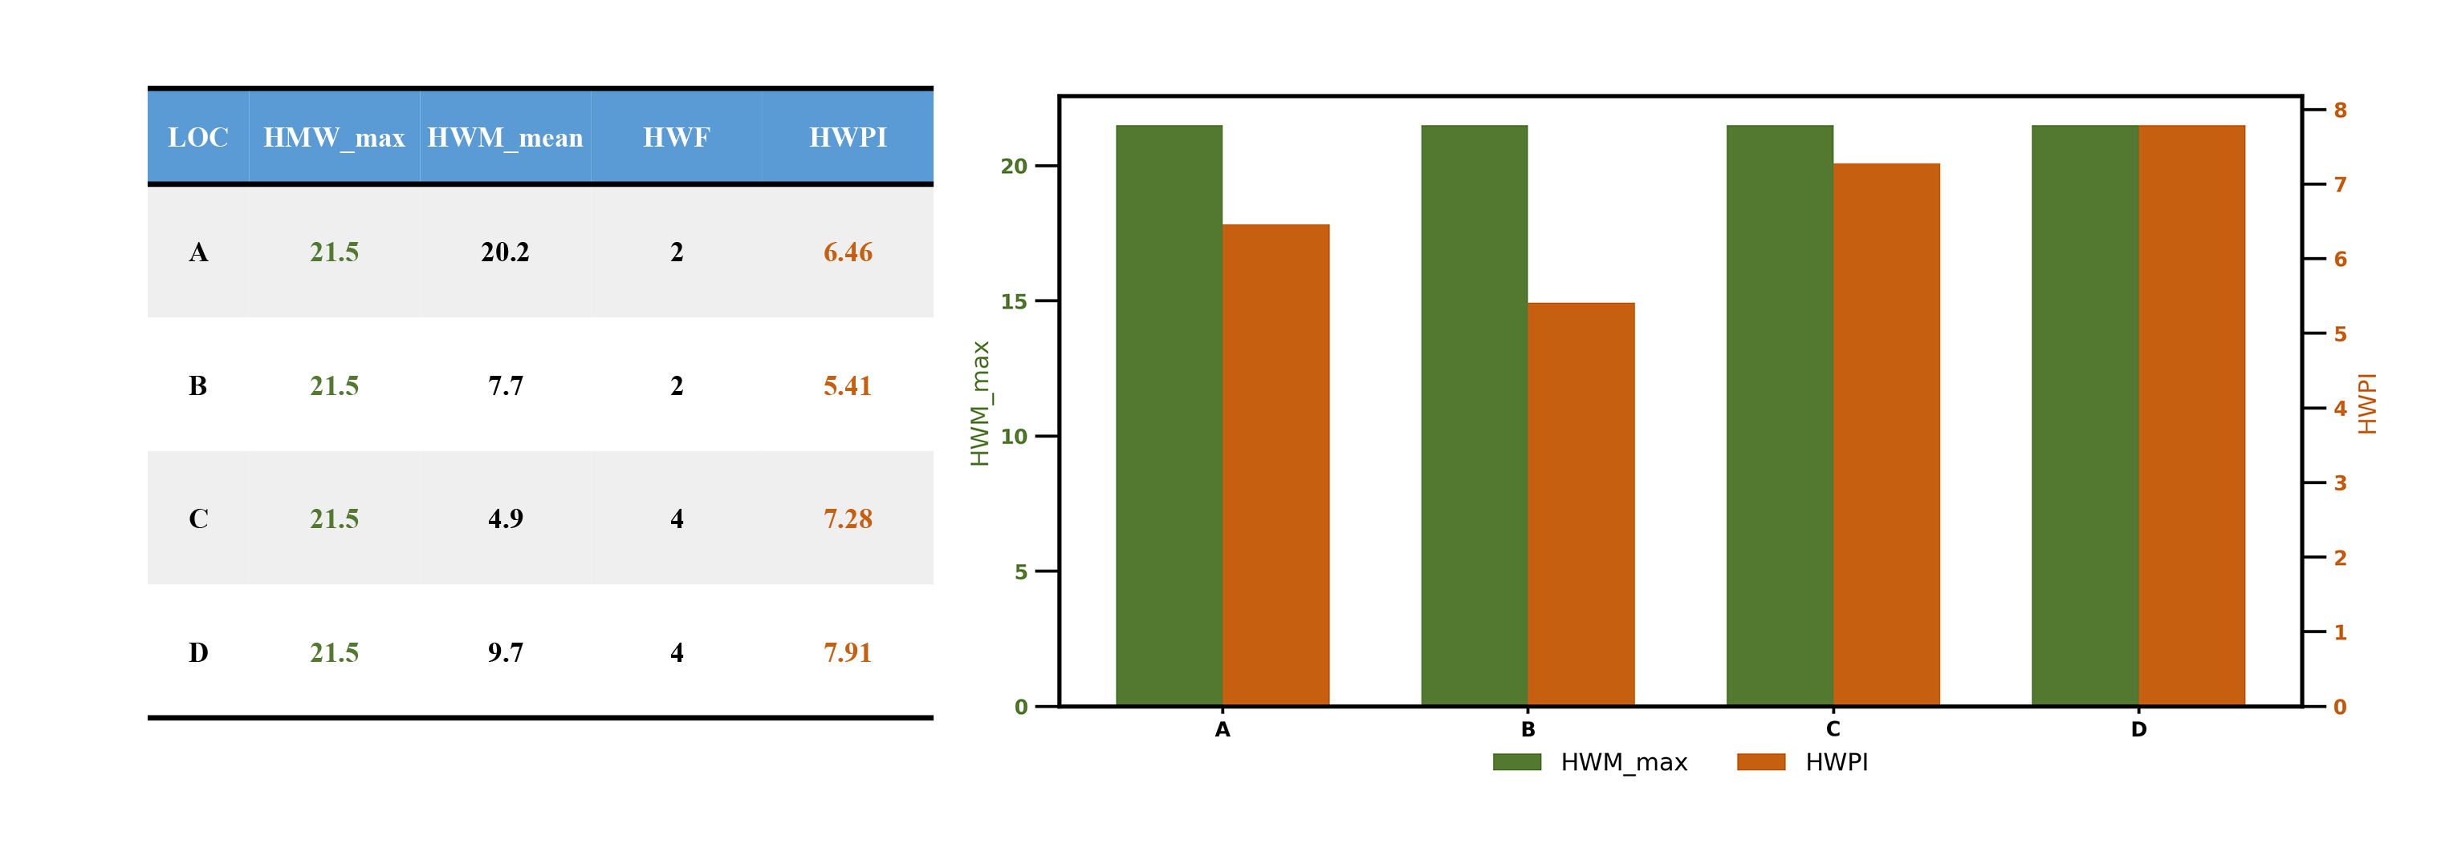
Fig. S1 Heatwave index values at locations A, B, C, D for their respective years.
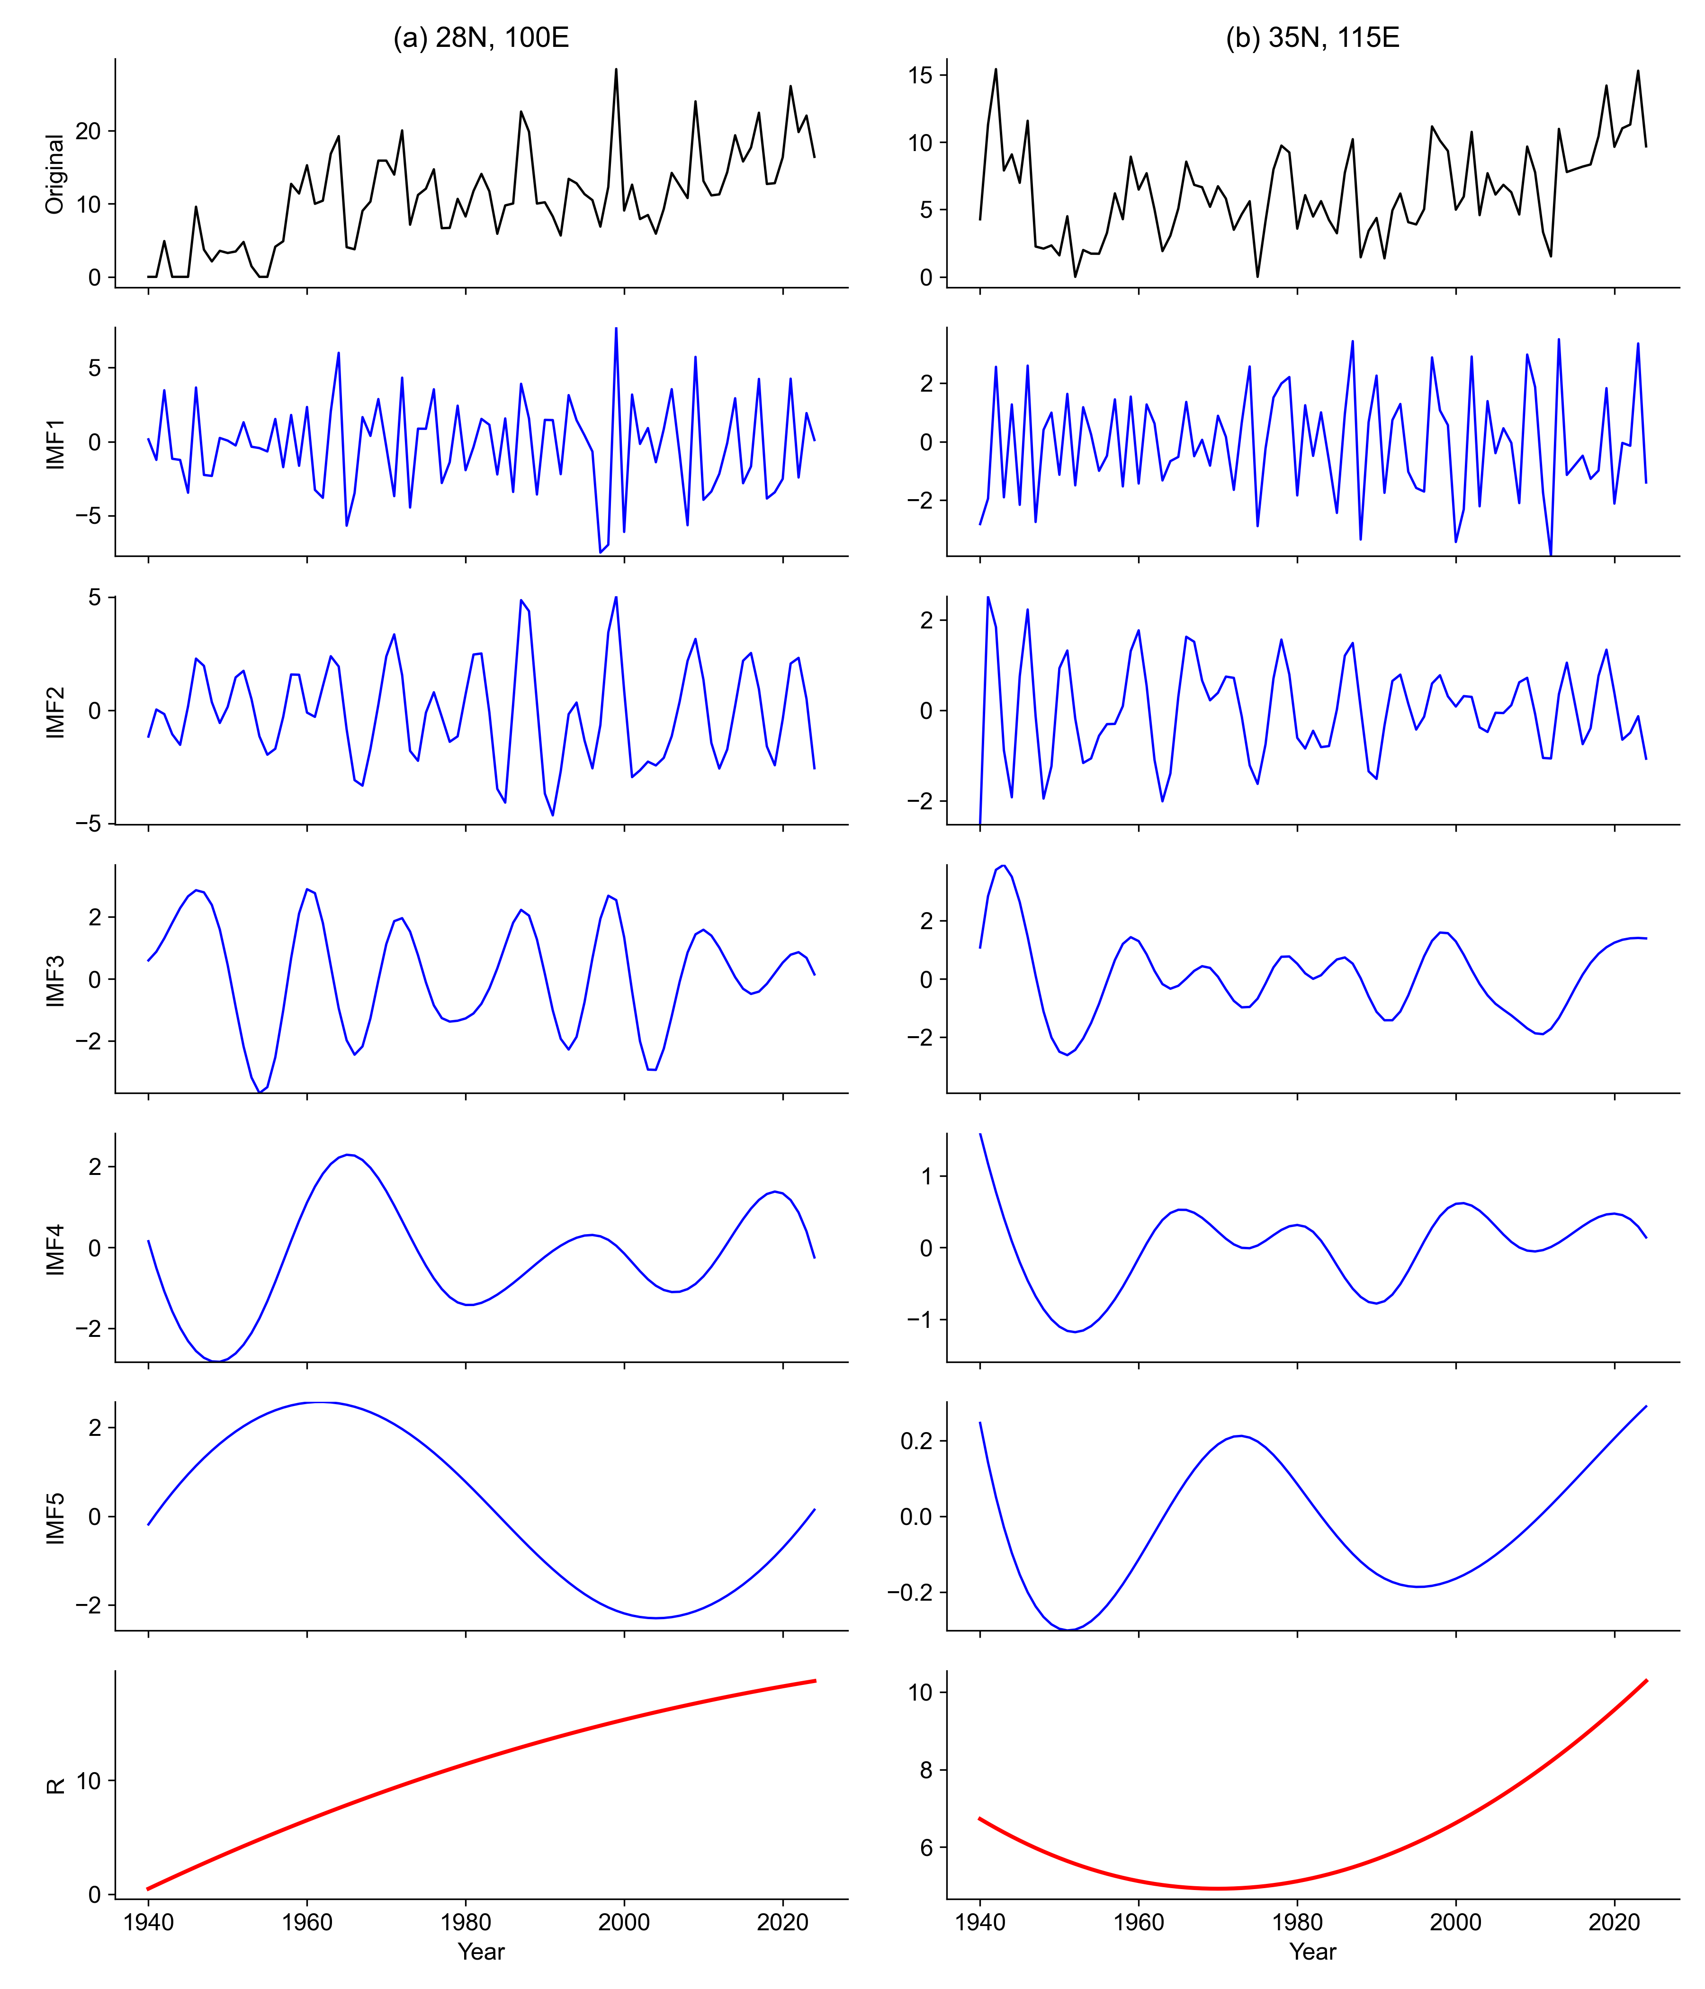
Fig. S2 EEMD decompositions of HWPI in China from 1940 to 2024 at two representative grid points: (a) 35°N, 115°E and (b) 28°N, 100°E. The black line is the original HWPI. The blue lines are the five different timescale components extracted by the EEMD, and the red line is the remainder after EEMD.
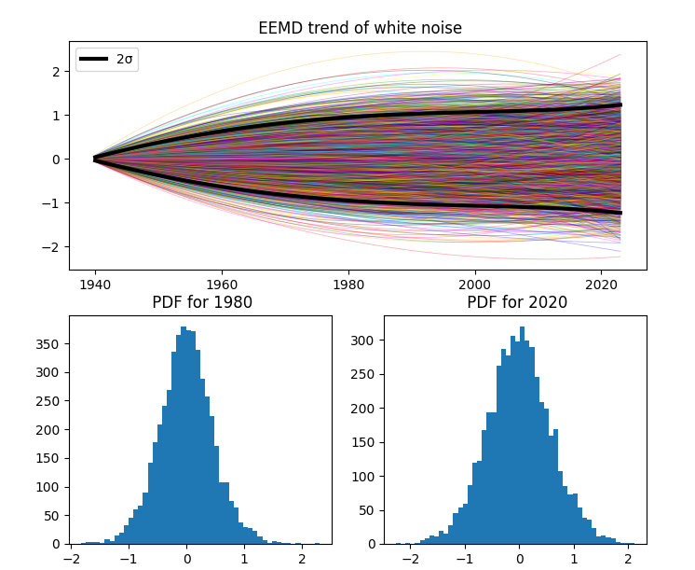
Fig. S3 EEMD trends of white noise series and their distributions. The upper panel plots EEMD trends of 5000 white noise series (thin lines of different colors); the lower left and right panels plot the histograms of EEMD trend values for locations 1980 and 2020, respectively. Two bold black lines are two-standard-deviation spread lines.
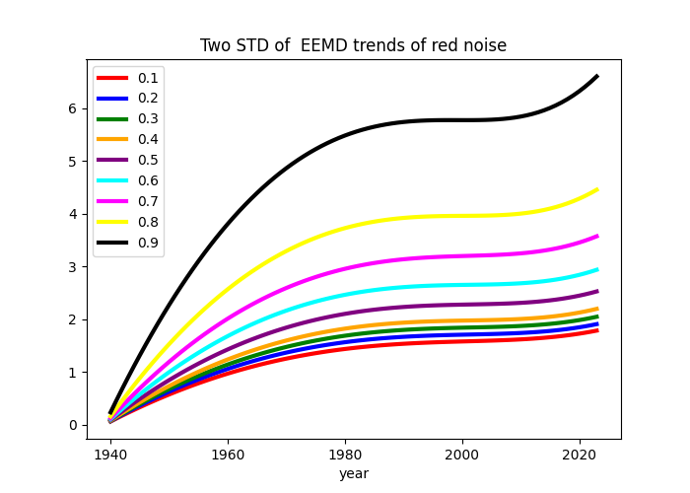
Fig. S4 The lines represent the two-standard-deviation of EEMD-derived trends for lag-1 autocorrelation coefficients ranging from 0 to 0.9.

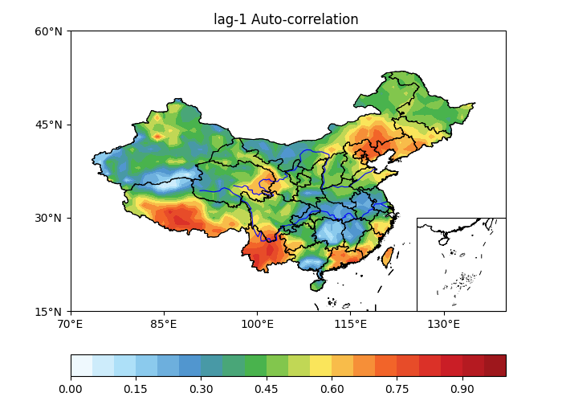
Fig. S5 Lag-1 auto-correlation of HWPI.
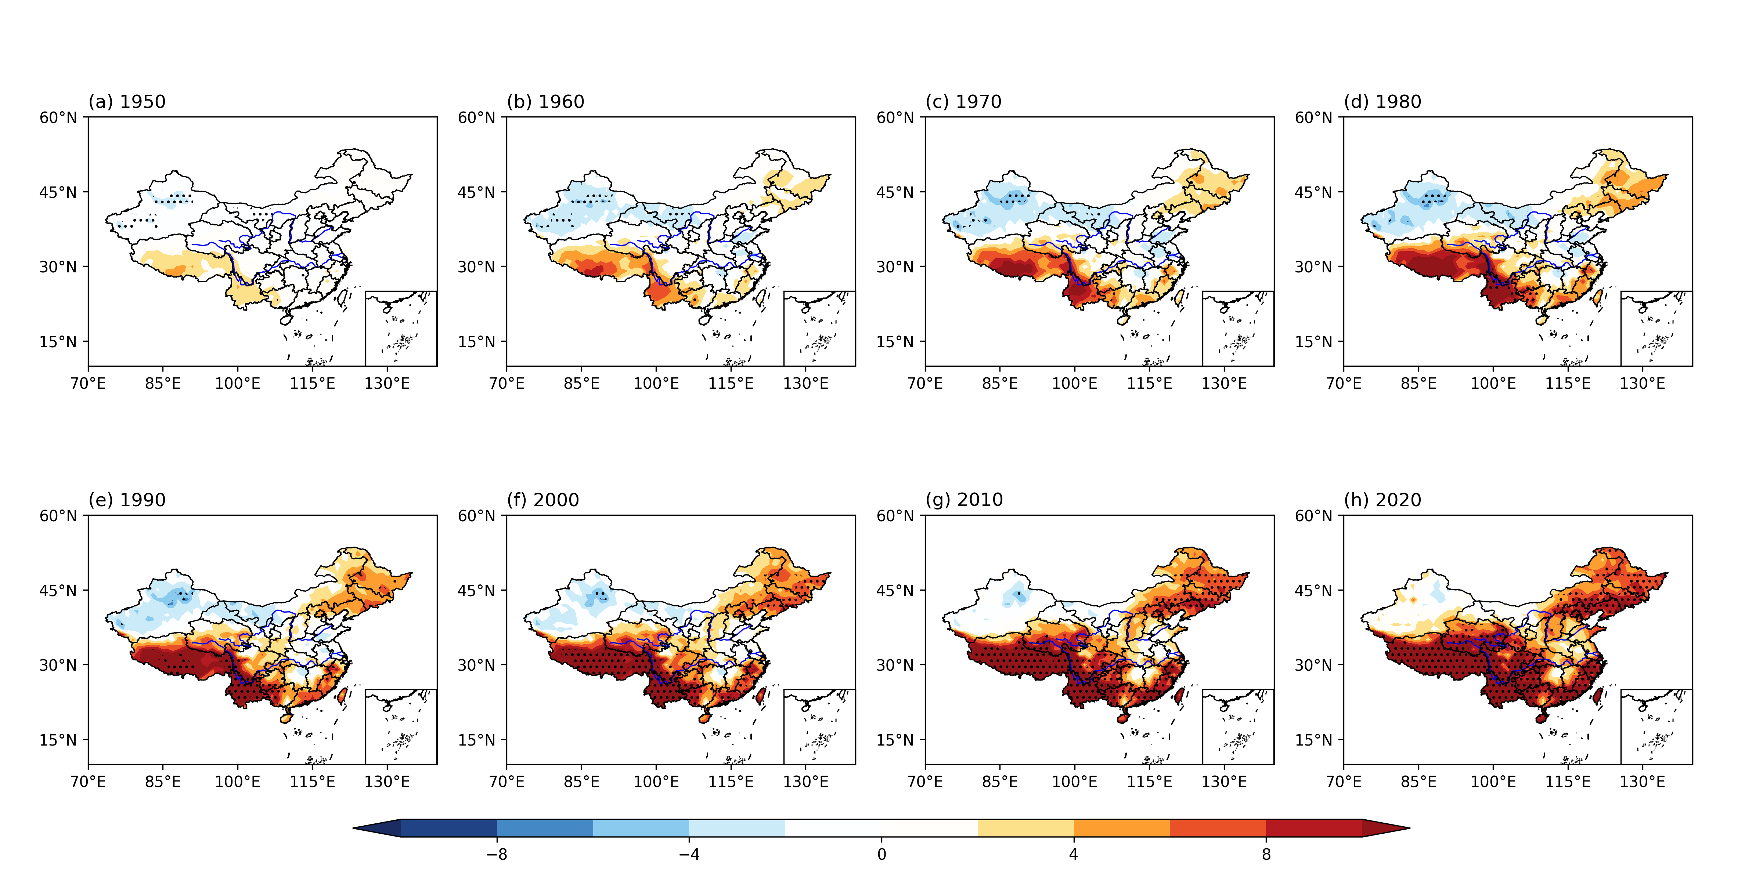
Fig. S6 Statistically significant EEMD trend of HWPI. An EEMD-derived trend at each grid point is considered significant if it exceeds the ±2 standard deviation of red noise corresponding to the local lag-1 autocorrelation coefficient.

