Supplementary Information for

Effects of the complexity of the ocean model on the sea ice data assimilation in a coupled sea ice-ocean model

Young-Chan Noh¹, Yonghan Choi¹, and Joo-Hong Kim¹

¹Korea Polar Research Institute, Incheon, Republic of Korea

Corresponding author:
Young-Chan Noh
Korea Polar Research Institute, 26 Songdomirae-ro, Yeonsu-gu, Incheon, South Korea, 21990
Email: ycnoh@kopri.re.kr

Contents of this file
Figure S1 and S2

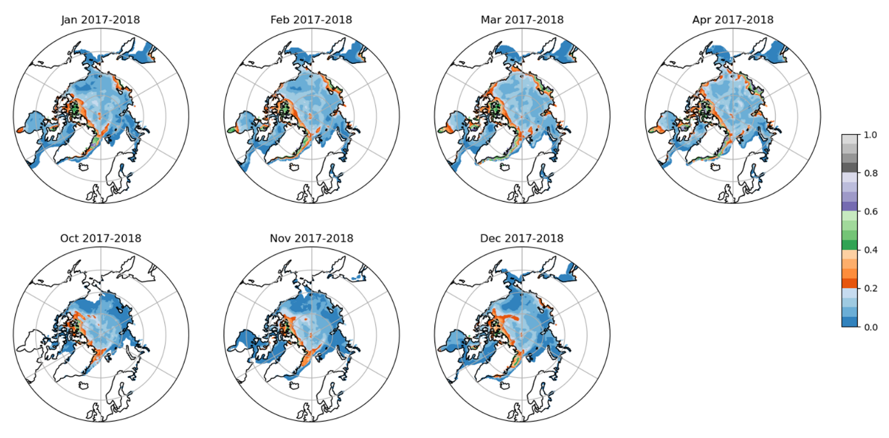
Fig. S1. Spatial distribution of monthly mean sea ice thickness uncertainty in the CryoSat-2/SMOS merged sea ice thickness product during the winter season (January–April and October–December) for 2017–2018.

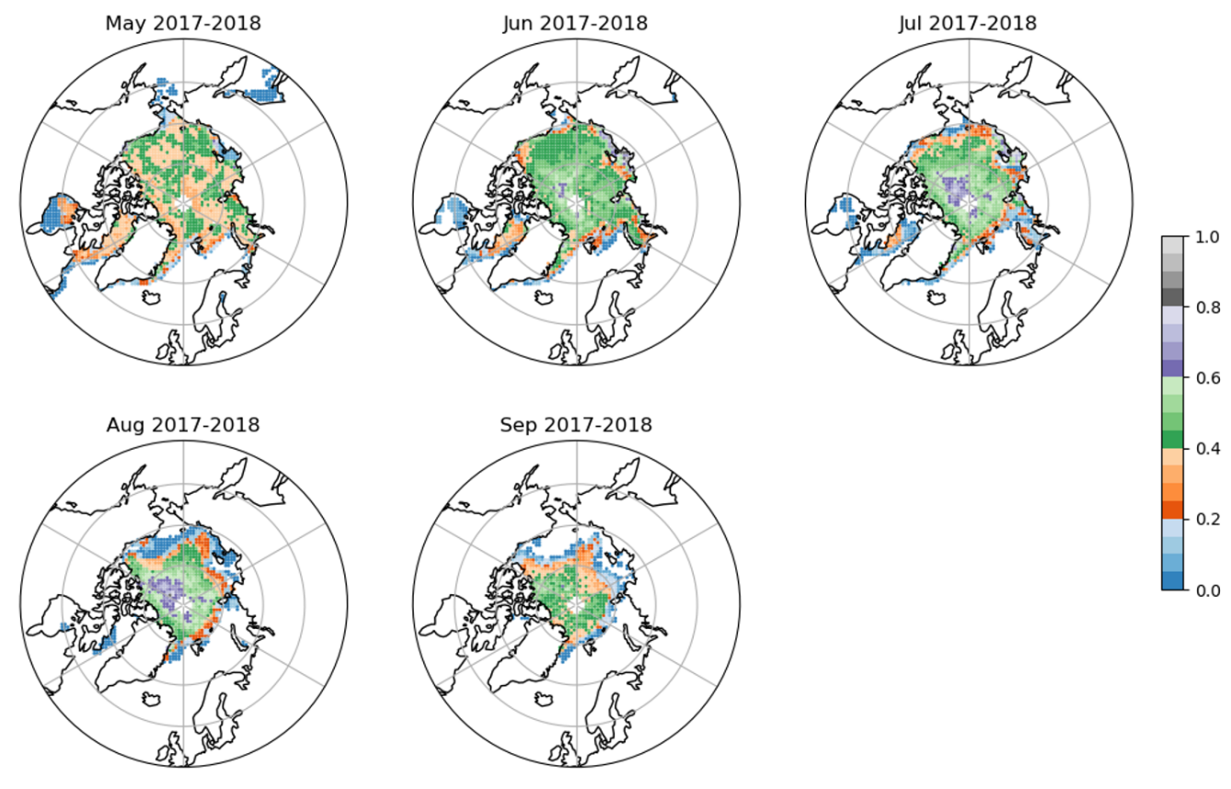
Fig. S2. Spatial distribution of monthly mean sea ice thickness uncertainty in the Landy-based sea ice thickness product during the summer season (May–September) for 2017–2018.

