Supplementary
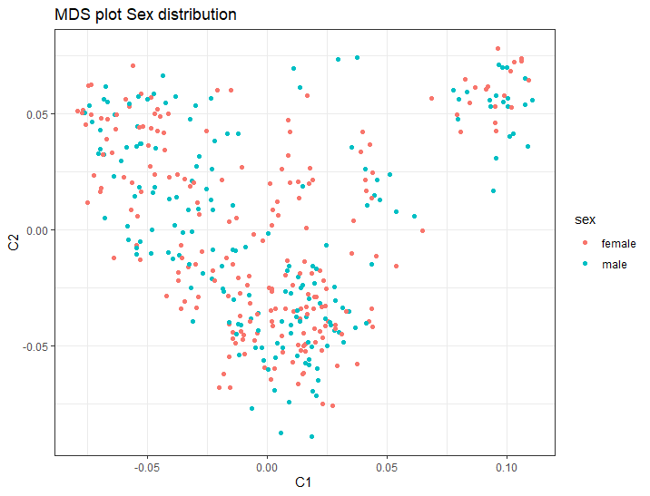
Supplementary figure 1: MDS-plot showing spread of male/female dogs.
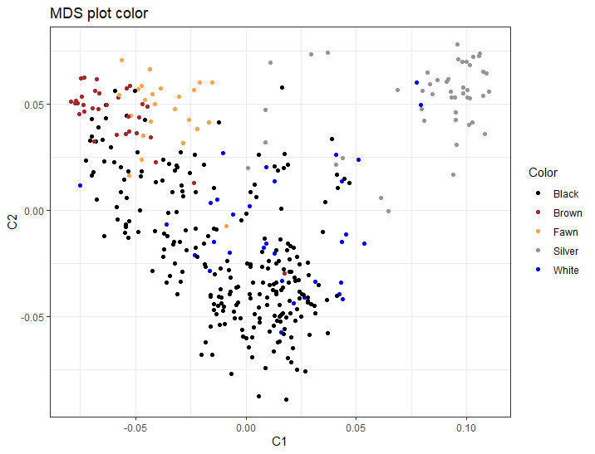
Supplementary figure 2: MDS-plot which show that the population is split in clusters that can be explained by selective breeding on solid colors where silver, brown and fawn (red) dogs tend to be bred separately from the black and white dogs.

