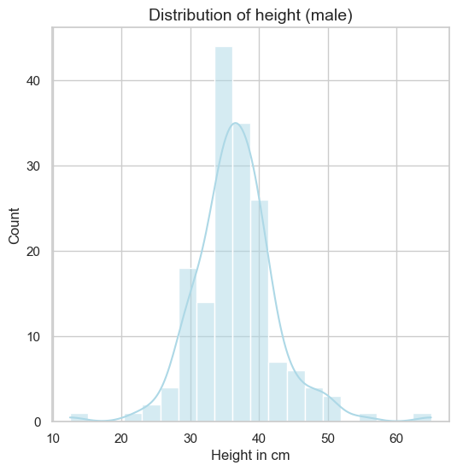
Supplement 1: Height distribution in male French bulldogs >1 year of age. This histogram displays the frequency distribution of height among male dogs in the dataset. The x-axis indicates height in centimeters, while the y-axis shows the number of individuals per height interval. The overlaid blue line represents a kernel density estimate, providing a smoothed visualization of the height distribution.

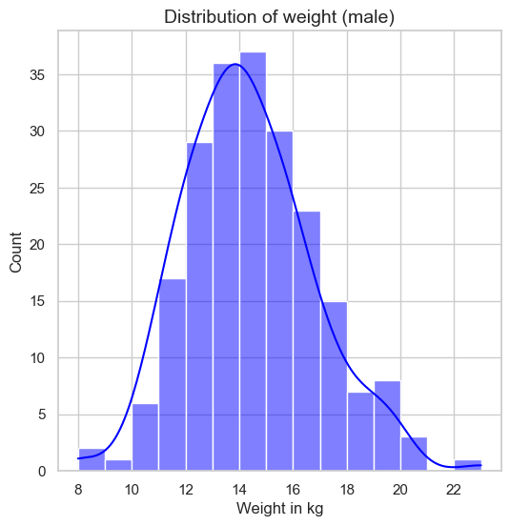
Supplement 2: Weight distribution in male French bulldogs >1 year of age. This histogram displays the frequency distribution of body weight among male dogs in the dataset. The x-axis indicates weight in kilograms, while the y-axis shows the number of individuals per weight interval. The overlaid blue line represents a kernel density estimate, providing a smoothed visualization of the weight distribution.

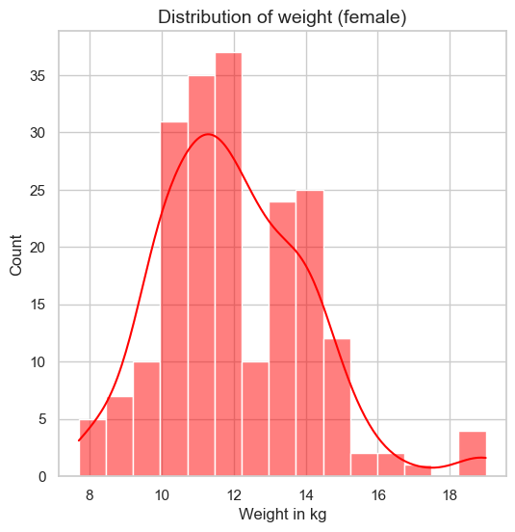
Supplement 3: Weight distribution in female French bulldogs >1 year of age. This histogram displays the frequency distribution of body weight among female dogs in the dataset. The x-axis indicates weight in kilograms, while the y-axis shows the number of individuals per weight interval. The overlaid blue line represents a kernel density estimate, providing a smoothed visualization of the weight distribution.
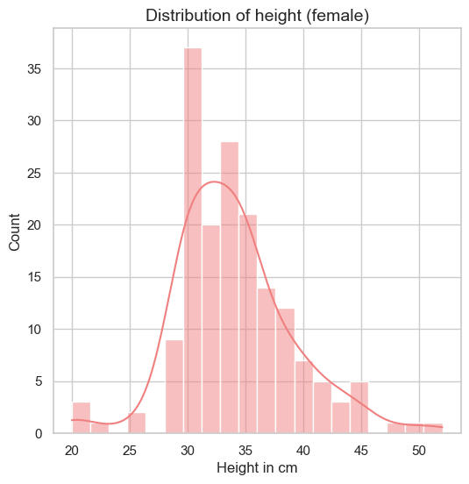
Supplement 4: Height distribution in female French bulldogs >1 year of age. This histogram displays the frequency distribution of height among female dogs in the dataset. The x-axis indicates height in centimeters, while the y-axis shows the number of individuals per height interval. The overlaid blue line represents a kernel density estimate, providing a smoothed visualization of the height distribution.

