Figure S1. Geographical distribution of the 96 Irish Wolfhounds
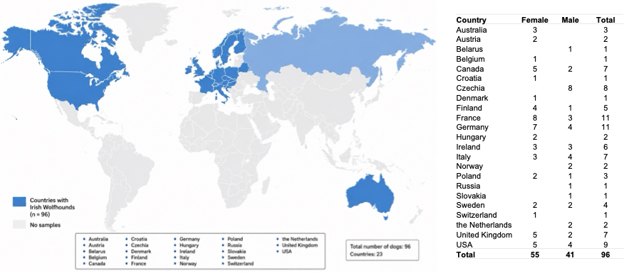

Figure S2. Cox proportional hazards analyses of pedigree-based inbreeding and pedigree depth in relation to survival. Points indicate hazard ratios (HR) and horizontal bars represent 95% confidence intervals. The dashed vertical line indicates HR = 1. Models were adjusted for birth cohort and sex; the full-dataset categorical model additionally included gen_equiv as a covariate. Limited pedigree depth was defined as gen_equiv < 2 and higher pedigree depth as gen_equiv ≥ 2.

Table S1. Top-ranking male and female ancestors according to path-weighted genealogical recurrence.
Ancestor | n_paths | n_probands | Total path weight | Normalized recurrence score (%) | Cumulative recurrence score (%)*
Sires
DOG_1753 | 49 | 34 | 2.50 | 0.52 | 0.52
DOG_1780 | 23 | 18 | 2.09 | 0.44 | 0.96
DOG_1774 | 49 | 33 | 2.00 | 0.42 | 1.37
DOG_1891 | 11 | 11 | 1.63 | 0.34 | 1.71
DOG_2193 | 9 | 9 | 1.63 | 0.34 | 2.05
DOG_0321 | 21 | 12 | 1.56 | 0.33 | 2.38
DOG_1375 | 10 | 9 | 1.53 | 0.32 | 2.70
DOG_0680 | 5 | 5 | 1.50 | 0.31 | 3.32
DOG_0514 | 36 | 27 | 1.31 | 0.27 | 3.59
DOG_0408 | 11 | 10 | 1.31 | 0.27 | 3.87
Dams
DOG_0513 | 31 | 24 | 1.50 | 0.31 | 3.01
DOG_1024 | 7 | 7 | 1.31 | 0.27 | 4.14
DOG_1550 | 6 | 6 | 1.25 | 0.26 | 4.66
DOG_2072 | 4 | 4 | 1.25 | 0.26 | 5.18
DOG_1025 | 15 | 10 | 1.19 | 0.25 | 5.94
DOG_1525 | 24 | 21 | 1.09 | 0.23 | 7.81
DOG_1798 | 30 | 22 | 1.03 | 0.21 | 8.91
DOG_1746 | 8 | 8 | 1.00 | 0.21 | 9.54
DOG_2099 | 3 | 3 | 1.00 | 0.21 | 10.38
DOG_0669 | 2 | 2 | 1.00 | 0.21 | 10.59
*Cumulative recurrence scores were calculated across the overall ranking of ancestors, irrespective of sex.

