Supporting Information
Multiplexed detection of various breast cancer cells by perfluorocarbon/quantum dot nanoemulsions conjugated with antibodies

Pan Kee Bae, Bong Hyun Chung*

Bionanotechnology Research Center, Korea Research Institute of Bioscience and Biotechnology, Daejeon 305-806, Korea
* CORRESPONDING AUTHOR EMAIL ADDRESS: chungbh@kribb.re.kr
Tel) +82-42-860-4442
Fax) +82-42-879-8594

Pan Kee Bae : bpkee@kribb.re.kr

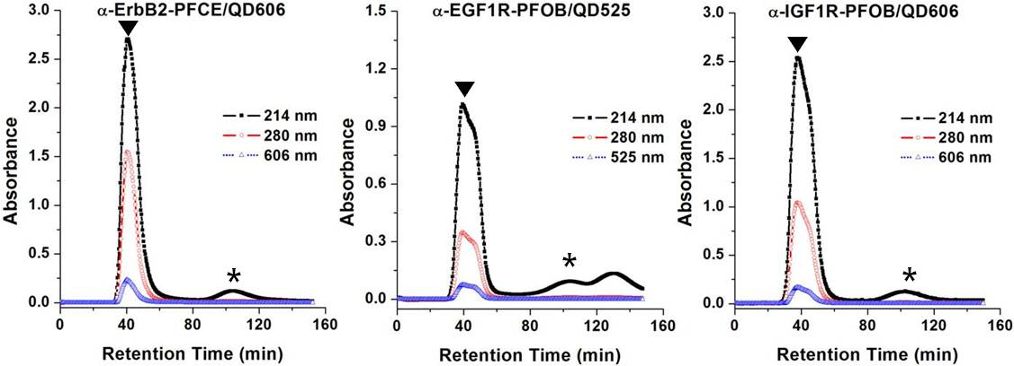
Figure S1. Gel permeation chromatogram of antibody-conjugated PFC/QDs nanoemulsions. The antibody-conjugated PFC/QDs nanoemulsions were separated by the sepharose 4B column. ▼, antibody-conjugated nanoemulsions; *, unreacted antibody.

