Facile synthesis of boronic acid-functionalized core-shell magnetic nanoparticles for efficient dopamine extraction

Jeong Keun Kook, Do-Yeong Koh, Phung Viet Duc, Sang-Wha Lee*

Department of Chemical and Biological Engineering, Gachon University, 1342 Seongnamdaero, Sujeong-gu, Seongnam-si, 461-701, Republic of Korea

*E-mail: lswha@gachon.ac.kr, TEL: +82-31-750-5360

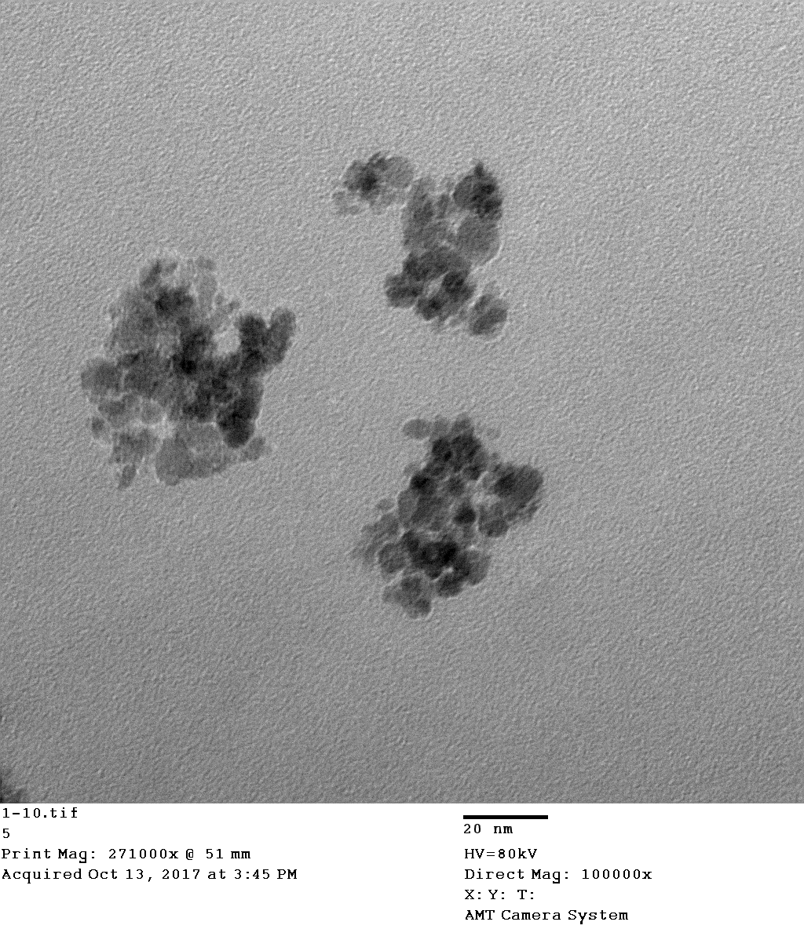
50 nm

Fig. S1. TEM image of A-Fe₃O₄.

Fig. S2. Particle size distribution of core-shell Fe₃O₄@SiO₂ by DLS method.

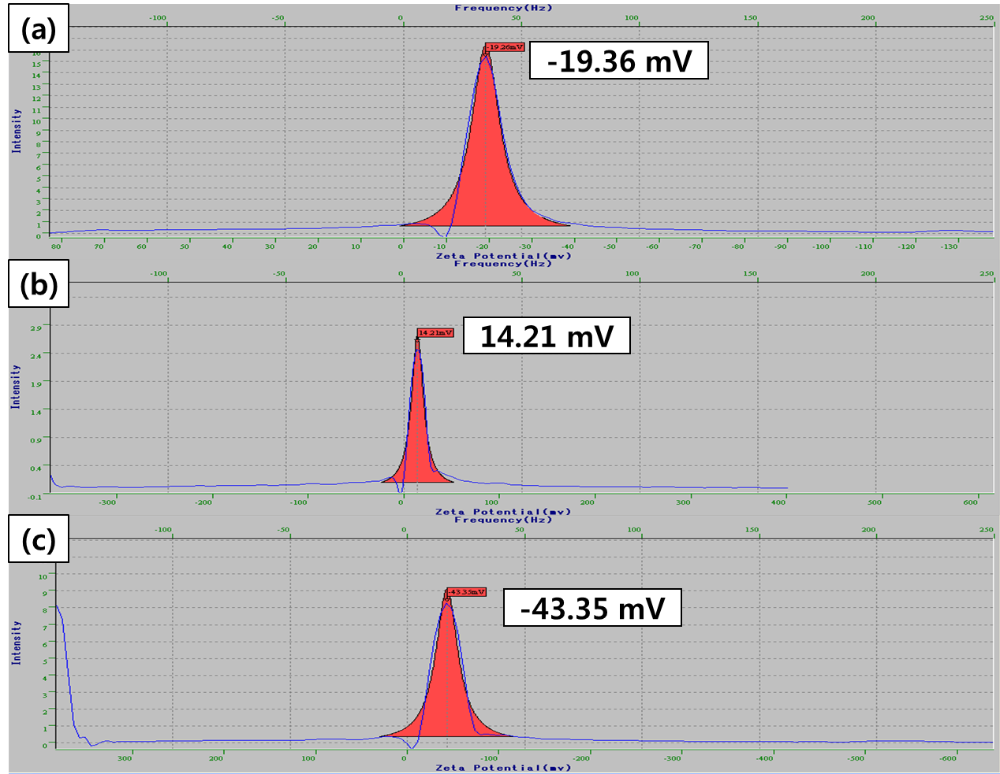

Fig. S3. Zeta-potentials of as-prepared samples: a) Fe₃O₄@SiO₂, b) Fe₃O₄@SiO₂–NH₂ c) Fe₃O₄@SiO₂-COOH.

Fig. S4. X-ray diffraction (XRD) patterns of A-Fe₃O₄ and Fe₃O₄@SiO₂.

(a) (b) (c)

Fig. S5. Comparative dispersion/redispersion of Fe₃O₄@SiO₂@APBA in various medias (1. Water, 2. PBS (pH7.4), 3. Tris-HCl buffer (pH8.0), 4. Tris-HCl buffer (pH 9.0), 5. Ethanol) at different times: a) 0 min, b) 3 hr, c) after re-dispersion .

Fig. S6. pH effect on the adsorption capacity of dopamine by Fe₃O₄@SiO₂@APBA.

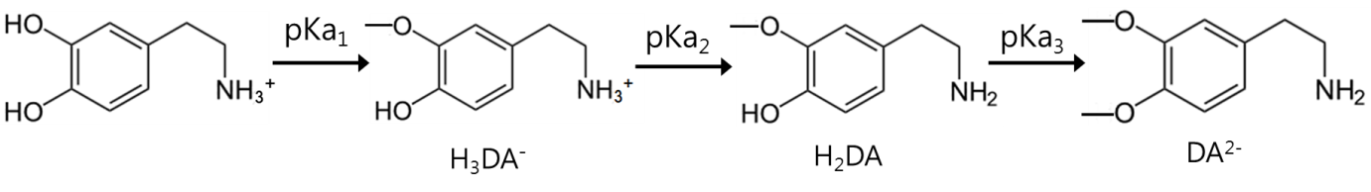
(a)
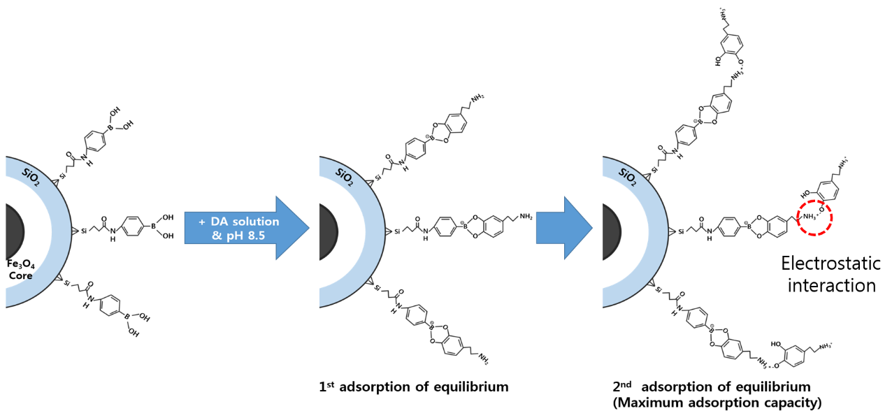
(b)

Fig. S7. Adsorption mechanism of dopamine by using boronic aicd-functionalized magnetic particles (Fe₃O₄@SiO₂@APBA).

