Supplementary Information
Graphene Impregnated Electrospun Nanofiber Sensing Materials: A Comprehensive Overview on Bridging Laboratory Set-up to Industry
Adel Mohammed Al-Dhahebi^{1,2}, Subash Chandra Bose Gopinath^{3,4}, Mohamed Shuaib Mohamed Saheed^{2,5*}
¹Department of Fundamental & Applied Sciences, Universiti Teknologi PETRONAS, 32610 Seri Iskandar, Perak Darul Ridzuan, Malaysia.
²Centre of Innovative Nanostructure & Nanodevices (COINN), Universiti Teknologi PETRONAS, 32610 Seri Iskandar, Perak Darul Ridzuan, Malaysia
³School of Bioprocess Engineering, Universiti Malaysia Perlis, 02600 Arau, Perlis, Malaysia.
⁴Institute of Nano Electronic Engineering, Universiti Malaysia Perlis, 01000 Kangar, Perlis, Malaysia.
⁵Department of Mechanical Engineering, Universiti Teknologi PETRONAS, 32610 Seri Iskandar, Perak Darul Ridzuan, Malaysia.

*corresponding author: shuaib.saheed@utp.edu.my

Table S1. Summary of recent significant works on electrospinning design of GNMs with polymer matrices using pre-processing methods
GNMs | Polymer | Solvent | Additives | Dispersion method/ External force | ES parameters: (Distance; Voltage; federate) | Reference
GO | PVDF | DMF: acetone  4:1 wt/wt% | - | ﻿Hydrophobic modification of  GO with subsequent sonication and stirring | (27.7 cm; 24.1 kV; 1.23mL/h) | (H. Li et al., 2020)
rGO | ﻿ PANCMA | DMF | ﻿ TiO2 | Ultrasonication and microwave heating | (30 cm; 14 kV; 0.02 mL/h) | (Du et al., 2020)
GO | ﻿Poly (lactic acid) (PLA)/poly(butylene carbonate) | DMF solvent | PBC | Stirring | 18 kV | (Gu et al., 2019)
GO | PCL | DMF: DCM 1:1 | - | Stirring | 14 cm; 18 kV; 10 mL/h | (Parandeh, Kharaziha, & Karimzadeh, 2019)
rGO | ﻿poly (ester amide) (PEA) |  |  | Ultrasonication bath | (12cm; 20kV; 0.1mL/h) | (Stone, Lin, & Mequanint, 2019)
GR | PLA | DCM: TFA  2:1 v/v | - | Ultrasonication | (15cm; 10-20kV,2mL/h) | (Darzi, Golestaneh, Kamali, & Karimi, 2019)
GR | PU | THF: DMAC  3:2 w/v | - | ultrasonication | (10 cm; 15 kV; 1mL/h) | (Bahrami, Solouk, Mirzadeh, & Seifalian, 2019)
GO | PAN | DMF | - | Probe and bath sonication and stirring | (15 cm; 18 kV; 0.2 mL/h) | (Ghaderi, Tavanai, & Bazarganipour, 2019)
Gr | 66nylon | TFA: acetone  1:1 v/v | - | Bath and tip sonication | (15-20 cm; 15-20 kV; 0.17 to 0.5 mL/h) | (Maccaferri, Mazzocchetti, Benelli, Zucchelli, & Giorgini, 2019)
Gr | Polycaprolactone | DMF | ﻿- | Stirring | (10 cm; 10-14 kV; 0.4-0.5 mL/h) | (Samani, Doostmohammadi, Nilforoushan, & Nazari, 2019)
GO | PLGA | ﻿1,1,1,3,3,3-hexafluoroisopropanol (HFIP) | - | Stirring | (10 cm; 40 kV; 0.07-0.1 mL/ min) | (Pan et al., 2019)
GO/MWCNT | PEO | DMF |  | Sonication and vigorous stirring | (15 cm; 18.4 kV; 0.5 mL/h) | (Banitaba, Semnani, Heydari‐Soureshjani, Rezaei, & Ensafi, 2019)
GR | Polyamide 66 | ﻿formic acid | - | Stirring | (15cm; 20kV;0.25 mL/h) | (Jahan Biglari, Semnani Rahbar, Shabanian, & Khonakdar, 2018)
GO | PVDF | DMF | - | Sonication and stirring | (15 cm; 18 kV; 1 mL/h) | (Ren et al., 2019)
GO-ZnO | Gum Arabic (GA) and PVA |  | - | Stirring and heating | (130 mm; 0-50 kV) | (Silvestri et al., 2019)
GO | Polyurethane (PU) | DMF | Ag | Stirring and heating | (18 cm; 18 kV;1 mL/h) | (Choi et al., 2019)
GO | poly(acrylonitrile-co-maleic acid | DMF | - | Microwave heating and ultrasonication | (12; 25 kV; 0.03 mL/h) | (Weng et al., 2019)
Graphene Nano sheets | poly (trimethylene terephthalate) | TFA | - | Stirring | (14 cm; | (Huang, Wu, Jeng, & Liang, 2019)
GO | CA | DMF: acetone  2:3 wt/wt% | - | Sonication & heating and stirring | (15 cm; 27 kV; 0.13 mL/h) | (Aboamera, Mohamed, Salama,  Osman, & Khattab, 2018)
GO | PLA | DMF | - | Stirring | (6 cm; 20 kV; 1 mL/h) | (Davoodi, Mazinani, Sharif, & Ranaei-Siadat, 2018)
rGO | Polystyrene (PS) | (DMF: THF) 1:1 | - | Magnetic stirrer | (22 kV; | (Ruan et al., 2018)
﻿GQD | PAN | DMF | - | ﻿  DMF Magnetic stirring | 240 cm; 15 kV; 0.63 mL/h | (Ruiz, Pérez-Marquez, Maudes, Grande, & Murillo, 2018)
GO | CA | Acetone/DMAc (w/w 2:1) | - | Stirring | (8-10 cm ;20-25 kV; 1.5 mL/h) | (Javed et al., 2018)
Fluorine-doped GO, GO, and GOCOOH | PVDF | DMAC: acetone (v/v 4:6) | ﻿1 g of selectfluor and 0.1 g silver nitrate | Stirring | (12 cm; 25 kV; 0.5 mL/h) | (Gebrekrstos, Madras, & Bose, 2018)
rGO | PVP/Chitosan | Acetic acid: water  9:1 (w/v) | - | Stirring | (6 cm; 22 kV; 0.5 mL/h) | (Pavinatto et al., 2018)
rGO | PMMA/PANI | DMF |  | Stirring and sonication | (15 cm;18-20 kV; 0.3 mL/h) | (Abdali & Ajji, 2017)
GO | PLA/PCL | CF: DMF (v/v=4/1) | - | Magnetic stirring and sonication | (20 cm ;20 kV; | (Wang et al., 2017)
GR | PVDF |  |  | Sonication and stirring | (17cm; 20 kV; 1mL/h) | (Abolhasani, Shirvanimoghaddam, & Naebe, 2017)
GR | PCL | Acetic acid | gelatin | Sonication and stirring | (15cm, 10-20kV;0.2-1.8mL/h) | (Heidari, Bahrami, & Ranjbar-Mohammadi, 2017) (Heidari et al., 2017)
Gr and GO | PVDF |  |  | Ultrasonication probe (100 W, 40kHz, 15 mints) | (100mm; 16kV;2mL/h) | (Abbasipour, Khajavi, Yousefi, Yazdanshenas, & Razaghian, 2017)

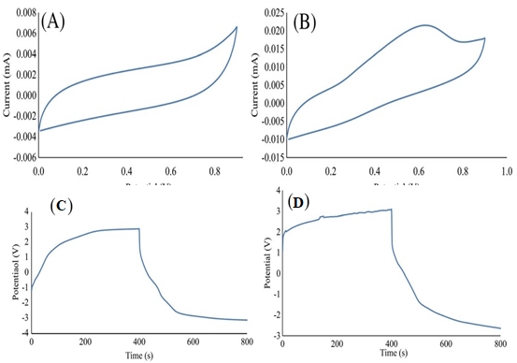
Figure S1. Cyclic voltammetry curves of (A) polyaniline (PANI)–coated nanofibers (NP3) and (B) PANI/graphene–coated nanofibers (NP3G2). Schematic representation of the charge/discharge curves of (C) polyaniline (PANI)–coated nanofibers (NP3) and (D) PANI/graphene–coated nanofibers (NP3G2). Reproduced with permission from (Tambakoozadeh, Youssefi, & Semnani, 2019) Copyright 2019 Wiley.

Table S2. Summary of recent significant works on electrospinning design of GNMs with polymer matrices using post-processing methods
GBMs | ES NFs | Postprocessing method | Mechanism | Potential Applications | Reference
Ag-AQGO | PEO/PVA | ﻿Wet chemical route method | The ESNFs were immersed into the as-prepared Ag-AQRGO solution to self- assemble the negatively Ag-AQRGO onto the positively charged NFs in an aqueous solution. The Ag-AQRGO was further washed away with deionized water. After drying in air, the AgNP-3D-AQRGO sensor was obtained. | Gas sensors | (F. Li et al., 2019)
PEDOT-CNT/rGO | PVDF-TrFE | ﻿Spray coating | PEDOT-CNT/rGO is decorated on ES PVDF-TrFE NFs following these steps:  1. Functionalization of PVDF-TrFE ES NF: using dip coating of ethanol, potassium hydroxide and potassium permanganate and finally hydrogen peroxide.  2. ﻿Spraying of the positively charged MCNTs suspension and negatively biased rGO solution on the functionalized PVDF-TrFE ESNF  3. Coating of PEDOT on the substrate to further enhance the electrical conductivity and sensitivity. | Piezo-electric pressure sensor and wearable smart textiles | (Ahmed et al., 2019)
rGO | PVP/InCl₃ | Ultrasonic dispersion | The hybrid nanofibers (NFI-rGO) were obtained via ultrasonic dispersion of 2 mg NFI in a rGO aqueous suspension (0.1 mg mL⁻¹) for 5 min | Gass sensing in different environments. with 44 ppb detection limit and a response time of 17 s | (Andre, Mercante, Facure, Mattoso, & Correa, 2019)
rGO | PVA | Cross linking and chemical radiation modification method | The PVA nanofibers were crosslinked (to make them stable and water resistant) with UV-light of 253.7 nm (UV-340 lamp) at 30 W with different duration (15, 30, 45 and 75 min) and then they were kept in both water and PBS solutions to optimize crosslinking duration | filtration, sensors/biosensors, thin films and packaging. | (Gozutok, Sadhu, & Sasmazel, 2019)

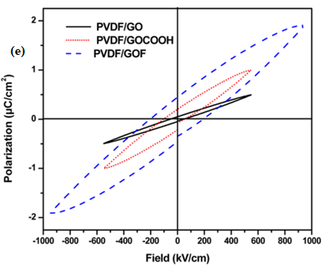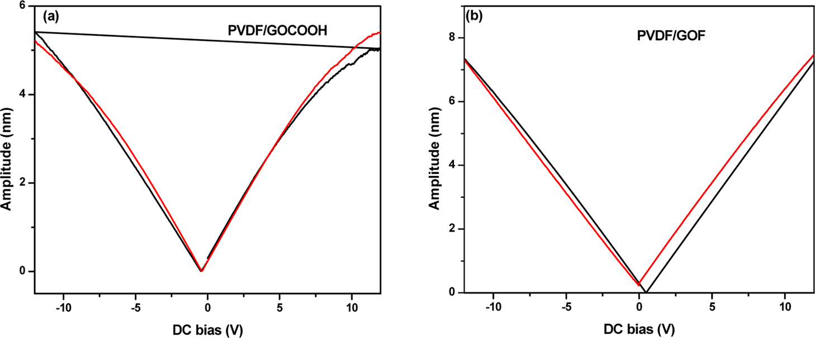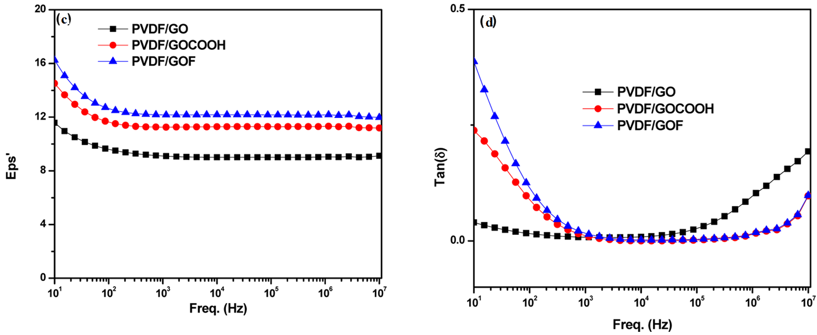
Figure S2. Piezoelectric force microscopy (PFM) amplitude vs dc voltage (voltage varying from −12 to 12 V) hysteresis loops for (a) PVDF/GOCOOH and (b) PVDF/GOF. Frequency dependence of (c) dielectric constant and (d) dielectric loss for PVDF/GO, PVDF/GOCOOH, and PVDF/GOF composites. (e) schematic representing the P−E loops for PVDF/GO, PVDF/GOCOOH, and PVDF/ GOF at room temperature. Reproduced with permission from (Gebrekrstos et al., 2018) Copyright 2018 American Chemical Society.

Table S3. Summary of studies on the improvement of various properties when adding GNMs in the polymer spinnable solution
GNMs/Polymer | Spinning parameters | Improved properties | Potential Applications | Remarks | Reference
Polyacrylonitrile (PAN)/GO | (15 cm; 15 kV; 0.8 mL/h)  GO=0.4%wt | Mechanical strength (by 3-4 times)  The thermal stability  Hydrophilicity (by 50%) | Water treatment and battery performance | The content of GO influences its dispersion and thus may affect the fiber formation as well as the final performance and properties of ES fibers. | (Hou, Yun, & Byun, 2019)
GO/GR/Halloysite NT/PVDF | (10 cm; 16 kV; 2mL/h) | ﻿Piezoelectric and pyroelectric  The thermal stability (by 94%) Young’s modulus increased by 20 times | Wearable electronics and energy harvesting applications from body movements | The content of the nanofillers shows significant effect on piezoelectric responses due to enhancement of electroactive β‐phase. | (Abbasipour et al., 2019)
GO/PEO/PAN | (20 cm; 20 kV; 1 mL/h) | electrolyte uptake  ionic conductivity | The content of GO influences the fiber diameter and ionic conductivity | Homogenous distribution of GO fillers in the polymer matrix causes increase in the electrolyte uptake and electrical conductivity of the nanofibers. | (Abdollahi, Ehsani, Morshedian, Khonakdar, & Aram, 2019)
PCL/rGO | (10cm; 10, 15kV, 6mL/h) s | Mechanical behaviour Electrical conductivity Thermal stability | ﻿Human tissue repair | The evaluated properties were affected according to the amount of rGO used and the applied voltage | (Correa, Moncada, Gutiérrez, Vargas, & Zapata, 2019)
GO/PET | (12 cm; 10 kV; 0.1 mL/h) | Young modulus by 50% MPa.  The electroconductivity is improved | Improve cell attachment and proliferation | The GO, spinning parameters and concentration control the electroconductivity, mechanical properties and the uniformity of NF | (Ghasemi et al., 2019)
PU-GO-PDA | (20 cm; 20 kV; 0.2 mL/h) | Wettability, water absorption, and both cell attachment and proliferation and ALP expression rate which denotes osteogenic differentiation property | Bone regeneration of tissues | ﻿PU/GO was prepared by electrospinning and then PDA was coated by immersing PU/GO NF in dopamine hydrochloride solution under constant stirring (1.5 mg/L in 10 mM of Tris buffer pH = 8.5) at room temperature in a dark environment. After 24 h, the scaffold was washed with deionized water three times, and air dried. | (Ghorbani, Zamanian, & Aidun, 2019)
GO/ (Sulfonated PVA) | (17 cm; 15 to 18 kV; 300 to 800 ﻿µL/h) | Thermal and hydrothermal stability  Proton conductivity  Retention of humiditys | Ionic polyelectrolyte membrane | The combination of the sulfonation, the crosslinking, and the addition of GO enhanced the proton conductivity | (Gil-Castell et al., 2019)
PVA/rGO | (6-10 cm; 15-25 kV; 10-20 ﻿﻿µL/min) | Tensile] strength (∼5 MPa) and and the elastic modulus (∼1.5 GPa)  Thermal stability  The electrical conductivities of the nanocomposites. | Biosensors, sensors etc. | The increment of rGO (1% wt) improved PVA NF properties due to the strong interfacial interaction between rGO and PVA.  rGO dispersion in the PVA solution did not alter the crystal structure of PVA | (Gozutok et al., 2019)
Ag/rGO/Polyamide (PI) | (20 kV;  ﻿DMAc: THF = 3:2, wt:wt %  Stirring | ﻿The λ, Tg and THRI values of the (Ag/rGO)/PI nanocomposites were all increased with increasing the Ag/ rGO filler loading. | ﻿- | ﻿The aggregation of rGO can be effectively restricted by introducing Ag nanoparticles.  ﻿  - | (Guo et al., 2019)
﻿PVDF-Pt-Pd/RGO-CeO2 | 15 cm; 12 kV; 1 mL/h | Increased thermal and catalytic properties | ﻿DMFC applications | Novel electrospinning of PVDF-Pt-Pd/RGO-CeO2 nanocomposites | (Hanifah et al., 2019)
GO-doped PVDF/CuO/Al | 15 cm; 0.07 mm/min | Heat of reaction and reaction efficiency of PVDF/CuO/Al nanocomposites  Strong anti-oxidation capability | - | Electrospinning and GO doping can improve the reaction efficiency due to the improvement of microstructure quality and nanocomposites performance. | (Lyu et al., 2019)
﻿PU and PU/rGO‐Ag | 17 cm; 18 kV; 0.3 mL/h | Tensile strength  Electrical conductivity Cardiogenic differentiation  Potential  Wettability | Cardiac tissue engineering | ﻿Adding rGO‐Ag and concentration influence the fiber diameter and the final properties | (Nazari et al., 2019)
MnO2-GO | 10 cm; 15 kV; 0.5 mL/h | electrochemical  dielectric behaviors  higher charge mobility, diffusivity, and conductivity. | Future energy storage devices. | - | (Saha et al., 2019)
﻿PCL/GO-Gelatin | 13 cm; 14 kV; 3 mL/h | Tensile stress and  Young’s modulus | Anti-tumor effect of classical therapies | ﻿The presence of 1 wt% graphene oxide increased mechanical strength of PCL/Gel | (Unal et al., 2019)

References
Abbasipour, M., Khajavi, R., Yousefi, A. A., Yazdanshenas, M. E., & Razaghian, F. (2017). The piezoelectric response of electrospun PVDF nanofibers with graphene oxide, graphene, and halloysite nanofillers: a comparative study. Journal of Materials Science: Materials in Electronics, 28(21), 15942–15952. https://doi.org/10.1007/s10854-017-7491-4
Abbasipour, M., Khajavi, R., Yousefi, A. A., Yazdanshenas, M. E., Razaghian, F., & Akbarzadeh, A. (2019). Improving piezoelectric and pyroelectric properties of electrospun PVDF nanofibers using nanofillers for energy harvesting application. Polymers for Advanced Technologies, 30(2), 279–291. https://doi.org/10.1002/pat.4463
Abdali, H., & Ajji, A. (2017). Preparation of electrospun nanocomposite nanofibers of polyaniline/poly(methyl methacrylate) with amino-functionalized graphene. Polymers, 9(9), 453. https://doi.org/10.3390/polym9090453
Abdollahi, S., Ehsani, M., Morshedian, J., Khonakdar, H. A., & Aram, E. (2019). Application of response surface methodology in assessing the effect of electrospinning parameters on the morphology of polyethylene oxide/polyacrylonitrile blend nanofibers containing graphene oxide. Polymer Bulletin, 76(4), 1755–1773. https://doi.org/10.1007/s00289-018-2448-1
Aboamera, N. M., Mohamed, A., Salama, A., Osman, T. A., & Khattab, A. (2018). An effective removal of organic dyes using surface functionalized cellulose acetate/graphene oxide composite nanofibers. Cellulose, 25(7), 4155–4166. https://doi.org/10.1007/s10570-018-1870-8
Abolhasani, M. M., Shirvanimoghaddam, K., & Naebe, M. (2017). PVDF/graphene composite nanofibers with enhanced piezoelectric performance for development of robust nanogenerators. Composites Science and Technology, 138, 49–56. https://doi.org/10.1016/j.compscitech.2016.11.017
Ahmed, A., Jia, Y., Huang, Y., Khoso, N. A., Deb, H., Fan, Q., & Shao, J. (2019). Preparation of PVDF-TrFE based electrospun nanofibers decorated with PEDOT-CNT/rGO composites for piezo-electric pressure sensor. Journal of Materials Science: Materials in Electronics, (0123456789). https://doi.org/10.1007/s10854-019-01751-w
Andre, R. S., Mercante, L. A., Facure, M. H. M., Mattoso, L. H. C., & Correa, D. S. (2019). Enhanced and selective ammonia detection using In 2 O 3 /reduced graphene oxide hybrid nanofibers. Applied Surface Science, 473, 133–140. https://doi.org/10.1016/j.apsusc.2018.12.101
Bahrami, S., Solouk, A., Mirzadeh, H., & Seifalian, A. M. (2019). Electroconductive polyurethane/graphene nanocomposite for biomedical applications. Composites Part B: Engineering, 168(March), 421–431. https://doi.org/10.1016/j.compositesb.2019.03.044
Banitaba, S. N., Semnani, D., Heydari‐Soureshjani, E., Rezaei, B., & Ensafi, A. A. (2019). Nanofibrous poly(ethylene oxide)‐based structures incorporated with multi‐walled carbon nanotube and graphene oxide as all‐solid‐state electrolytes for lithium ion batteries. In Polymer International (Vol. 68). https://doi.org/10.1002/pi.5889
Choi, Y. I., Hwang, B. U., Meeseepong, M., Hanif, A., Ramasundaram, S., Trung, T. Q., & Lee, N. E. (2019). Stretchable and transparent nanofiber-networked electrodes based on nanocomposites of polyurethane/reduced graphene oxide/silver nanoparticles with high dispersion and fused junctions. Nanoscale, 11(9), 4015–4024. https://doi.org/10.1039/c8nr10170a
Correa, E., Moncada, M. E., Gutiérrez, O. D., Vargas, C. A., & Zapata, V. H. (2019). Characterization of polycaprolactone/rGO nanocomposite scaffolds obtained by electrospinning. Materials Science and Engineering C, 103(30), 109773. https://doi.org/10.1016/j.msec.2019.109773
Darzi, M. E., Golestaneh, S. I., Kamali, M., & Karimi, G. (2019). Thermal and electrical performance analysis of co-electrospun-electrosprayed PCM nanofiber composites in the presence of graphene and carbon fiber powder. Renewable Energy, 135, 719–728. https://doi.org/10.1016/j.renene.2018.12.028
Davoodi, A. H., Mazinani, S., Sharif, F., & Ranaei-Siadat, S. O. (2018). GO nanosheets localization by morphological study on PLA-GO electrospun nanocomposite nanofibers. Journal of Polymer Research, 25(9), 16–19. https://doi.org/10.1007/s10965-018-1589-0
Du, F., Sun, L., Huang, Z., Chen, Z., Xu, Z., Ruan, G., & Zhao, C. (2020). Electrospun reduced graphene oxide/TiO2/poly(acrylonitrile-co-maleic acid) composite nanofibers for efficient adsorption and photocatalytic removal of malachite green and leucomalachite green. Chemosphere, 239, 124764. https://doi.org/10.1016/j.chemosphere.2019.124764
Gebrekrstos, A., Madras, G., & Bose, S. (2018). Piezoelectric Response in Electrospun Poly(vinylidene fluoride) Fibers Containing Fluoro-Doped Graphene Derivatives [Research-article]. ACS Omega, 3(5), 5317–5326. https://doi.org/10.1021/acsomega.8b00237
Ghaderi, G., Tavanai, H., & Bazarganipour, M. (2019). Electrospun graphene oxide incorporated PAN nanofibers, before and after activation. Materials Research Express, 6(10), 105047.
Ghasemi, A., Imani, R., Yousefzadeh, M., Bonakdar, S., Solouk, A., & Fakhrzadeh, H. (2019). Studying the Potential Application of Electrospun Polyethylene Terephthalate/Graphene Oxide Nanofibers as Electroconductive Cardiac Patch. Macromolecular Materials and Engineering, 304(8), 1900187. https://doi.org/10.1002/mame.201900187
Ghorbani, F., Zamanian, A., & Aidun, A. (2019). Bioinspired polydopamine coating-assisted electrospun polyurethane-graphene oxide nanofibers for bone tissue engineering application. Journal of Applied Polymer Science, 136(24), 1–9. https://doi.org/10.1002/app.47656
Gil-Castell, O., Galindo-Alfaro, D., Sánchez-Ballester, S., Teruel-Juanes, R., Badia, J. D., & Ribes-Greus, A. (2019). Crosslinked sulfonated poly(Vinyl alcohol)/graphene oxide electrospun nanofibers as polyelectrolytes. Nanomaterials, 9(3), 1–20. https://doi.org/10.3390/nano9030397
Gozutok, M., Sadhu, V., & Sasmazel, H. T. (2019). Development of Poly(vinyl alcohol) (PVA)/Reduced Graphene Oxide (rGO) Electrospun Mats. Journal of Nanoscience and Nanotechnology, 19(7), 4292–4298. https://doi.org/10.1166/jnn.2019.16290
Gu, X., Li, Y., Cao, R., Liu, S., Fu, C., Feng, S., … Wang, Y. (2019). Novel electrospun poly(lactic acid)/poly(butylene carbonate)/graphene oxide nanofiber membranes for antibacterial applications. AIP Advances, 9(6). https://doi.org/10.1063/1.5100109
Guo, Y., Yang, X., Ruan, K., Kong, J., Dong, M., Zhang, J., … Guo, Z. (2019). Reduced Graphene Oxide Heterostructured Silver Nanoparticles Significantly Enhanced Thermal Conductivities in Hot-Pressed Electrospun Polyimide Nanocomposites [Research-article]. ACS Applied Materials & Interfaces, 11(28), 25465–25473. https://doi.org/10.1021/acsami.9b10161
Hanifah, M. F. R., Jaafar, J., Othman, M. H. D., Ismail, A. F., Rahman, M. A., Yusof, N., & Aziz, F. (2019). Electro-spun of novel PVDF-Pt-Pd/RGO-CeO2 composite nanofibers as the high potential of robust anode catalyst in direct methanol fuel cell: Fabrication and characterization. Inorganic Chemistry Communications, 107(July), 107487. https://doi.org/10.1016/j.inoche.2019.107487
Heidari, M., Bahrami, H., & Ranjbar-Mohammadi, M. (2017). Fabrication, optimization and characterization of electrospun poly(caprolactone)/gelatin/graphene nanofibrous mats. Materials Science and Engineering C, 78, 218–229. https://doi.org/10.1016/j.msec.2017.04.095
Hou, J., Yun, J., & Byun, H. (2019). Fabrication and Characterization of Modified Graphene Oxide/PAN Hybrid Nanofiber Membrane. Membranes, 9(9), 122. https://doi.org/10.3390/membranes9090122
Huang, C. L., Wu, H. H., Jeng, Y. C., & Liang, W. Z. (2019). Electrospun graphene nanosheet-filled poly(trimethylene terephthalate) composite fibers: Effects of the graphene nanosheet content on morphologies, electrical conductivity, crystallization behavior, and mechanical properties. Polymers, 11(1). https://doi.org/10.3390/polym11010164
Jahan Biglari, M., Semnani Rahbar, R., Shabanian, M., & Khonakdar, H. A. (2018). Novel composite nanofibers based on polyamide 66/graphene oxide- grafted aliphatic- aromatic polyamide: preparation and characterization. Polymer - Plastics Technology and Engineering, 00(00), 1–10. https://doi.org/10.1080/03602559.2018.1542712
Javed, K., Krumme, A., Viirsalu, M., Krasnou, I., Plamus, T., Vassiljeva, V., … Chen, C. M. (2018). A method for producing conductive graphene biopolymer nanofibrous fabrics by exploitation of an ionic liquid dispersant in electrospinning. Carbon, 140, 148–156. https://doi.org/10.1016/j.carbon.2018.08.034
Li, F., Peng, H., Xia, D., Yang, J., Yang, K., Yin, F., & Yuan, W. (2019). Highly Sensitive, Selective, and Flexible NO 2 Chemiresistors Based on Multilevel Structured Three-Dimensional Reduced Graphene Oxide Fiber Scaffold Modified with Aminoanthroquinone Moieties and Ag Nanoparticles [Research-article]. ACS Applied Materials and Interfaces, 11(9), 9309–9316. https://doi.org/10.1021/acsami.8b20462
Li, H., Shi, W., Zeng, X., Huang, S., Zhang, H., & Qin, X. (2020). Improved desalination properties of hydrophobic GO-incorporated PVDF electrospun nanofibrous composites for vacuum membrane distillation. Separation and Purification Technology, 230(February 2019), 115889. https://doi.org/10.1016/j.seppur.2019.115889
Lyu, J. Y., Chen, S., He, W., Zhang, X. X., Tang, D. yun, Liu, P. J., & Yan, Q. L. (2019). Fabrication of high-performance graphene oxide doped PVDF/CuO/Al nanocomposites via electrospinning. Chemical Engineering Journal, 129–137. https://doi.org/10.1016/j.cej.2019.02.170
Maccaferri, E., Mazzocchetti, L., Benelli, T., Zucchelli, A., & Giorgini, L. (2019). Morphology, thermal, mechanical properties and ageing of nylon 6,6/graphene nanofibers as Nano2 materials. Composites Part B: Engineering, 166(November 2018), 120–129. https://doi.org/10.1016/j.compositesb.2018.11.096
Nazari, H., Azadi, S., Hatamie, S., Zomorrod, M. S., Ashtari, K., Soleimani, M., & Hosseinzadeh, S. (2019). Fabrication of graphene-silver/polyurethane nanofibrous scaffolds for cardiac tissue engineering. Polymers for Advanced Technologies, 30(8), 2086–2099. https://doi.org/10.1002/pat.4641
Pan, S., Qi, Z., Li, Q., Ma, Y., Fu, C., Zheng, S., … Yang, X. (2019). Graphene oxide-PLGA hybrid nanofibres for the local delivery of IGF-1 and BDNF in spinal cord repair. Artificial Cells, Nanomedicine and Biotechnology, 47(1), 651–664. https://doi.org/10.1080/21691401.2019.1575843
Parandeh, S., Kharaziha, M., & Karimzadeh, F. (2019). An eco-friendly triboelectric hybrid nanogenerators based on graphene oxide incorporated polycaprolactone fibers and cellulose paper. Nano Energy, 59, 412–421. https://doi.org/10.1016/j.nanoen.2019.02.058
Pavinatto, A., Mercante, L. A., Facure, M. H. M., Pena, R. B., Sanfelice, R. C., Mattoso, L. H. C., & Correa, D. S. (2018). Ultrasensitive biosensor based on polyvinylpyrrolidone/chitosan/reduced graphene oxide electrospun nanofibers for 17α – Ethinylestradiol electrochemical detection. Applied Surface Science, 458(June), 431–437. https://doi.org/10.1016/j.apsusc.2018.07.035
Ren, J., Woo, Y. C., Yao, M., Lim, S., Tijing, L. D., & Shon, H. K. (2019). Nanoscale zero-valent iron (nZVI) immobilization onto graphene oxide (GO)-incorporated electrospun polyvinylidene fluoride (PVDF) nanofiber membrane for groundwater remediation via gravity-driven membrane filtration. Science of the Total Environment, 688, 787–796. https://doi.org/10.1016/j.scitotenv.2019.05.393
Ruan, K., Guo, Y., Tang, Y., Zhang, Y., Zhang, J., He, M., … Gu, J. (2018). Improved thermal conductivities in polystyrene nanocomposites by incorporating thermal reduced graphene oxide via electrospinning-hot press technique. Composites Communications, 10(June), 68–72. https://doi.org/10.1016/j.coco.2018.07.003
Ruiz, V., Pérez-Marquez, A., Maudes, J., Grande, H. J., & Murillo, N. (2018). Enhanced photostability and sensing performance of graphene quantum dots encapsulated in electrospun polyacrylonitrile nanofibrous filtering membranes. Sensors and Actuators, B: Chemical, 262, 902–912. https://doi.org/10.1016/j.snb.2018.02.081
Saha, S., Maji, P., Pethsangave, D. A., Roy, A., Ray, A., Some, S., & Das, S. (2019). Effect of morphological ordering on the electrochemical performance of MnO2-Graphene oxide composite. Electrochimica Acta, 317, 199–210. https://doi.org/10.1016/j.electacta.2019.05.148
Samani, D. A., Doostmohammadi, A., Nilforoushan, M. R., & Nazari, H. (2019). Electrospun Polycaprolactone/Graphene/Baghdadite Composite Nanofibres with Improved Mechanical and Biological Properties. Fibers and Polymers, 20(5), 982–990. https://doi.org/10.1007/s12221-019-1161-5
Silvestri, D., Mikšíček, J., Wacławek, S., Torres-Mendieta, R., Padil, V. V. T., & Černík, M. (2019). Production of electrospun nanofibers based on graphene oxide/gum Arabic. International Journal of Biological Macromolecules, 124, 396–402. https://doi.org/10.1016/j.ijbiomac.2018.11.243
Stone, H., Lin, S., & Mequanint, K. (2019). Preparation and characterization of electrospun rGO-poly(ester amide) conductive scaffolds. Materials Science and Engineering C, 98(December 2018), 324–332. https://doi.org/10.1016/j.msec.2018.12.122
Tambakoozadeh, N., Youssefi, M., & Semnani, D. (2019). A composite polyaniline/graphene–coated polyamide6 nanofiber mat for electrochemical applications. Polymers for Advanced Technologies, (March), 1–8. https://doi.org/10.1002/pat.4714
Unal, S., Arslan, S., Gokce, T., Atasoy, B. M., Karademir, B., Oktar, F. N., & Gunduz, O. (2019). Design and characterization of polycaprolactone-gelatin-graphene oxide scaffolds for drug influence on glioblastoma cells. European Polymer Journal, 115(March), 157–165. https://doi.org/10.1016/j.eurpolymj.2019.03.027
Wang, X., Gao, Y., Li, X., Xu, Y., Jiang, J., Hou, J., … Turng, L. S. (2017). Selective localization of graphene oxide in electrospun polylactic acid/poly(ε-caprolactone) blended nanofibers. Polymer Testing, 59, 396–403. https://doi.org/10.1016/j.polymertesting.2017.02.022
Weng, R., Sun, L., Jiang, L., Li, N., Ruan, G., Li, J., & Du, F. (2019). Electrospun Graphene Oxide–Doped Nanofiber-Based Solid Phase Extraction Followed by High-Performance Liquid Chromatography for the Determination of Tetracycline Antibiotic Residues in Food Samples. Food Analytical Methods, 12(7), 1594–1603. https://doi.org/10.1007/s12161-019-01495-7

