Electronic Supporting Information
Boosting Capacitive Performance of Manganese Oxide Nanorods by Decorating with Three-Dimensional Crushed Graphene
Akter Hossain Reaz¹, Shimul Saha², Chanchal Kumar Roy¹, Md Abdul Wahab³, Geoffrey Will⁴, Mohammed A Amin⁵, Yusuke Yamauchi^{3,6}, Shude Liu⁶*, Yusuf Valentino Kaneti³*, Md Shahriar Hossain⁷, and Shakhawat H. Firoz¹*

¹Department of Chemistry, Bangladesh University of Engineering and Technology, Dhaka 1000, Bangladesh.
²Department of Chemistry, Jashore University of Science and Technology, Jashore 7408, Bangladesh.
³Australian Institute for Bioengineering and Nanotechnology (AIBN), The University of Queensland, Brisbane, QLD 4072, Australia.
⁴School of Mechanical, Medical and Process Engineering, Faculty of Engineering, Queensland University of Technology, Brisbane City, 4000, QLD, Australia.
⁵ Department of Chemistry, College of Science, Taif University, P.O. Box 11099, Taif 21944, Saudi Arabia.
⁶JST-ERATO Yamauchi Materials Space-Tectonics Project and International Center for Materials Nanoarchitectonics (WPI-MANA), National Institute for Materials Science, Tsukuba, Ibaraki 305-0044, Japan.
⁷School of Mechanical and Mining Engineering, Faculty of Engineering, Architecture, and Information Technology (EAIT), The University of Queensland, Brisbane, QLD 4072, Australia.

Corresponding authors: lsdyy@yonsei.ac.kr (Shude Liu); v.kaneti@uq.edu.au (Yusuf Valentino Kaneti) shfiroz@chem.buet.ac.bd (Shakhawat H. Firoz)

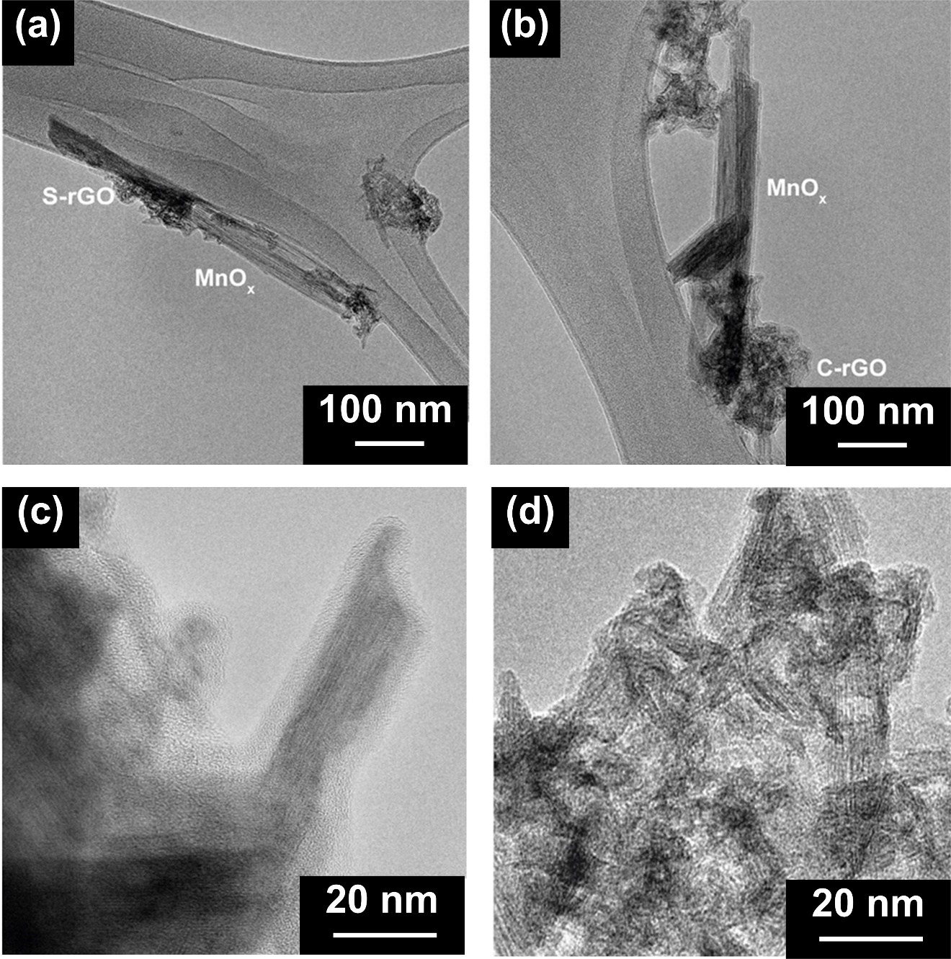
Figure S1. TEM images of (a) MnO_{x}/S-rGO and (b) MnO_{x}/C-rGO and HRTEM images of (c) MnO_{x}/S-rGO and (d) MnO_{x}/C-rGO.

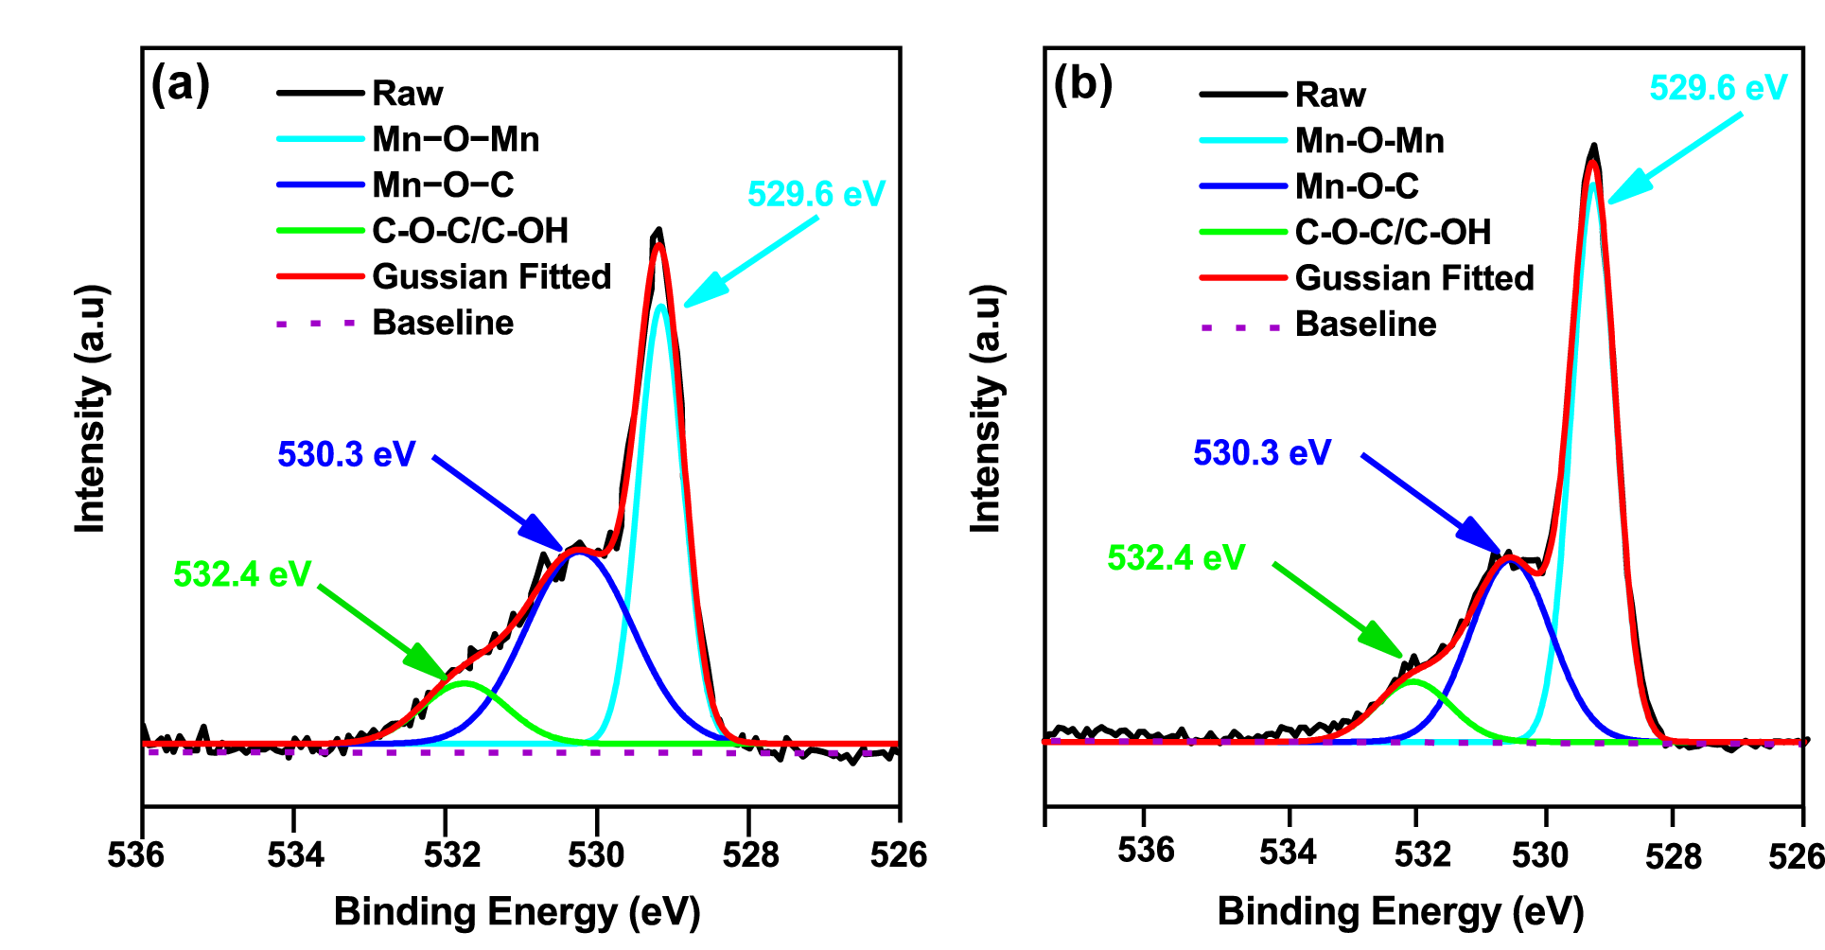
Figure S2. High-resolution O1s XPS spectra of (a) MnO_{x}/S-rGO and (b) MnO_{x}/C-rGO.

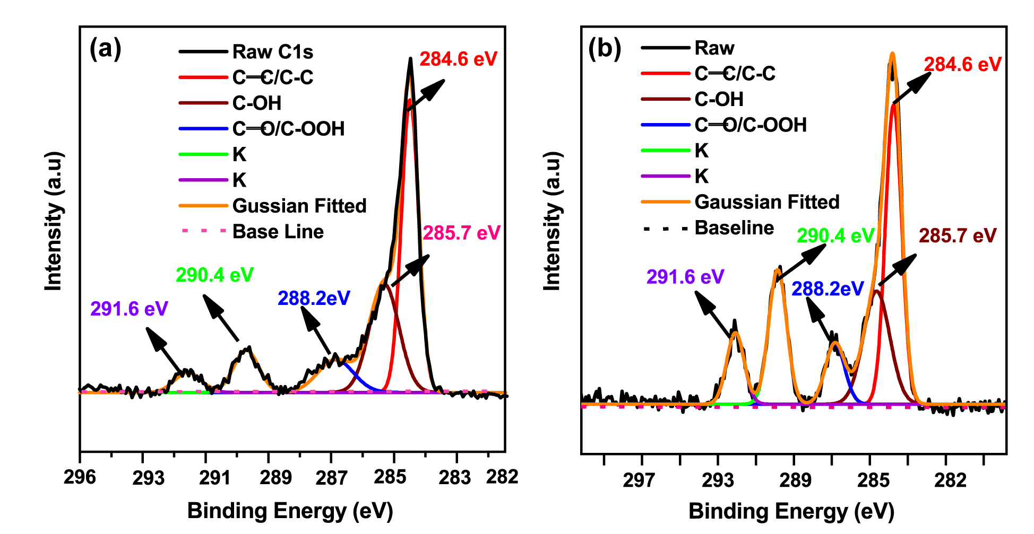
Figure S3. High resolution C 1s XPS spectra of (a) MnO_{x}/S-rGO and (b) MnO_{x}/C-rGO.

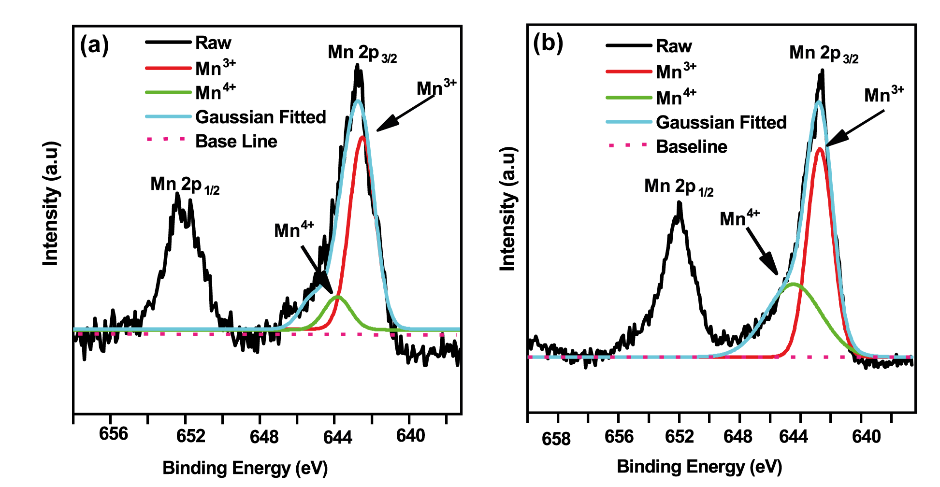
Figure S4. High resolution Mn 2p XPS spectra of (a) MnO_{x}/S-rGO and (b) MnO_{x}/C-rGO.

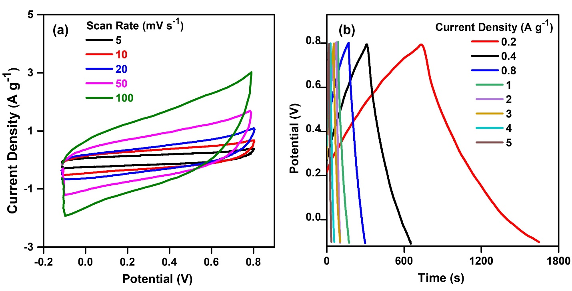

Figure S5. (a) CV curves at different scan rates and (b) GCD curves at different current densities of MnO_{x} in 0.5 M Na₂SO₄ electrolyte in the potential range of −0.1 to 0.8 V.

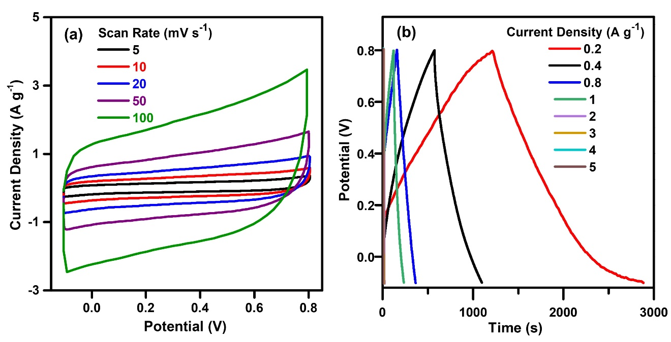
Figure S6. Electrochemical study in 0.5 M Na₂SO₄ electrolyte with a three-electrode system: (a) CV curves at different scan rates and (b) GCD curves at different current densities of MnO_{x}/S-rGO in the potential range of −0.1 to 0.8 V.
.
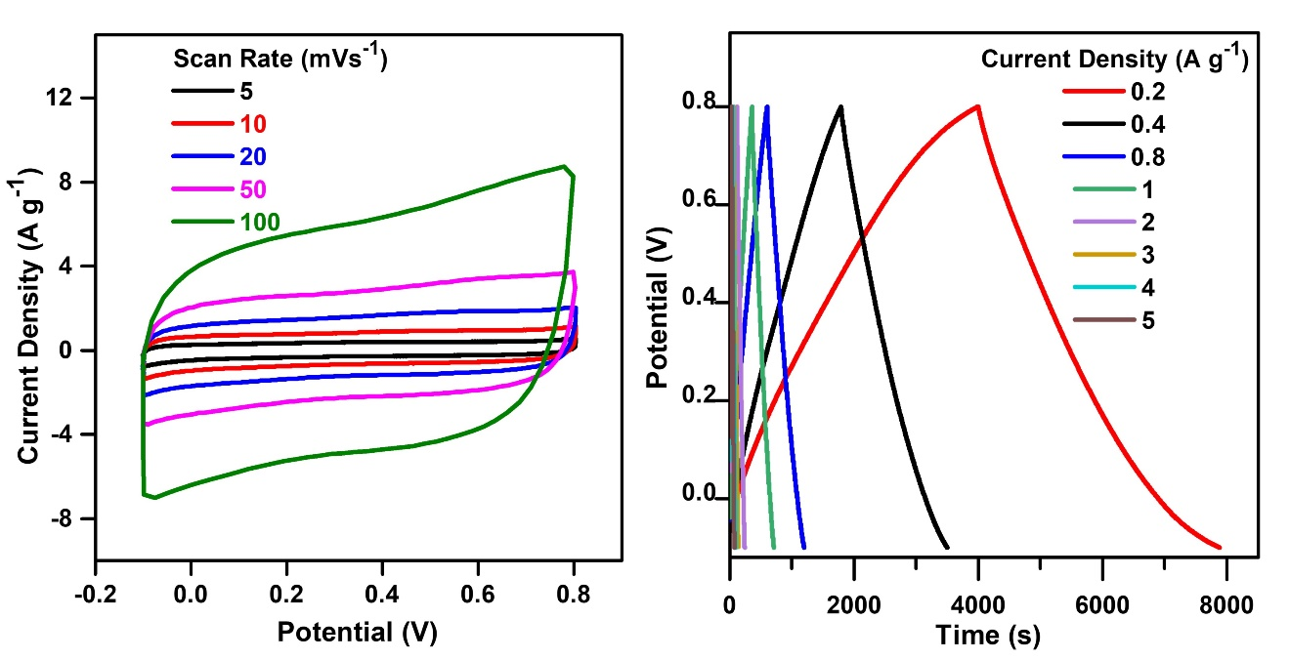
Figure S7. (a) CV curves at different scan rates and (b) GCD at different current densities of MnO_{x}/C-rGO in 0.5 M Na₂SO₄ electrolyte in the potential range of −0.1 to 0.8 V.

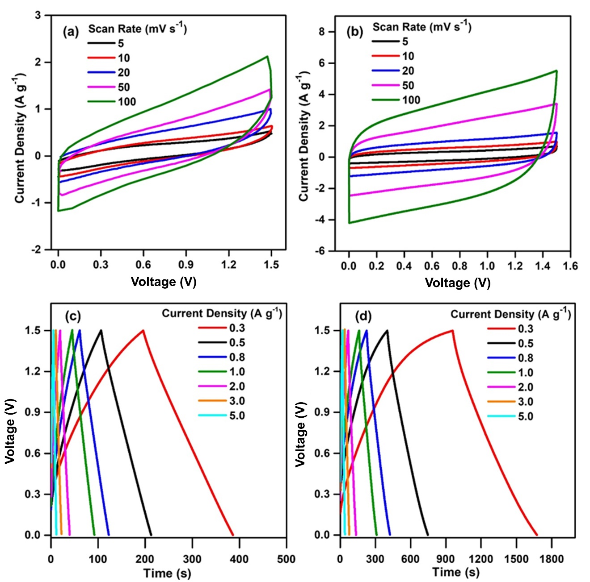
Figure S8. Electrochemical study in 1 M Na₂SO₄ electrolyte with a two-electrode system. CV curves of the symmetric devices prepared with (a) MnO_{x}/S-rGO and (b) MnO_{x}/C-rGO at different scan rates. GCD curves of the symmetric devices prepared with (c) MnO_{x}/S-rGO and (d) MnO_{x}/C-rGO at different current densities in the voltage range of 0 to 1.5 V.

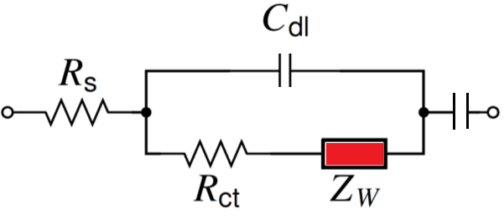

C_{p}

Figure S9. Equivalent fitting circuit

Table. S1 The obtained values of R_{S}, R_{ct}, C_{dl}, Z_{w}, C_{p}, from EIS fitting.

Symmetric supercapacitor device | R_{s} (Ohm) | R_{ct} (Ohm) | C_{dl} (µF) | Z_{W} | C_{p} (F)
MnO_{x}/S-rGO-based device | 5.531 | 10.454 | 7.21 | 0.01605 | 0.03546
MnO_{x}/C-rGO-based device | 3.742 | 8.734 | 4.67 | 0.02194 | 0.03798

