Additional Information
Dual-mode SERS-based lateral flow assay strips for simultaneous diagnosis of SARS-CoV-2 and influenza A virus
Mengdan Lu^{1,a}, Younju Joung^{1,a}, Chang Su Jeon², Sunjoo Kim³, Dongeun Yong⁴, Hyowon Jang⁵, Sung Hyun Pyun^{2,*}, Taejoon Kang^{5,*}, Jaebum Choo^{1,*}
¹ Department of Chemistry, Chung-Ang University, Seoul 06974, South Korea
² R&D Center, Speclipse Inc., Seongnam 13461, South Korea
³ Department of Laboratory Medicine, Gyeongsang National University College of Medicine, Jinju 52727, South Korea
⁴ Department of Laboratory Medicine and Research Institute of Bacterial Resistance, Yonsei University College of Medicine, Seoul 03722, South Korea
⁵ Bionanotechnology Research Center, Korea Research Institute of Bioscience and Biotechnology (KRIBB), Daejeon 34141, South Korea

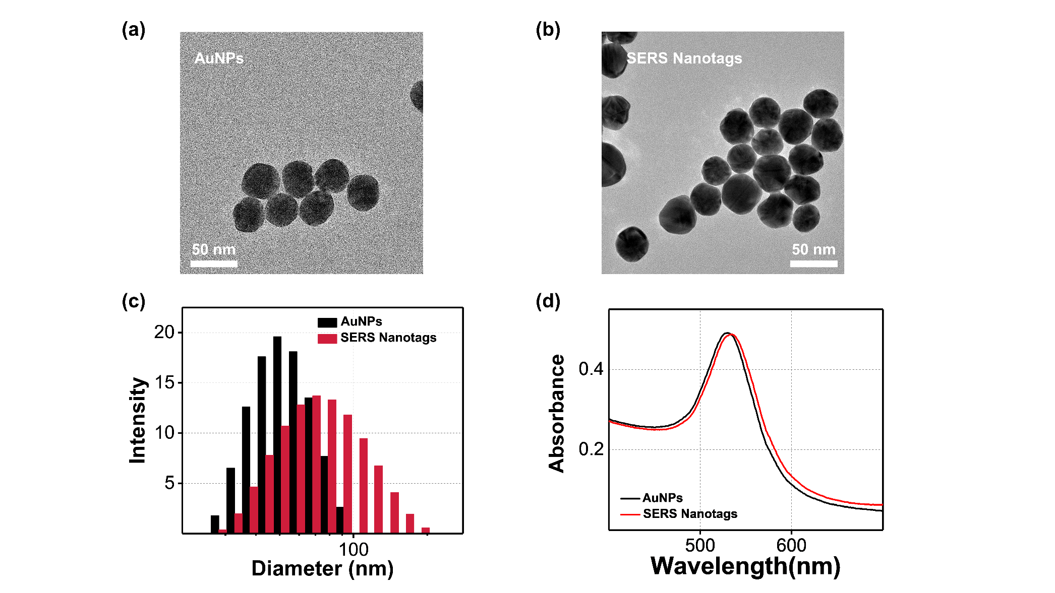
Fig. S1. TEM images of (a) AuNPs and (b) SERS nanotags. (c) DLS size distributions, (d) corresponding UV-vis absorption spectra of AuNPs (black) and SERS nanotags (red).
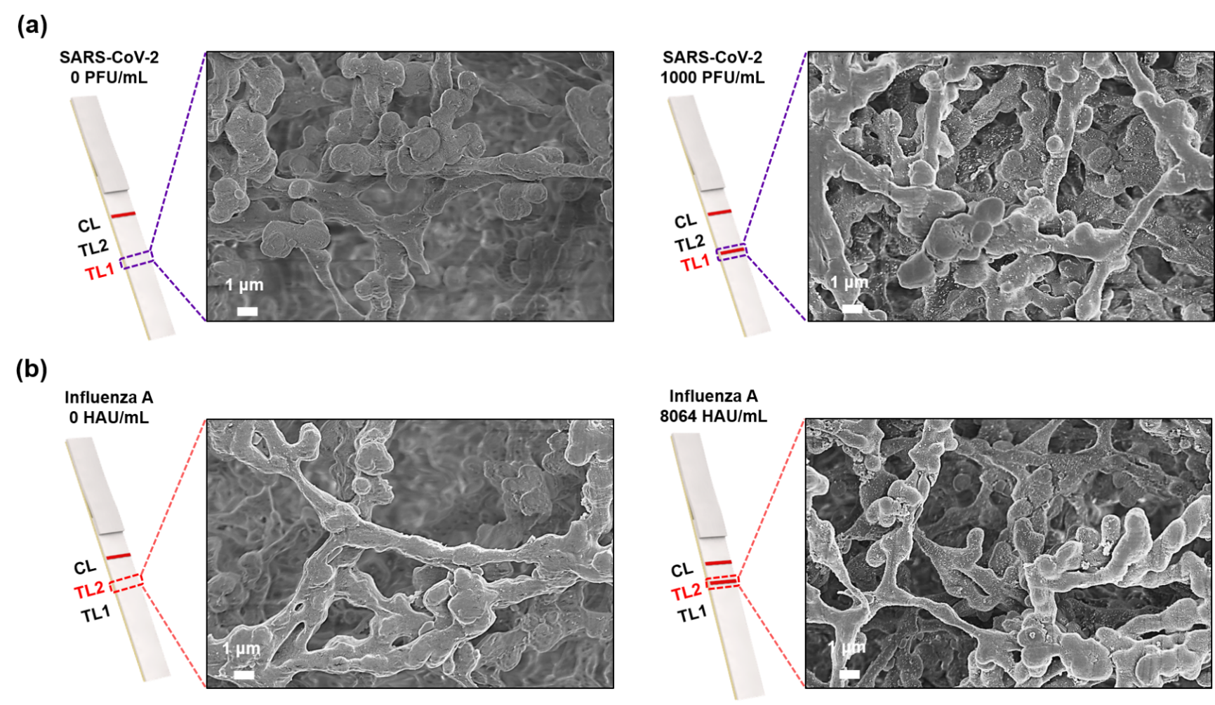
Fig. S2. SEM images for test lines: (a) in the absence (0 PFU/mL) and presence (1000 PFU/mL) of SARS-CoV-2, and (b) in the absence (0 HAU/mL) and presence (8064 HAU/mL) of influenza A virus.

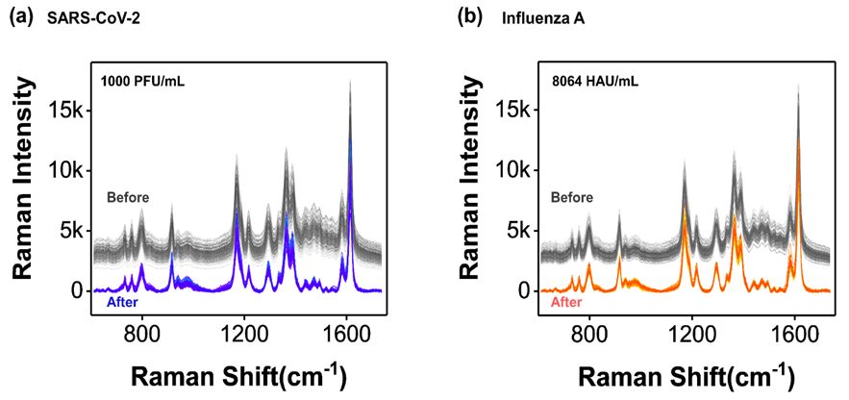
Fig. S3. Raman spectra of 130 mapping points before (gray) and after (blue/red) base line corrections for (a) 1000 PFU/mL SARS-CoV-2 and 8064 HAU/mL influenza A virus.

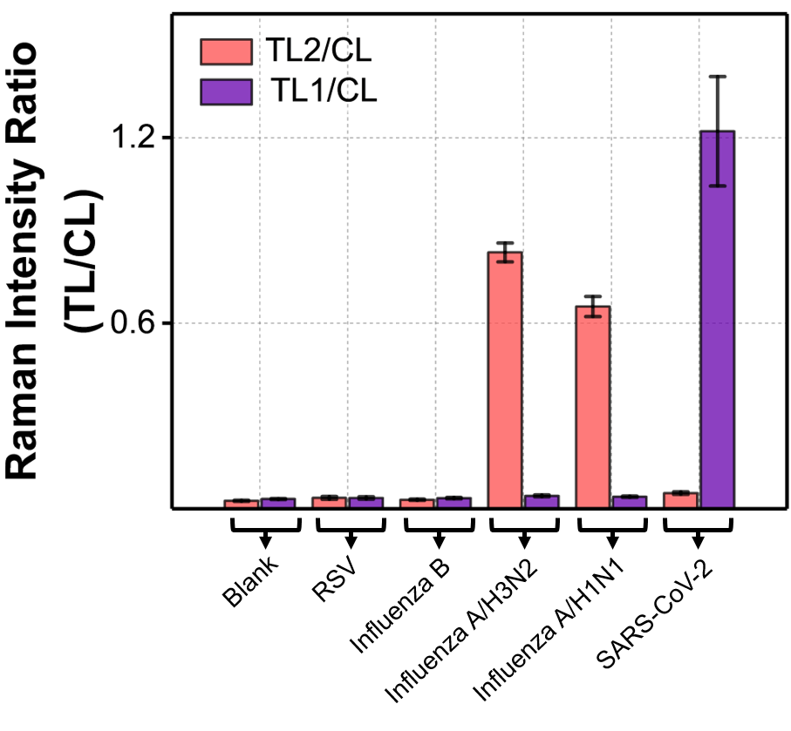
Fig. S4. Selectivity tests for five different respiratory viruses (RSV, influenza B, influenza A/H3N2, influenza A/H1N1, and SARS-CoV-2) using a SERS-LFA strip.
Table S1. SERS intensity ratios for eight different SARS-CoV-2 concentrations.

Concentration (PFU/mL) | 1000 | 500 | 100 | 50 | 10 | 5 | 1 |  | 0
TL1 | 12978.3 | 10458.4 | 2879.09 | 2230.93 | 861.36 | 734.36 |  | 657.40 | 600.08
CL | 9395.64 | 10036.1 | 10551.9 | 10370.2 | 8763.94 | 10694.8 |  | 11194.6 | 11540.2
Ratio (TL1/CL) | 1.381 | 1.042 | 0.273 | 0.215 | 0.098 | 0.068 |  | 0.058 | 0.052

Table S2. SERS intensity ratios for eight different influenza A virus concentrations.

Concentration (HAU/mL) | 8064 | 4032 | 2016 | 1008 | 504 | 168 | 56 |  | 0
TL2 | 7806.26 | 7113.04 | 4748.64 | 3456.06 | 2244.07 | 1292.90 |  | 938.26 | 671.16
CL | 10137.6 | 10644.36 | 2937.67 | 13607.2 | 14169.5 | 12389.7 |  | 11483.5 | 22906.5
Ratio (TL2/CL) | 0.770 | 0.668 | 0.367 | 0.254 | 0.158 | 0.104 |  | 0.082 | 0.029

Table S3. Determination of LoDs using four-parameter sigmoidal function and calculated LoD values for ELISA and dual-mode SERS-LFA.
Methods | Model | Equation | Parameters
Methods | Model | Equation | Term | Value
ELISA  (SARS-CoV-2) | Four-parameter sigmoidal function | $$y=\frac{A_{1}-A_{2}}{1+{(x/{x_{0})}}^{p}}+A_{2}$$ | A₁ | 0.09579
ELISA  (SARS-CoV-2) | Four-parameter sigmoidal function | $$y=\frac{A_{1}-A_{2}}{1+{(x/{x_{0})}}^{p}}+A_{2}$$ | A₂ | 0.57348
ELISA  (SARS-CoV-2) | Four-parameter sigmoidal function | $$y=\frac{A_{1}-A_{2}}{1+{(x/{x_{0})}}^{p}}+A_{2}$$ | x₀ | 713.13
ELISA  (SARS-CoV-2) | Four-parameter sigmoidal function | $$y=\frac{A_{1}-A_{2}}{1+{(x/{x_{0})}}^{p}}+A_{2}$$ | p | 2.0520
ELISA  (Influenza A virus) | Four-parameter sigmoidal function | $$y=\frac{A_{1}-A_{2}}{1+{(x/{x_{0})}}^{p}}+A_{2}$$ | A₁ | 0.07502
ELISA  (Influenza A virus) | Four-parameter sigmoidal function | $$y=\frac{A_{1}-A_{2}}{1+{(x/{x_{0})}}^{p}}+A_{2}$$ | A₂ | 0.88293
ELISA  (Influenza A virus) | Four-parameter sigmoidal function | $$y=\frac{A_{1}-A_{2}}{1+{(x/{x_{0})}}^{p}}+A_{2}$$ | x₀ | 18502
ELISA  (Influenza A virus) | Four-parameter sigmoidal function | $$y=\frac{A_{1}-A_{2}}{1+{(x/{x_{0})}}^{p}}+A_{2}$$ | p | 1.4707
Dual-mode SERS-LFA  (SARS-CoV-2) | Four-parameter sigmoidal function | $$y=\frac{A_{1}-A_{2}}{1+{(x/{x_{0})}}^{p}}+A_{2}$$ | A₁ | 0.05980
Dual-mode SERS-LFA  (SARS-CoV-2) | Four-parameter sigmoidal function | $$y=\frac{A_{1}-A_{2}}{1+{(x/{x_{0})}}^{p}}+A_{2}$$ | A₂ | 2.51215
Dual-mode SERS-LFA  (SARS-CoV-2) | Four-parameter sigmoidal function | $$y=\frac{A_{1}-A_{2}}{1+{(x/{x_{0})}}^{p}}+A_{2}$$ | x₀ | 807.95
Dual-mode SERS-LFA  (SARS-CoV-2) | Four-parameter sigmoidal function | $$y=\frac{A_{1}-A_{2}}{1+{(x/{x_{0})}}^{p}}+A_{2}$$ | p | 1.0412
Dual-mode SERS-LFA  (Influenza A virus) | Four-parameter sigmoidal function | $$y=\frac{A_{1}-A_{2}}{1+{(x/{x_{0})}}^{p}}+A_{2}$$ | A₁ | 0.03143
Dual-mode SERS-LFA  (Influenza A virus) | Four-parameter sigmoidal function | $$y=\frac{A_{1}-A_{2}}{1+{(x/{x_{0})}}^{p}}+A_{2}$$ | A₂ | 1.9543
Dual-mode SERS-LFA  (Influenza A virus) | Four-parameter sigmoidal function | $$y=\frac{A_{1}-A_{2}}{1+{(x/{x_{0})}}^{p}}+A_{2}$$ | x₀ | 13759
Dual-mode SERS-LFA  (Influenza A virus) | Four-parameter sigmoidal function | $$y=\frac{A_{1}-A_{2}}{1+{(x/{x_{0})}}^{p}}+A_{2}$$ | p | 0.74507

