Supporting information

Contents | Dimension
Porosity of membrane [%] | 50
Pore size of membrane [μm] | 0.22
Thickness of membrane [μm] | 60
Width×height of culture chamber [mm×mm] | 6×0.1
Radius×depth of microwell array [mm×mm] | 0.1×0.15

Table S1. Geometric parameters of the 3D computational fluid dynamics model.

Figure S1. Comparison graph according to (A) pore size and (B) porosity of membranes.

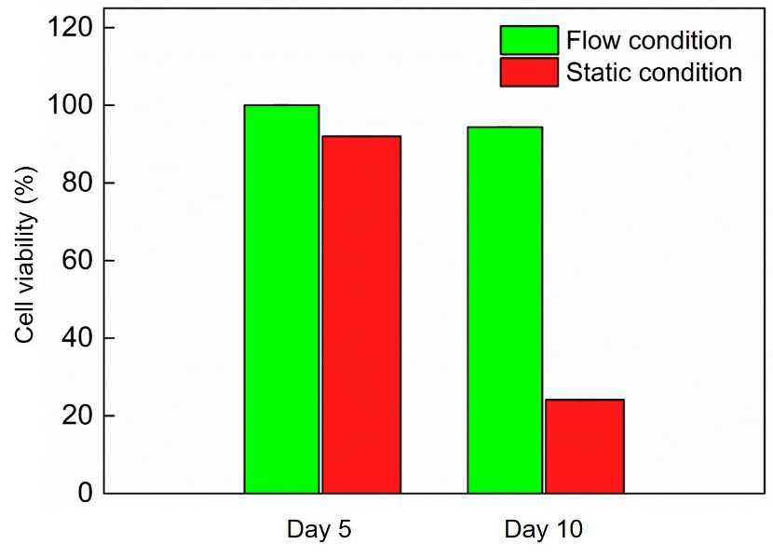
Figure S2. Effects of the fluidic flow on viability in hepG2 spheroids.

