Additional file 1

Transmissible H-aggregated NIR-II fluorophore to the tumor cell membrane for enhanced PTT and synergistic therapy of cancer
Haoli Yu¹, Yuesong Wang¹, Yan Chen¹, Mengyuan Cui¹, Fang Yang^{1, *}, Peng Wang^{2, *}, Min Ji^{1, *}
¹State Key Laboratory of Bioelectronics, Jiangsu Laboratory for Biomaterials and Devices, School of Biological Science and Medical Engineering, Southeast University, Nanjing, 210096, China
²Department of Biomedical Engineering, School of Engineering, China Pharmaceutical University, Nanjing, 210009, China.
Author for correspondence:
Min Ji, 101010516@seu.edu.cn
Peng Wang, wangpeng159seu@hotmail.com
Fang Yang, yangfang2080@seu.edu.cn
Fig. S1. Absorption and fluorescence spectra of IALP-C4, RIALP-C4, TIALP-C4 and RRIALP-C4.
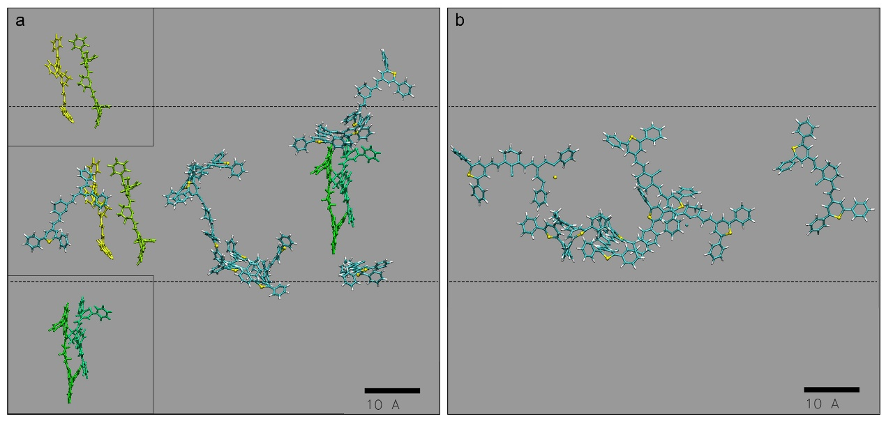
Fig. S2. The H-aggregated state of IR-1061 in the system after running for 90 ns (dash line: distribution layers of IR-1061 in H-aggregated state). (a) The ratio of IR-1061 to DPPG is 1:10. (b) The ratio of IR-1061 to DPPG is 1:20.
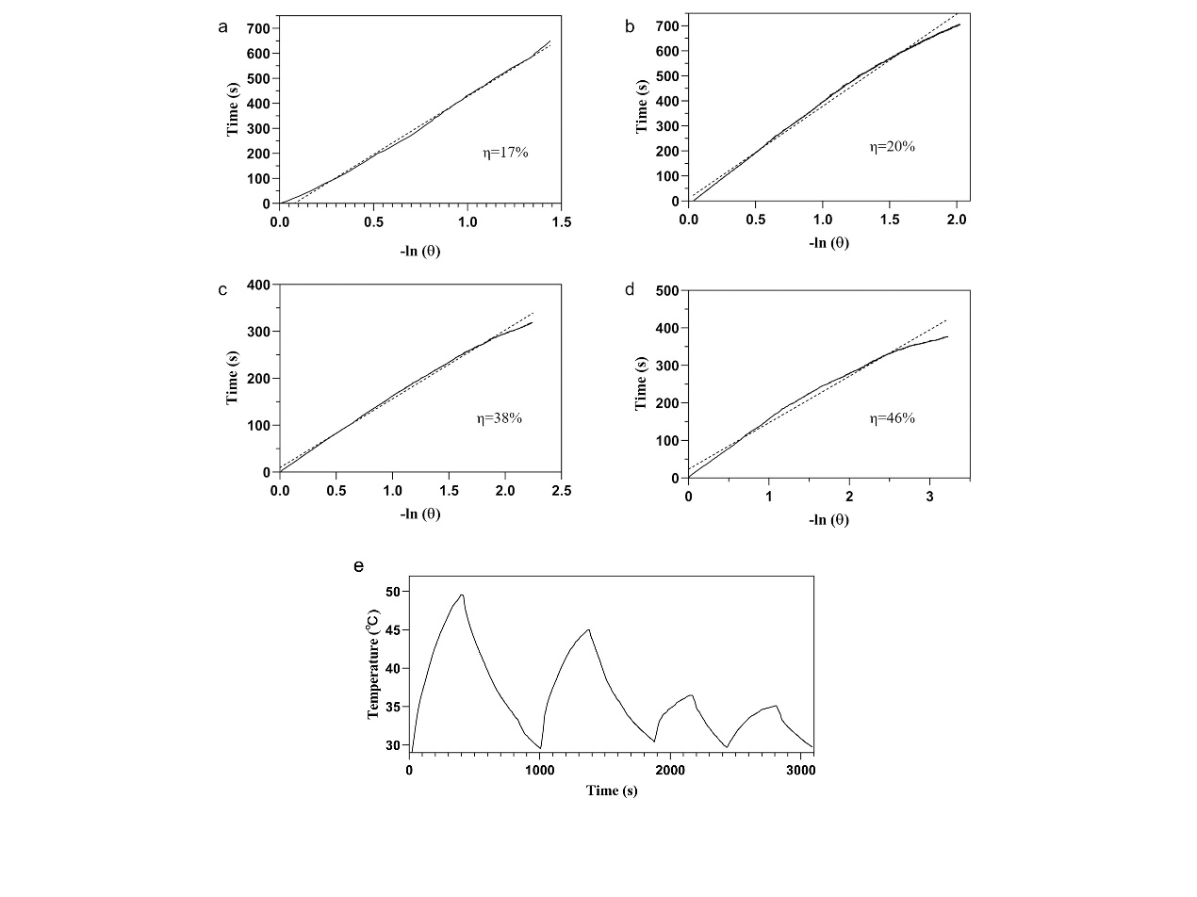
Fig. S3. The linear fitting of −ln^{θ} and time in the cooling curve and photothermal conversion efficiency. (a) IALP-1. (b) IALP-2. (c) IALP-3. (d) IALP-5. (e) Photothermal stability of ICG-ALP (laser on/off for 4 consecutive cycles) irradiated with 808 nm laser at 0.3 W/cm².
Fig. S4. The photothermal conversion efficiency and photothermal stability of IR-780-loaded liposomes (phospholipid concentration: 10 mg/mL). (a) The linear fitting of −ln^{θ} and time in the cooling curve and photothermal conversion efficiency. (b) Photothermal stability of IR-780-loaded liposomes (laser on/off for 4 consecutive cycles) irradiated with 808 nm laser at 0.3 W/cm².
Fig. S5. The absorption of RRIALP-C4 (phospholipid concentration: 10 mg/mL) after being irradiated with 808 nm laser (0.3 W/cm²) for different cycles
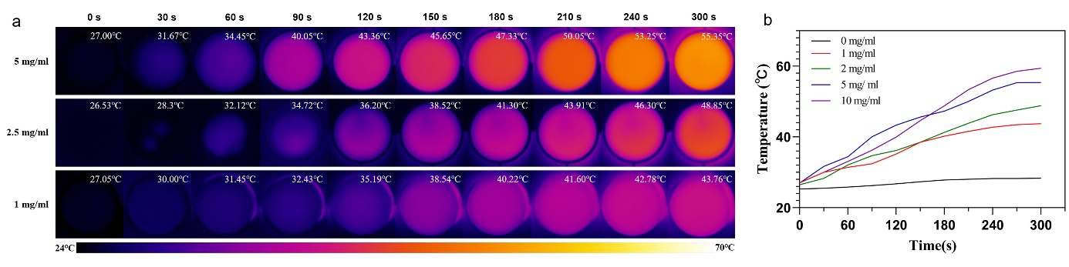
Fig. S6. (a) Thermal images of RRIALP-C4 with different phospholipid concentrations after being irradiated with 808 nm laser at 0.3 W/cm² in 24-well plates (diluted withcell culture medium). (b) Temperature changes of RRIALP-C4 with different phospholipid concentrations.
Fig. S7. Cell viability after drug treatment. (a) ICG aqueous solution with different concentrations. (b) ICG-loaded liposomes (2% molar content) with different phospholipid concentrations.
Fig. S8. In vitro photothermal therapy and synergistic treatment for A549 cells. (a) Cytotoxicity of A549 cells treated with drugs group (6.7 μM Carbo+1 mg/mL IALP-4+L) and single liposomes combi group (1mg/mL ALP-C+1mg/mL IALP+L) after treatment for 24 h. (b) Flow cytometry of apoptosis cells treated with different conditions. Q1, Q2, Q3, and Q4 represent necrotic, late apoptotic, early apoptotic, and viable cells, respectively. (c) Fluorescent staining of dead/living cells treated with different conditions. Green channel: viable cells. Red channel: dead cells.
Fig. S9. (a) CLSM images (100× oil) of A549 cells treated with 2 mg/mL RALP, RRALP, and TRALP for 30 min. Blue channel: nucleus. Green channel: cell membrane. Red channel: liposomes. (b) CLSM images (100× oil) of A549 cells treated with 2 mg/mL DALP, RDALP, and TDALP for 30 min. Blue channel: nucleus. Green channel: liposomes. (c) CLSM images (100× oil) of A549 cells treated with 2 mg/mL DRALP, RDRALP, and TDRALP for 30 min. Blue channel: nucleus. Green and red channels: liposomes.
Fig. S10. Fluorescence properties of different phospholipid concentrations of DiO-ALP and Rhb-ALP. (a) and (b) Excitation and emission spectra of DiO-ALP. (c) Maximum emission peak of DiO-ALP. (d) and (e) Excitation and emission spectra of Rhb-ALP. (f) Maximum emission peak of Rhb-ALP.
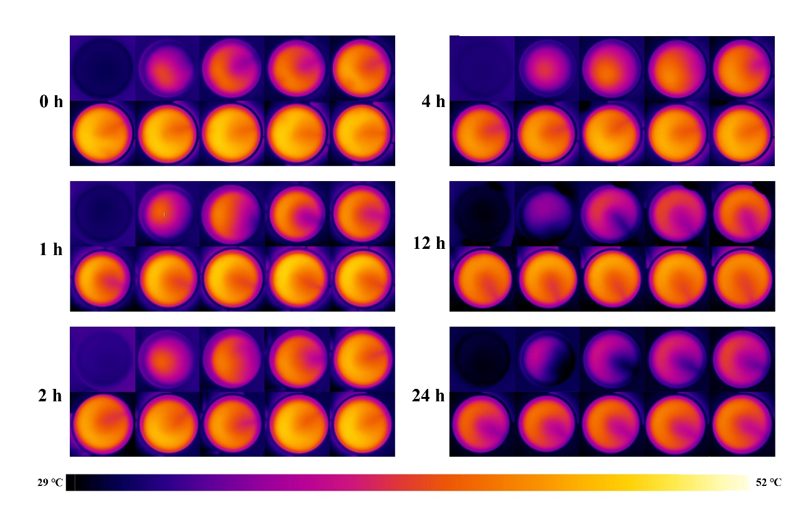
Fig. S11. Thermal images of A549 cells treated with RRIALP-4 (2 mg/mL) in different times (irradiated with 808 nm laser at 0.3 W/cm² for 5 min).
Fig. S12. Thermal images of A549 cells treated with ICG aqueous solution and ICG-ALP in different times. (a) Top: ICG aqueous solution (50 μg/mL); Bottom: 2% molar content ICG-ALP (phospholipid concentration: 2 mg/mL). (b) and (c) Temperature change curves of ICG aqueous solution and ICG-ALP.
Fig. S13. Fluorescence images of A549 cells phagocytosis of liposomes. (a) A549 cells treated with DRALP, RRDRALP, and RRDRALP+Pitstop 2 for 30 min. (b) Fluorescence analysis of RhB in A549 cells.
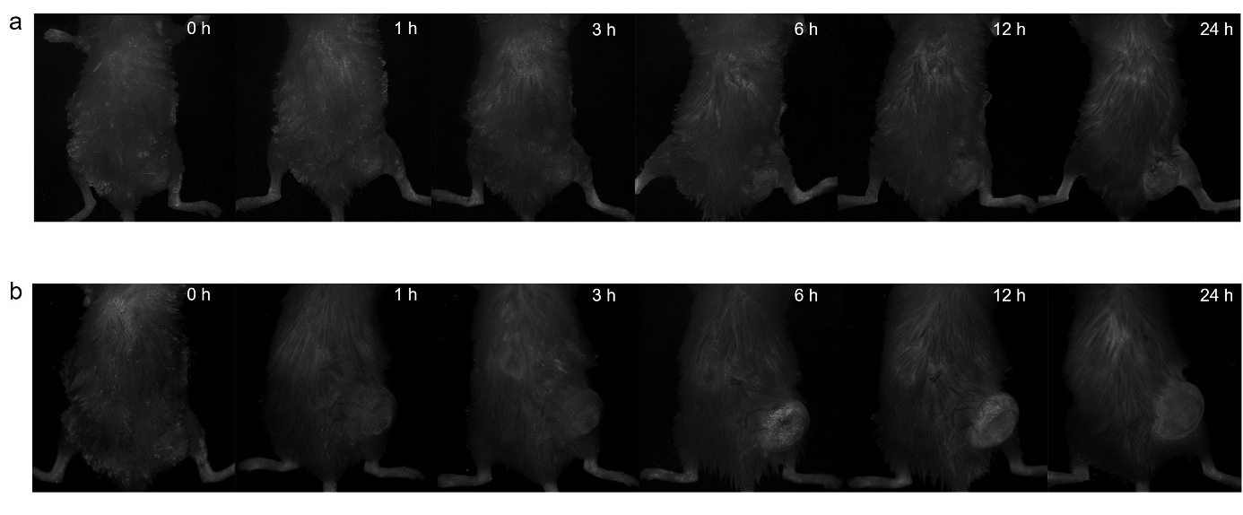
Fig. S14. (a) In vivo NIR-II FI of RIALP-C4 at different time points (0, 1, 3, 6, 12, 24 h). (b) In vivo NIR-II FI of TIALP-C4 at different time points (0, 1, 3, 6, 12, 24 h).
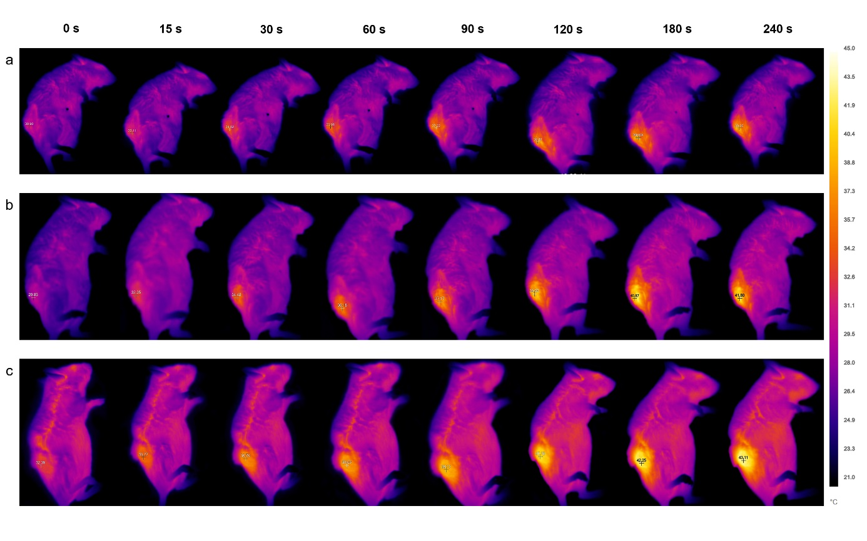
Fig. S15. (a) In vivo PTI of IALP-C4 at different time points (0, 15, 30, 60, 90, 120, 180, 240 s). (b) In vivo PTI of RIALP-C4 at different time points (0, 15, 30, 60, 90, 120, 180, 240 s). (c) In vivo PTI of TIALP-C4 at different time points (0, 15, 30, 60, 90, 120, 180, 240 s).
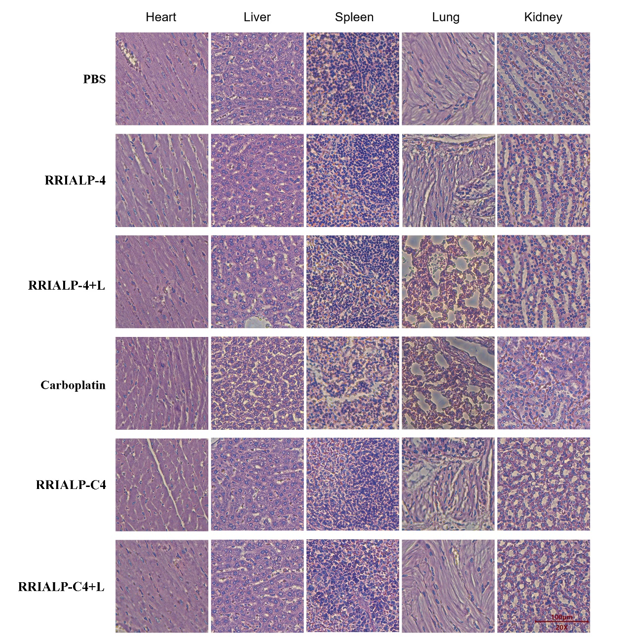
Fig. S16. H&E staining sections of organs from different groups.
Fig. S17. In vivo synergistic therapy of RR-ICG-ALP and single liosome combi group (RRALP-C+RRIALP-4+L)
Fig. S18. Absorption peaks of purified cell membrane after Incubated with IALP-4.

