Hollow Ni/NiO /C Composite Derived from Metal–Organic Frameworks as a High-Efficiency Electrocatalyst for the Hydrogen Evolution Reaction
Ha Huu Do ª, Mahider Asmare Tekalgne ª, Quyet Van Le ^{b}, Jin Hyuk Cho ^{b}, Sang Hyun Ahn ^{a,*}, Soo Young Kim ^{c,*}
ª School of Chemical Engineering and Materials Science, Chung-Ang University, 84 Heukseok-ro, Dongjak-gu, Seoul 06974, Republic of Korea
^{b}Department of Materials Science and Engineering, Institute of Green Manufacturing Technology, Korea University, 145 Anam-ro, Seongbuk-gu, Seoul 02841, Republic of Korea.
*Corresponding author
Email: shahn@cau.ac.kr (S.H. Ahn);
Email: sooyoungkim@korea.ac.kr (S.Y. Kim);

Synthesis of Ni-MOF non hollow structure
Ni(NO₃)₂.6H₂O (216 mg) and H₃BTC (75 mg) were dissolved in a mixed solvent containing 5 mL of DMF, 5 mL of C₂H₅OH, and 5 mL of DI for 30 min under magnetic stirring. This solution was transferred into a 25 mL Teflon-lined stainless-steel reactor and heated to 150$°$C for 10 h. The obtained green Ni-MOF crystals were washed by C₂H₅OH and dried at 60$°$C for 10 h.

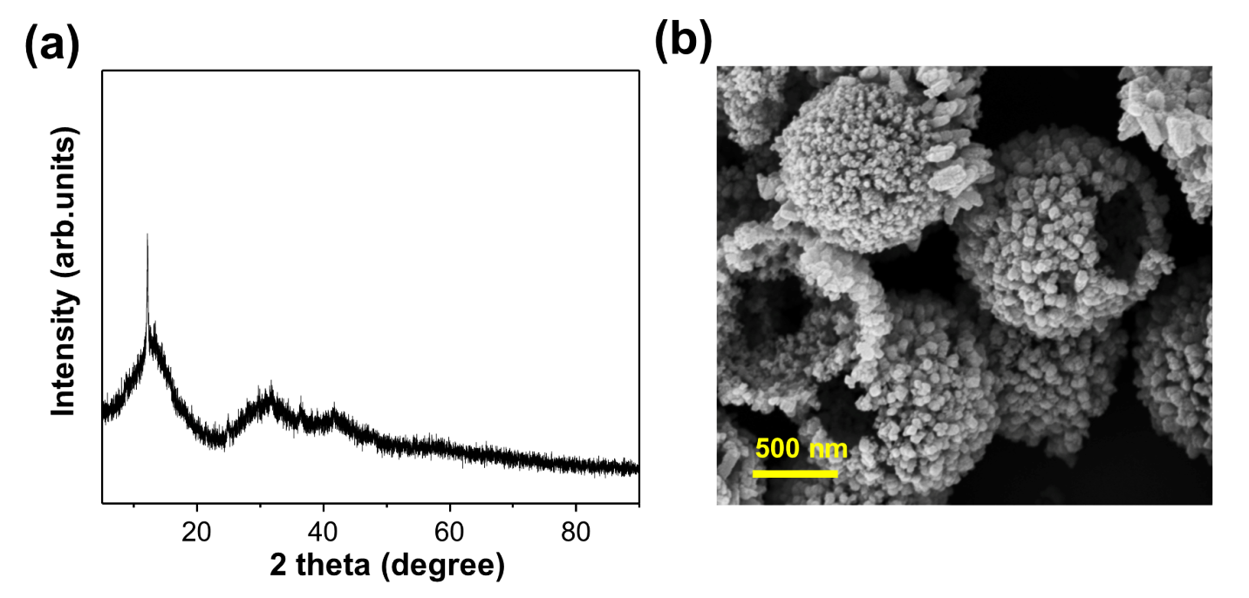
Fig. S1. (a) XRD pattern and (b) FE-SEM image of the Ni-MOF hollow structure

Fig. S2. SEM images of (a) H-Ni/C and (b) H-NiO/C

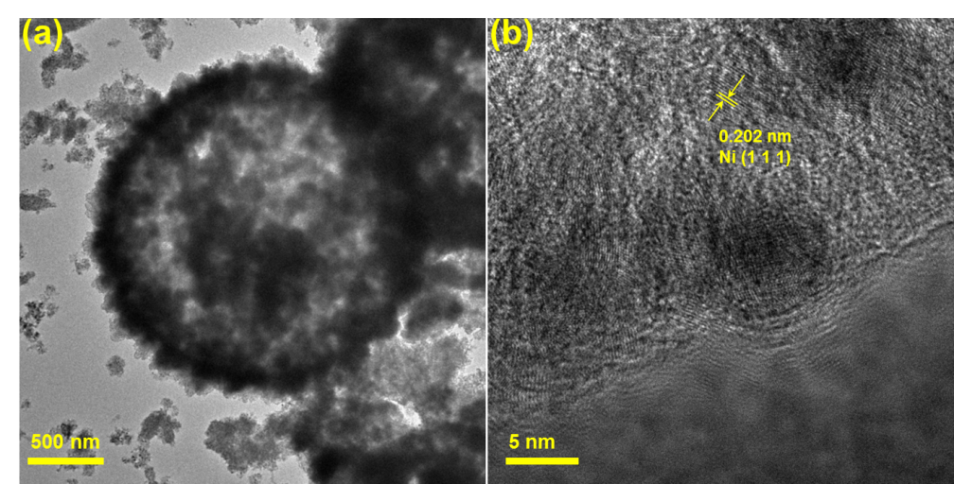
Fig S3. (a) TEM, and (b) Field emission TEM images of H-Ni/C.

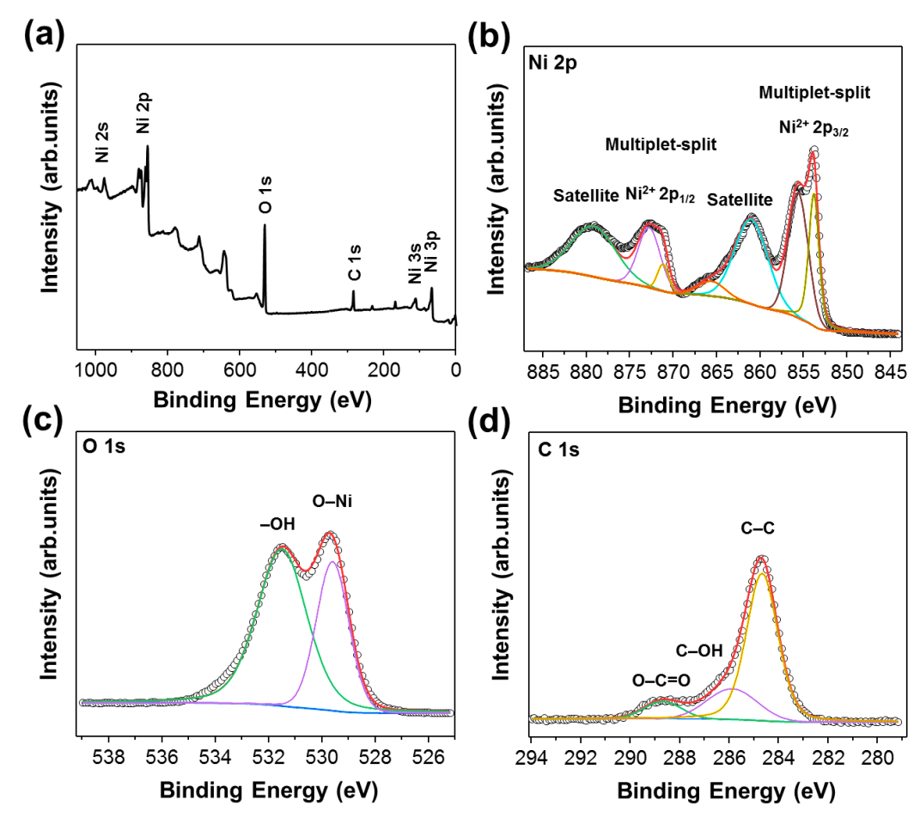
Fig. S4. (a) XPS survey spectrum. High-resolution XPS profiles of H-NiO/C: (b) Ni 2p, (c) O 1s, and (d) C 1s.

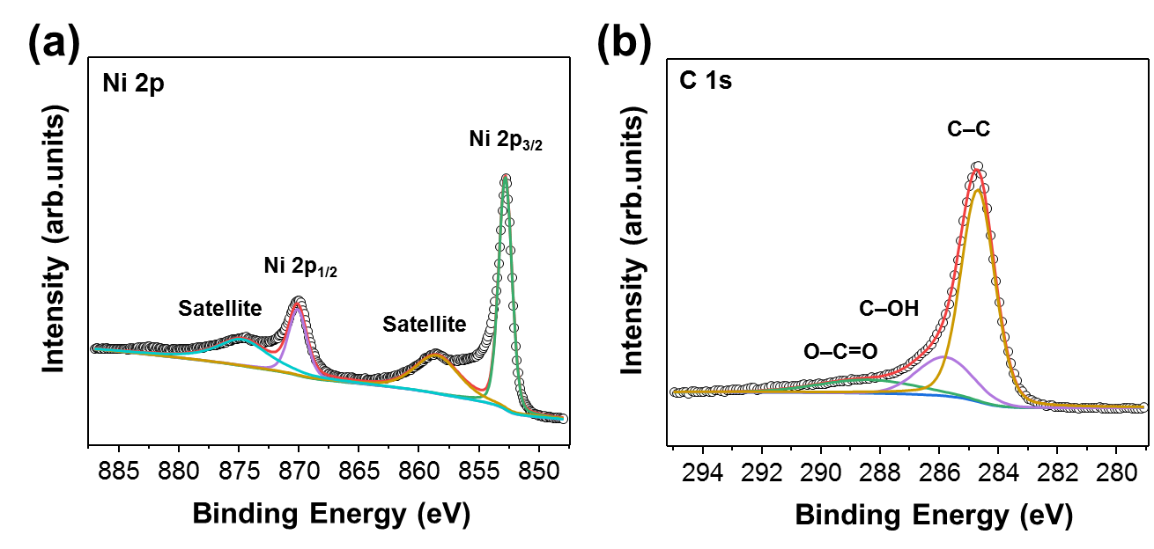
Fig. S5. High-resolution XPS profiles of H-Ni/C: (a) Ni 2p, and (b) C 1s.

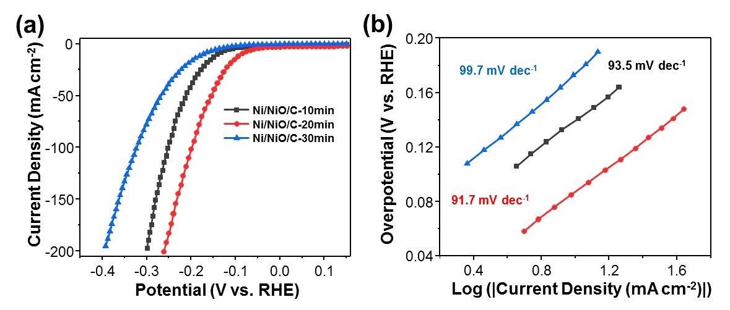
Fig. S6. (a) Polarization curves of the H-Ni/NiO/C-10min, H-Ni/NiO/C-20min, and H-Ni/NiO/C-30min catalysts at a scan rate of 2 mV s⁻¹ in a 1 M KOH solution. (b) Tafel plots of the same catalysts derived from (a).

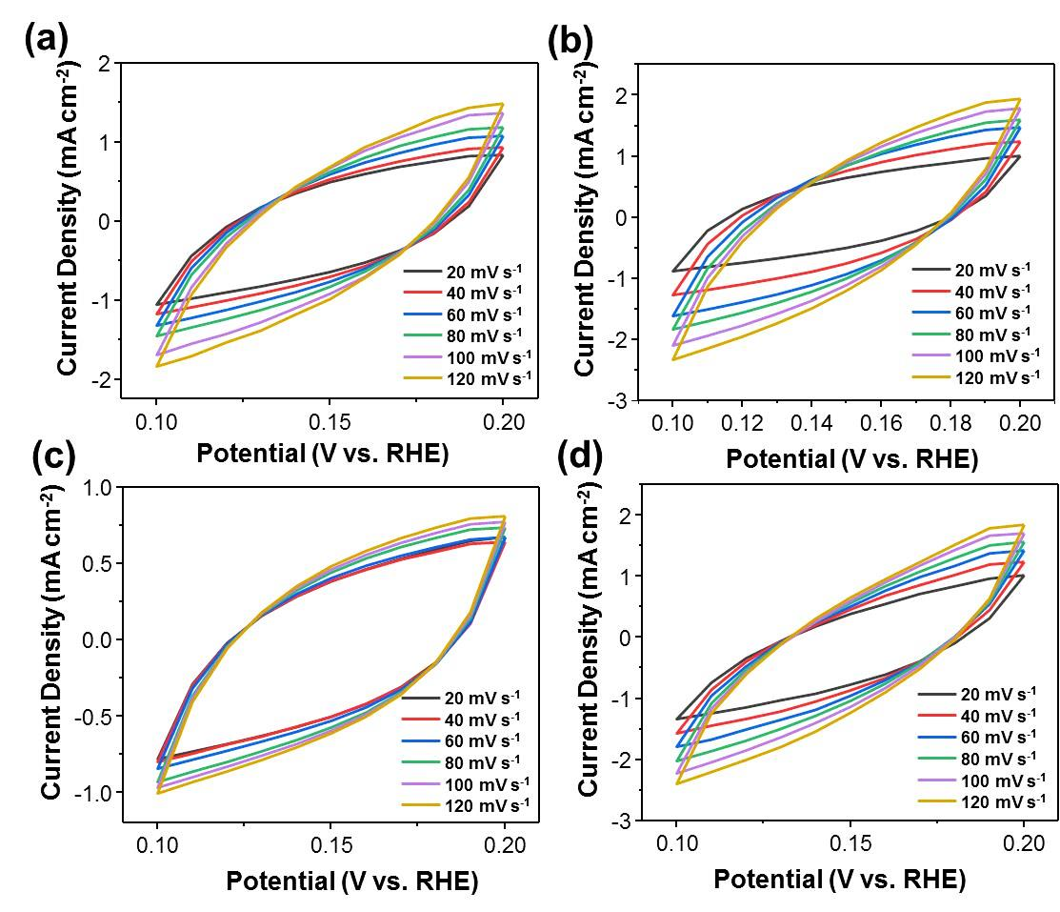
Fig. S7. Cyclic voltammograms (0.1–0.2 V) of (a) H-Ni/C, (b) H-Ni/NiO/C, (c) H-NiO/C, and (d) NH-Ni/NiO/C at various scan rates (20–120 mV s⁻¹) in a 1 M KOH solution.

Fig. S8. (a) XRD pattern and (b) SEM images of H-Ni/NiO/C after 2000 CV cycles.

The ECSA was calculated using C_{dl} with the following relation:
$ECSA=\frac{C_{dl}}{Cs {cm}_{ECSA}^{-2}}$. (1)
where Cs = 0.040 mF cm⁻² in an alkaline solution. The C_{dl} values were calculated from the CV profiles at different scan rates (ν) in the non-Faradaic region (from 0.1 to 0.2 V vs. the RHE), using the slope of the plot of ΔJ/2 versus the scan rate.

Table S1: Comparison of the HER performance of different samples in an alkaline solution
Samples | Overpotential (mV) at 10 mA cm⁻² | Tafel slope (mV dec⁻¹) | C_{dl} (mF cm⁻²) | ECSA  (cm²) | R_{ct}/R_{ad} (Ω)
H-Ni/NiO/C | 87 | 91.7 | 4.89 | 122.25 | 75.9/6.1
NH-Ni/NiO/C | 117 | 98.7 | 3.69 | 92.25 | 133.4/7.4
H-Ni/C | 167 | 106.5 | 2.75 | 68.75 | 189.6/8.9
H-NiO/C | 246 | 124.2 | 1.08 | 27 | 229.4/14.25

Table S2. Comparison of the catalytic activity of the Ni/NiO/C hollow structure with those of nickel-based catalysts for the HER in an alkaline solution.
Precursors | Catalysts | Current density  (mA cm⁻²) | Overpotential (mV) | Tafel slope (mV dec⁻¹) | Reference
Ni(NO₃)₂·6H₂O | Ni/NiO/NCW-1 | 10 | 105.3 | 55.2 | [1]
NiAc/PVP | Ni/NiO-CNTs | 10 | 98 | 79 | [2]
Ni(NO₃)₂·6H₂O | NiO/C composite | 10 | 565 | 77.8 | [3]
Ni(NO₃)₂·6H₂O | NiO | 5 | 209 | 60 | [4]
Ni metal | NiO/Ni@C-O | 10 | 89 | - | [5]
Ni(OH)₂ | Ni/NiO | 10 | 120 | 114 | [6]
Ni-MOF | H-Ni/NiO/C | 10 | 87 | 91.7 | This work

References
[1] H. Han, S. Park, D. Jang, W.B. Kim, N-doped carbon nanoweb-supported Ni/NiO heterostructure as hybrid catalysts for hydrogen evolution reaction in an alkaline phase. J. Alloys Compd. 853, 157338 (2021)
[2] L. Yang, X. Zhao, R. Yang, P. Zhao, Y. Li, P. Yang, J. Wang, D. Astruc, In-situ growth of carbon nanotubes on Ni/NiO nanofibers as efficient hydrogen evolution reaction catalysts in alkaline media. Appl. Surf. Sci. 491, 294-300 (2019)
[3] S. Lu, M. Hummel, Z. Gu, Y. Gu, Z. Cen, L. Wei, Y. Zhou, C. Zhang, C. Yang, Trash to treasure: A novel chemical route to synthesis of NiO/C for hydrogen production. International Journal of Hydrogen Energy 44, 16144-16153 (2019)
[4] X. Yan, L. Tian, X. Chen, Crystalline/amorphous Ni/NiO core/shell nanosheets as highly active electrocatalysts for hydrogen evolution reaction. J. Power Sources 300, 336-343 (2015)
[5] J. Wang, Z. Zhao, C. Shen, H. Liu, X. Pang, M. Gao, J. Mu, F. Cao, G. Li, Ni/NiO heterostructures encapsulated in oxygen-doped graphene as multifunctional electrocatalysts for the HER, UOR and HMF oxidation reaction. Catal. Sci. Technol. 11, 2480-2490 (2021)
[6] Y. Kuang, G. Feng, P. Li, Y. Bi, Y. Li, X. Sun, Single‐crystalline ultrathin nickel nanosheets array from in situ topotactic reduction for active and stable electrocatalysis. Angew. Chem. 128, 703-707 (2016)

