Supplementary Information

Freestanding VO₂ membranes on epidermal nanomesh for ultra-sensitive correlated breathable sensors

Dongha Kim,^{1,#} Dongju Lee,^{1,#} Jiseok Park,¹ Jihoon Bae,¹ Aiping Chen,² Judith L. MacManus-Driscoll,³ Sungwon Lee,^{1,}* and Shinbuhm Lee^{1,}*

¹Department of Physics and Chemistry, Department of Emerging Materials Science, DGIST, Daegu 42988, Republic of Korea
²Center for Integrated Nanotechnologies, Los Alamos National Laboratory, Los Alamos, New Mexico, 87545 USA
³Department of Materials Science and Metallurgy, University of Cambridge, 27 Charles Babbage Road, Cambridge, CB3 0FS, UK

#D.K. and D.L. equally contributed to this work.

*E-mail: (Sungwon Lee) swlee@dgist.ac.kr
*E-mail: (Shinbuhm Lee) lee.shinbuhm@dgist.ac.kr

Keywords: Correlated breathable sensor, VO₂, freestanding membrane, epidermal nanomesh, Sr₃Al₂O₆, tactile sensor, respiratory sensor

Figures S1−S7
1. Selective etching of Sr₃Al₂O₆ layer in deionized water

Figure S1. Snapshots for selective etching of Sr₃Al₂O₆ layer in deionized water. (a) We immerse the VO₂/Sr₃Al₂O₆/SrTiO₃ in deionized water. (b−e) The Sr₃Al₂O₆ sacrificial layer starts to be dissolved within 2 minutes. We keep the sample in the deionized water for 6 hours to completely release the VO₂ membranes from the SrTiO₃ substrate. (f) When we immerse the sample in deionized water again, we can separate the VO₂ membrane from the SrTiO₃ substrate. We take the VO₂ membranes from water and dry them for 60 minutes to remove water.

2. Freestanding VO₂ membranes on non-breathable polyethylene terephthalate

Figure S2. Conventional process to transfer freestanding VO₂ membranes onto non-breathable polyethylene terephthalate (PET) with assistance of Sr₃Al₂O₆ sacrificial layer. There are three steps: depositing VO₂ films, etching Sr₃Al₂O₆ sacrificial layer in deionized water, and transferring VO₂ membrane on PET. The photos, from the left under the schematics, show VO₂ films on Sr₃Al₂O₆ sacrificial layer-coated SrTiO₃ substrates, separation of VO₂ membranes from SrTiO₃ substrate after complete etching of Sr₃Al₂O₆ sacrificial layer in deionized water, and scooping floated VO₂ membranes by the oxygen-plasma-treated PET. The final photo displays the VO₂/PET.

3. Monoclinic VO₂ phase in freestanding membranes
Figure S3. Magnified X-ray diffraction of Figure 3, clearly showing monoclinic VO₂ diffraction peaks (green-colored Miller indexes).

4. Transition temperature for reversible and colossal resistance changes in VO₂ upon heating and cooling
Figure S4. Temperature dependence of $\frac{d(log⁡(R))}{dT}$ (R: resistance of VO₂, T: temperature). Independent of the substrates, all VO₂ samples show negatively maximum $\frac{d(log⁡(R))}{dT}$ values near 60.7 ± 1.1°C upon heating and near 37.3 ± 3.2ºC upon cooling. Therefore, the temperature at which the resistance changes in VO₂ membranes occur are similar to ~68ºC of the VO₂ bulk.

5. Raw data of Raman spectra of VO₂ freestanding membranes
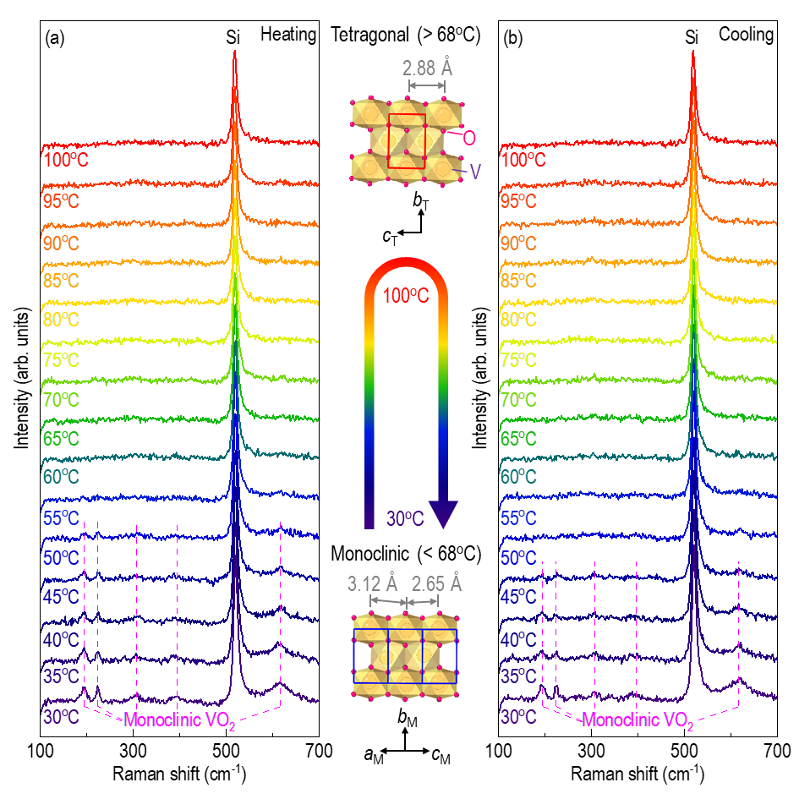
Figure S5. Temperature dependence of Raman spectra of VO₂ freestanding membranes transferred on Si substrates. We acquire the spectra at each temperature between 30−100ºC with 5ºC interval upon (a) heating and (b) cooling.

6. Poor performance of VO₂/PET for respiration sensors
Figure S6. Respiratory test of VO₂/PET. The resistance changes of VO₂/PET are very weak with (a) ‘normal’ exhalation and (b) ‘marathon’ exhalation.

7. Robust respiration sensors of VO₂/nanomesh
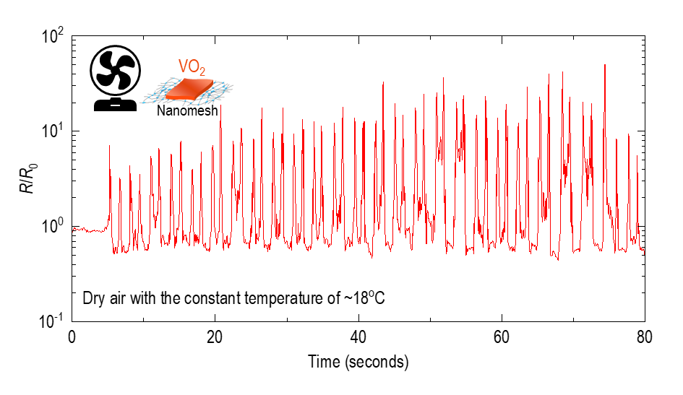
Figure S7. Long-term reversible resistance changes of VO₂/nanomesh. When we blow dry air (with the constant temperature of ~18ºC) towards the VO₂/nanomesh, the breathable quantum sensor shows excellent endurance of resistance change up to at least 52 times. Between the exhalation, the resistance was stably recovered to its initial value.

