Supplementary Information
AI-Driven Quantitative Review of Mobility–Stability Trade-off in Oxide Semiconductors
Ji Hoon Hong^{1,2,†}, Chi-Hoon Lee^{4, †}, Hyeon Woo Kim^{1,3}, Dong Won Jeon^{1,2}, Jun Hyuk Kang^{1,2}, Yoon-Seo Kim^{4,5}, Ji-Su Bae⁴, Seonggil Heo⁵, Sangyeon Lee⁵, Jooyeong Na⁶, Jaegook You⁶, Soyeon Hong⁶, Hyunsouk Cho^{6*}, Jin-Seong Park^{4*}, Sung Beom Cho^{1,2*}

¹ Department of Material Science and Engineering, Ajou University, Suwon 16499, Republic of Korea
² Department of Energy Systems Research, Ajou University, Suwon 16499, Republic of Korea
³ Department of Mechanical Engineering and Material Science, Washington University in St. Louis, St. Louis, Missouri 63130, United States
⁴ Division of Materials Science and Engineering, Hanyang University, 222 Wangsimni-ro, Seongdong-gu, Seoul 04763, Republic of Korea
⁵ IMEC, Kapeldreef 75, B-3001 Leuven, Belgium
⁶ Department of Artificial Intelligence, Ajou University, Suwon 16499, Republic of Korea

†Two authors contributed equally.
∗Corresponding author: Hyunsouk Cho: hyunsouk@ajou.ac.kr
Jin-Seong Park: jsparklime@hanyang.ac.kr
Sung Beom Cho: csb@ajou.ac.kr

Supplementary Figures
Supplementary Figure S1.
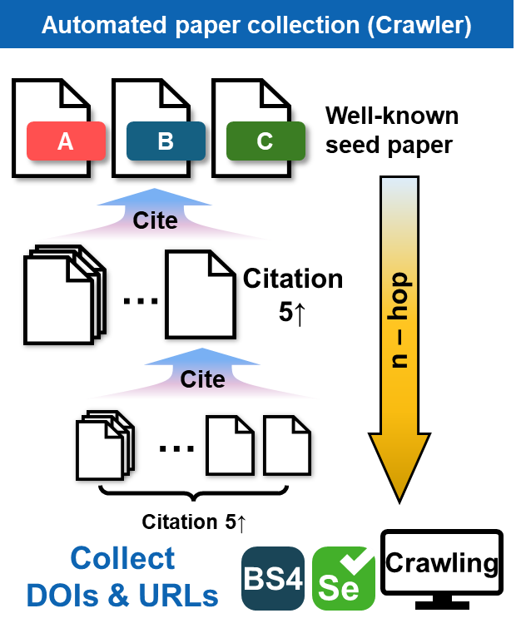
Supplementary Figure S1. Workflow of the automated paper collection pipeline. Seed papers are expanded through multi hop citation crawling, and DOIs and URLs are collected for subsequent metadata retrieval.

Supplementary Figure S2.
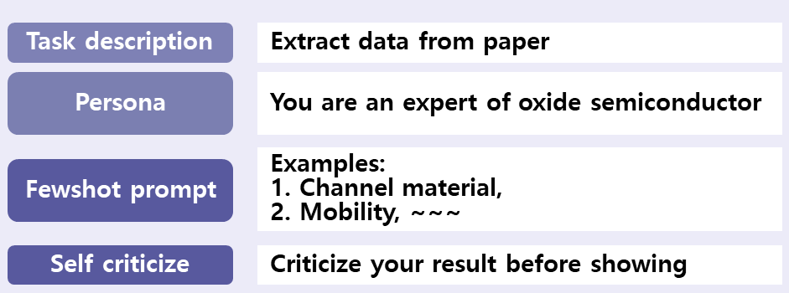
Supplementary Figure S2. Schematic illustration of the structured prompt design used for data extraction, highlighting the four main components: Task description, Persona definition, Few-shot prompting, and Self-criticism.

Supplementary Figure S3.
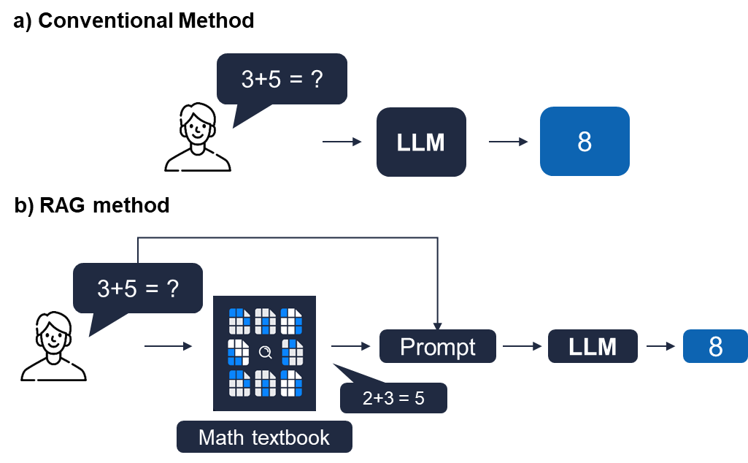
Supplementary Figure S3. Schematic illustration comparing the conventional method with the Retrieval-Augmented Generation (RAG) method used in this study. Unlike the conventional method, RAG integrates relevant knowledge from our provided database (e.g. “Math textbook”) into the prompt, enhancing accuracy.

Supplementary Figure S4.
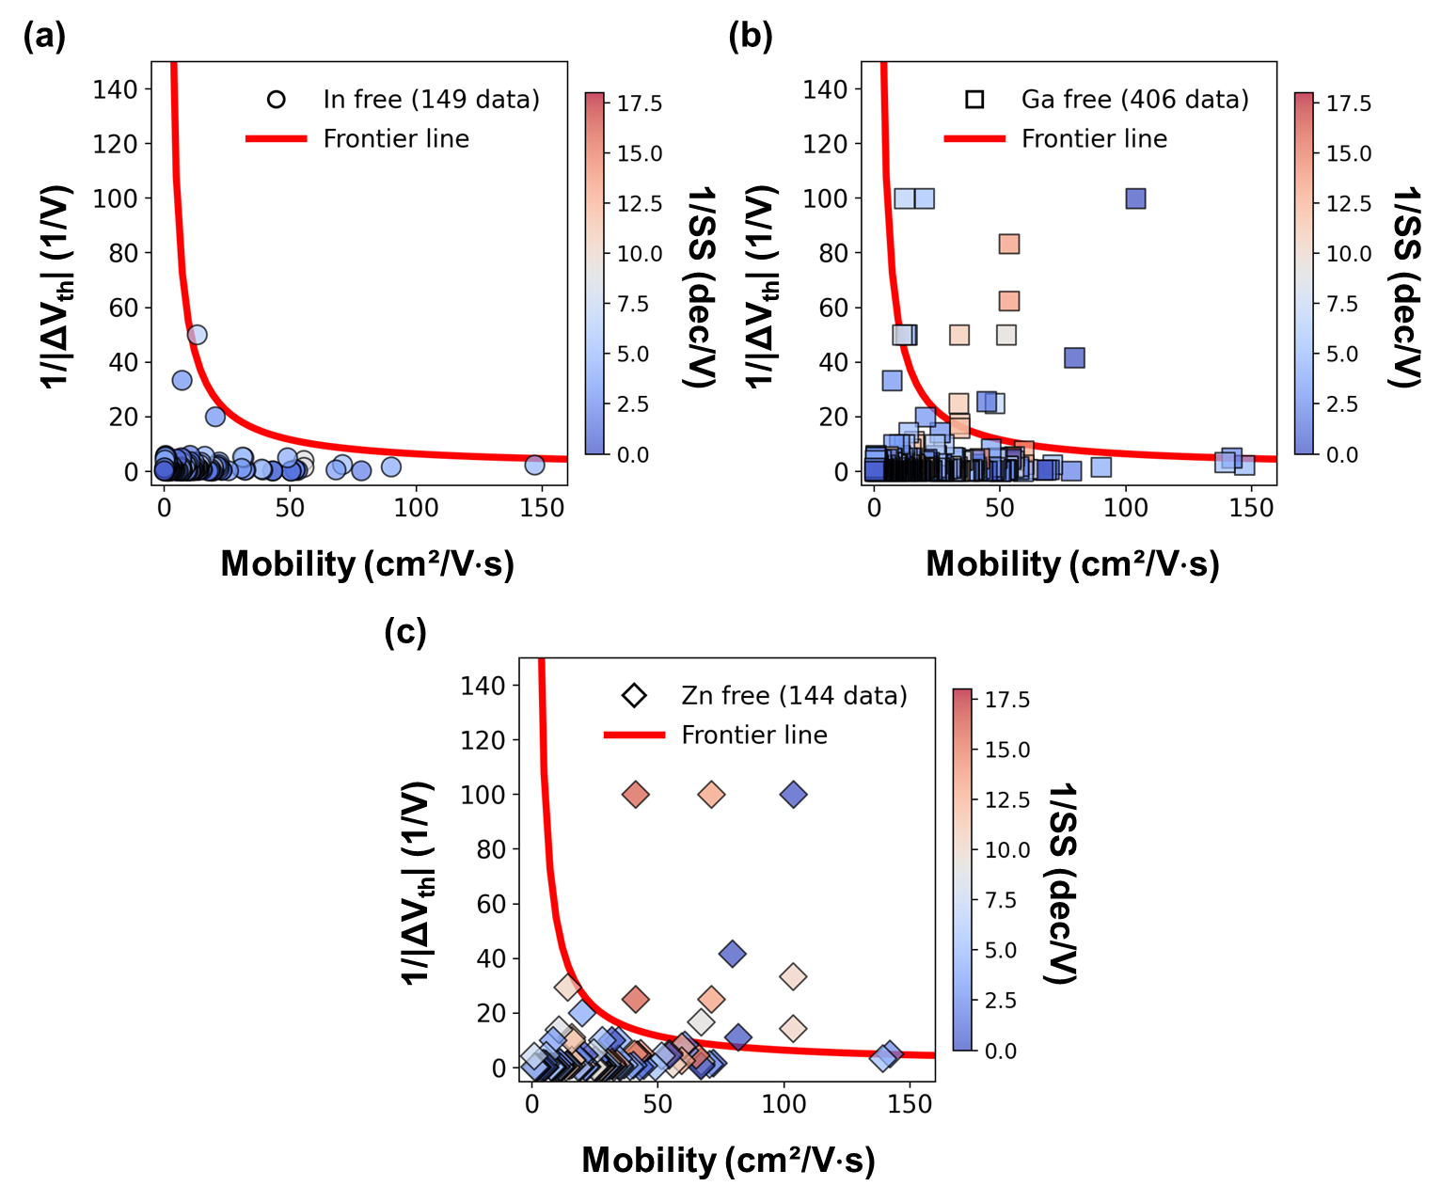
Supplementary Figure S4. Scatter plots illustrating detailed distributions of mobility and stability for oxide TFT channel material groups: (a) In-free, (b) Ga-free, and (c) Zn-free.

Supplementary Figure S5.
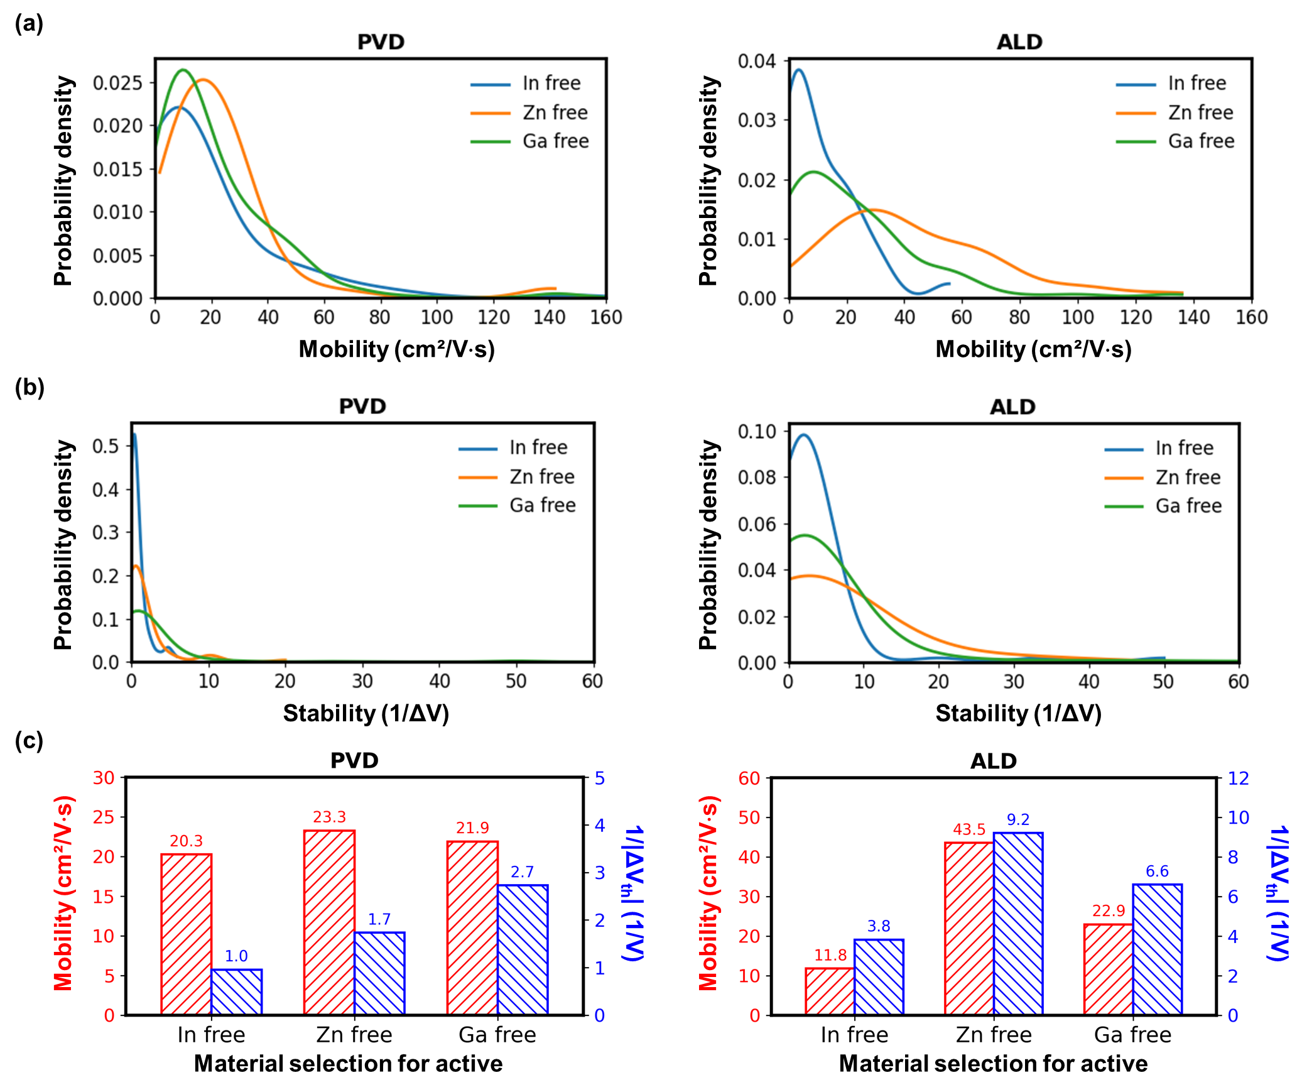 Supplementary Figure S5. Comparison of mobility and stability characteristics of oxide TFTs fabricated by PVD and ALD for different channel materials. (a) KDE distributions of mobility, (b) KDE distributions of stability, and (c) mean values of mobility and stability.
Supplementary Figure S6.
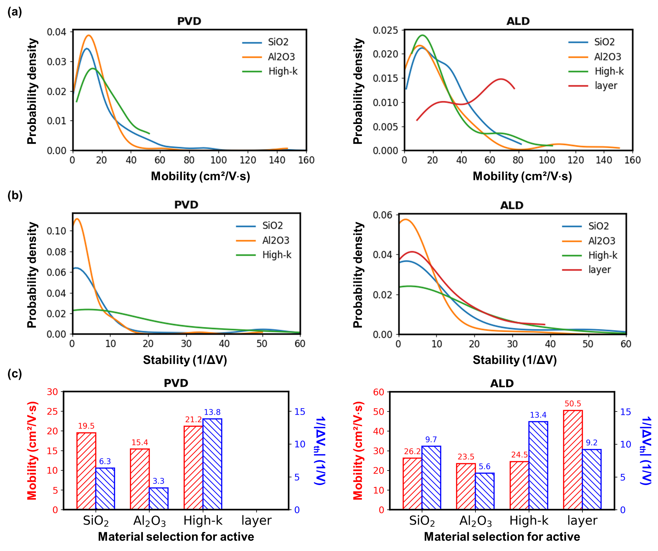
Supplementary Figure S6. Comparison of mobility and stability characteristics of oxide TFTs fabricated by PVD and ALD for different gate insulator materials. (a) KDE distributions of mobility, (b) KDE distributions of stability, and (c) mean values of mobility and stability.

Supplementary Figure S7.
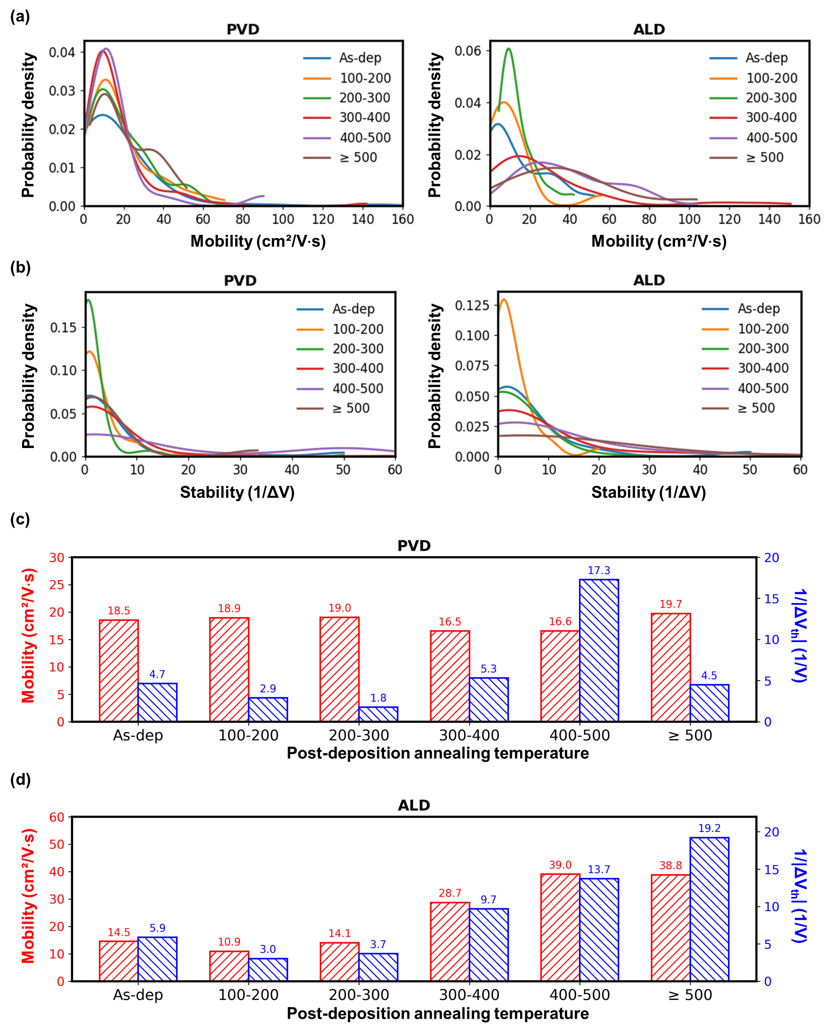
Supplementary Figure S7. Comparison of mobility and stability characteristics of oxide TFTs fabricated by PVD and ALD for different post-deposition annealing temperatures. (a) KDE distributions of mobility, (b) KDE distributions of stability, (c) mean mobility and stability of PVD devices, and (d) mean mobility and stability of ALD devices.
Supplementary Figure S8.
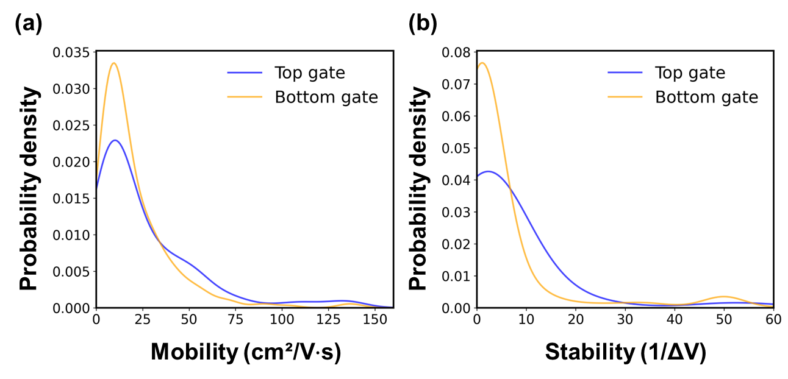
Supplementary Figure S8. KDE plots showing statistical distributions of (a) mobility and (b) stability according to different device structures.

Supplementary Table
Supplementary Table S1. Detailed channel material name categorized by channel material groups
Group | Specific channel material names
In-free | ZnO, GZO, AZO, ZTO, SZTO, HZTO, ZnON, ZnSnO, HZO, ZnGaO, GTO
Ga-free | In₂O₃, ITO, IZO, IZTO, SiIZO, CdScInO, HIZO, AZTO, ZnSnO, ZnON, AIZO, Al:ITZO, InHfZnO
Zn-free | In₂O₃, IGO, IGTO, IAO, IWO, ITGO, ITO, ScInO, GeInGaO, InNdO

Table S2. Detailed gate insulator material name categorized by gate insulator material groups
Group | Specific channel material names
High-k | HfO₂, ZrO₂
Hybrid | SiO₂/ZrO₂, SiO₂/HfO₂

Supplementary note
S1. Data Extraction and Literature Crawling Method
Seed Papers and Researchers
A comprehensive list of initial seed papers (31 papers) and key researchers (13 researchers) selected for oxide semiconductor literature analysis, along with detailed selection criteria, is provided in the supplementary Excel file. As illustrated in Supplementary Figure S1, we expanded the literature dataset from these seeds by multi hop citation following, and we collected the resulting DOIs and URLs using web scraping implemented with BeautifulSoup^{1,2} and Selenium 4¹. Because this expansion is driven by citation links rather than geographic attributes, the collection step does not intentionally target any specific country. In addition, institutional access can affect which full texts are available for download, which may introduce unintended differences in full-text coverage.

Keywords for Literature Filtering
To refine the dataset, keyword-based filtering was performed. The keywords employed included: Oxide semiconductor, TFT, thin-film, thin-film transistor, oxide thin film, oxide film, n-type, IGZO, InGaZnO, ZnO, I-, -O

Prompt Engineering for Data Extraction
Data extraction was conducted through prompt engineering applied to a GPT model (OpenAI). As depicted in Supplementary Figure S2, the engineered prompt consisted of four main components. The task description explicitly defined the extraction of detailed experimental parameters from scientific articles focusing on oxide semiconductor research, including semiconductor channel materials, gate insulator materials, fabrication methods (e.g., ALD or PVD), annealing conditions, electron mobility, threshold voltage shifts, and subthreshold swing. The persona instructed the GPT model to act as an expert in oxide semiconductor materials, ensuring scientifically accurate responses. Few-shot examples guided the GPT model towards accurate and consistent extraction results. Finally, a self-criticism mechanism required the model to internally evaluate and refine its extraction results, further improving accuracy.

Retrieval-Augmented Generation (RAG) Implementation
To further enhance extraction accuracy, a Retrieval-Augmented Generation (RAG) approach was implemented in addition to prompt engineering, as schematically illustrated in Supplementary Figure S3. Conventionally, large language models (LLMs) rely solely on pretrained internal knowledge to generate answers. In contrast, the implemented RAG approach can be conceptually explained by analogy: when posing a mathematics-related question, instead of relying on internal knowledge alone, an LLM is provided with a specific reference (e.g., a "Math textbook"). The LLM thus retrieves and utilizes information exclusively from this provided reference, ensuring contextually precise and verifiable responses.
In practice, this RAG methodology was applied to oxide semiconductor data extraction by individually feeding each of the approximately 2,000 oxide semiconductor papers downloaded through literature crawling to a GPT model. This approach strictly constrained the LLM's responses to the context of the given paper, significantly enhancing extraction accuracy while minimizing irrelevant or fabricated outputs.

Accuracy Evaluation of Extracted Data
To validate the accuracy of GPT-based automated data extraction, manual verification was performed by comparing the extracted data against the original literature for a subset of papers. This validation process involved 30 ALD-based papers and 30 PVD-based papers, yielding extraction accuracies of 95.2% and 94.9% for ALD-based and PVD-based literature, respectively, demonstrating the reliability of the automated extraction methodology. The final dataset, contains 1030 data samples with paired mobility and stability values, is provided as supplementary data in Excel format.

(1) Zhao, L.; Sun, H. Design and Implementation of Web Crawler System Based on Python Technology. 2023 3rd Int. Signal Process., Commun. Eng. Manag. Conf. (ISPCEM) 2023, 00, 390–395. https://doi.org/10.1109/ispcem60569.2023.00076.
(2) Pant, S.; Yadav, Er. N.; Milan; Sharma, M.; Bedi, Y.; Raturi, A. Web Scraping Using Beautiful Soup. 2024 Int. Conf. Knowl. Eng. Commun. Syst. (ICKECS) 2024, 1, 1–6. https://doi.org/10.1109/ickecs61492.2024.10617017.

