Supporting Information
Nanoarchitectonics of Nitrogen/Selenium Functionalized Co-ZIF-9(III) Nanorod/Nanosheet for Nanomolar-Level Detection of Nitrofurantoin Antibiotics in Environmental and Biomedical Samples
Harshitha B. Tyagaraj¹, Sanjay Ballur Prasanna², Gagankumar S K¹, Ali Mohammadi¹, Swapnil R. Patil³, Shalmali R. Burse¹, Amal Al Ghaferi⁴, Ebrahim Al Hajri⁵, Suk Soon Choi⁶, Nilesh R. Chodankar^{5,*}, Yun Suk Huh^{3,*}, Young-Kyu Han^{1,*}
¹Department of Energy and Materials Engineering, Dongguk University–Seoul, Seoul 04620, Republic of Korea.
Email: ykenergy@dongguk.edu (Y.-K. Han)
²Department of Chemical Engineering and Biotechnology, National Taipei University of Technology (Taipei Tech), Taipei 10608, Taiwan.
²Department of Materials and Mineral Resources Engineering, National Taipei University of Technology, Taipei 10608, Taiwan.
³Department of Biological Engineering, Biohybrid Systems Research Center (BSRC), Inha University, Incheon 22212, Republic of Korea.
Email: yunsuk.huh@inha.ac.kr (Y. S. Huh)
⁴Rabdan Academy P.O. Box 127788, Abu Dhabi 114646, United Arab Emirates.
⁵Mechanical and Nuclear Engineering Department, Khalifa University of Science and Technology, 127788, Abu Dhabi, United Arab Emirates.
Email: nilesh.chodankar@ku.ac.ae (N. R. Chodankar)
⁶Department of Biological and Environmental Engineering, Semyung University, Jecheon 27136, Republic of Korea.

1. Experimental details
1.1. Chemicals: Analytical-grade chemicals and reagents were used as supplied without further purification. Cobalt(II) nitrate hexahydrate (Co(NO₃)₂·6H₂O) was purchased from Chemical Co., Ltd. Benzimidazole (blm), sodium bicarbonate (NaHCO₃), and Se powder were obtained from Sigma-Aldrich.
1.2. Material characterization: The surface morphology and elemental composition of CZ@N/SeX (X: 500, 600, 700, 800, 900 °C) were analysed using high-resolution scanning electron microscopy (HRSEM, Hitachi SU8010) and high-resolution transmission electron microscopy (HRTEM) equipped with energy-dispersive X-ray (EDX) spectroscopy and mapping studies. Raman analysis was performed using a laser Raman spectrometer (Raman, FEX, NOST, Republic of Korea) at an excitation wavelength of 532 nm. Fourier-transform infrared spectroscopy (FTIR, JASCO FTIR-6600, range: 4000–400 cm⁻¹) was employed to identify the functional groups present in CZ@N/SeX nanohybrid. The elemental composition, valence states, purity, and crystalline phases of CZ@N/SeX were examined using X-ray photoelectron spectroscopy (XPS, Thermo Scientific K-Alpha) and powder X-ray diffraction (XRD, PANalytical X'Pert with Cu Kα radiation, λ = 1.5406 Å) over a 2θ range of 5° to 90°. The electrocatalytic sensing investigation was performed using a CHI 7089E electrochemical workstation with a standard three-electrode configuration. The working electrode was a CZ@N/SeX-modified glassy carbon electrode (GCE, 3 mm diameter, geometric surface area: 0.0706 cm²). The reference electrode was a saturated Ag/AgCl electrode (saturated KCl, 25 °C). The auxiliary electrode was a platinum wire. Electrochemical techniques, including electrochemical impedance spectroscopy (EIS), differential pulse voltammetry (DPV), and cyclic voltammetry (CV), were used to evaluate the electrocatalytic performance.
1.3. Synthesis of CZ: Co(NO₃)₂·6H₂O (88.50 mg), blm (71.45 mg), and NaHCO₃ (47.38 mg) were mixed in the presence of 2 mL of ethanol, and the mixture was ground for approximately 10 min in a mortar[1]. The resulting product was washed three times with anhydrous ethanol and deionised water to remove the remaining NaHCO₃ and NaNO₃. A purple-pink powder product was obtained after drying at 60 °C for 12 hrs in a vacuum oven.

1.4. Synthesis of CZ@N/SeX (X: 500, 600, 700, 800, 900 °C): The as-acquired CZ powder was uniformly mixed with pure selenium powder in a 1:1 weight ratio. The mixture was then placed in a tubular furnace and heat-treated at 500, 600, 700, 800, and 900 °C with a heating rate of 5 °C/min for 1 hrs under a nitrogen atmosphere to obtain CZ@N/SeX nanohybrid. The material was then cooled to 200 °C at 3 °C/min under nitrogen and subsequently cooled naturally to room temperature. The final products were denoted as CZ@N/Se500, CZ@N/Se600, CZ@N/Se700, CZ@N/Se800, and CZ@N/Se900, respectively.
1.5. Fabrication of CZ@N/Se800 modified electrode: Before loading the CZ@N/Se800 onto the electrode, the surface of a GCE was polished using 0.3 μm and 0.5 μm alumina suspensions on micro cloth pads. Then, ultrasonically cleaned for 3 min in a 1:(v/v) HNO₃/water solution, followed by ethanol, and finally washed with ultrapure water to remove residual impurities and obtain a smooth, mirror-like surface. The GCE was acid-treated by applying a voltage between –1.0 and +1.0 V for three consecutive cyclic voltammetry (CV) cycles at a scan rate of 0.05 mV s⁻¹ in 0.1 M H2SO4, thereby removing metal impurities. Then, the activated GCE was washed several times vbwith DI water and ethanol, placed in a vacuum oven at 25 °C for 20 min, and then stored in a desiccator. The electrocatalyst was prepared by dispersing 1 mg of CZ@Se800 in 1000 μL of a solution containing water (380 μL), ethanol (600 μL), and Nafion (20 μL), and then ultrasonically dispersing the mixture for 30 min until homogeneous. Subsequently, 4 μL of the resulting ink (1 mg/mL) was dropped onto the prepared GCE and allowed to dry at room temperature in a vacuum oven. The electrochemical experiments were performed using CV under the potential range of 0.2 V to –0.8 V for the detection of NFT. For comparison, the CZ, CZ@N/Se500, CZ@N/Se600, CZ@N/Se700, and CZ@N/Se900electrodes were prepared using the same procedure.
1.6. Collections and preparation of real samples
1.6.1. Environmental samples: The river water was collected from the Han River in Seoul, South Korea, while drinking water, pond water, tap water, and wastewater were obtained from the Inha University campus, respectively. The collected samples were centrifuged at 9000 rpm for 20 minutes, with the supernatant collected separately and preserved at 4 °C for practical purposes. The water samples were used directly to prepare buffers for electrochemical analysis.
1.6.2. Biological samples (human saliva, human serum, and human urine): Samples of human saliva, serum, and urine were gathered from healthy volunteers of Chang-Gung Memorial Hospital, IRB No:20181660B). The samples were centrifuged at 9000 rpm for 20 min to remove any precipitates. Subsequently, 2.5 mL of saliva and serum supernatant were moved to a 25 mL volumetric flask and diluted using 0.1 M PBS (pH 5.0). Likewise, 1.0 mL of the urine sample was placed into a 100 mL volumetric flask and diluted with 0.1 M PBS (pH 5.0) to the designated mark on the flask, without further processing.
1.6.3. Preparation of samples for the spiked method: To evaluate the practical use and analytical precision of the created electrochemical sensor, spiking experiments were conducted with actual sample matrices. The samples were first gathered and underwent standard pre-treatment processes as outlined in sections 2.6.1 and 2.6.2. Concentrations of NFT (10, 20, 30, 40, and 50 μM) were added individually to the pretreated samples. Each spiked solution was carefully mixed and allowed to equilibrate for 10 min at room temperature to ensure effective interaction between the analyte and matrix components. The spiked samples were subsequently analysed using electrochemical methods under optimized experimental conditions. All measurements were conducted three times to guarantee the reproducibility and dependability of the results.
Fig. S1 HRSEM images of (a) CZ, (b) CZ@N/Se500, (c) CZ@N/Se600, (d) CZ@N/Se700, and (e) CZ@N/Se900.

The pristine Se exhibited sharp diffraction peaks at 2θ values of 23.5°, 29.7°, 41.3°, and 43.6°, which correspond to its orthorhombic phase (JCPDS No. 06-0362).[2] The XRD curve of CZ@Se500 and CZ@Se600 exhibited the characteristic diffraction peaks of Se, demonstrating the partial preservation of crystalline selenium at lower selenization temperatures. As the temperature increased to 700 °C, the Se diffraction peaks became less prominent, suggesting gradual diffusion of Se into the carbon matrix and interaction with Co-based species. At 900 °C, the diffraction pattern showed well-defined crystalline peaks assigned to Co and its selenides. In contrast, the characteristic Se peaks disappeared, confirming complete incorporation of Se into the Co-based carbon framework for CZ@N/Se900. The disappearance or weakening of Se crystalline peaks in CZ@N/Se500, CZ@N/Se600, CZ@N/Se700, and CZ@N/Se900 indicates that selenium becomes well-dispersed or incorporated into the matrix, particularly at 800 °C, where no distinct Se peaks are detected, implying atomic-level dispersion or amorphous transformation.
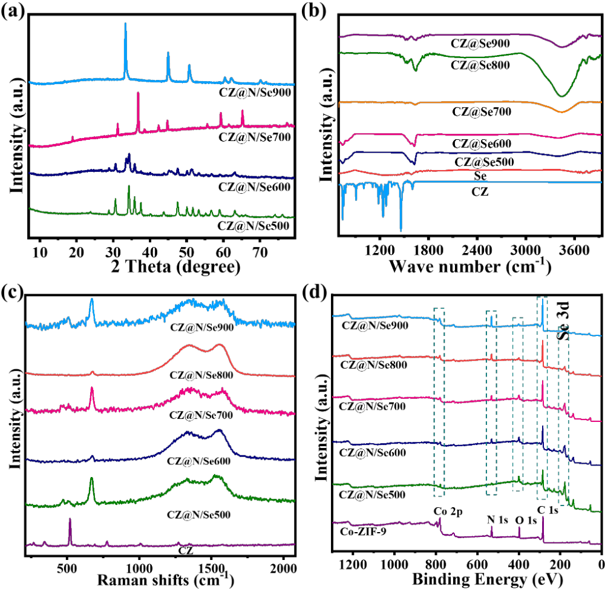Fig. S2 (a) XRD spectra of CZ@N/Se500, CZ@N/Se600, CZ@N/Se700, and CZ@N/Se700. (b) FTIR (c) Raman, (d) XPS survey spectra of CZ, CZ@N/Se500, CZ@N/Se600, CZ@N/Se700, CZ@N/Se800, and CZ@N/Se700.

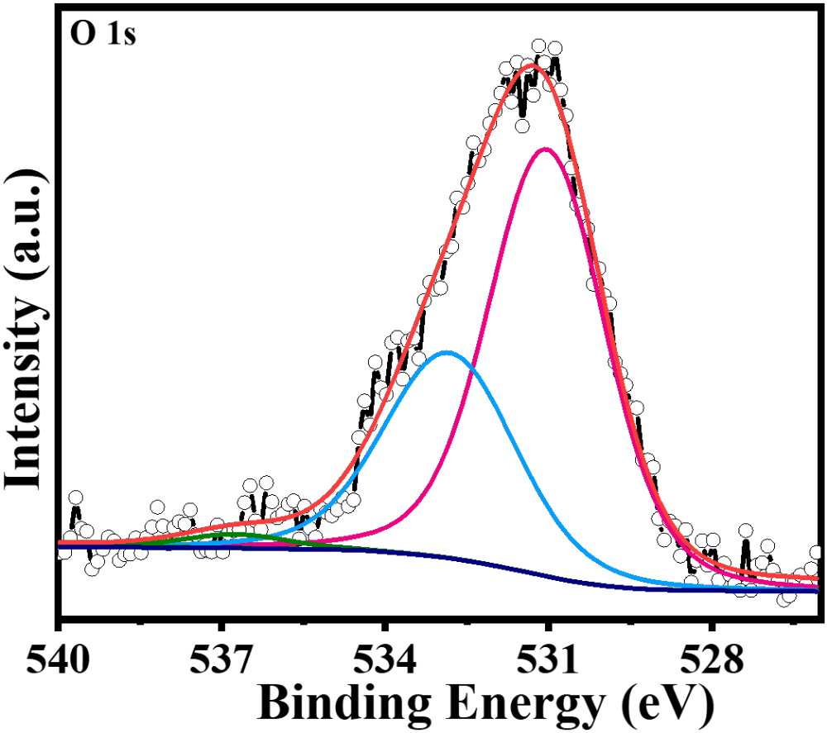Fig. S3 High-resolution XPS spectra of O 1s of CZ@N/Se800.
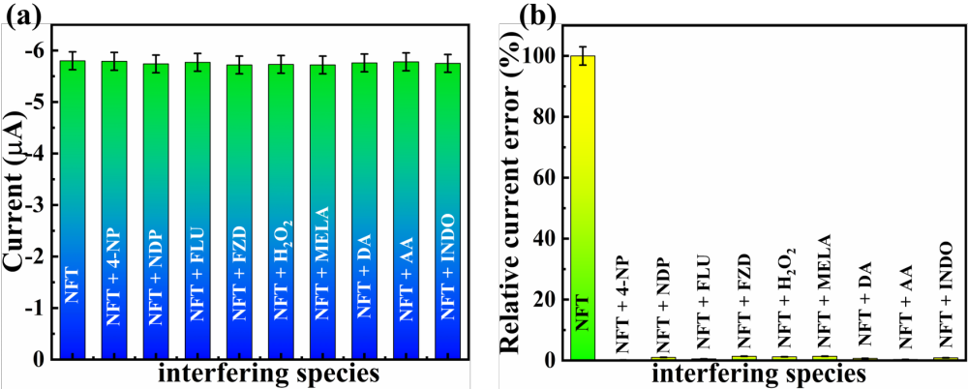Fig. S4 (a) Bar graph representation of various interferents vs. current and (b) relative current error (%) of CZ@N/Se800.

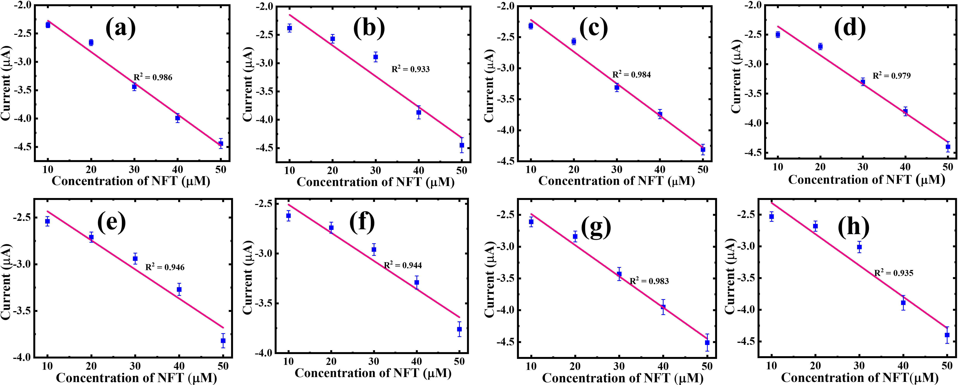
Fig. S5 DPV response of spiked NFT with linear fits in (a) river water, (b) drinking water, (c) pond water, (d) tap water, (e) waste water, (f) human saliva, (g) serum, and (h) urine samples.

Table S1. Comparison of electrooxidation performance of CZ@N/Se800/GCE with previously reported electrocatalysts for NFT sensing.
Electrocatalyst | Detection technique | pH values | Linear range (µM) | LOD (nM) | References
ZnO/Co₃O₄/ZnCo₂O₄ | DPV | 7.0 | 0.01 - 1987 | 1.0 | [3]
Cl-CuPc/g-C₃N₄ | DPV | 7.0 | 0.2498 - 589.3 | 6.0 | [4]
VS₂/Ti₃C₂T_{x} | LSV | 7.0 | 0.01 - 400 | 4.7 | [5]
Ru/NiFe-LDH-MXene | LSV | 6.0 | 0.01 - 275 | 2.2 | [6]
SVG-2 | i-t | 7.0 | 0.035 - 672.3 | 8.7 | [7]
CZ@N/Se800 | DPV | 5.0 | 0.05 – 914.8 | 1.03 | Present work

Table S2. Determination of NFT using the DPV technique in various samples using the CZ@Se800/GCE sensor.
Real samples | Added  (µM) | Found  (µM) | Recovery  (%) | RSD  (%)
River water sample | 10 | 9.86 | 98.6 | 2.31
River water sample | 20 | 19.92 | 99.6 | 1.71
River water sample | 30 | 29.85 | 99.5 | 1.81
River water sample | 40 | 39.92 | 99.8 | 1.99
River water sample | 50 | 49.89 | 99.78 | 2.31
Drinking water sample | 10 | 9.95 | 99.5 | 1.89
Drinking water sample | 20 | 19.88 | 99.4 | 1.99
Drinking water sample | 30 | 29.94 | 99.8 | 1.78
Drinking water sample | 40 | 39.85 | 99.62 | 1.91
Drinking water sample | 50 | 49.91 | 99.82 | 2.01
Pond water sample | 10 | 9.91 | 99.1 | 1.88
Pond water sample | 20 | 19.89 | 99.45 | 1.89
Pond water sample | 30 | 29.88 | 99.6 | 2.02
Pond water sample | 40 | 39.96 | 99.9 | 2.09
Pond water sample | 50 | 49.91 | 99.82 | 2.11
Tap water sample | 10 | 9.95 | 99.5 | 2.11
Tap water sample | 20 | 19.96 | 99.8 | 1.81
Tap water sample | 30 | 29.88 | 99.6 | 1.91
Tap water sample | 40 | 39.91 | 99.77 | 1.77
Tap water sample | 50 | 49.92 | 99.84 | 1.81
Waste water sample | 10 | 9.89 | 98.9 | 1.31
Waste water sample | 20 | 19.94 | 99.7 | 1.11
Waste water sample | 30 | 29.91 | 99.7 | 1.61
Waste water sample | 40 | 39.96 | 99.9 | 1.71
Waste water sample | 50 | 49.95 | 99.9 | 2.11
Human saliva sample | 10 | 9.91 | 99.1 | 1.33
Human saliva sample | 20 | 19.89 | 99.45 | 1.71
Human saliva sample | 30 | 29.94 | 99.8 | 1.51
Human saliva sample | 40 | 39.88 | 99.7 | 1.45
Human saliva sample | 50 | 49.94 | 99.88 | 1.31
Human serum sample | 10 | 9.89 | 98.9 | 1.61
Human serum sample | 20 | 19.85 | 99.25 | 1.11
Human serum sample | 30 | 29.91 | 99.7 | 1.89
Human serum sample | 40 | 39.94 | 99.85 | 2.01
Human serum sample | 50 | 49.92 | 99.84 | 1.91
Human urine sample | 10 | 9.91 | 99.1 | 2.09
Human urine sample | 20 | 19.89 | 99.45 | 1.91
Human urine sample | 30 | 29.95 | 99.83 | 1.88
Human urine sample | 40 | 39.94 | 99.85 | 2.19
Human urine sample | 50 | 49.89 | 99.78 | 1.81

References
[1] K. Jayaramulu, J. Masa, D.M. Morales, O. Tomanec, V. Ranc, M. Petr, P. Wilde, Y.T. Chen, R. Zboril, W. Schuhmann, R.A. Fischer, Ultrathin 2D Cobalt Zeolite-Imidazole Framework Nanosheets for Electrocatalytic Oxygen Evolution, Adv. Sci. 5 (2018) 1–9. https://doi.org/10.1002/advs.201801029.
[2] Q. Xu, T. Liu, Y. Li, L. Hu, C. Dai, Y. Zhang, Y. Li, D. Liu, M. Xu, Selenium Encapsulated into Metal-Organic Frameworks Derived N-Doped Porous Carbon Polyhedrons as Cathode for Na-Se Batteries, ACS Appl. Mater. Interfaces 9 (2017) 41339–41346. https://doi.org/10.1021/acsami.7b14380.
[3] T.S. Priya, T.W. Chen, S.M. Chen, R. Balaji, N. Chandrasekar, Xin-EePhang, K.K. Sarigamala, M.T. Hwang, Imidazolate framework–derived porous ZnO/Co3O4/ZnCo2O4 interfaced nitrogen-rich g-C3N4 sheets for electrochemical detection of nitrofurantoin, Adv. Compos. Hybrid Mater. 8 (2025). https://doi.org/10.1007/s42114-025-01327-9.
[4] N. Nataraj, D.P. Jaihindh, S.M. Chen, A. Sabbah, S. Muthusamy, S. Devi, Y.F. Lin, A. Mahalingam, Substitution-functionalized copper phthalocyanine (CuPc)/carbon nitride (g-C3N4) electrocatalysts for the simultaneous detection of 4-nitroaniline and nitrofurantoin, Environ. Sci. Nano 12 (2025) 3731–3746. https://doi.org/10.1039/d5en00092k.
[5] M. Liu, T. Zhe, L. Zhu, F. Li, K. Ma, C. Xuan, Q. Feng, S. Ouyang, L. Wang, Interfacial engineering of VS2/Ti3C2Tx MXene heterojunctions for portable electrochemical sensing of nitrofurantoin residues in food and water samples, Food Chem. 486 (2025) 144624. https://doi.org/10.1016/j.foodchem.2025.144624.
[6] M. Liu, T. Zhe, F. Li, L. Zhu, S. Ouyang, L. Wang, An ultrasensitive electrochemical sensor based on NiFe-LDH-MXene and ruthenium nanoparticles composite for detection of nitrofurantoin in food samples, Food Chem. 461 (2024) 140915. https://doi.org/10.1016/j.foodchem.2024.140915.
[7] S.M. Babulal, C. Koventhan, S.M. Chen, W. Hung, Construction of sphere like samarium vanadate nanoparticles anchored graphene nanosheets for enhanced electrochemical detection of nitrofurantoin in biological fluids, Compos. Part B Eng. 237 (2022) 109847. https://doi.org/10.1016/j.compositesb.2022.109847.

